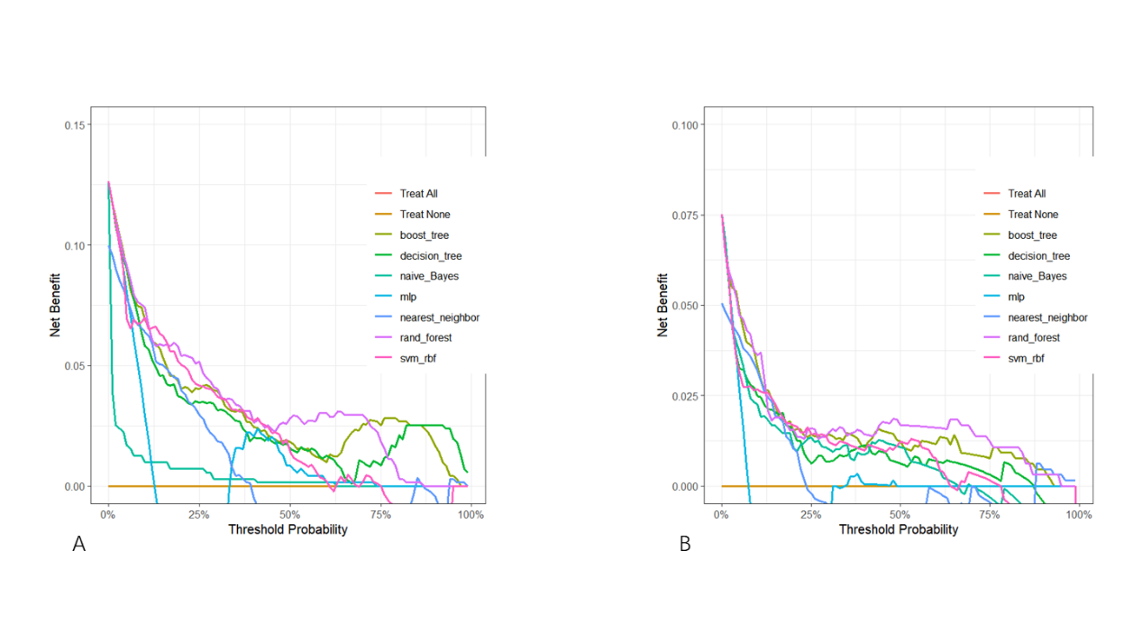
Figure S1 The decision curve analysis of the nomogram in the two groups.
(A)Intertrochanteric fracture; (B)Femoral neck fracture

