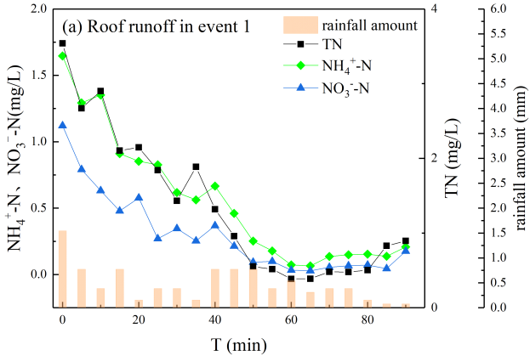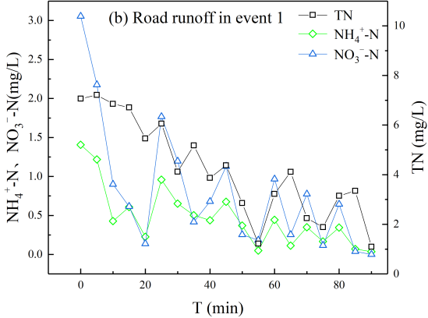
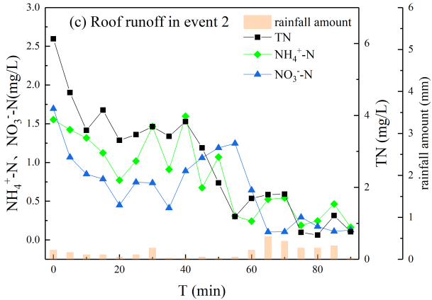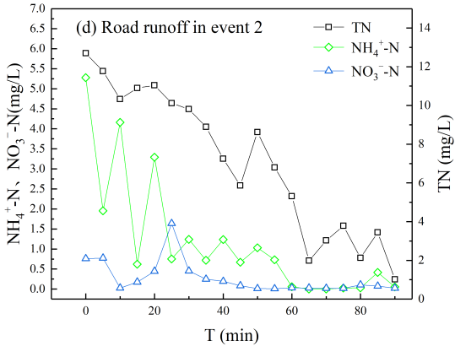
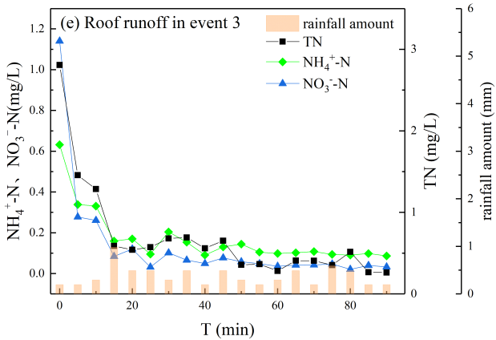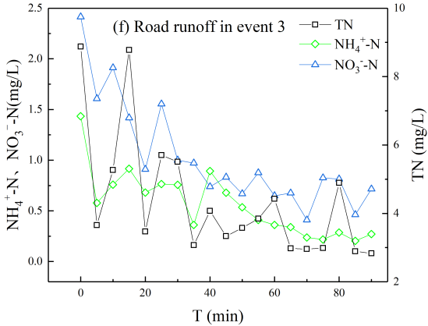
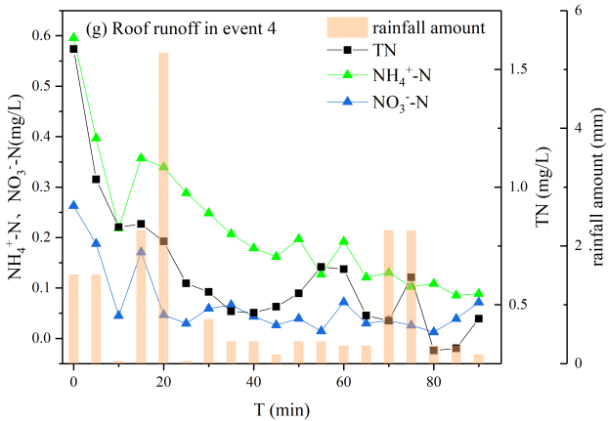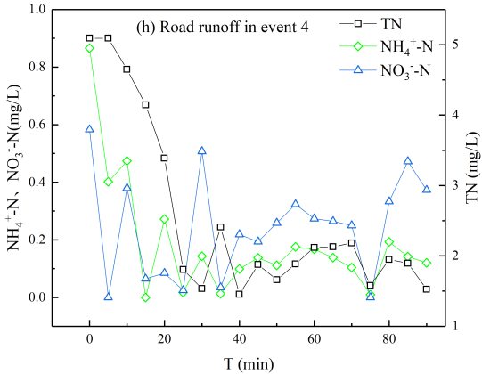
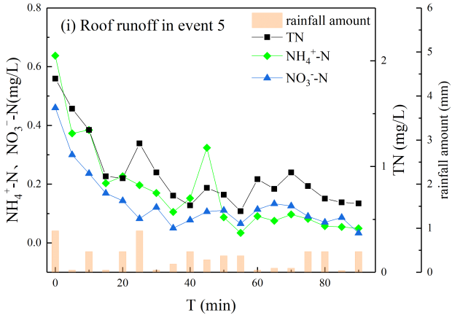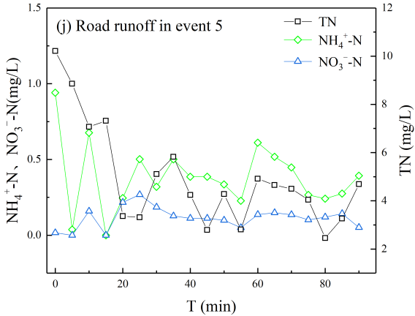
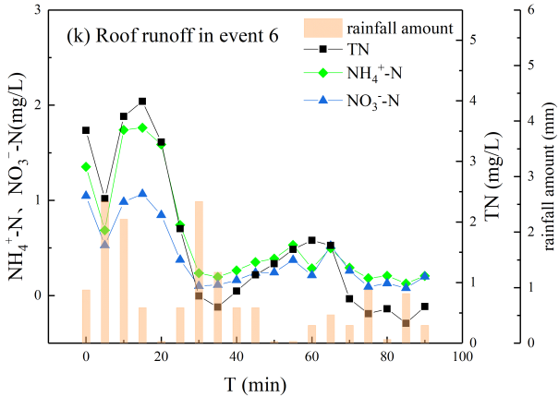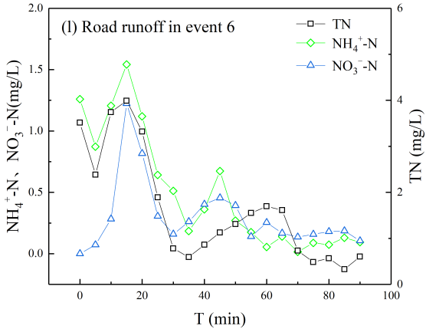
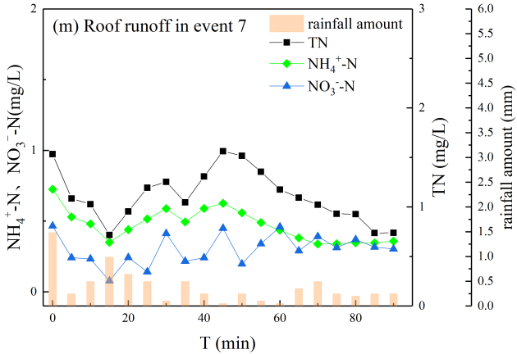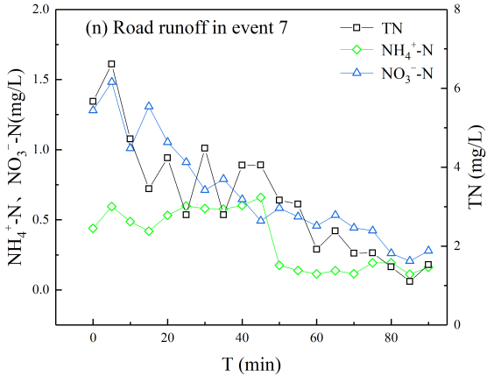
Fig. S1 The temporal variations of different N forms in (a) roof runoff and (b) road runoff in even 1; (c) roof runoff and (d) road runoff in event 2; (e)roof runoff and (f) road runoff in event 3; (g)roof runoff and (h) road runoff in event 4; (i)roof runoff and (j) road runoff in event 5; (k)roof runoff and (l) road runoff in event 6; (m)roof runoff and (n) road runoff in event 7.

Table S1 Pearson’s correlation coefficient of measured parameters in roof runoff and road runoff.
 | ADWP | TN | DTN | NO₃⁻-N | NH₄⁺-N | PN | DON | TSS | COD
Roof runoff (n=165)
ADWP | 1
TN | .341** | 1
DTN | .336** | .992** | 1
NO₃⁻-N | .221** | .925** | .926** | 1
NH₄⁺-N | .284** | .916** | .919** | .901** | 1
PN | .166* | .460** | .342** | .363** | .347** | 1
DON | .369** | .791** | .808** | .585** | .537** | .205** | 1
TSS | .409** | .354** | .353** | .300** | .376** | 0.144 | .251** | 1
COD | -.004 | .401** | .387** | .360** | .287** | .251** | .386** | .290** | 1
Road runoff (n=156)
ADWP | 1
TN | .355** | 1
DTN | .357** | .858** | 1
NO₃⁻-N | .100 | .269** | .495** | 1
NH₄⁺-N | .255** | .693** | .823** | .320** | 1
PN | .201* | .757** | .315** | -.133 | .233** | 1
DON | .372** | .829** | .869** | .126 | .555** | .427** | 1
TSS | -.026 | .541** | .300** | -.091 | .243** | .619** | .377** | 1
COD | .179* | .604** | .374** | -.122 | .316** | .642** | .466** | .669** | 1
**. Correlation is significant at the 0.01 level (2-tailed).
* . Correlation is significant at the 0.05 level (2-tailed).
n: Number of the samples;
ADWP: Antecedent dry weather period

Table S2 The δ¹⁵N-NO₃⁻ and δ¹⁸O-NO₃⁻ values and the δD-H₂O and δ¹⁸O-H₂O values in the roof runoff and road runoff and the δ¹⁵N-NO₃⁻ and δ¹⁸O-NO₃⁻ values of NO₃⁻ sources used in SIAR.
Sample |  | δ¹⁵N-NO₃⁻ |  | δ¹⁸O-NO₃⁻ |  | δD-H₂O |  | δ¹⁸O-H₂O
 |  | Mean | SD | Mean | SD | Mean | SD | Mean | SD
Roof runoff | Storm event 3 (n=10) | -1.41 | 1.19 | 57.53 | 6.26
Roof runoff | Storm event 4 (n=11) | -2.45 | 1.43 | 46.47 | 3.53
Roof runoff | Storm event 7 (n=11) | -7.84 | 2.02 | 75.66 | 2.36
Road runoff | Storm event 3 (n=13) | -2.95 | 2.41 | 31.17 | 10.11 | -34.67 | 7.62 | -5.39 | 0.89
Road runoff | Storm event 4 (n=11) | -2.17 | 4.52 | 22.20 | 5.79
Road runoff | Storm event 7 (n=11) | -3.73 | 2.45 | 70.01 | 2.66 | -70.43 | 1.41 | -10.11 | 0.29
 | Atmospheric deposition ª | -1.00 | 1.90 | 60.20 | 12.50
 | NH₄⁺ Fertiliser ^{b} | -0.20 | 2.28 | -2.00 | 8.00
 | NO₃⁻ Fertiliser ^{c} | 1.10 | 2.78 | 21.30 | 3.01
 | Soil and organic N ^{d} | 7.50 | 5.23 | -2.00 | 8.00
n: Number of the samples
ªJin et al., 2019.^{b} Curt et al., 2004; Kendall et al., 2007; Li et al., 2007; Yang and Toor, 2016.^{c}Curt et al., 2004; Kendall et al., 2007; Yang and Toor, 2016.^{d}Bedard-Haughn et al., 2003; Curt et al., 2004; Divers et al., 2014; Kendall et al., 2007; Yang and Toor, 2016.

Table S3 The contributions of NO₃⁻ sources in roof runoff and road runoff by SIAR.
Sample | Event |  | Atmospheric deposition | NH₄⁺ fertiliser | NO₃⁻ fertiliser | Soil and organic N
Roof runoff | Storm event 3 (n=10) |  | 94.98 |  |  | 5.02
Roof runoff | Storm event 4 (n=11) |  | 83.61 |  |  | 16.39
Roof runoff | Storm event 7 (n=11) |  | 97.83 |  |  | 2.17
Road runoff | Storm event 3 (n=13) |  | 40.52 | 31.33 | 21.71 | 6.44
Road runoff | Storm event 4 (n=11) |  | 34.15 | 29.97 | 24.35 | 11.53
Road runoff | Storm event 7 (n=11) |  | 91.91 | 2.59 | 3.68 | 1.82
Road runoff | Storm event 3 | Ini. | 48.32 | 17.85 | 23.1 | 10.73
Road runoff | Storm event 3 | M.&L. | 37.97 | 31.67 | 22.88 | 7.48
Road runoff | Storm event 4 | Ini. | 32.12 | 20.79 | 24.85 | 22.24
Road runoff | Storm event 4 | M.&L. | 24.55 | 30.42 | 31.01 | 14.02
Road runoff | Storm event 7 | Ini. | 41.21 | 23.6 | 23.63 | 11.56
Road runoff | Storm event 7 | M.&L. | 83.43 | 5.58 | 7.65 | 3.34
n: Number of the samples
Ini.: initial period of stormwater runoff (first 10 minutes of sampling time); M.&L.: middle and late periods of stormwater runoff (after the first 10 minutes of sampling time)

