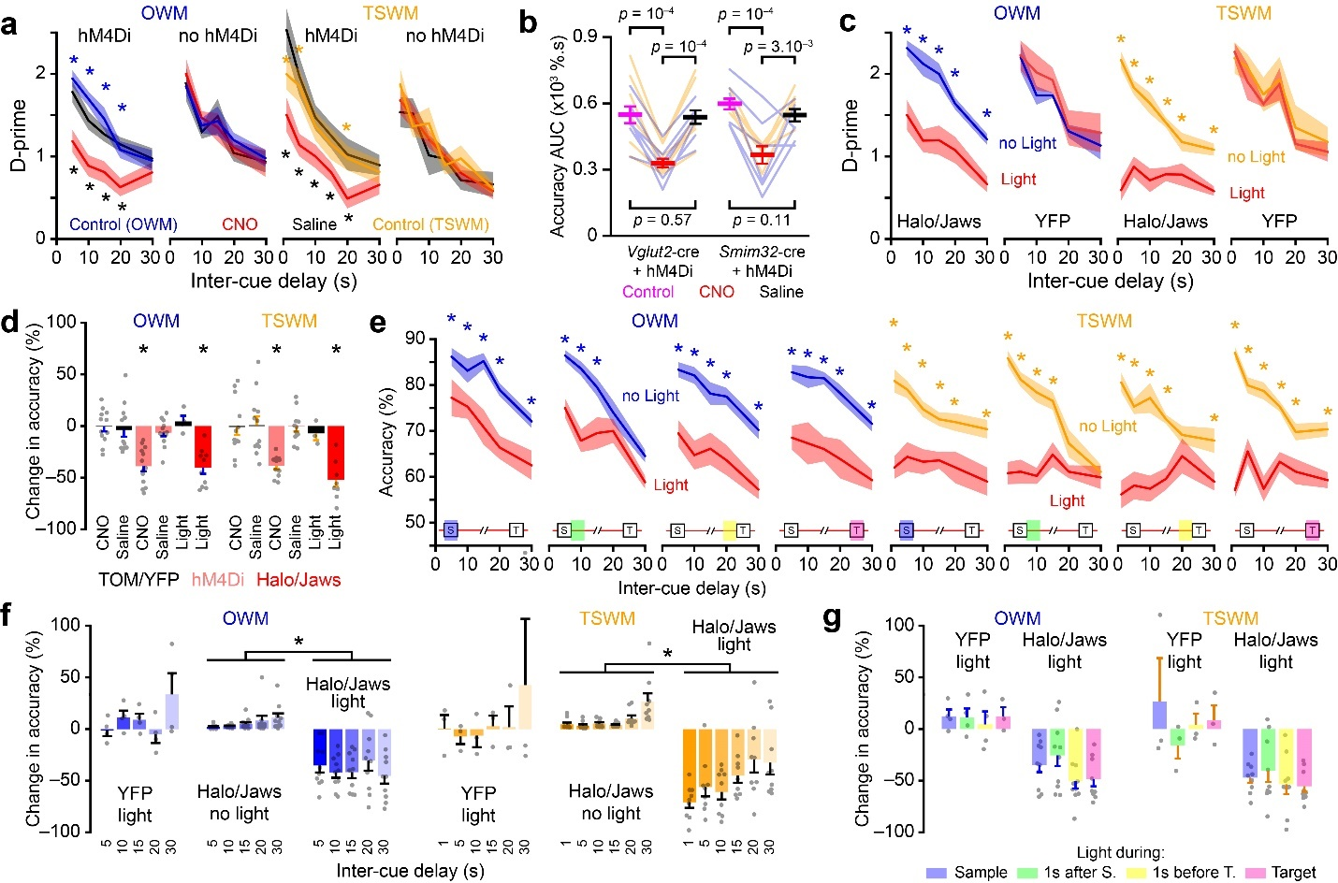

Supplementary Figure 1. Chemo- and optogenetic inhibition of CLA neurons impair working memory performance.
a, WM performances calculated from d-prime values and plotted as a function of the inter-cue delay duration for groups of mice either expressing hM4Di in the CLA (OWM: n = 13, TSWM: n = 11) and control mice without hM4Di (n = 12 for OWM and TSWM). Control sessions (no injection), sessions with CNO injection, and sessions with saline injection were performed sequentially in this order (RM ANOVA; post-hoc Fisher’s test comparisons *: P < 0.05, significant comparisons for Control vs. CNO and Saline vs. CNO are color-coded in blue/orange and black, respectively). b, WM AUC values quantified in two different transgenic lines targeting the CLA. The lines represent the AUC for individual mice across the different treatments and tasks (OWM [n = 13] and TSWM [n = 11], data are shown in blue and orange, respectively. RM ANOVA with post-hoc Fisher’s test comparisons). c, WM performance calculated from d-prime values and averaged across the four stimulation epochs as a function of inter-cue delay duration for mice expressing either Halo/Jaws or YFP in the CLA. Performances for no light and light trials are compared within each group (Number of mice: Halo/Jaws [OWM: n = 10, TSWM: n = 9]; YFP [OWM: n = 4, TSWM: n = 3]. RM ANOVA; post-hoc Fisher’s test comparisons *: P < 0.05, significant comparisons are indicated in either blue or orange). d, Change in global response accuracy (relative to control performance, i.e. no CNO or no light conditions) following either chemogenetic or optogenetic CLA inhibition or saline injection in OWM and TSWM tasks. The performance of individual mice is indicated as grey dots. Comparisons were made between CNO and Saline groups using paired t-tests (*: P < 0.05). Comparisons were between YFP control group and Halo/Jaws experimental group using unpaired t-tests (*: P < 0.05). e, WM performance for individual stimulation epoch plotted as a function of inter-cue delay duration for mice expressing either Halo/Jaws or YFP in the CLA. Performances for no light and light trials are compared within each group (RM ANOVA; post-hoc Fisher’s test comparisons *: P < 0.05, significant comparisons are indicated in either blue or orange). The schematic of the stimulation epoch is provided within each plot. f, Effect of optogenetic inhibition of CLA neurons on WM performance across various inter-cue delays. Accuracy change is calculated for light trials relative to no-light conditions. For Halo/Jaws no-light conditions, performance during the no-light trials of a given stimulation epoch is compared to the averaged performance of the no-light trials across the other three stimulation epochs. (RM ANOVA: *: P < 0.05). g, Effect of optogenetic inhibition of CLA neurons on WM performance during different light stimulation epochs for both OWM and TSWM tasks in control and experimental mouse groups (One-Way ANOVA between the different light stimulation epochs P > 0.05 for all comparisons). All data represented as mean ± SEM. See Supplementary Table 1 for detailed statistics.

Supplementary Table 1- detailed statistics

Figure 1
Comparison: Early trained vs. Trained
1b RM ANOVA | P value | F (DFn, DFd)
OWM Accuracy  TSWM Accuracy  OWM d-prime  TSWM d-prime | <0.0001  <0.0001  <0.0001  <0.0001 | F (7, 203) = 65.62  F (5, 110) = 13.34  F (7, 203) = 40.33  F (5, 110) = 6.606
1c Paired two-tailed t-test | P value | t, df
OWM Accuracy % | <0.0001 | t = 15.79, df = 29
TSWM Accuracy % | <0.0001 | t = 7.190, df = 22
OWM d’ | <0.0001 | t = 9.332, df = 29
TSWM d’ | 0.0002 | t = 4.386, df = 22
Comparison: OWM vs. TSWM
1d RM ANOVA | P value | F (DFn, DFd)
Accuracy | <0.0001 | F (1, 357) = 38.12
d-prime | <0.0001 | F (1, 357) = 29.38
1f-h Unpaired two-tailed t-test | P value | t, df
T₀ Accuracy | 0.0009 | t = 3.529, df = 51
T₀ d-prime | 0.0278 | t = 2.264, df = 51
Half-life Accuracy | 0.4767 | t = 0.7169, df = 51
Half-life d-prime | 0.6123 | t = 0.5099, df = 51
Kolmogorov-Smirnov test
1i OWM vs. TSWM | P value | D value
Half-life Accuracy | 0.8259 | 0.1739
Half-life d-prime | 0.7100 | 0.1942

Figure 3
Kolmogorov-Smirnov test
3d Comparison | P value | D value
Baseline vs. Sample | <0.0001 | 0.6667
Baseline vs. Delay | 0.0011 | 0.5000
Sample vs. Delay | 0.0165 | 0.4000
RM ANOVA (post-hoc Fisher’s LSD)
3e Comparison (Sample) | P value | t, df
5s vs. 15s | 0.7011 | t = 0.3900, df = 18
5s vs. 30s | 0.8908 | t = 0.1393, df = 18
15s vs. 30s | 0.6031 | t = 0.5292, df = 18
3e Comparison (Delay) | P value | t, df
5s vs. 15s | 0.0001 | t = 4.935, df = 18
5s vs. 30s | 0.0084 | t = 2.961, df = 18
15s vs. 30s | 0.0639 | t = 1.974, df = 18
Figure 4
RM ANOVA (post-hoc Fisher’s LSD)
4b Performance Accuracy | P value | F (DFn, DFd)
OWM Accuracy (hM4Di) | <0.0001 | F (2, 36) = 15.81
OWM Accuracy (no hM4Di) | 0.9037 | F (2, 33) = 0.1016
TSWM Accuracy (hM4Di) | <0.0001 | F (2, 30) = 21.64
TSWM Accuracy (no hM4Di) | 0.7044 | F (2, 33) = 0.3541
4c AUC | P value | t, df
OWM (hM4Di)  Control vs. CNO  Control vs. Saline  CNO vs. Saline | <0.0001  0.3078  0.0002 | t = 5.123, df = 36  t = 1.034, df = 36  t = 4.088, df = 36
OWM (no hM4Di)  Control vs. CNO  Control vs. Saline  CNO vs. Saline | 0.9365  0.6149  0.6717 | t = 0.0802, df = 33  t = 0.5079, df = 33  t = 0.4277, df = 33
TSWM (hM4Di)  Control vs. CNO  Control vs. Saline  CNO vs. Saline | <0.0001  0.7850  <0.0001 | t = 5.288, df = 30  t = 0.275, df = 30  t = 5.013, df = 30
TSWM (no hM4Di)  Control vs. CNO  Control vs. Saline  CNO vs. Saline | 0.5660  0.5107  0.9326 | t = 0.5798, df = 33  t = 0.6650, df = 33  t = 0.0852, df = 33
RM ANOVA (post-hoc Fisher’s LSD)
4f Performance Accuracy | P value | F (DFn, DFd)
OWM Halo/Jaws (no light vs. light) | <0.0001 | F (1, 18) = 31.3
OWM YFP (no light vs. light) | 0.3462 | F (1, 6) = 1.044
TSWM Halo/Jaws (no light vs. light) | <0.0001 | F (1, 16) = 99.1
TSWM YFP (no light vs. light) | 0.3080 | F (1, 4) = 1.362
4g Unpaired two-tailed t-test | P value | t, df
OWM : Tom vs. hM4Di | <0.0001 | t = 5.604, df = 23
OWM : YFP vs. Halo/Jaws | 0.0007 | t = 4.535, df = 12
TSWM : Tom vs. hM4Di | 0.0003 | t = 4.330, df = 21
TSWM : YFP vs. Halo/Jaws | 0.0028 | t = 3.936, df = 10
4h RM One-Way ANOVA | P value | F (DFn, DFd)
OWM vs. TSWM | 0.1555 | F (5, 5) = 2.637
4i RM One-Way ANOVA | P value | F (DFn, DFd)
OWM | 0.0787 | F (3, 26) = 2.536
TSWM | 0.2390 | F (3, 24) = 1.504
4j Paired two-tailed t-test | P value | t, df
ODT YFP no light vs. light | 0.6238 | t = 0.5447, df = 3
ODT Halo/Jaws no light vs. light | >0.9999 | t = 1 x 10⁻⁶, df = 10
TSDT YFP no light vs. light | 0.4778 | t = 0.8659, df = 2
TSDT Halo/Jaws no light vs. light | 0.0171 | t = 3.000, df = 8
4j Paired two-tailed t-test | P value | t, df
OWM vs. ODT | 0.0002 | t = 5.977, df = 9
TSWM vs. TSDT | <0.0001 | t = 10.07, df = 8

Supplementary Figure 1
RM ANOVA (post-hoc Fisher’s LSD)
S1a Performance D-Prime | P value | F (DFn, DFd)
OWM D-Prime (hM4Di) | <0.0001 | F (2, 36) = 15.64
OWM D-Prime (no hM4Di) | 0.9591 | F (2, 33) = 0.042
TSWM D-Prime (hM4Di) | 0.0023 | F (2, 30) = 7.500
TSWM D-Prime (no hM4Di) | 0.7356 | F (2, 33) = 0.3099
S1b AUC | P value | t, df
Slc6a17-cre + hM4Di  Control vs. CNO  Control vs. Saline  CNO vs. Saline | <0.0001  0.5693  <0.0001 | t = 7.655, df = 12  t = 0.585, df = 12  t = 9.528, df = 12
Tg(CLA)-cre + hM4Di  Control vs. CNO  Control vs. Saline  CNO vs. Saline | <0.0001  0.1143  0.0029 | t = 8.227, df = 12  t = 1.730, df = 12  t = 3.904, df = 12
RM ANOVA (post-hoc Fisher’s LSD)
S1c Performance D-Prime | P value | F (DFn, DFd)
OWM Halo/Jaws (no light vs. light) | <0.0001 | F (1, 18) = 25.14
OWM YFP (no light vs. light) | 0.4659 | F (1, 6) = 0.6060
TSWM Halo/Jaws (no light vs. light) | <0.0001 | F (1, 16) = 61.80
TSWM YFP (no light vs. light) | 0.5973 | F (1, 4) = 0.3284
S1d Paired two-tailed t-test | P value | t, df
OWM : Tom (CNO vs. Saline) | 0.5633 | t = 0.596, df = 11
OWM : hM4Di (CNO vs. Saline) | 0.0003 | t = 5.097, df = 12
TSWM : Tom (CNO vs. Saline) | 0.8489 | t = 0.195, df = 11
TSWM : hM4Di (CNO vs. Saline) | <0.0001 | t = 8.552, df = 10
S1d Unpaired two-tailed t-test | P value | t, df
OWM : YFP vs. Halo/Jaws | 0.0007 | t = 4.535, df = 12
TSWM : YFP vs. Halo/Jaws | 0.0028 | t = 3.936, df = 10
RM ANOVA (post-hoc Fisher’s LSD)
S1e Performance D-Prime | P value | F (DFn, DFd)
OWM : During Sample | 0.0007 | F (1, 18) = 16.43
OWM : 1s after Sample | 0.0009 | F (1, 18) = 15.91
OWM : 1s before Target | <0.0001 | F (1, 18) = 31.90
OWM : During Target | <0.0001 | F (1, 16) = 29.27
TSWM : During Sample | <0.0001 | F (1, 16) = 81.57
TSWM : 1s after Sample | <0.0001 | F (1, 16) = 54.85
TSWM : 1s before Target | <0.0001 | F (1, 16) = 49.36
TSWM : During Target | <0.0001 | F (1, 18) = 144.2
S1f RM ANOVA | P value | F (DFn, DFd)
OWM : YFP light vs. Halo/Jaws no light | 0.2290 | F (1, 12) = 1.607
OWM : Halo/Jaws light vs. no light | <0.0001 | F (1, 18) = 64.98
TSWM : YFP light vs. Halo/Jaws no light | 0.5403 | F (1, 10) = 0.402
TSWM : Halo/Jaws light vs. no light | <0.0001 | F (1, 16) = 74.06
S1g RM One-Way ANOVA | P value | F (DFn, DFd)
OWM : YFP light | 0.9203 | F (3, 11) = 0.161
OWM : Halo/Jaws Light | 0.1122 | F (3, 35) = 2.145
TSWM : YFP light | 0.6641 | F (3, 8) = 0.5467
TSWM : Halo/Jaws Light | 0.5576 | F (4, 32) = 0.702

