SUPPLEMENTARY MATERIAL
SM1: LANDSCAPE SCENARIOS IN BOM JESUS GALHO MUNICIPALITY
This work was developed throughout a Master thesis on environmental modelling. The reference is as follows:
SILVA, E. F. Como implementar paisagens multifuncionais? Futuros possíveis (cenários) para o entorno do Parque Estadual do Rio Doce - MG. Dissertação de Mestrado. Programa de Pós-Graduação em Análise e Modelagem de Sistemas Ambientais. Departamento de Cartografia. Universidade Federal de Minas Gerais, Belo Horizonte, MG, mai. 2019.

INTRODUCTION
One of the major difficulties in moving towards sustainable development is the compatibility of economic, social and environmental functions in different landscapes. It is well known in the literature that different actors have specific demands for their landscape and, therefore, participatory approaches in which several actors are heard, very often, have associated visions of Multifunctional Landscapes. By definition, all landscapes are multifunctional, however while some functions in the landscape are synergistic, others are sources of conflict. For this reason, the study on the compatibility of productive, socio-economic and environmental functions is a huge challenge for the practical application of the concept of sustainable development. (DI LUCIA, USAI and WOODS, 2018).
The surroundings of protected areas are subject to numerous, often contradictory, pressures to preserve the environment and produce food or fiber and thus reconcile the different demands of production versus conservation. In order to make economic functions compatible, combined with the views of local populations with nature conservation, the use of Participatory Methodologies has been gaining prominence.
Using the concept of Multifunctional Landscapes for the elaboration of participatory scenarios around the Rio Doce State Park, it was explored it was explored in Revés do Belém district in the Municipality of Bom Jesus do Galho, Brazil, how economic, social, environmental and cultural functions can be integrated at the landscape scale, seeking to respond to society's demands in order to to reconcile socioeconomic development with the protection of biodiversity.
Bom Jesus do Galho covers an area of 593.12 km². It has a population of 15,364 inhabitants and a demographic density of 25.94 inhab./km². The Municipality is officially subdivided into four Districts, these being Bom Jesus do Galho, Passa Dez, Quartel do Sacramento and Revés do Belém. Approximately one third of the Revés do Belém District also includes the park's buffer zone.
The park's buffer zone partially covers nine municipalities, namely: Bom Jesus do Galho, Caratinga, Córrego Novo, Dionísio, Jaguaraçu, Marliéria, Water drop, Raul Soares and Timóteo, totaling an area of ​​61 thousand hectares. The municipalities of Coronel Fabriciano and Ipatinga also integrate the limit with the PERD, but because they contain already urbanized areas bordering the park, they were not included in the PERD's buffer zone. Considering the municipalities that are located in the buffer zone of the park, Bom Jesus do Galho has one of the three lowest degrees of urbanization (Table 1) and it is the Municipality that is located most contiguously to a region composed of urban nuclei in the region of surrounding the park (Timóteo, Coronel Fabriciano and Ipatinga). This condition favors the development of human activities in the locality, putting at risk the restrictive environmental function of part of the Municipality's area, which belongs to the Revés do Belém District and which composes in the park's buffer zone (IEF, 2008; IBGE, 2010).
Table 1. Municipalities surrounding the PERD: total population, urban and rural and degree of population urbanization.
Municipality | Total  Population | Urban population | Rural  population | Degree of population urbanization
Bom Jesus do Galho¹ | 15.364 | 10.024 | 5.340 | 65,24
Caratinga¹ | 85.239 | 70.474 | 14.765 | 82,68
Córrego Novo¹ | 3.127 | 2.038 | 1.089 | 65,17
Dionísio¹ | 8.739 | 7.165 | 1.574 | 81,99
Jaguaraçu¹ | 2.990 | 2.138 | 852 | 71,50
Marliéria¹ | 4.012 | 2.844 | 1.168 | 70,89
Pingo d'água¹ | 4.420 | 4.035 | 385 | 91,29
Raul Soares¹ | 23.818 | 15.484 | 8.334 | 65,01
Timóteo¹ | 81.243 | 81.124 | 119 | 99,85
Coronel Fabriciano² | 103.694 | 102.395 | 1.299 | 98,75
Ipatinga² | 239.468 | 236.968 | 2.500 | 98,96
Source: IBGE, 2010.
¹ - Composes the park's buffer zone.
² - Doesn't make up the park's buffer zone.

At first, through the snowball sampling, community members were interviewed, allowing some members of the community to approach this research, the recognition of the study area with the help of local people and the search for potential local actors to participate in the workshops.
Then, through two local workshops and a third meeting with project partners, participatory scenarios were developed exploring different “possible and desirable” futures by the community of the Revés do Belém district in the Municipality of Bom Jesus do Galho.
At the first local workshop, participants filled out individual forms containing their desired futures and the land uses that are associated with them. These ideas were brought together and a matrix of prioritization in pairs was discussed in plenary. To preserve the anonymity of the participants, the completed forms were shuffled by the workshop facilitator. With the help of the participants, similar ideas were brought together. This moment was used to question the participants about each opinion and which institutional arrangements can assist in the realization of the desired future. In the same workshop, a participatory mapping with local actors was prepared, taking into account the ideas of the future suggested by the participants. In the form of drawings or texts, participants were encouraged to insert them on the printed map of the studied site. Members of the local community included by small farmers, church members, teachers, park employee, merchant, volunteers and members of the community in general participated in the meeting.
The second workshop was used to deepen the views of the first workshop, combining the knowledge of local communities with experts through proposals of multifunctional scenarios with greater or lesser functional scales. Members of the local community and potential partners who could assist in the preparation and execution of the proposals participated in the meeting.
The third workshop was used to present the potential scenarios developed by the local actors and specialists to the regional partners of the project that could assist in the implementation of projects around the Rio Doce State Park.
All participatory meetings were reported verbatim and underwent analysis in the Iramuteq software, to assist in the interpretation of demands and planning attempts by local actors considering the landscape's functions. The analyzes used in the research were the Word Cloud (WC) and the Descending Hierarchical Classification (DHC) (SALVIATI, 2017; CAMARGO and JUSTO, 2018). The WC is the most simplified lexical analysis developed by the software, but the graphic result allowed a visualization of the most representative words of the textual corpus. While the DHC groups the vocabulary and correlates the content by similarity, forming a hierarchical scheme of classes, considering that the analyzed content is inserted in the same context, integrating the discourse and allowing the interpretation regarding the identified landscape functions.
The demands reported by the local actors permeated the four sectors of multifunctional use of the landscape (economic, social, cultural and environmental). However, the economic sector showed greater prominence for allowing other sectors to be boosted through financial resources.
One of the demands of the community of the District of Revés do Belém in the Municipality of Bom Jesus do Galho was to develop agricultural production in order to promote food production, associated with the generation of jobs and income, in addition to favoring gastronomic and ecological tourism in the region.
After creating visions for the future, associating with the demands that the community understands as desirable, it was necessary to estimate whether there are areas in the Municipality with the potential to supply such demands. In the form of spatially explicit models, the cartographic variables sought to represent phenomena that were associated in some way with the demands of local actors and that could explain anthropic and natural elements of the study area, evaluating how the study area could undergo interventions.

METHODS

This work focused on the development of a spatially explicit model to identify the potential for agricultural use in the Municipality of Bom Jesus do Galho, located around the Park. The Socioeconomic Transformation Potential and the Need for Environmental Conservation were also estimated, in the sense of identifying conflict-free areas between the views that integrate the different scenarios and potential areas of multifunctional investment in the landscape.
In order to assess the agricultural physical fitness of the study area, aspects of slope, soil and lithology were considered in relation to the ability to resist the denudation of rocks, supply of nutrients in the process of soil formation, drainage, fertility and effective soil depth, also considering the type of relief. Thus, weighting criteria were determined for each class of variables in relation to the physical capacity of the studied environment to meet the potential (COSTA et al., 2017a and COSTA et al., 2017b). The variables used in the model met the specificities of the methodology, according to tables 2, 3 and 4 below:

Table 2. Notes attributed to each slope class present in the study area.
% | Relief Type | Note
0 a 3 | Flat | 5
3 a 8 | Smooth wavy | 4
8 a 20 | Moderately Wavy to Wavy | 3
20 a 45 | Strong Wavy | 2
>45 | Mountainous to rugged | 1
Source: Costa et al (2017b) and research data.

Table 3. Notes attributed to each soil class present in the study area.
Class | Note
Red Argisol | 4,1
Yellow Latosol | 4,7
Red-Yellow Latosol | 4,7
Source: Costa et al (2017b) and research data.

Table 4. Notes attributed to each lithology class present in the study area.
Classe | Note
Amphibolite, Hornblende-biotite gneiss | 2,7
Sand deposits, Gravel deposits | 1,1
Metatonalite | 1,9
Tonalito | 1,9
Source: Costa et al (2017b) and research data.

Potential areas of conflict due to agricultural use, comprising water PPA, Integral Protection Units and urban areas, were also included in the model due to restrictions related to Brazilian legislation. The areas considered urban were extracted from the census sectors by IBGE (2010).
In order to identify conflict-free areas in the scenarios and potential areas for multifunctional investment in the landscape, an impact assessment model was developed based on models of socioeconomic transformation and the need for environmental conservation, using multicriteria analysis based on a matrix of conflicting interests (MOURA, 2007; MOURA, MAGALHÃES and PARIZZI, 2011). The algebra of the maps determined the impact assessment model divided the municipal scenario into five classes, which refer from areas with a High Potential of Impacts (conflicting use of the soil), Potential Multifunctional Landscape Investment, Environmental Conservation, Low Potential of Impacts of Anthropic and Environmental Use and High Potential for Urbanization.
The socioeconomic transformation model was obtained using the normalized variables Distance from urbanized areas, Accessibility and Capillarity and Distance from Silviculture, in which it was inferred that the closer to these variables, the greater the capacity for socioeconomic transformation. In relation to the Declivity of Land Use, the specific legislation of Land Installment and the suitability of occupation of the Lithology was considered.
While the model for the need for environmental conservation was elaborated from normalized environmental variables (springs, water courses, lagoons, slopes and forest fragments), followed by the evaluation of the need for conservation of Park and its surroundings, as well as variables that repel this condition (distance from accesses and urban centers).
In order to observe the landscape's capacity to support possible functions associated with the demands of local actors, the models that assessed the potential for agricultural use and impacts were analyzed together. The result presented information containing the classes of impact assessment and potential for agricultural use related. The land use and land cover map of Bom Jesus do Galho was also included (Fig. 1). In this way, a more realistic character is brought to the analysis, considering the importance of the analysis, since the desires of a community are in question.
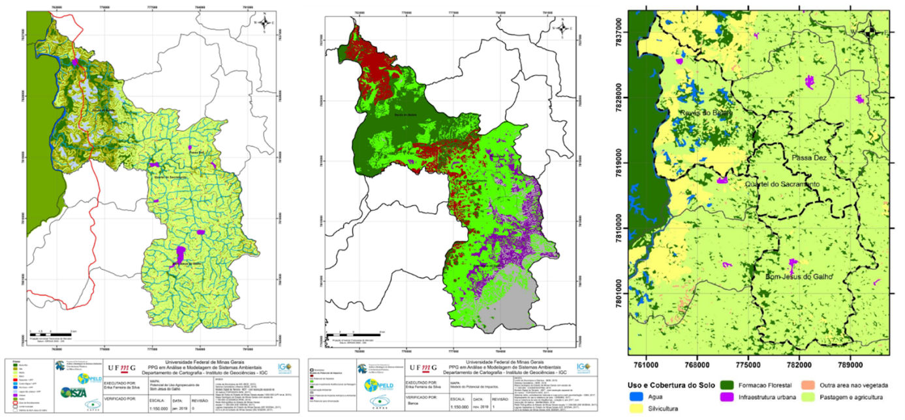
Figure 1. Elaborated models. In this order: Agricultural potential; Impact Assessment and Land Use and Coverage. Source: Silva (2019).

RESULTS
The analysis favored the identification of areas subject to a more specific assessment, and may assist in the discussion of policies and projects linked to the economic, social, cultural and environmental functions of the landscape associated with those demanded by the community. Some highlights of this result can be seen in the table below.
Table 5. Highlights of the joint assessment of cartographic models.
Impact Assessment | Land Use and Coverage | Agricultural Potential | area km²
High potential  for  Urbanization | Pasture and Agriculture | Average | 36,621
High potential  for  Urbanization | Pasture and Agriculture | High | 5,4901
High potential  for  Urbanization | Pasture and Agriculture | Very high | 0,2388
High potential  for  Urbanization | Another non-vegetated area | Average | 0,0005
High potential  for  Urbanization | Another non-vegetated area | High | 0,0006
High potential  for  Urbanization | Another non-vegetated area | Very high | 0,0006
High potential  for  Urbanization | Forestry | Average | 0,1157
High potential  for  Urbanization | Forestry | High | 0,3191
High potential  for  Urbanization | Forestry | Very high | 0,0031
Low Conflict  Anthropic use  and Environmental | Pasture and Agriculture | Average | 52,168
Low Conflict  Anthropic use  and Environmental | Pasture and Agriculture | High | 3,4415
Low Conflict  Anthropic use  and Environmental | Pasture and Agriculture | Very high | 1,1076
Low Conflict  Anthropic use  and Environmental | Another non-vegetated area | Average | 0,0083
Low Conflict  Anthropic use  and Environmental | Another non-vegetated area | High | 0,0032
Low Conflict  Anthropic use  and Environmental | Another non-vegetated area | Very high | 0,0024
Low Conflict  Anthropic use  and Environmental | Forestry | Average | 0,0017
Low Conflict  Anthropic use  and Environmental | Forestry | High | 0,0001
Potential Investment  Multifunctional  Landscape | Forest Formation | Low | 7,9999
Potential Investment  Multifunctional  Landscape | Forest Formation | Average | 33,354
Potential Investment  Multifunctional  Landscape | Forest Formation | High | 3,8554
Potential Investment  Multifunctional  Landscape | Forest Formation | Very high | 0,3171
Potential Investment  Multifunctional  Landscape | Forest Formation | Watercourse + PPA | 2,6930
Potential Investment  Multifunctional  Landscape | Forest Formation | Source + PPA | 0,2188
Potential Investment  Multifunctional  Landscape | Forest Formation | Doce River + PPA | 0,0213
Potential Investment  Multifunctional  Landscape | Forest Formation | Non-urban pond + PPA | 1,0762
Potential Investment  Multifunctional  Landscape | Forest Formation | Urban | 0,4846
Potential Investment  Multifunctional  Landscape | Pasture and Agriculture | Average | 123,39
Potential Investment  Multifunctional  Landscape | Pasture and Agriculture | High | 20,615
Potential Investment  Multifunctional  Landscape | Pasture and Agriculture | Very high | 7,0772
Potential Investment  Multifunctional  Landscape | Another non-vegetated area | Average | 0,0179
Potential Investment  Multifunctional  Landscape | Another non-vegetated area | High | 0,0104
Potential Investment  Multifunctional  Landscape | Another non-vegetated area | Very high | 0,0020
Potential Investment  Multifunctional  Landscape | Forestry | Average | 4,6075
Potential Investment  Multifunctional  Landscape | Forestry | High | 8,3973
Potential Investment  Multifunctional  Landscape | Forestry | Very high | 2,3625
Need for Environmental Conservation | Forest Formation | Average | 20,006
Need for Environmental Conservation | Forest Formation | High | 10,242
Need for Environmental Conservation | Forest Formation | Very high | 1,5332
Need for Environmental Conservation | Forest Formation | Watercourse + PPA | 1,9957
Need for Environmental Conservation | Forest Formation | Source + PPA | 0,2675
Need for Environmental Conservation | Forest Formation | Doce River + PPA | 0,8395
Need for Environmental Conservation | Forest Formation | Non-urban pond + PPA | 3,3087
Need for Environmental Conservation | Pasture and Agriculture | Average | 18,740
Need for Environmental Conservation | Pasture and Agriculture | High | 14,369
Need for Environmental Conservation | Pasture and Agriculture | Very high | 10,954
Need for Environmental Conservation | Another non-vegetated area | Average | 0,0195
Need for Environmental Conservation | Another non-vegetated area | High | 0,0020
Need for Environmental Conservation | Another non-vegetated area | Very high | 0,0023
Need for Environmental Conservation | Forestry | Average | 5,4065
Need for Environmental Conservation | Forestry | High | 10,774
Need for Environmental Conservation | Forestry | Very high | 8,0450
TOTAL |  |  | 422,52
Source: MapBiomas, Collection 3 - year 2017 and research data.
Areas identified with High Potential for Urbanization and Potential Multifunctional Investment in Landscape, classified as Pasture and Agriculture, Other non-vegetated area and Silviculture, have potential for agricultural use, especially in areas of pasture and agriculture. Such areas are initially not inserted in areas sensitive to the need for conservation and are able to receive some type of proposal that involves the anthropic transformation of use and occupation for economic, social and cultural purposes, including food production and marketing. Given the demand of each location, the functions of the landscape can be distributed in different ways. Pasture and Agriculture areas can hold crops segregated in time and space, as well as spatially integrated. Both trade in agricultural products and guided tours encouraging gastronomic tourism can be developed in these places. In the Silviculture areas, intercropping is feasible, as well as activities such as beekeeping, which is present around the Park. Areas classified as Forest Formation in areas of Potential Multifunctional Landscape Investment can be evaluated for the development of ecotourism, valuing visits to the lagoons in the region and surrounding areas, involving the economy and educational activities for environmental conservation. If feasible, the insertion of agroforestry systems or Forestry Livestock Integration can be encouraged in some of these locations. Just as areas classified as Forest Formation were identified in stretches that need environmental conservation, other classes deserve mention. Pasture and Agriculture, Other non-vegetated area and Forestry are inserted in areas indicated for conservation. These regions can be assessed in a particular way, to identify their potential (capacity to insert productive systems combined with conservation), weaknesses (need to recover degraded areas).
In view of the meetings held with local actors and potential research partners, it is believed that this work may influence the application of public policies, project design and improvements for the region. Specifically, the company in the cellulose branch CENIBRA, which showed interest in contributing to the development of the region, either through the provision of areas or a consortium for the cultivation of food. The same company also made itself available to train workers in the production of asphalt pavement with the use of steel aggregate, currently donated to some municipalities in the Vale do Aço region. In this way, it would contribute to the improvement of access routes to these locations. The time involved in mobilizing, establishing and maintaining bonds of trust with the community, and skepticism on the part of some local actors in relation to the research were difficulties that existed throughout this process.
Some gaps could have been filled to improve mobilization and bonds of trust with the community: a longer stay in the study site, including activities suggested by the community to strengthen the bond with our team and the project. For example: meetings, mini-courses, periodic presentations of the progress of the project, among others. As it is a participatory research, the continuity of the project is essential. The challenges are, therefore, the strengthening of ties with the community; effective contact with the project partners, envisioning the development of the Action Plan; elaboration of more detailed studies on the areas selected for the implementation of projects, etc.
In a complementary way and reporting events in the study area during the execution of the project, the city of Bom Jesus do Galho and EMATER resumed discussions on family farming, adding issues on the planting of vegetables and tubers, production of greengrocers and the creation of a Fair Free from the Rural Producer of the Municipality. There was a technical visit to the municipality of Piedade de Caratinga, which is a reference in growing vegetables and tubers in the region and the delivery of irrigation kits. Discussions about the program operation with local farmers also include technical assistance activities and rural extension of project adherence, diagnostic steps, participatory management plan elaboration, market prospecting, individual and collective services, until the evaluation of the results. . Other actions of the city hall in progress were: corn silage, grass and sugar cane to ensure the feeding of herds in Bom Jesus do Galho; plowing land to assist rural producers, technical guidance from EMATER and delivery of poultry at more affordable prices to producers in the region, supporting poultry farming to increase household income through the production of meat and eggs. The Social Assistance Reference Center - CRAS, was carrying out training activities on Modern Russian Stitch Embroidery, including an exhibition of embroidery produced during classes in Revés do Belém. EMATER, in cooperation between the Banco do Brasil foundation and the city hall, was disclosing the monitoring and fencing of springs in the rural area of ​​the Municipality. The city hall's institutional website also linked the project to the Sustainable Development Goals that are part of the United Nations' Agenda with goals for the year 2030. In relation to social interaction, the public sector, together with the Renova Foundation and Instituto Elos carried out in the Revés do Belém District a joint effort methodology that resulted in the construction of a square for the community next to the state school and the renovated court next to the football field.
All of these ongoing actions lead us to believe that this process is under development and its evaluation will have to be continuous over the next few years. However, all the initiatives that have been carried out so far have been previously discussed within the scope of this project and it can be said that, although in a modest way, this participatory process allowed to change the local reality. We understand that this result of a large number of initiatives occurring after the implementation of this participatory process can be considered a very positive gain given the social context of Revés do Belém before the realization of this project.
References
CAMARGO, B.V.; JUSTO, A.M. Tutorial para uso do software IRAMUTEQ. Interface de R pourles Analyses Multidimensionnelles de Textes et de Questionnaires [Florianópolis]: Universidade Federal de Santa Catarina, 2018. 74p.
COSTA, A. M. C.; SALIS, H. C.; VIANA, J. H. M.; AQUINO, J. N.; PEREIRA, M. P. R. Zoneamento Ambiental e Produtivo: uso da modelagem para identificação de potencialidades e limitações no uso do solo. Informe Agropecuário, v 38, 2017a. p. 81-91.
COSTA, A. M. C.; VIANA, J. H. M.; EVANGELISTA, L. P.; CARVALHO, D. C.; PEDRAS, K. C.; HORTA, I. M. F.; SALIS, H. C.; PEREIRA, M. P. R.; SAMPAIO, J.D.L. Ponderação de variáveis ambientais para a determinação do Potencial de Uso Conservacionista para o estado de Minas Gerais. Geografias, v 14. n.1, 2017b. p. 118-134.

IBGE. Instituto Brasileiro de Geografia e Estatística. Censo Demográfico 2010. Disponível em: <https://cidades.ibge.gov.br/brasil/mg/bom-jesus-do-galho/panorama> Acesso em: 25 jun. 2017.

IEF. Instituto Estadual de Florestas. Plano de Manejo do Parque Estadual do Rio Doce. 2008.. Disponível em: <http://www.ief.mg.gov.br/component/content/article/306> Acesso em: 09 maio 2017.
MAPBIOMAS. Projeto MapBiomas - Coleção [3]. Ano 2017. Da Série Anual de Mapas de Cobertura e Uso de Solo do Brasil. Disponível em: <https://code.earthengine.google.com/?accept_repo=users/mapbiomas/user-toolkit> Acesso em: 30 nov. 2018.
MOURA, A.C.M. Reflexões metodológicas como subsídio para estudos ambientais baseados em Análise de Multicritérios. In.: Anais do XIII Simpósio de Sensoriamento Remoto (SBSR), 13, 2007, Florianópolis, Anais... São José dos Campos: INPE, 2007. Artigos, p. 2899-2906.
MOURA, A C M; MAGALHÃES, D. M.; PARIZZI, M. G. Vocações e Conflitos de Interesse na Ocupação do Território da Região Metropolitana de Belo Horizonte – Apoio ao Plano Diretor de Desenvolvimento Integrado - PDDI. In. XV Simpósio Brasileiro de Sensoriamento Remoto - SBSR. Anais... Curitiba: INPE, 2011. p.690–687.

SALVIATI, M. E. Manual do Aplicativo Iramuteq. Compilação, organização e notas. Versão 0.7 Alpha 2 e R Versão 3.2.3. Planaltina, março 2017.

SM2 LANDSCAPE SCENARIOS IN CÓRREGO NOVO AND DIONÌSIO
This work was developed throughout a Master thesis on Biological sciences. The reference is as follows:
RODRIGUES, N. R..Áreas prioritárias para conservação e restauração florestal no entorno do Parque Estadual do Rio Doce. Dissertação de Mestrado. Programa de Pós-Graduação em Ecologia, Conservação e Manejo da Vida Silvestre. Departamento de Biologia Geral. Universidade Federal de Minas Gerais, Belo Horizonte, MG, Mai. 2019.

Introduction

The human being has always interacted with the environment in different ways and pressures. However, in the last centuries this interaction has become synonymous with environmental degradation (PALUMBI, 2001).
Around the Rio Doce State Park (PERD) the picture is no different. Considered one of the largest continuous remnants of the Atlantic Forest biome in Minas Gerais and housing most of the lakes that make up the lacustrine system of the middle Rio Doce (IEF, 2008), PERD is surrounded by an anthropogenic matrix of agriculture, pastures and eucalyptus monocultures (PEIXOTO, 2012). This intense pressure around the Park, in addition to the ecological succession itself, resulted in several transformations in its landscape, forming a mosaic of different successional stages (PEIXOTO, 2012; OLIVEIRA, 2019). Predictive studies for the next 15 years point to an advance of pastures and urban centers on small forest fragments (OLIVEIRA, 2019), which will impair the connectivity of the landscape between the park and its surroundings. This scenario is even more worrying when we take into account the degree of endemism of Atlantic forest and the capacity of large forest fragments to shelter and serve as source areas for animal populations.
In order to try to change this situation, it has become increasingly common to propose multifunctional landscapes that fit the local reality (GASTON et al., 2008). One of the most used methodologies to guarantee the proposition of multifunctional landscapes, has as one of the premises the definition of priority areas for ecological conservation and restoration. This happens because this type of approach allows for more assertive and economical management of these areas and facilitates decision making in the face of conflicts with other economic land uses (GENELETTI, 2004).
In this context, the present study aims to define priority areas for forest conservation and restoration in the surroundings of the Rio Doce State Park, through methodological approaches, and to propose public conservation policies for the implementation of the proposed scenario. To achieve this goal, we proposed two prioritization models using a multicriteria approach integrated with geographic information systems. In the first model, we use weights of importance defined by the literature and in the second weights of importance defined by the needs and desires of the local communities.
Methods
The present study was developed around the Rio Doce National Park. Its surroundings, considered in this study to be 10 km from its limit, according to CONAMA resolution No. 13/1990 (BRAZIL, 1990), has a total area of ​​127.8 thousand hectares belonging to 16 municipalities: Antônio Dias, Bom Jesus do Galho, Caratinga, Córrego Novo, Coronel Fabriciano, Dionísio, Ipatinga, Jaguaraçu, Marliéria, Pingo D'água, Raul Soares, Santana do Paraíso, São José do Goiabal, São Pedro dos Ferros, Timóteo and Vargem Alegre .
To define the priority areas for conservation and restoration, an analytical technique based on the spatial overlap of multiple criteria with different weights of importance was chosen. Thus, the final result is a map of greater importance or greater potential for finished use, according to the objectives of the study (GENELETTI, 2004; ORSI; GENELETTI, 2010 ) . Nine criteria were used to compose the models to define priority areas for conservation and restoration around the Rio Doce State Park , which were then multiplied by weights in two different scenarios (Table 1). The notes referring to the information in the maps of the criteria were the same in both scenarios.
Table 1: Criteria selected for the composition of the models for the definition of priority areas for conservation and restoration in the vicinity of the Rio Doce State Park, Minas Gerais, Brazil.

Criteria selected for each model
Priority conservation areas | Priority areas for restoration
Areas fragments | Proximity to forest fragments
Natural Erosive Potential | Natural Erosive Potential
Importance for connectivity | Likely areas to ecological corridors
Proximity to springs | Proximity to springs
Proximity to streams and rivers | Proximity to streams and rivers
Proximity to headwaters | Proximity to headwaters
Hilltop areas | Hilltop areas
Distance from urban centers | Distance from urban centers
Distance from the road network | Distance from the road network

The first scenario the weights used to select priority areas for conservation and restoration were sought in the literature, based on a systematic search. In the second scenario, the wishes of the local population were considered , based on participatory multi-layer techniques. In this case, we opted for the application of semi-structured interviews and participatory workshops.
In total, 102 interviews were carried out in the municipalities of Bom Jesus do Galho, Córrego Novo, Dionísio and Pingo D'água. In this study, the semi-structured scripts applied contained open, closed questions and a randomly applied photo-questionnaire . In order to complement the interviews, seven participatory workshops were held , six within the municipalities where the interviews were applied and one in the Rio Doce State Park. In total, 148 people participated in the workshops.
The option to perform this type of collective diagnosis in multiple layers is based on the fact that information discussed collectively tends to be more assertive when compared to individual analyzes (VIEIRA; ZOUAIN, 2004). In these meetings, participatory techniques and methods were used that allowed analysis by triangulation, to understand the thoughts and desires of the participants and expand the collective understanding of the phenomena, reducing biases that may arise in perceptual research (RUEDIGER; RICCIO, 2004).
After completing the application of the interviews and workshops, the qualitative and quantitative data obtained were digitized, tabulated and pre-processed to correct spelling errors and standardize the semantic words. For the interviews, we performed a simplified analysis to outline the interviewees' profiles and a content analysis to classify the answers in thematic axes (BARDIN, 1977). For the workshops, due to the large volume of information, we performed a textual statistical analysis with the aid of the Iramuteq 4.1 software, which uses the statistical environment of the R software (RATINAUD; MARCHAND, 2012).
Finally, to compose the paired comparison matrix, the volume of discussions on the different topics was compared, aiming to classify the criteria established for the definition of priority areas for conservation and recovery in order of importance . The weights considered in each scenario can be seen in Figure 1 .
Figure 1: Weights used to define priority areas for conservation and restoration for each of the criteria used in the two proposed scenarios.
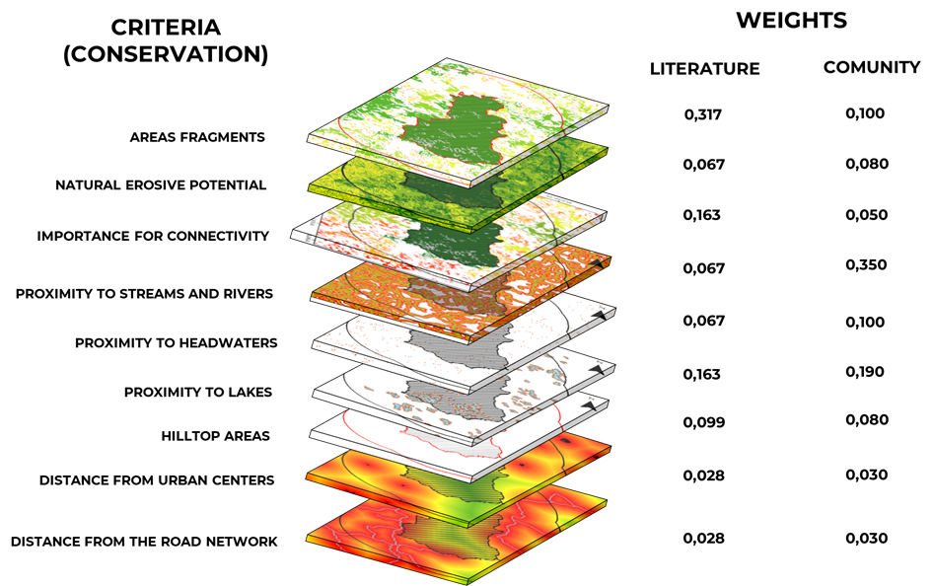
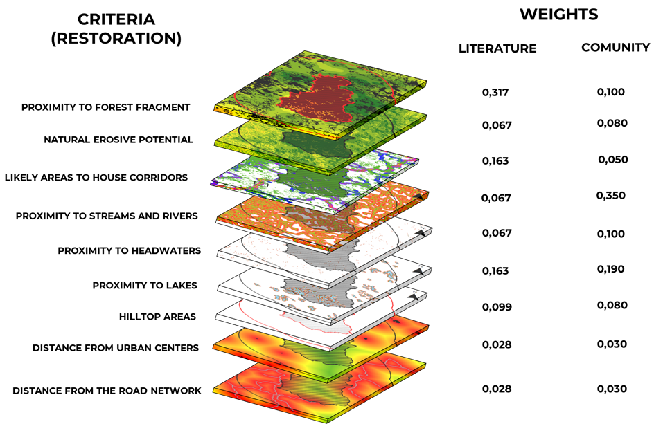

Results
In the model based on the weights defined by the literature, there was a trend towards the selection of forest fragments in full, due to the higher concentration of weights in factors with these characteristics, such as the area of ​​the fragment and the importance for functional connectivity (Figure 2 ) . The selection of priority areas based on integral areas, usually ranking entire fragments of the landscape, is more common in studies that rely heavily on habitat quality (GENELETTI, 2004; PRESSEY; TAFFS, 2001; MERGULES; PRESSEY, 2000; MYERS, et al., 2000) and, therefore, more focused on the preservation of biodiversity. As there is a ranking of fragments, the area defined as high and very high priority was higher in the scenario built according to the wishes of the community, 18.17% against 3.2% in the second scenario (Figure 3)
Figure 2: Map of priority conservation areas around the Rio Doce State Park, Minas Gerais, Brazil, according to weights taken from the literature.
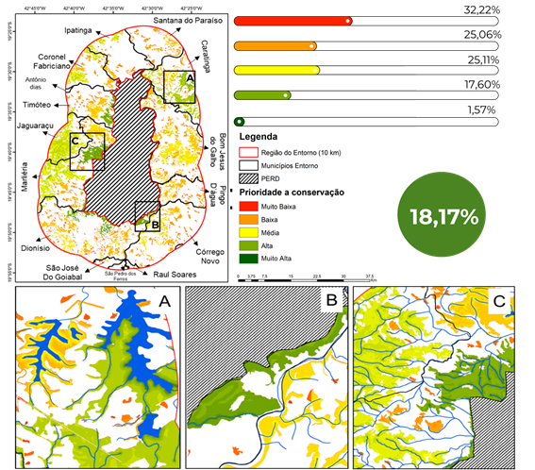
In the model based on the wishes and needs of the local community for conservation, there was a trend in the selection of specific areas within the fragment, such as areas close to water courses and areas with high erosive potential. In this type of approach, it is considered that parts of the same fragment have different roles for conservation, and, therefore, should be prioritized in different ways (DUARTE et al., 2016). In this way, areas of a fragment at the bottom of valleys, which house springs and streams, will have a higher priority in conservation in relation to the other areas of the fragment. This type of approach is becoming more and more common due to the difficulty of conservationists in obtaining human and financial resources for the protection of integral areas that do not demonstrate their benefits to society (SEPPELT et al., 2011).

Figure 3 : Map of priority areas for conservation around the Rio Doce State Park, Minas Gerais, Brazil, as desired by local communities.
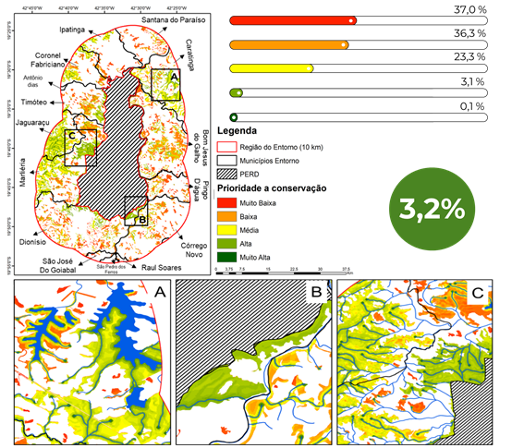

As for the model for defining priority areas for restoration, the pattern was repeated for the model for defining priority areas for conservation. The model built based on the weights in the literature classified a larger area as being of high priority, precisely because it concentrated the weights on integral factors of the landscape such as the proximity to fragments of a larger area, which was strongly influenced by the presence of PERD in the center of the region . In this model, it was also possible to observe that there was a predominance of very high classes, in regions with a high probability of housing corridors and close to the largest forest fragments, proving to be very effective in the selection of areas of permanent preservation that had to be increased in width.
Zimbres et al., (2018) studying the use of riparian areas preserved in a degraded matrix in the Amazon biome by large mammals, found that these areas have high potential for landscape connectivity and that their effectiveness of use is directly linked to their structure, such as width and quality of resources. Therefore, its effectiveness as an ecological corridor depends directly on restoration actions, mainly by implementing areas of legal reserves linked to them as a way of increasing its width (Figure 4).

Figure 4 : Map of priority areas for forest restoration around the Rio Doce State Park, Minas Gerais, Brazil, according to weights taken from the literature.
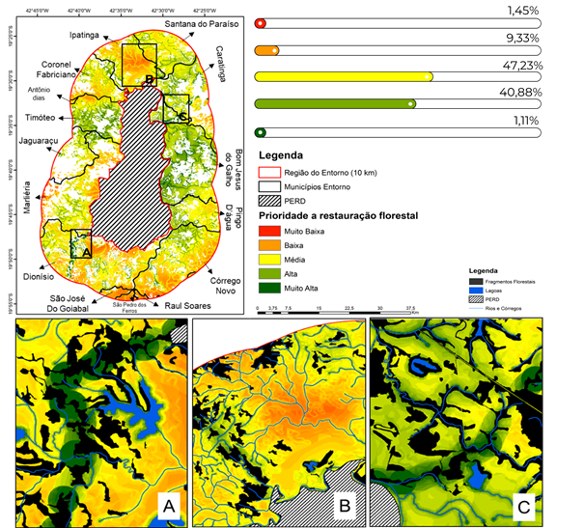
On the other hand, in the restoration model based on the wishes of the local community, there was a strong concentration of areas with very high priority within the areas of permanent preservation of water bodies, justified by the concentration of the population's wishes for the maintenance of water resources. Despite this strong concentration, it was also possible to identify areas of permanent preservation that can also be used as ecological corridors. As in the model defined from the weights in the literature, this model clearly indicated the areas in need of increased width by restorative techniques, by rural owners or private companies and areas for the application of artificial techniques for restoring connectivity, such as bridges, tunnels and airline tickets over highways (Figure 5).

Figure 5 : Map of priority areas for forest restoration for the surroundings of the Rio Doce State Park, Minas Gerais, Brazil, according to weights relative to the desire of the local community.
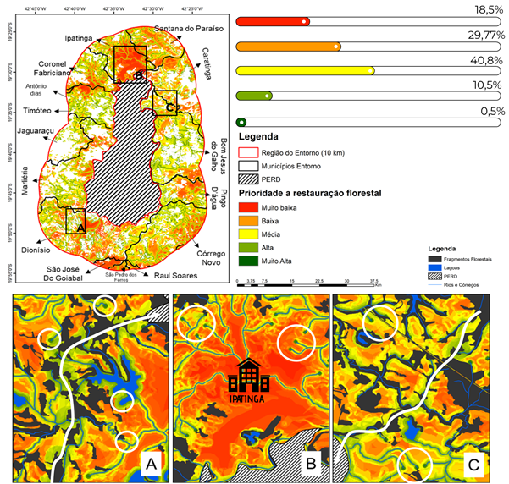
Within the local scale, the establishment of priority areas for conservation and restoration, at this level of detail, can support several aspects of decision-making, both in the public and private spheres.
In the public sphere, this type of model could help the creation of new conservation units at the municipal level, guaranteeing the conservation of areas of high importance for the maintenance of ecosystem services and biodiversity, directly and indirectly. Considering the existing units, this approach could assist managers in the more assertive definition of areas for the implementation of preventive actions, such as the construction of firebreaks, the inspection and awareness of local communities, and remedial actions, such as planting seedlings. and fire fighting. More specifically, with regard to the Environmental Protection Areas - APAs in the surrounding municipalities (20 in total; PINTO, 2018), this type of approach, in addition to subsidizing the actions mentioned above, could facilitate the process of zoning and definition of management actions, ensuring greater efficiency in the definition of more restrictive zones, which does not happen for the vast majority of Brazilian APAs (ESTEVES; SOUZA, 2014).
Within the private sphere, this level of detail may allow a more assertive decision-making in the definition of the Legal Reserve areas, provided for in the Brazilian Forest Code (Federal Law No. 12651/2012). In this way, legal reserves can become important conservation instruments, especially if used in conjunction with Permanent Preservation Areas - APP's, which is not currently happening (SOARES-FILHOS, 2014). In addition, prioritization models of this type can be important decision-making tools within public policies aimed at Payment for Environmental Services - PSA (WUNDER, 2008). This happens, therefore, most of the PES Programs, instituted in Brazil, do not take into account the quality of the habitat or the needs of the population for valuation and subsequent payment for the service provided (SANTOS, et al. 2012). Within the State of Minas Gerais, more specifically in the “Bolsa Verde ”, although there is a gradation of the amount paid according to compliance with the limits established by the Forest Code, the financial aid paid is calculated proportionally to the dimensions of the area (BRASIL, 2009 ) and not in proportion to the quality of the habitat or the potential in the provision of ecosystem services, decreasing its effectiveness.
Within the reality of the Rio Doce State Park, the implementation of PES and other public policies mentioned above, together with the proposed prioritization models, could be an effective solution to the problems faced by the population, mainly related to the region's water scarcity and the decrease water quality of the Doce River, after the rupture of the tailings dam in Mariana - MG. Carvalho (2016), for example, studying the perception of the residents of Dionísio, regarding the importance of ecosystem services for their lives, concludes that fostering spring recovery activities in the region, although they are growing, will depend at some point on resources external to the project.

References
BARDIN. L. Análise de conteúdo. Lisboa: Editora Edições 70, 1977.
CARVALHO, A.A. Percepção ambiental de produtores rurais do entorno do Parque Estadual do Rio Doce (MG): subsídios para a educação ambiental. Dissertação de Mestrado. Universidade Federal de Minas Gerais. 2016.
DUARTE, G. T.; RIBEIRO, M. C.; PAGLIA, A. P. 2016. Ecosystem Services Modeling as a Tool for Defining Priority Areas for Conservation. PLOS ONE, v. 11, n. 5, p. 1 - 19.
GASTON, K.J.; JACKSON, S.F.; CANTU-SALAZAR, L.; CRUZ, G., 2008. The ecological performance of protected areas. Annual Review of Ecology, Evolution, and Systematics. v. 39. p. 93–113.
GENELETTI, D. 2004. A GIS-based decision support system to identify nature conservation priorities in an alpine valley. Land Use Policy, v.21, p. 149–160.
GOLDMAN, R.L.; TALLIS, H.; KAREIVA, P.; DAILY, G.C. 2008. Field evidence that ecosystem service projects support biodiversity and diversify options. PNAS – USA, v. 5, n. 27, p. 9445 – 9448.
INSTITUTO ESTADUAL DE FLORESTAS – IEF. 2008. Plano de Manejo do Parque Estadual do Rio Doce. Marliéria, Minas Gerais. Disponível em: http://www.ief.mg.gov.br/compone nt/content/article/306. Acesso em: 10/12/2018.
MARGULES, C. R.; PRESSEY, R. L. 2000. Systematic conservation planning. Nature, v. 405, p. 243 - 253.
OLIVEIRA, B. R.; CARVALHO-RIBEIRO, S. M.; MAIA-BARBOSA, P, M. 2019. A multiscale analysis of land use dynamics in the buffer zone of Rio Doce State Park. Journal of Environmental Planning and Management, Accepted, in prep.
ORSI, F.; GENELETTI, D. 2010. Identifying priority areas for Forest Landscape Restoration in Chiapas (Mexico): An operational approach combining ecological and socioeconomic criteria. Landscape and Urban Planning, v. 94, p. 20 – 30.
PALUMBI, S. R. 2001. Humans as the world’s greatest evolutionary force. Science, v. 293, p. 1786-1790.
PEIXOTO, E. L. 2012. Caracterização e perspectivas do Parque Estadual do Rio Doce – MG: Uma abordagem a partir de imagens de sensoriamento remoto e fotografias hemisféricas do dossel. Dissertação de Mestrado. Instituto de Geociências da Universidade Federal de Minas Gerais.
PRESSEY, R.; TAFFS, K. 2001. Scheduling conservation action in production landscapes: priority areas in western New South Wales defined by irreplaceability and vulnerability to vegetation loss. BIOLOGICAL CONSERVATION, v. 100, n. 3, p. 355 – 376.
RATINAUD, P. ; MARCHAND, P. 2012. Application de la méthode ALCESTE à de “gros” corpus et stabilité des “mondes lexicaux” : analyse du “CableGate” avec IraMuTeQ. Journées internationales d’Analyse statistique des Données Textuelles. JADT. 36p.
SOARES-FILHO, B.; RAJÃO, R.; MACEDO, M.; CARNEIRO, A.; COSTA, W.; COE, M.; RODRIGUES, H.; ALENCAR, A. 2014. Cracking Brasil’s Forest Code. Science, v. 344, p. 363 – 364.
ZIMBRES, B.; PERES, C. A.; PENIDO, G.; MACHADO, R. B. 2018. Thresholds of riparian forest use by terrestrial mammals in a fragmented Amazonian deforestation frontier . Biodiversity and Conservation, V.27, p. 2815 – 2836.

SM3 Participatory scenario development in Pingo de Água
This work develeoped through a master thesis on environmental modelling:
PAULA, L. G. S. Cenários Participativos e Governança no Entorno do Parque Estadual do Rio Doce: o papel dos Sistemas Agroflorestais como estratégia de desenvolvimento . Dissertação de Mestrado. Programa de Pós-Graduação em Análise e Modelagem de Sistemas Ambientais. Departamento de Cartografia. Universidade Federal de Minas Gerais, Belo Horizonte, MG, mai. 2019.

introduction

The Long-Term Ecological Research Program (PELD) carried out studies with the neighboring communities of the Rio Doce State Park (PERD) that resulted in several participatory scenarios.
For this, different participatory methodologies were implemented for the purpose of involving the local public in the stages of the project. These methodologies were carried out during three workshops promoted in the municipality of Pingo d’Água, where dozens of people from the community were able to participate and contribute to the construction of the results.
These methodologies served to present initial ideas of scenarios; identifying and georeferencing community priorities; refine previously presented scenarios and models; prepare a prior proposal for recommendations for actions and public policies prepared by specialists; and deliver to the community final material with models and future scenarios, accompanied by a scope indicating the implementation of actions and public policies aimed at governance of local socio-biodiversity.
During the workshops, the participating public was formed only by people residing in the municipality, whether from the public, business or non-governmental sectors.

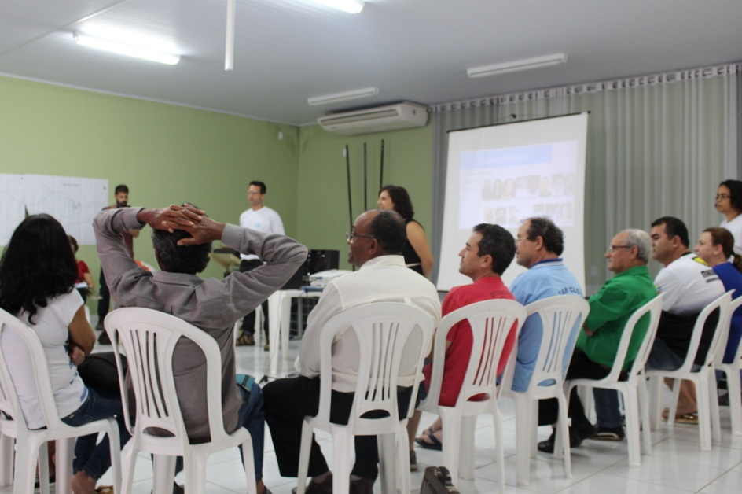

Figure 1: Workshop in Pingo d’Água. Source: project collection - PELD
Research Area: Municipality of Pingo d’Água-MG
Pingo d’Água is a municipality in Minas Gerais, in the Vale do Aço region, therefore, within the radius of influence of the Ipatinga metropolitan region. Located east of PERD, where the banks of the Rio Doce make the border. The main access of Pingo d’Água to the park is through the well-known Queimada Bridge, which is an outstanding tourist spot. The area is also characterized by the presence of dozens of natural lagoons that are a kind of local geographic mark. The total area of its territory is 66,570 km².

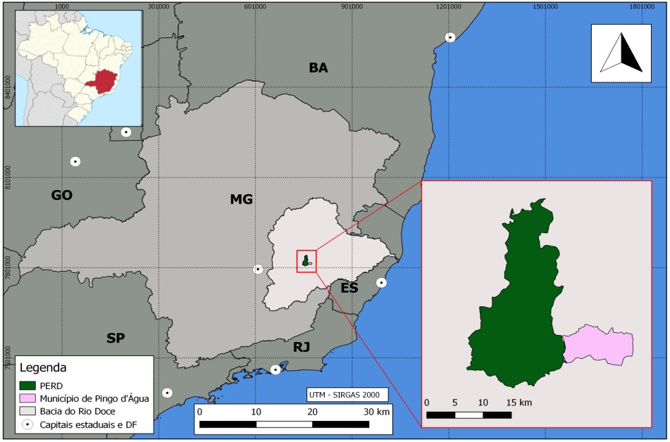

Figure 2: Location of the Research Area - Municipality of Pingo d’Água-MG. Source: IBGE.
The total estimated population, according to IBGE (2017), is 4,870 inhabitants, among whom the percentage of formally employed people of working age is 12.2%, with an average income of 1.3 minimum wages. This last figure is far below the State average, which is approximately 60.0% of formal occupation and income above 2 minimum wages. The Human Development Index (HDI) is 0.619 and the Gross Domestic Product (GDP) per capita is R $ 7,591.00, being among the lowest in the State. The schooling rate of children and young people between 6 and 14 years old is 98% (IBGE, 2014). Public health and education networks can be considered reasonable, given the size of the population and in comparison with similar municipalities in the region.
The history of Pingo d’Água dates back to the origins of the training of workers at the Acesita Company, which explores eucalyptus plantations in the region. In the 1990s, it became a district of the municipality of Córrego Novo and, in the second half of the same decade, it achieved its political emancipation, starting to house the structure of the municipal public power.
Pingo d’Água is the youngest municipality, among PERD's neighbors, and also has the smallest territorial area (66.57 km²). Excluding the larger and more urbanized municipalities surrounding the park (Ipatinga, Timóteo and Coronel Fabriciano), Pingo d'Água has the highest coverage rate in the sewage system (89.1%), one of the highest rates of urbanization of roads (41.2%) and the highest demographic density (66.4 inhabitants / km²) (IBGE, 2017).
Therefore, it can be observed that the specificity of the municipality of Pingo d'Água, in relation to the other locations around the PERD, is that it is a location that provides a reasonable quality of life for most of its inhabitants. and an urban infrastructure above the micro-regional average.
METHODS
Among the products built, a spatially explicit model was developed that shows the skills of the areas, belonging to the park's surroundings, for implementing agroforestry systems (SAF). The model was built based on the multicriteria analysis method AHP (Analytic Hierarchy Process) and the use of geographic information system tools. The result shows the locations and sizes of the areas, in view of their levels of aptitude to receive agroforestry planting programs.
The AHP method is a process of decision making based on a procedure of successive comparisons of variables, pair by pair. These comparisons result in a hierarchical order of priority, formed among the several variables that make up the set of significant criteria for the decision-making process in question. This hierarchical order of importance is represented through certain assigned values (weights) for each variable. These variables play the role of the various criteria that make up the model and, here in this case, they are constructed in the form of layers of georeferenced spatial representation. This is so that the result is also a spatially explicit model, obtained by map algebra, weighted by the weights identified in the Hierarchical Analytical Process.
The variables applied in the analysis were: a) Normalized Difference Vegetation Index (NDVI); b) occurrence of Permanent Preservation Areas (APP); c) Classification of Land Use and Coverage; d) proximity to access roads.

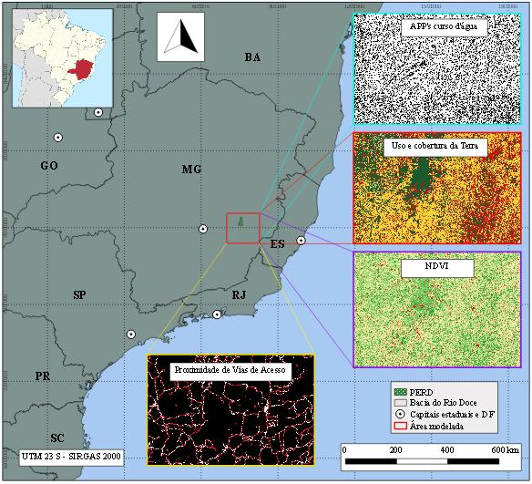
FIGURE 3: Location and Coverage of the Area and Layers of the Model. Source: The Author (2019).

The AHP method requires the different variables to be compared pairwise. The level of difference in importance or priority between them is given according to a numerical scale ranging from 1 to 9, according to the table below.
TABLE 1: Fundamental Scale of Comparative Judgments.
Intensity of importance on an absolute scale | Definition | Description
1 | Equally important | Two variables contribute equally to the objective
3 | Moderate importance of one over the other | Experiences and / or judgments favor one variable over another
5 | Essential or of strong importance | Experiences and / or judgments strongly favor one variable over the other
7 | Very strong importance | A variable is strongly preferred and its dominance is demonstrated in practice
9 | Extremely important | The evidence favors one variable over the other with the highest degree of certainty
2,4,6,8 | Intermediate values between two adjacent judgments | When adjustments are needed
Fonte: Adaptado de Saaty (1987)
Thus, for this work, the various attributes of the four variables applied (land use and cover, APPs, proximity to access roads and NDVI) received scores from 1 to 3 (see Table 2); 1 being the representation of the ‘very low’ level of aptitude for implementing SAF, 2 the moderate level and grade 3 being the ‘very high’ level.

table 2: Attributes of Variables Score.

Variables | Attributes | Grades | APTUDE
Proximity to access roads | Distance > 200 m | 1 | Very low
Proximity to access roads | Distance between 200 m e 100 m | 2 | Moderate
Proximity to access roads | Distance < 100 m | 3 | Very high
Land use / coverage | Water | 1 | Very low
Land use / coverage | Urbanized areas | 1 | Very low
Land use / coverage | Forests and woods | 1 | Very low
Land use / coverage | Silviculture | 2 | Moderate
Land use / coverage | Áreas rurais desmatadas | 3 | Very high
NDVI | High | 1 | Very low
NDVI | Average | 2 | Moderate
NDVI | Low | 3 | Very high
APP’s corpos d’água | Inside | 3 | Very high
APP’s corpos d’água | Outside | 1 | Very low

The importance matrix, of the AHP method, with each criterion used for the model, presents the values shown below, according to the stipulated scale and presented in Chart 2. As can be seen, the value of λ (eigenvalue) resulted in 4, 08, that of the consistency index (CI) at 0.027 and that of the consistency ratio (CR) at 0.03. Considering that, according to the requirements of the method presented by Saaty (1987), the CR needs to demonstrate a result lower than 0.1. In this way, it is possible to affirm the existence of consistency in the choice of importance of the criteria, according to the proposal of the work.

TABLE 3: Matrix of Pairwise Comparisons of The Criteria and Importance.

Criteria | Land use and coverage | PPA of bodies of water | NDVI | Proximity to access roads | Weights
Land use and coverage | 1 | 4,5 | 5,5 | 5 | 0,605
PPA of bodies of water | 2/9 | 1 | 3 | 1,5 | 0,185
NDVI | 2/11 | 1/3 | 1 | 0,5 | 0,079
Proximity to access roads | 1/5 | 2/3 | 2 | 1 | 0,132
λ = 4,08 CI = 0,027 CR = 0,03

RESULTS
Of the entire modeled area (1,677,033 ha), 5,580 ha obtained top marks, that is, they were in anthropized rural areas, low NDVI, within riparian APPs and close to highways. Among these areas considered to be 'very high' for the implementation of SAFs, the largest of them have areas of more than 30 hectares, on the banks of the Piracicaba River, relatively closer to its mouth on the Doce River.

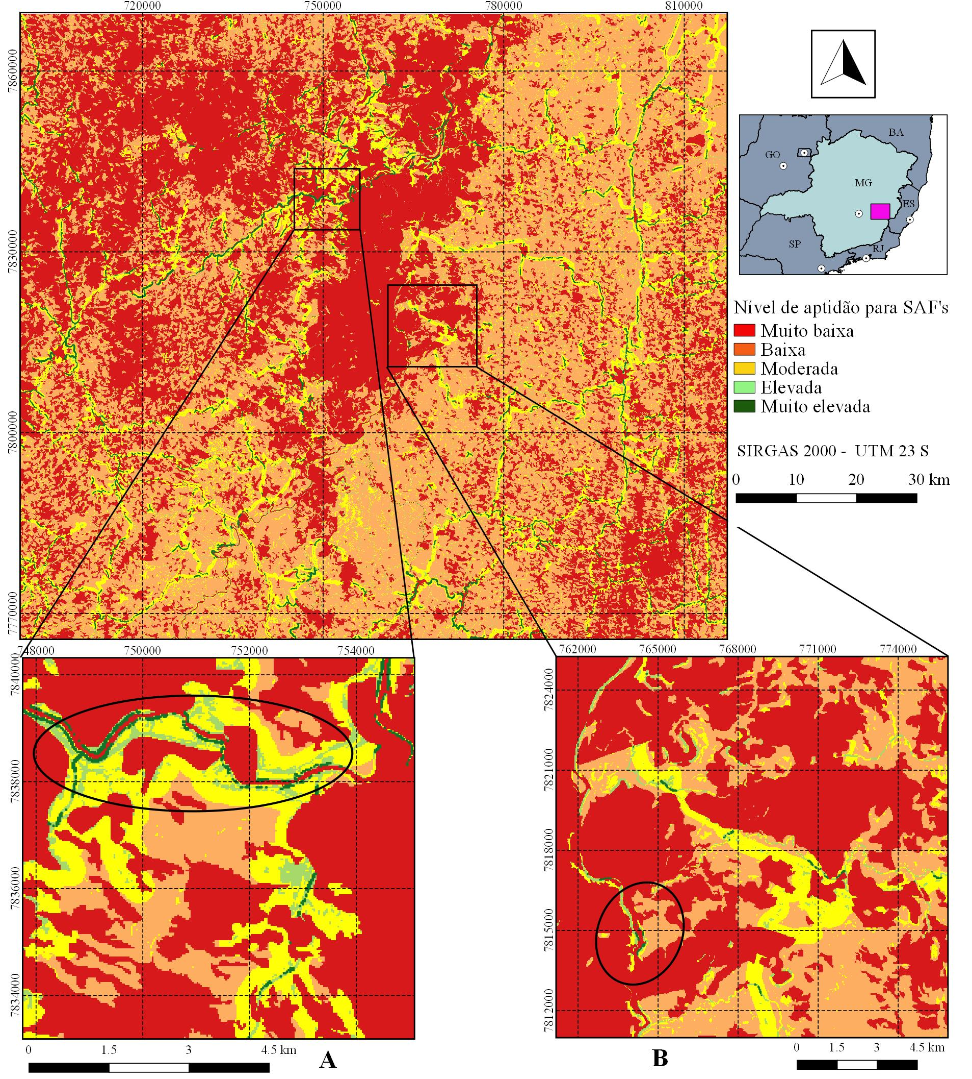
FIGURE 4: Result of the Model Analysis.

In a subsequent analysis, looking for the areas with the highest fitness scores outside APPs, there is a greater concentration in the rural areas of the municipalities of Coronel Fabriciano-MG, Ipatinga-MG and Caratinga-MG.

FINAL CONSIDERATIONS

The final result showed that there are more than five and a half thousand hectares of man-made rural areas, close to highways, within APPs and with a low vegetation index in the region surrounding the Rio Doce State Park. It is a significant extension of land, when it comes to implementing agroforestry systems. The most frequent presence of larger areas, considered to have a very high suitability for implementing SAFs, occurs along APPs of the most voluminous rivers. Smaller rivers, which consequently have smaller APPs, also have a lot of potential, albeit on a smaller scale. For this type of information to be useful in the decision making of a supposed program for revegetation of degraded areas, other filters may possibly be needed, using different variables.

Bibliography

BRASIL. Lei n. 9.985, de 18 de julho de 2000. Regulamenta o artigo 225, parágrafo 1, incisos I, II, III e VII da Constituição Federal; institui o Sistema Nacional de Unidades de Conservação da Natureza e dá outras providências. Diário Oficial da União, Atos do Poder Legislativo, Brasília, DF, 19 jul. 2000. Seção 1, p. 1. Disponível em: <http://www.planalto.gov.br/ccivil_03/LEIS/L9985.htm>. Acesso em: 09 abr. 2019.
BRASIL. Ministério do Meio Ambiente. Dispõe sobre procedimentos técnicos para a utilização da vegetação da Reserva Legal sob regime de manejo florestal sustentável, e dá outras providências. Instrução Normativa n. 04, de 08 de setembro de 2009. Sistema Nacional de Informações Florestais, Brasília, set. 2009. Disponível em: <http://snif.florestal.gov.br/images/pdf/legislacao/normativas/in_mma_04_2009.pdf>. Acesso em: 09 abr. 2019.
CORSEUIL, C. W. Técnicas de Geoprocessamento e de Análise de Multicritérios na Adequação de Uso das Terras. 2006. 101 f. Tese (Doutorado em Agronomia) – Universidade Estadual Paulista, Botucatu, 2006.
FÁVERO, C. Uso e degradação de solos na microrregião de Governador Valadares, MG. 2001. 80 f. Tese (Doutorado em Solos e Nutrição de Plantas) – Universidade Federal de Viçosa. Viçosa, 2001.
Fávero, C.; Lovo, I. C.; Mendonça, E. S. Recuperação de Área Degradada com Sistema Agroflorestal no Vale do Rio Doce, Minas Gerais. Revista Árvore, Viçosa, v.32, n.5, p.861-868, Out. 2008.
Fonseca, E. L.; Locatelli M.; Silva Filho, E. P. NDVI Aplicado na Detecção de Degradação de Pastagens Cultivadas. Revista Franco Brasileira de Geografia Confins, [S. l.], n. 35, abr. 2018. Disponível em: <https://journals.openedition.org/confins/13180#quotation>. Acesso em: 15 mai. 2019.
GONÇALVES, J. L. G.; FRANCISCO, P. R. M.; MORAES NETO, J. M. Análise da Degradação Ambiental do Município de Soledade Utilizando Índice de Vegetação. In: Congresso Técnico Científico da Engenharia e da Agronomia, 2., 2015, Fortaleza. Anais… Fortaleza: Confea/Crea-CE, 2015. v. 2.
LANFREDI, M. Early Identification of Land Degradation Hotspots in Complex Bio-Geographic Regions. Remote Sensing. v. 7, p. 8154-8179, 2015.
LEITE, T. V. P. Sistemas Agroflorestais na Recuperação de Espaços Protegidos por Lei (app e reserva legal): estudo de caso do Sítio Geranium, DF. 2014. 117 f. Tese (Doutorado em Ciências Florestais) - Universidade de Brasília, Brasília, 2014.
LITTLE, P. E. Territórios sociais e povos tradicionais no Brasil: por uma antropologia da territorialidade. In:
MARTINS, T. P.; RANIERI, V. E. L. Sistemas Agroflorestais como Alternativa para as Reservas Legais. Ambiente & Sociedade, São Paulo, v. 17, n. 3, p. 79-96, set. 2014.
MELO, E. T.; SALES, M. C. L.; OLIVEIRA, J. G. B. Aplicação do Índice de Vegetação por Diferença Normalizada (NDVI) para Análise da Degradação Ambiental da Microbacia Hidrográfica do Riacho dos Cavalos, Crateús-CE. Raega - O Espaço Geográfico em Análise, v. 23, p. 520-533, nov. 2011.
Montebelo, L. A. et al. Relação entre uso e cobertura do solo e risco de erosão nas áreas de preservação permanente na bacia do ribeirão dos Marins, Piracicaba-SP. In: Simpósio Brasileiro de Sensoriamento Remoto, 12., 2005, Goiânia. Anais... Goiânia: INPE, 2005. p. 3829-3836. v. 12.
Nepomuceno, M. Q.; Lobão, J. S. B.; Vale, R. M. C. Uso e cobertura da terra como indicativo do processo de desertificação na região de Irecê – BA. In: Simpósio Brasileiro de Sensoriamento Remoto, 15., 2011, Curitiba. Anais… Curitiba: INPE. 2011. p.6794-6802. v. 15.
Pinese Jr., J. F.; Rodrigues, S. C. O Método de Análise Hierárquica – AHP – como Auxílio na Determinação da Vulnerabilidade Ambiental da Bacia Hidrográfica do Rio Piedade (MG). Revista do Departamento de Geografia – USP, São Paulo, v. 23, p. 4-26, jul. 2012.
Saaty, R. W. The Analytic Hierarchy Process: what it is and how it is used. Mathematical Modeling, v. 9, n. 3-5, p. 161-176, 1987.

