Appendix 1. Relationships between the probability of a Crown Burn and stand age
We quantified the factors affecting the severity of the 2019-2020 fires in Victoria, south-eastern Australia. We constructed logistic regression models of relationships between fire severity (as reflected by the extent of a Crown Burn at at 33 850 grid points spaced at 500-metre intervals across a 988,854ha section of the footprint of the 2019-2020 fires, and a suite of key covariates. These included: (1) fire weather, (2) forest (stand) age, (3) forest type, (4) slope, and (5) aspect.
From these statistical analyses, the best supported model (as identified using the Widely Applicable Information Criteria [WAIC]; Vehtari et al. 2017) for the probability of a Crown Burn was a three-way interaction between fire weather, forest type, and stand age as well as two-way interactions between: (i) fire weather and slope, and (ii) fire weather and aspect. These analyses revealed an increase in the probability of Crown Burn in Wet/Damp Forest types under extreme fire weather (fire zone categories 2 and 3 which corresponded to catastrophic fire weather conditions). In addition, stand age-fire severity relationships exhibited non-linear, negative polynomial shape with a peak around 10-40 years; the probability of a Crown Burn was generally low in very old forest (see Figure 2b in the main text).
A key component of the analysis was an assessment of the magnitude of spatial dependence in the probability of a Crown Burn using a Gaussian Random Field approach implemented in the R-package R-INLA (Rue et al. 2017, Bakka et al. 2018). The analysis indicated a very high level of spatial correlation approaching 1 between sites located less than 200 metres apart, declining to 0.25 for sites ~ 11 km apart.

Appendix 2. Theoretical fire interval distributions and production and conservation thresholds.
A recent study (Blanchard et al. 2021) used three mechanistically-diverse, theoretical fire interval distributions for Mountain Ash forest in the recent past and future to estimate the probability of realising: (i) minimum sawlog harvesting rotation time (80 years); (ii) canopy species maturation (20 years); and (iii) adequate habitat hollows for cavity-dependent fauna (180 years) such as the Critically Endangered Leadbeater’s Possum Gymnobelideus leadbeateri and the vulnerable Greater Glider Petauroides volans (Lindenmayer et al. 2017). The three fire regime distributions modeled were exponential, Olsen’s, and moisture and analyses show broadly similar patterns. These hazard functions corresponded to the probability of fire in the landscape (see Blanchard et al. 2021 for further details).
The likelihood of realising key production and conservation thresholds of fire interval diminish markedly for the future fire regime compared to the recent past. For example, the analyses by (Blanchard et al. 2021) revealed that only one in five future fire intervals will be sufficiently long enough (~80 years) to grow sawlogs in this forest type, and that the probability of forests becoming old growth stands and developing adequate habitat hollows (~180 years) is predicted to be as low as 0.03 (3% of fire intervals) under a future fire regime (Blanchard et al. 2021).

Appendix 3 – Recurrent fire impacts in Wet/Damp EVC and montane ash forests in Victoria

Appendix 3. Table 1. Number of fires recorded for montane ash forest (Alpine Ash, Mountain Ash and Shining Gum) for state forests across Eastern Victoria (Department of Sustainability and Environment 2007, Department of Environment and Land and Water Planning 2021).
Number of Fires 1980-2020 | Alpine Ash | Mountain Ash | Shining Gums | Total Montane Ash (ha)
No Fires (ha) | 24,825 | 49,787 | 8,485 | 83,096
No Fires % | 16% | 49% | 80% | 31%
1 Fire (ha) | 77,528 | 77,528 | 1,786 | 123,811
1 Fire % | 50% | 44% | 17% | 47%
2 Fires (ha) | 41,357 | 7,058 | 354 | 48,769
2 Fires % | 27% | 7% | 3% | 18%
3 Fires (ha) | 8,661 | 115 | 5 | 8,782
3 Fires % | 6% | 0% | 0% | 3%
4 Fires (ha) | 1,652 | - | - | 1,652
4 Fires % | 1% | 0% | 0% | 1%
5 Fires (ha) | 32 | - | - | 32
5 Fires % | 0% | 0% | 0% | 0%
Total (ha) | 154,055 | 101,457 | 10,630 | 266,142
Total % | 100% | 100% | 100% | 100%

Appendix 3. Figure 1. False colour vegetation imagery showing the impacts of three major fires occurring across the Carey River State Forest in 1998, 2007 and 2019. Areas of mapped Alpine Ash forest (hatched) have been burned multiple times (Images generated from Landsat 4-5 TM (Landsat 4-5 TM data 1998; Landsat 4-5 TM data 2007; Copernicus Sentinel data 2019).

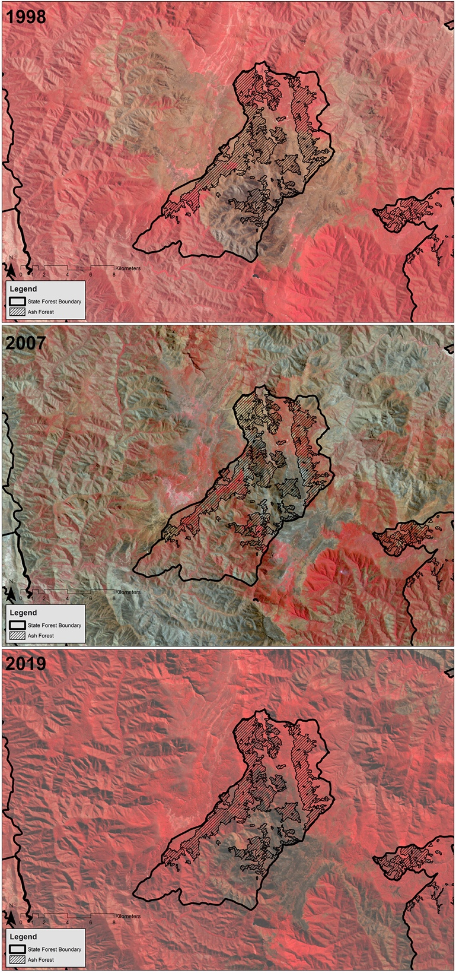

Appendix 3. Figure 2. Total number of fires occurring across Alpine Ash forests in the Carey River State Forest between 1980-2020 (fire data derived from Department of Environment and Land and Water Planning 2021). Much of the state forest has been burned three times between 1998 and 2019. Large areas of Alpine Ash forest were also clearfell logged following fires in 1998 and 2007 across this state forest.

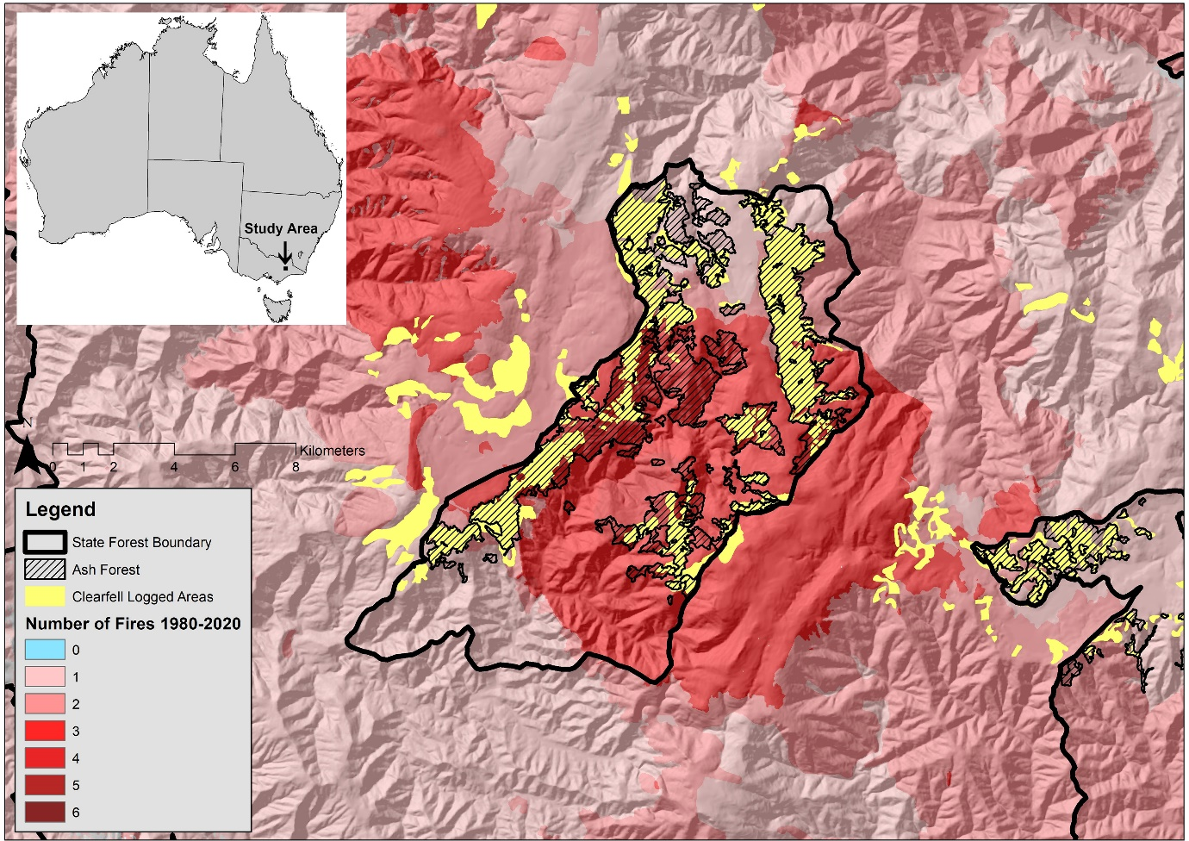

References

Bakka, J., H. Rue, G. Fuglstad, A. Riebler, D. Bolin, J. Illian, E. Krainski, D. Simpson, and F. Lindgren. 2018. Spatial modeling with R-INLA: A review. Computational Statistics, 10:e1443.
Cary G., Blanchard W., Foster C. N., Lindenmayer D. B., Effects of altered fire regimes on critical timber production and conservation rotations. International Journal of Wildland Fire in press (2021).
Copernicus Sentinel data. 2019. Copernicus Sentinel data.
Department of Environment and Land and Water Planning. 2021. Fire History Records of Fires primarily on Public Land showing the fire scars.
Department of Sustainability and Environment. 2007. Victoria's statewide forest resource inventory.
Landsat 4-5 TM data. 1998. Landsat 4-5 TM data.
Landsat 4-5 TM data. 2007. Landsat 4-5 TM data.
Lindenmayer D. B., Blanchard W., Blair D., McBurney L., Banks S. C., Relationships between tree size and occupancy by cavity-dependent arboreal marsupials. Forest Ecol. Manage. 391, 221-229 (2017).
Rue, H., Riebler, A., Sørbye, S. H., Illian, J. B. and Simpson, D. P.. 2017. Bayesian computing with INLA: A review. Annual Reviews of Statistics and Its Applications 4:395-421.
Vehtari, A., Gelman, A., and Gabry, J. 2017. Practical Bayesian model evaluation using leave-one-out cross-validation and WAIC. Statistics and Computing 27:1413-1432.

