Extended Data for "The triple-dip La Niña was key to Earth’s extreme heat uptake in 2022-2023"

Ko Tsuchida¹, Yu Kosaka¹, and Shoshiro Minobe²

¹Research Center for Advanced Science and Technology, The University of Tokyo
²Faculty of Science, Hokkaido University
Extended Data Table 1: List of model names and ensemble IDs from CMIP6 historical, SSP2-4.5, SSP5-8.5, piControl, and AMIP simulations used in this study.
Models highlighted in bold characters indicate those with large ensembles.
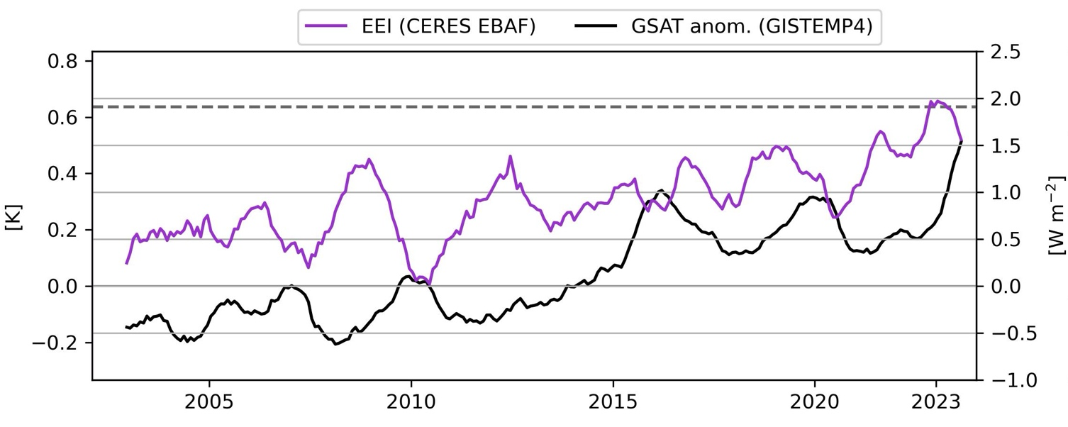
Extended Data Figure 1: Time evolution of EEI and GSAT anomaly, shown as a 12-month running average from 2001 to 2023.
Time series are plotted at the center of a twelve-month running window. The dashed line indicates the mean plus three standard deviations from 2002/03 to 2021/22.

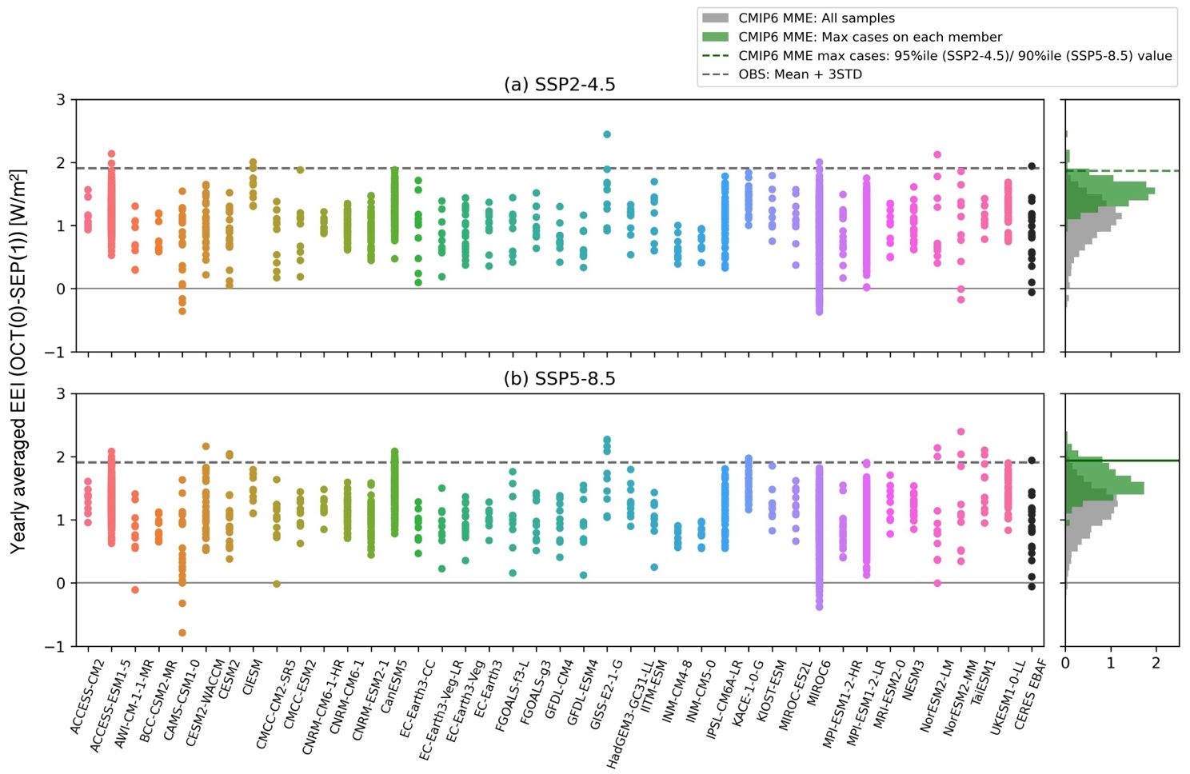
Extended Data Figure 2: Strip plots yearly mean EEI averaged over the October(0) to September(1) period across CMIP6 models and observations.
Results are based on (a) the SSP2-4.5 scenario and (b) the SSP5-8.5 scenario. The CMIP6 model data spans the period from 2021 to 2030, while the observational data (black dots) covers 2001-2023. The right-hand boxes display histograms: orange bars represent all samples, and green bars indicate the subsampled cases with the maximum of each ensemble member. The solid gray line marks the EEI observed in 2023, while the dashed gray line represents the mean plus three standard deviations in observational records. The red dashed line indicates the 99.5th (SSP2-4.5) and 99th (SSP5-8.5) percentiles of all the cases, while the green dashed line represents and 95th (SSP2-4.5) and 90th (SSP5-8.5) percentiles of the maximum cases of individual ensemble members.

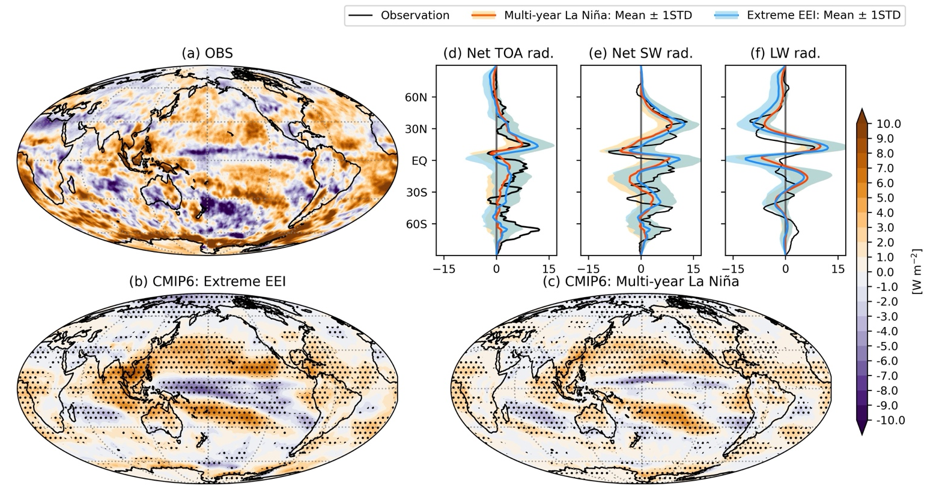

Extended Data Figure 3: Same as Figure 2, but for DJFMAM average.

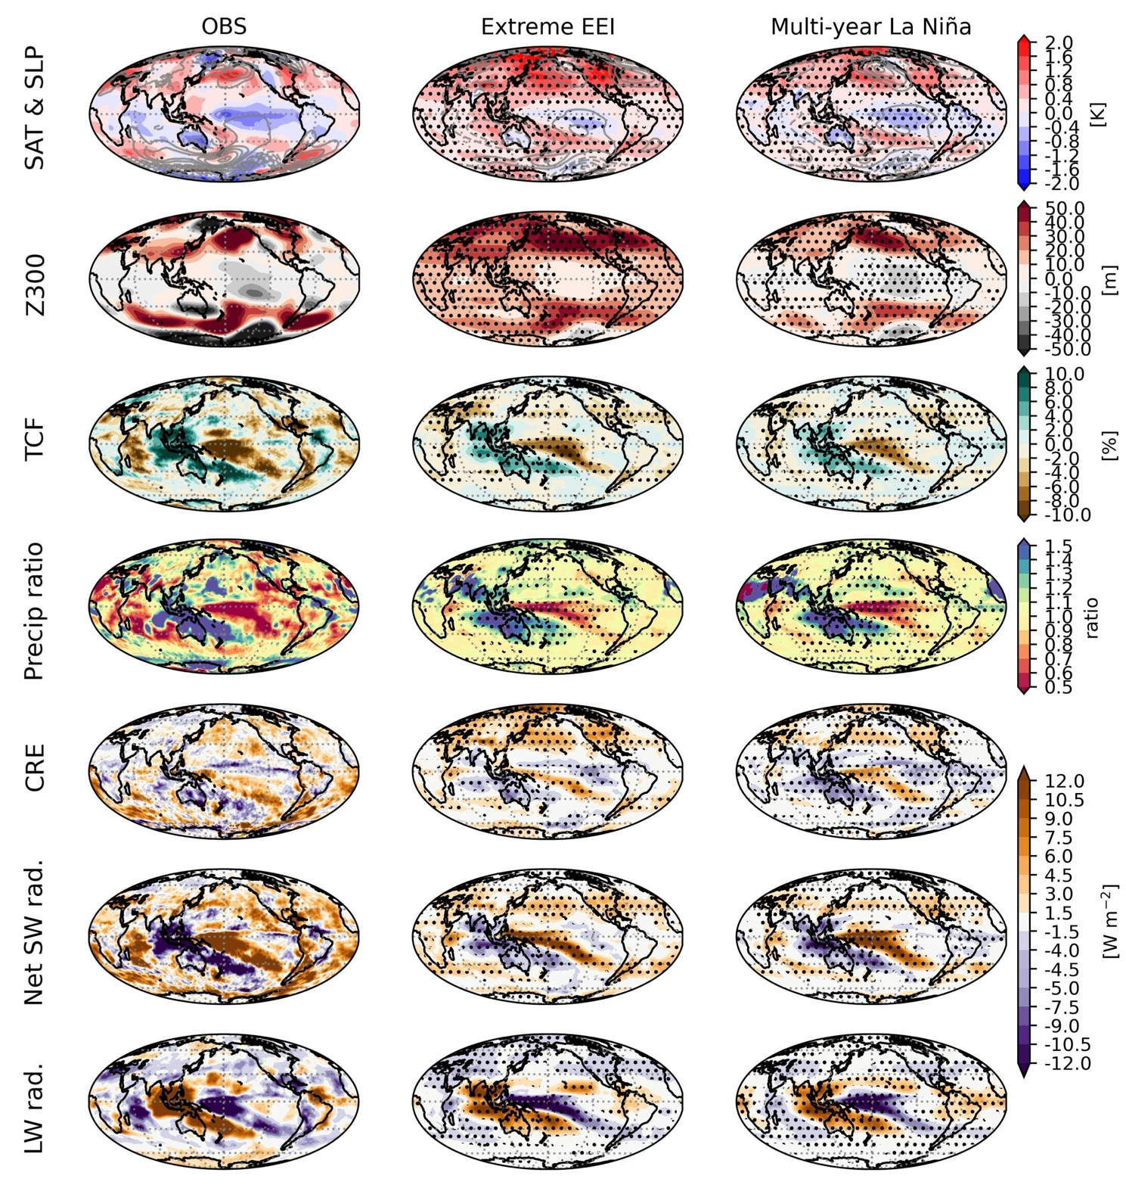

Extended Data Figure 4: Spatial patterns of anomalies in surface air temperature (SAT), sea level pressure (SLP), geopotential height at 300hPa (Z300), total cloud fraction (TCF), precipitation (scaled by climatology), cloud radiative effect (CRE), net SW radiation, and LW radiation averaged over DJFMAM. (Left) Observations (OBS), (middle) the extreme EEI composite, and (right) multi-year La Niña composite based on CMIP6. The SLP is represented by contours with intervals of 1 hPa for OBS and 0.5 hPa for CMIP6 composites. The data for OBS is based on 2022/23 observations (with CERES-EBAF for radiation and TCF, GPCP for precipitation, and ERA5 for SLP and Z300), while multi-model ensembles represent years –1 to 0.

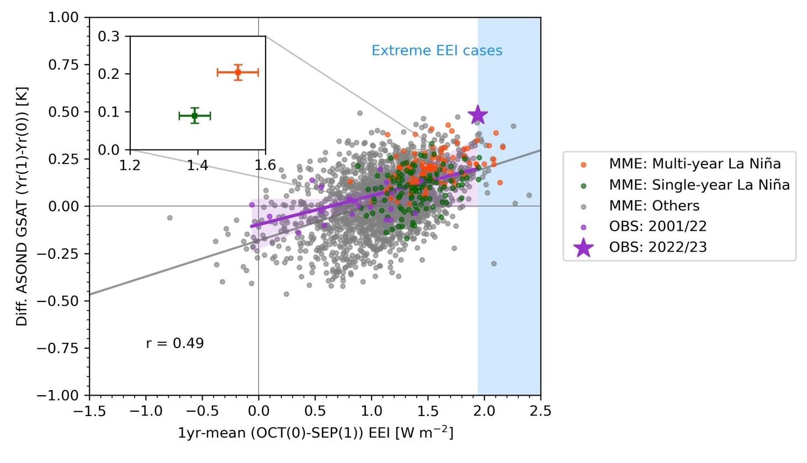
Extended Data Figure 5: Relationship between the year-to-year change in ASOND (August–December) GSAT [K] and annual mean EEI [W m^{–2}].
The EEI is evaluated as the yearly mean in the period from October(0) to September(1). The GSAT change is calculated as the ASOND difference between year(0) and year(1). The gray line represents the regression based on CMIP6 samples. Orange and green dots indicate multi-year and single-year La Niña cases, respectively (Methods). Purple dots represent the observations from 2001 to 2022, with the 2022/23 case highlighted by a purple star. The purple line shows the observational regression line, with the 95% confidence interval indicated by the purple shading. Blue shading highlights the extreme EEI cases. The inset in the top-left corner shows the sample means and 95% confidence intervals for multi-year (orange) and single-year (green) La Niña cases.

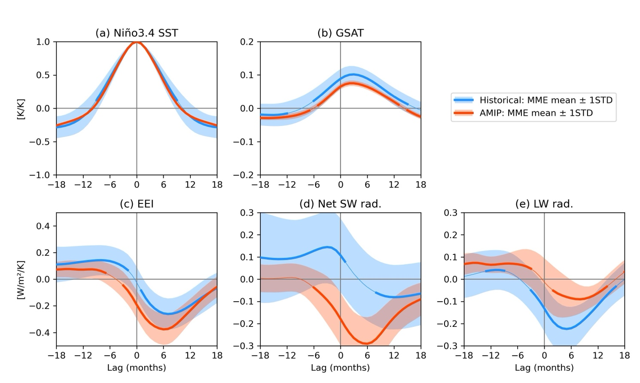

Extended Data Figure 6: Lagged regression of (a) Niño3.4 SST, (b) GSAT, (c) EEI, (d) net SW radiation, and (e) LW radiation anomalies against the Niño3.4 SST anomaly for historical and AMIP simulations.
The unit is (a, b) K K^{–1} and (c-e) W m^{–2} K^{–1}. All lagged regressions are based on linearly detrended time series for 1979-2014 with a 3-month running average. Lines and shading represent the MME mean and ±1 standard deviation for the historical (blue) and AMIP (red) simulations. Bolded lines indicate where the MME mean anomalies are statistically significant at the 95% confidence level. The analysis utilizes 31 models for both historical and AMIP simulations, limited by our availability of the AMIP simulations.

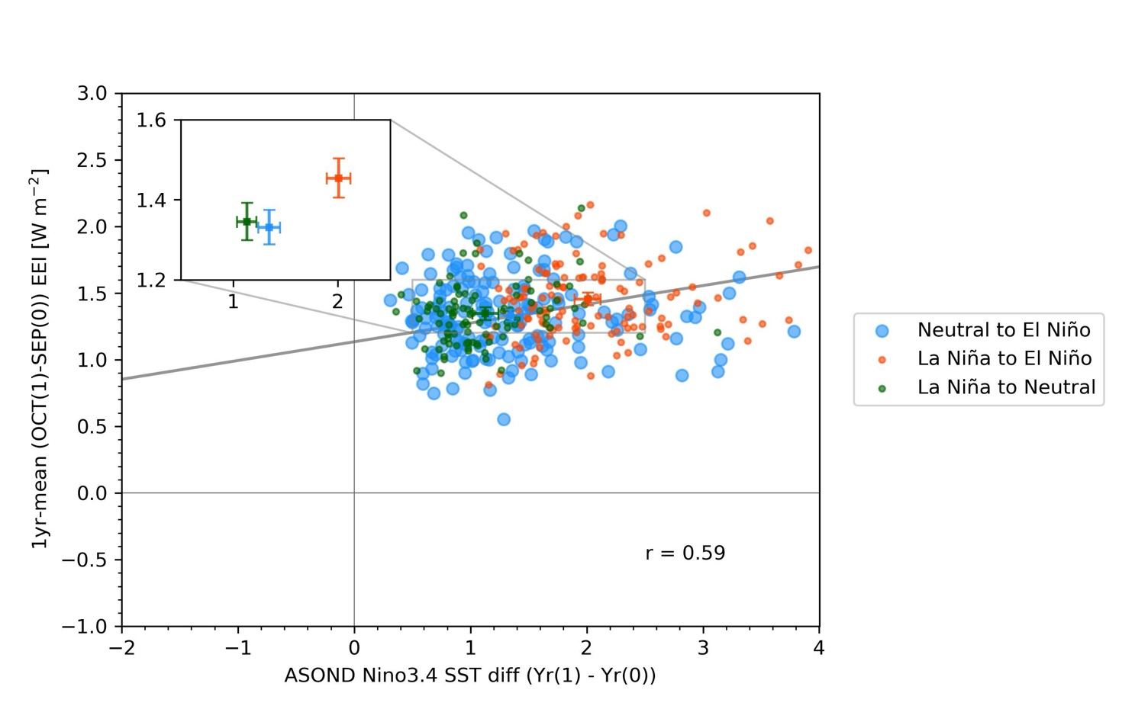
Extended Data Figure 7: Same as Figure 3, but categorized by ENSO transitions: neutral to El Niño, La Niña to neutral, and La Niña to El Niño.
The yearly (October(0)-September(1)) mean values (±95% confidence interval) of EEI mean-retained anomalies are 1.30 (±0.05), 1.36 (±0.06), and 1.49 (±0.06) W m–², respectively. These results suggest that either decaying La Niña or developing El Niño conditions can induce enhanced EEI compared to non-transition cases (1.1 W m–²). However, transitions from La Niña to El Niño exhibit a more pronounced EEI, indicating that the observed transition to El Niño in 2023 contributed to the enhancement of EEI in conjunction with the triple-dip La Niña termination.

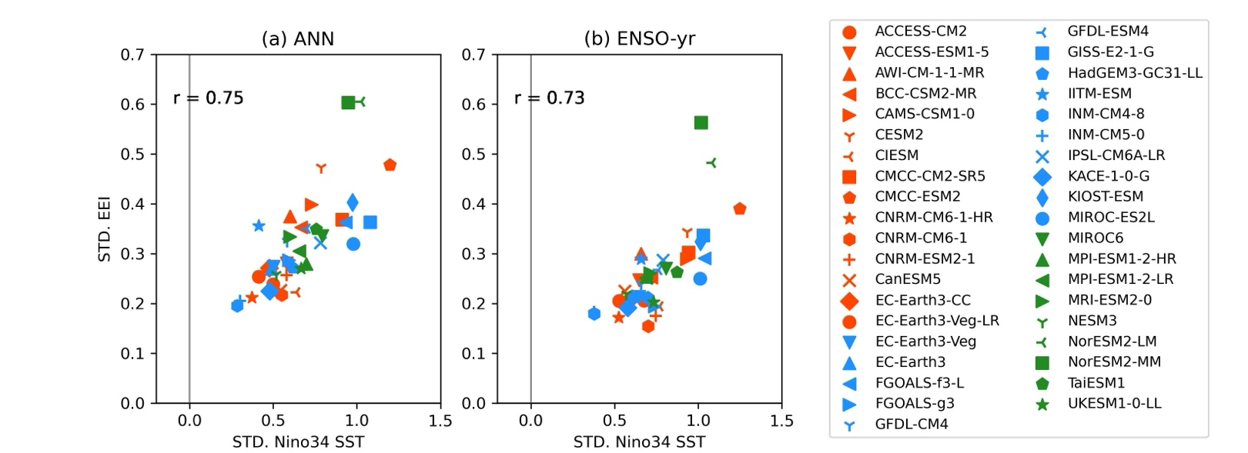

Extended Data Figure 8: Relationship between the amplitudes of ENSO and EEI internal variability.
The scatter plot shows the standard deviations of Niño 3.4 SST anomalies versus the standard deviation of EEI for (a) calendar-year mean (ANN) and (b) ENSO year (ENSO-yr) mean, based on CMIP6 piControl simulations. The ENSO-yr is defined as the period starting from July(0) and ending in June(1).

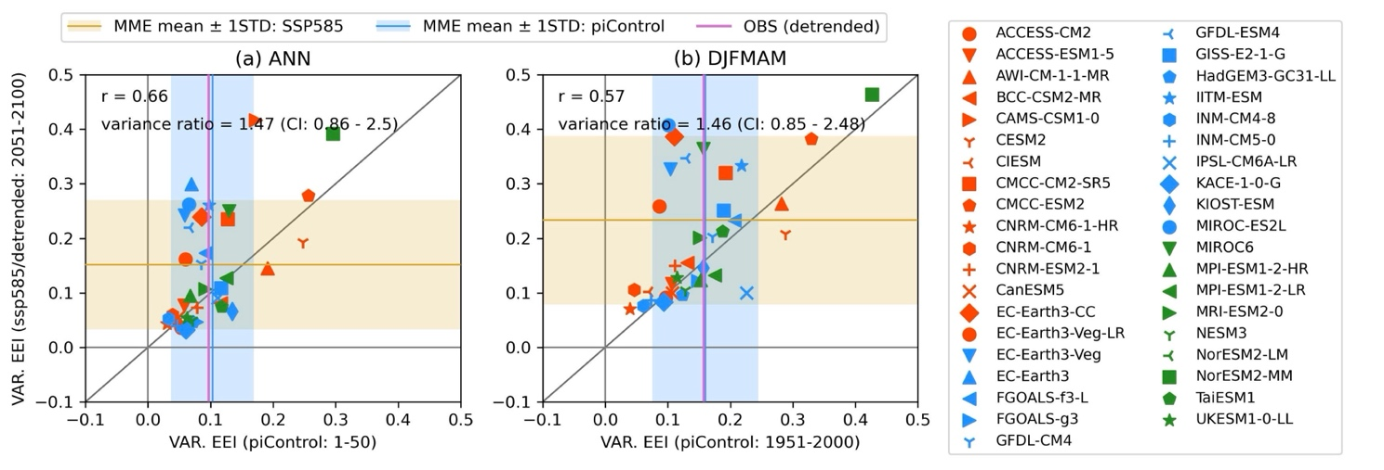
Extended Data Figure 9: Relationship of EEI variance between the piControl and SSP5-8.5 simulations.
Scatter plots show the variance of EEI using data from the first 50 years of the piControl simulation and from 2051–2100 in the SSP5-8.5 simulation for (a) the calendar-year mean (ANN) and (b) the December(0)–May(1) mean (DJFMAM) period. Out of 39 models, 24 and 27 show larger EEI variance in SSP5-8.5 simulations for (a) and (b), respectively. The top-left values indicate the correlation (r) and variance ratio with the 90% confidence interval, based on multi-model ensemble mean variance values, represented by blue (piControl) and yellow (SSP5-8.5) lines. The purple line shows the variance from CERES-EBAF observations for the period 2001–2023. EEI values in SSP5-8.5 and CERES-EBAF are detrended for each calendar month beforehand.

