Supplementary Table S1. Results of next-generation sequencing, trimming analysis, de novo assembly and mapping
Sample | Raw Reads | Clean Reads | Clean Bases | Error(%) | Q20(%) | Q30(%) | GC Content(%)
Fries3_1 | 58879086 | 56756522 | 8.51G | 0.03 | 97.83 | 93.96 | 52.91
Fries3_2 | 57422470 | 55513366 | 8.33G | 0.03 | 97.59 | 93.39 | 53.15
PD_1 | 66274742 | 63895868 | 9.58G | 0.03 | 97.84 | 93.92 | 53.15
PD_2 | 57546742 | 55551080 | 8.33G | 0.03 | 97.84 | 93.93 | 53.3
PS_1 | 53897816 | 51924186 | 7.79G | 0.03 | 97.75 | 93.75 | 52.71
PS_2 | 43482480 | 41616744 | 6.24G | 0.03 | 97.84 | 93.94 | 52.82

Supplementary Table S2. Combined Trinity assembly of the transcriptomes
 | Count
Total Number of transcripts | 43,979
Total number of unigenes | 14,208
Min Length | 301
Max length | 40521
Mean length of transcripts | 4745
Mean length of genes | 2124
Unigene N50 | 4001
Unigene N90 | 803

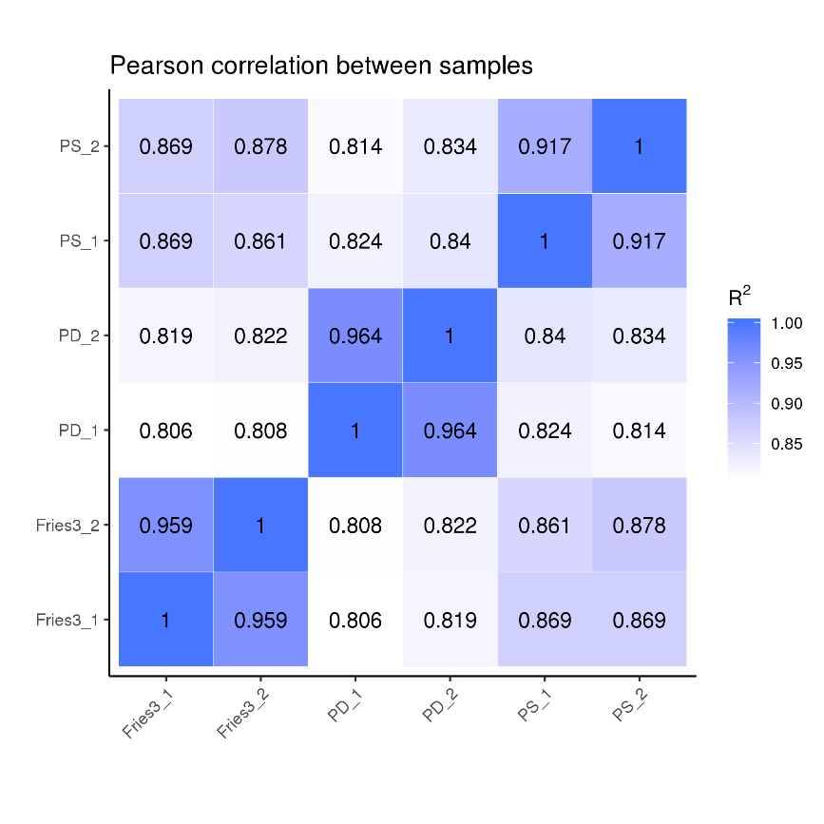
Supplementary Figure S1. Thermogram of correlation coefficient between samples
Note: abscissa is log10 (fpkm + 1) of sample 1, ordinate is log10 (fpkm + 1) of sample 2, R2: square of Pearson correlation coefficient

Supplementary Table S3. Analysis of carbohydrate-active enzymes from Trichoderma koningiopsis Tk1 strain
CBM |  | CE |  | GH |  | GT |  | PL |  | AA
Name | Number | Name | Number | Name | Number | Name | Number | Name | Number | Name | Number
CMB1 | 11 | CE1 | 47 | GH1 | 1 | GT1 | 13 | PL1 | 2 | AA1 | 3
CMB4 | 1 | CE2 | 1 | GH10 | 1 | GT2 | 13 | PL5 | 1 | AA2 | 15
CMB5 | 4 | CE3 | 5 | GH2 | 9 | GT3 | 2 | PL7 | 1 | AA3 | 16
CMB13 | 5 | CE4 | 6 | GH3 | 17 | GT4 | 3 | PL8 | 1 | AA4 | 5
CMB18 | 6 | CE5 | 7 | GH4 | 1 | GT8 | 4 |  |  | AA5 | 1
CMB19 | 2 | CE7 | 1 | GH5 | 6 | GT9 | 3 |  |  | AA6 | 4
CMB20 | 5 | CE8 | 3 | GH7 | 2 | GT15 | 4 |  |  | AA7 | 31
CMB21 | 2 | CE9 | 2 | GH11 | 2 | GT17 | 2 |  |  | AA9 | 3
CMB24 | 3 | CE10 | 35 | GH12 | 3 | GT20 | 7
CMB32 | 4 | CE12 | 1 | GH13 | 6 | GT21 | 2
CMB35 | 1 | CE14 | 1 | GH15 | 6 | GT22 | 4
CMB36 | 1 | CE16 | 3 | GH16 | 21 | GT24 | 1
CMB42 | 2 |  |  | GH17 | 5 | GT26 | 2
CMB48 | 3 |  |  | GH18 | 22 | GT28 | 1
CMB50 | 8 |  |  | GH20 | 4 | GT30 | 1
CMB54 | 1 |  |  | GH23 | 2 | GT31 | 4
CMB63 | 1 |  |  | GH24 | 1 | GT32 | 13
CMB66 | 2 |  |  | GH25 | 1 | GT34 | 2
CMB67 | 2 |  |  | GH27 | 3 | GT39 | 4
 |  |  |  | GH28 | 3 | GT48 | 2
 |  |  |  | GH30 | 5 | GT50 | 1
 |  |  |  | GH31 | 5 | GT51 | 2
 |  |  |  | GH32 | 1 | GT54 | 2
 |  |  |  | GH35 | 2 | GT57 | 6
 |  |  |  | GH37 | 5 | GT58 | 1
 |  |  |  | GH38 | 1 | GT59 | 2
 |  |  |  | GH39 | 1 | GT62 | 2
 |  |  |  | GH43 | 6 | GT64 | 2
 |  |  |  | GH47 | 11 | GT66 | 1
 |  |  |  | GH54 | 2 | GT69 | 6
 |  |  |  | GH55 | 7 | GT71 | 2
 |  |  |  | GH62 | 2 | GT90 | 10
 |  |  |  | GH63 | 2
 |  |  |  | GH64 | 4
 |  |  |  | GH65 | 2
 |  |  |  | GH67 | 2
 |  |  |  | GH71 | 8
 |  |  |  | GH72 | 2
 |  |  |  | GH73 | 1
 |  |  |  | GH74 | 3
 |  |  |  | GH75 | 7
 |  |  |  | GH76 | 11
 |  |  |  | GH78 | 2
 |  |  |  | GH79 | 1
 |  |  |  | GH81 | 1
 |  |  |  | GH89 | 1
 |  |  |  | GH92 | 7
 |  |  |  | GH93 | 4
 |  |  |  | GH95 | 3
 |  |  |  | GH99 | 2
 |  |  |  | GH109 | 12
 |  |  |  | GH113 | 1
 |  |  |  | GH114 | 2
 |  |  |  | GH115 | 2
 |  |  |  | GH125 | 1
 |  |  |  | GH128 | 6
 |  |  |  | GH132 | 2

