Supplemental Materials for “Coastal resilience in the face of increasing wildfires: a land-sea perspective”

Amanda M. Lopez^{1,2}, Christine M. Lee¹, Erin L. Hestir³, Lori A. Berberian⁴, Carmen Blackwood¹, Michelle Gierach¹

Author Affiliations:
¹ Jet Propulsion Laboratory, California Institute of Technology 4800 Oak Grove Drive M/S 300-329 Pasadena, CA 91109 USA amanda.m.lopez@jpl.nasa.gov, christine.m.lee@jpl.nasa.gov, carmen.blackwood@jpl.nasa.gov, michelle.gierach@jpl.nasa.gov
² Joint Institute for Regional Earth System Science and Engineering, University of California, Los Angeles
³Department of Civil & Environmental Engineering, University of California, Merced 5200 N. Lake Road Merced, CA, 95340 USA ehestir@ucmerced.edu
⁴ Department of Geography, University of California, Los Angeles 315 Portola Plaza, Los Angeles, CA 90095 USA loriberberian@g.ucla.edu

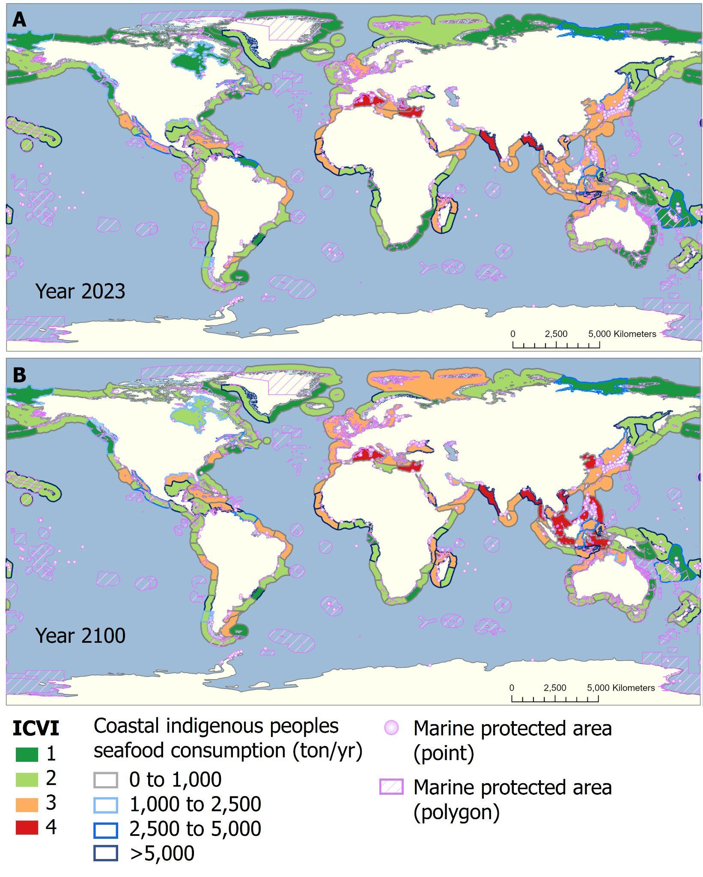

Figure S1. Global (A) ICVI₂₀₂₃ and (B) ICVI₂₁₀₀ values indicating coastal vulnerability to fire in the years 2023 and 2100, respectively, alongside seafood consumption by coastal indigenous peoples (tonnes/year) and marine protected areas data. Each ecoregion is bordered by a color that denotes the total amount of seafood consumption by coastal indigenous peoples each year in that ecoregion, gray indicates 0 to 1,000 tonnes, light blue denotes 1,000 to 2,500 tonnes, medium blue denotes 2,500 to 5,000 tonnes, and dark blue denotes >5,000 tonnes. Marine protected area data are shown in purple with points (purple outlined circles) indicating MPA presence without spatial extent information and polygons (purple outlined with diagonal cross hatching) indicating MPAs with reported spatial coverage. Original dataset sources [58, 69-72, 74].

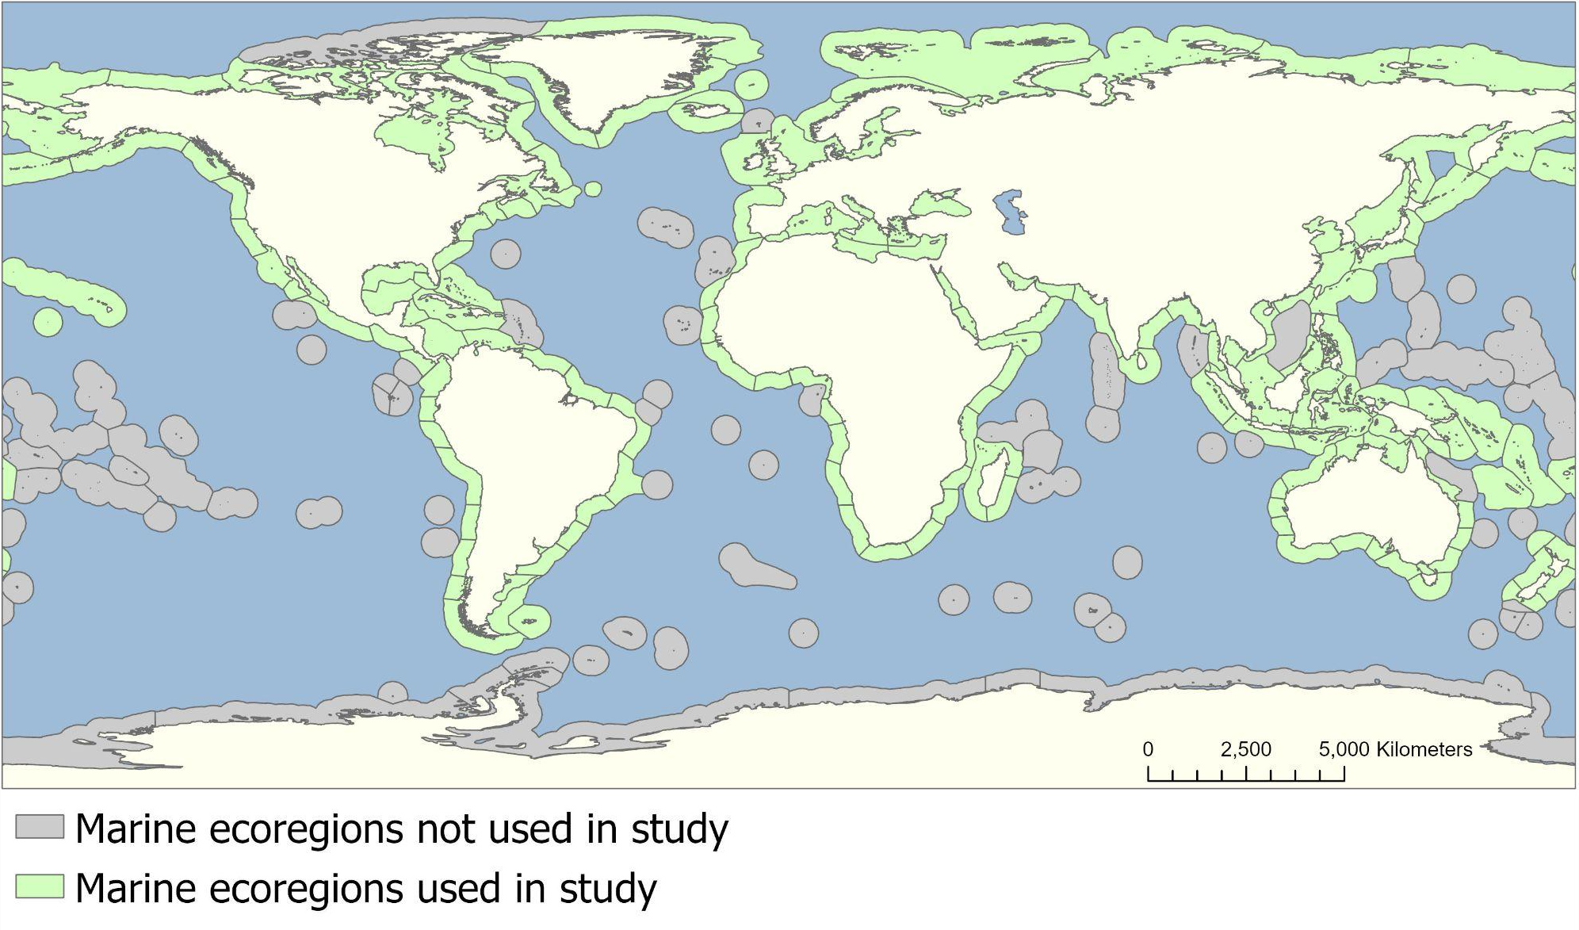
Figure S2. Marine ecoregions of the world from [100]. Ecoregions shown in green contain SEDAC population count data and are included in this study. Ecoregions shown in gray do not contain SEDAC population count data and are excluded from this analysis. Global population count original data source [73].

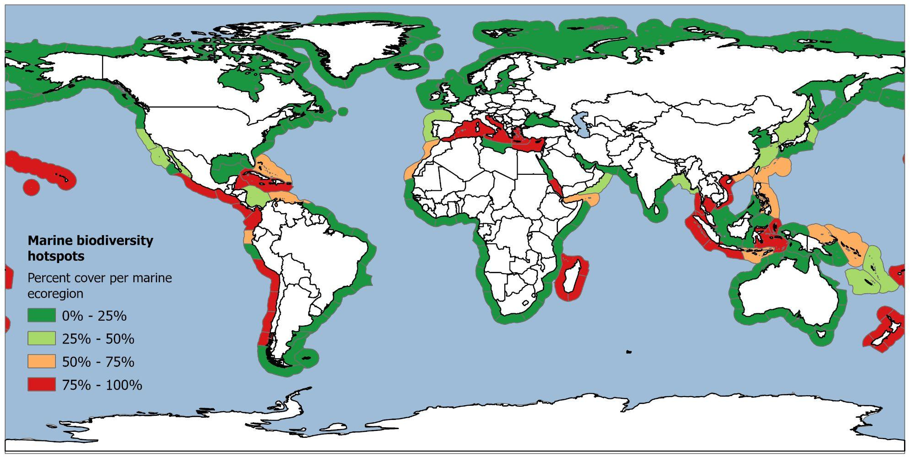
Figure S3. Percent cover of marine biodiversity hotspot per marine ecoregion of the world. The color scale follows the vulnerability scores given in Table 1 with dark green representing low vulnerability, light representing low to moderate vulnerability, orange representing moderate to high vulnerability, and red representing high vulnerability. Original dataset sources [72, 100].

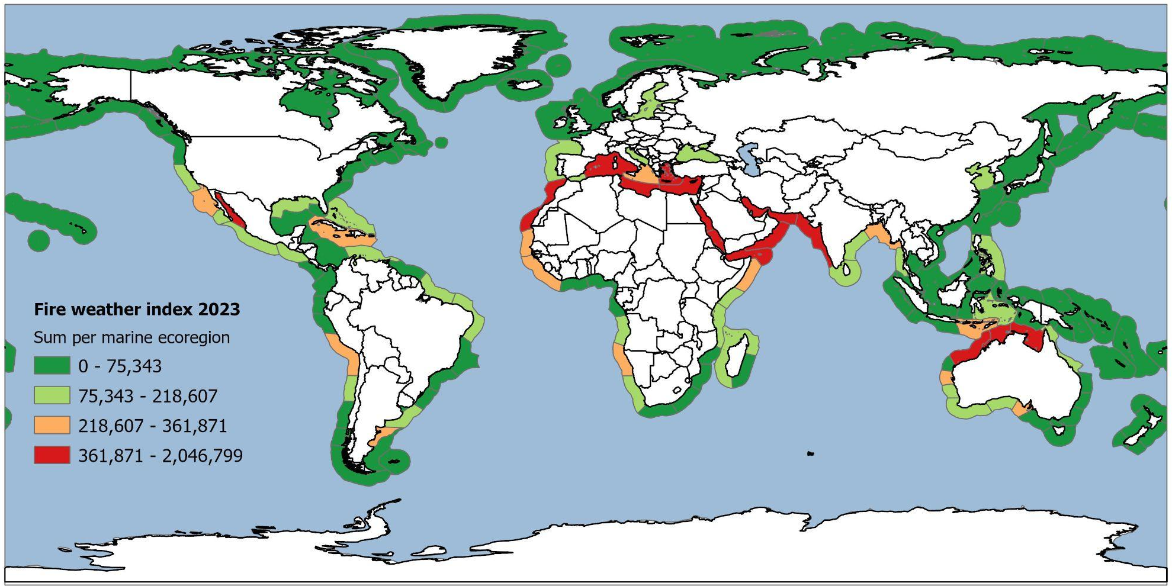
Figure S4. Fire weather index year 2023 summed per marine ecoregion of the world. The color scale follows the vulnerability scores given in Table 1 with dark green representing low vulnerability, light representing low to moderate vulnerability, orange representing moderate to high vulnerability, and red representing high vulnerability. Original dataset sources [70, 100].

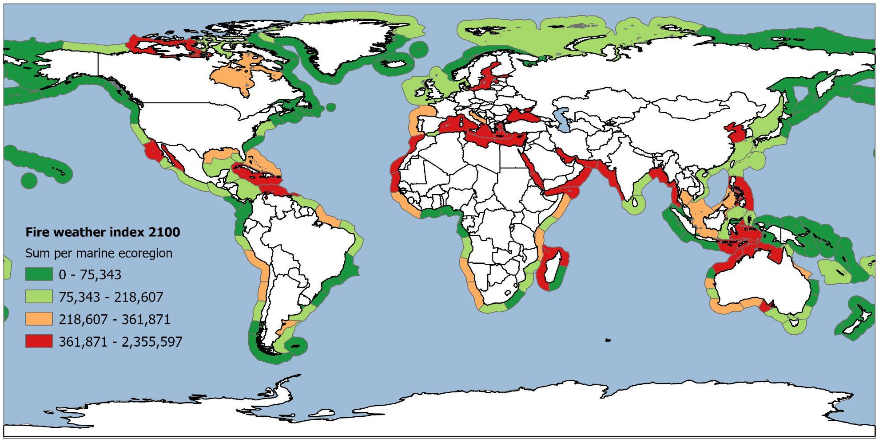
Figure S5. Projected fire weather index year 2100 summed per marine ecoregion of the world. The color scale follows the vulnerability scores given in Table 1 with dark green representing low vulnerability, light representing low to moderate vulnerability, orange representing moderate to high vulnerability, and red representing high vulnerability. Original dataset sources Original dataset sources [70, 100].

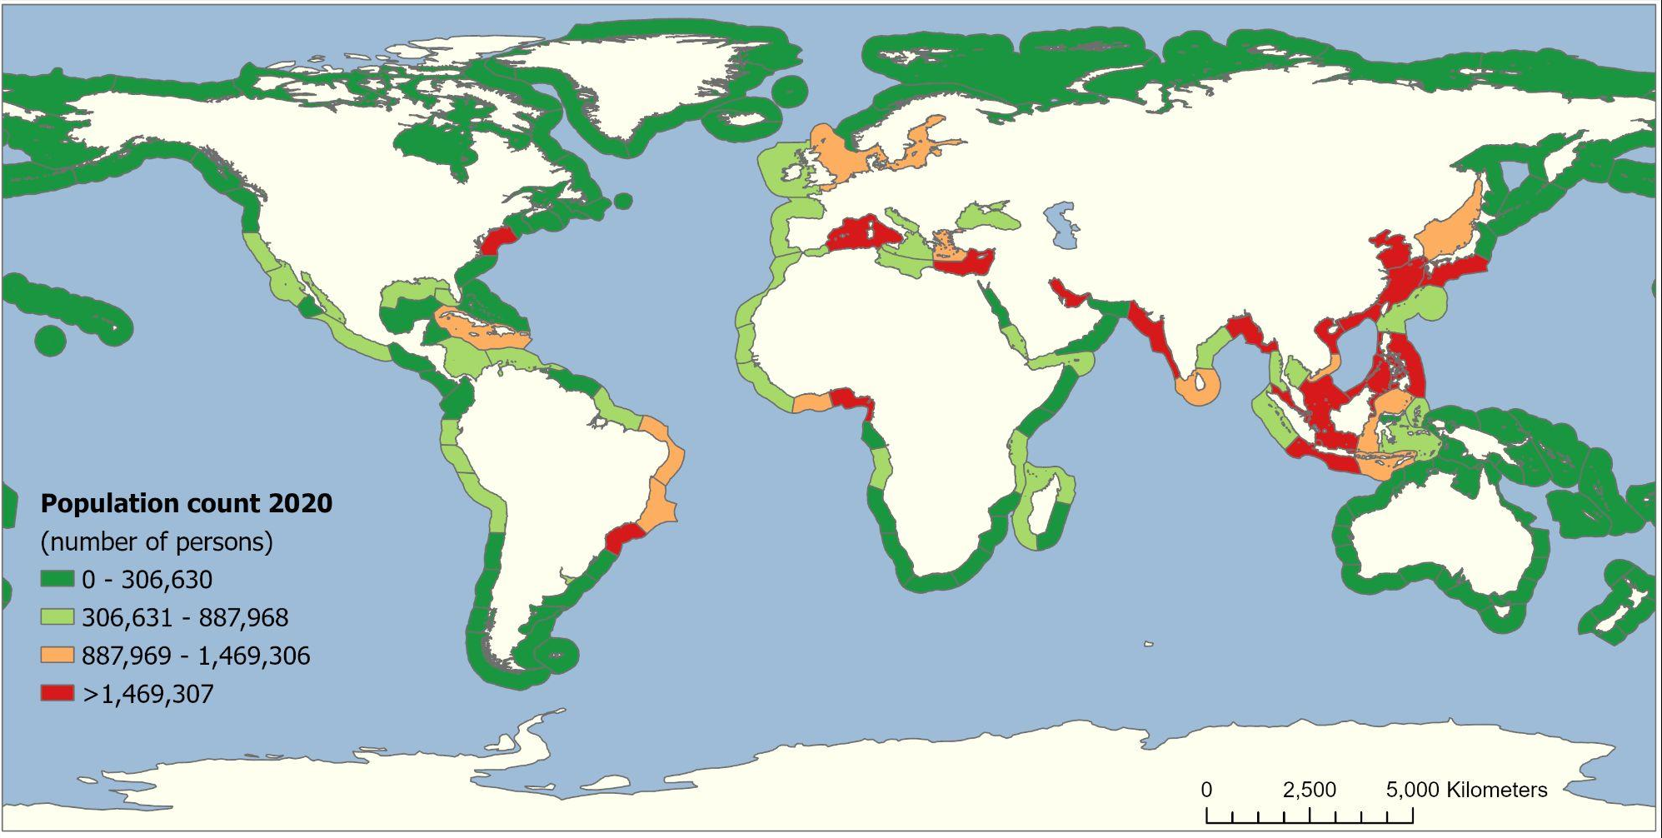
Figure S6. Global population count for the year 2020 summed per marine ecoregion of the world. The color scale follows the vulnerability scores given in Table 1 with dark green representing low vulnerability, light representing low to moderate vulnerability, orange representing moderate to high vulnerability, and red representing high vulnerability. Original dataset sources [73, 100].

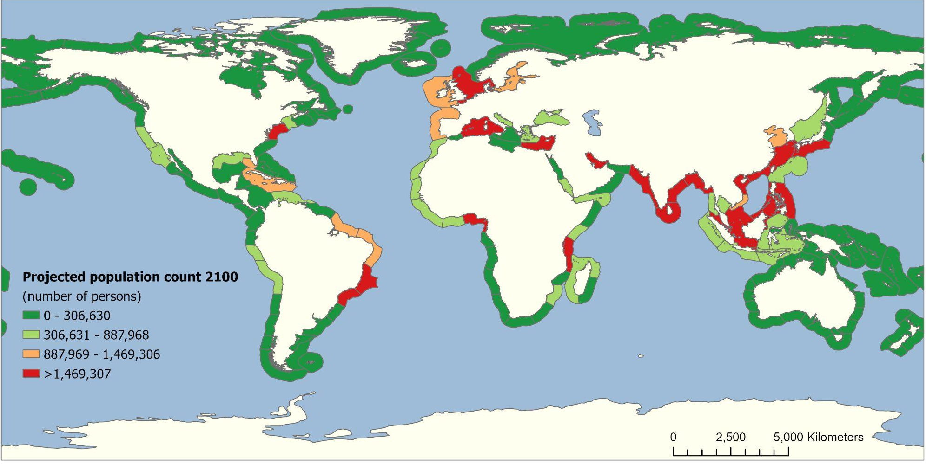
Figure S7. Projected global population count for the year 2100 summed per marine ecoregion of the world. Projection based on Shared Socioeconomic Pathways Scenario 2. The color scale follows the vulnerability scores given in Table 1 with dark green representing low vulnerability, light representing low to moderate vulnerability, orange representing moderate to high vulnerability, and red representing high vulnerability. Original dataset sources [73, 100].

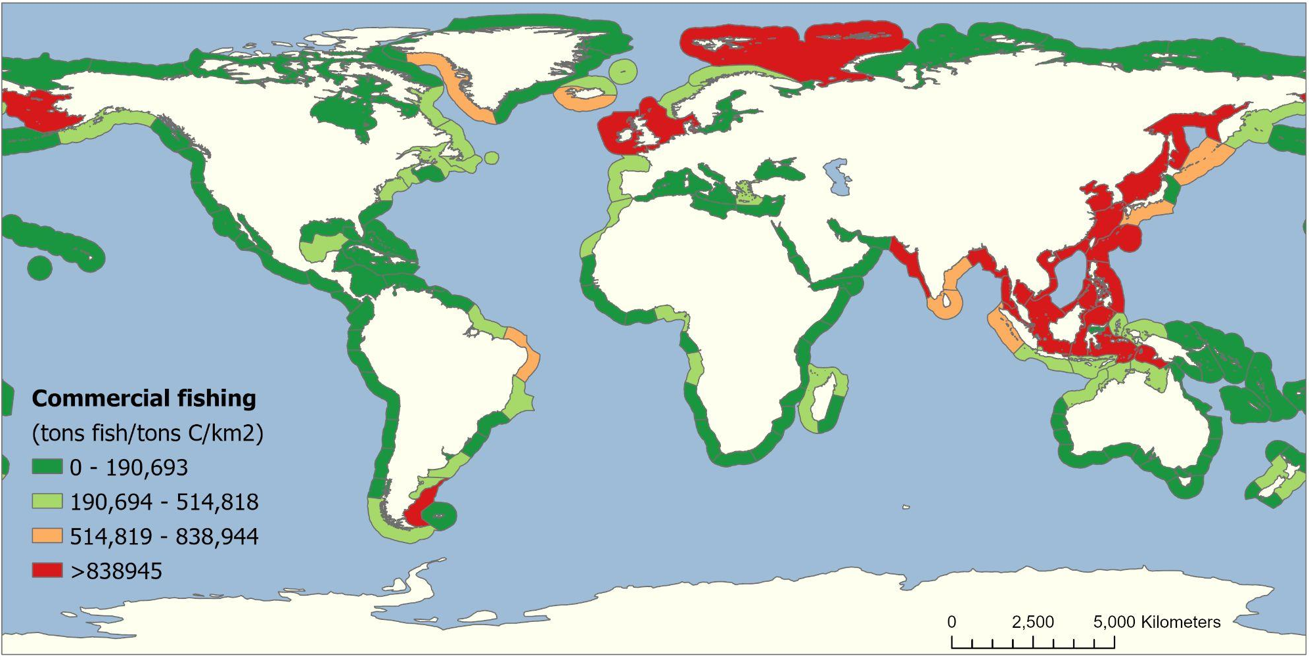
Figure S8. Commercial demersal fishing (tons of fish per tons of carbon per km2 cell) summed per marine ecoregion of the world. The color scale follows the vulnerability scores given in Table 1 with dark green representing low vulnerability, light representing low to moderate vulnerability, orange representing moderate to high vulnerability, and red representing high vulnerability. Original dataset sources [58, 100].

Table S1. Summary of marine ecoregions of the world that demonstrate moderate to high vulnerability (ICVI = 3 or 4) in 2023 and/or 2100 with corresponding United Nations (UN) geoscheme regions and major bordering countries. Underline denotes marine ecoregions in which the ICVI value decreased between 2023 and 2100 (became less vulnerable). Bold denotes ecoregions in which the ICVI value increased between 2023 and 2100 (became more vulnerable). Visualization of the UN geoscheme regions can be found in [75] and through the UN Geodata portal https://geoportal.un.org/arcgis/home/item.html?id=fa74ef8499094e41bf0d025006e37fc9.

Highest vulnerability (ICVIs between 3 and 4)
ICVI 2023 | ICVI 2100 | UN geoscheme region | Major bordering country | Marine ecoregion of the world
4 | 4 | North Africa | Egypt | Levantine Sea
4 | 4 | South Europe | Italy | Western Mediterranean
4 | 3 | South Europe | Greece | Aegean Sea
4 | 4 | South Asia | India | Western India
3 | 4 | South Asia | India | Andaman Sea Coral Coast
4 | 4 | Southeast Asia | Myanmar (Burma) | Northern Bay of Bengal
3 | 4 | Southeast Asia | Indonesia | Banda Sea
3 | 4 | Southeast Asia | Philippines | Eastern Philippines
3 | 4 | Southeast Asia | Vietnam | Gulf of Tonkin
3 | 4 | Southeast Asia | Philippines | Palawan/North Borneo
3 | 4 | Southeast Asia | Vietnam | Southern Vietnam
3 | 4 | Southeast Asia | Indonesia | Sunda Shelf/Java Sea
3 | 4 | East Asia | China | Yellow Sea
Moderate to high vulnerability (ICVIs between 2 and 3)
ICVI 2023 | ICVI 2100 | UN geoscheme region | Major bordering country | Marine ecoregion of the world
2 | 3 | North America | USA | Northern Gulf of Mexico
2 | 3 | North America | USA | Virginian
3 | 3 | The Caribbean | Cuba | Greater Antilles
3 | 3 | Central America | Mexico | Cortezian
3 | 3 | Central America | Mexico | Southern California Bight
3 | 2 | Central America | Mexico | Mexican Tropical Pacific
3 | 3 | South America | Peru | Humboldtian
3 | 3 | South America | Argentina | North Patagonian Gulfs
3 | 3 | South America | Brazil | Northeastern Brazil
2 | 3 | South America | Brazil | Amazonia
2 | 3 | South America | Argentina | Patagonian Shelf
2 | 3 | South America | Venezuela | Southern Caribbean
2 | 3 | North Europe | Sweden | Baltic Sea
2 | 3 | North Europe | UK | Celtic Seas
3 | 3 | North Europe | UK | North Sea
3 | 3 | South Europe | Italy | Adriatic Sea
3 | 3 | South Europe | Italy | Ionian Sea
3 | 2 | South Europe | Spain | Alboran Sea
2 | 3 | West Europe | France | South European Atlantic Shelf
3 | 3 | North Africa | Morocco | Saharan Upwelling
3 | 2 | North Africa | Libya | Tunisian Plateau/Gulf of Sidra
3 | 3 | East Africa | Madagascar | Western and Northern Madagascar
2 | 3 | East Africa | Tanzania | East African Coral Coast
3 | 3 | West Africa | Liberia | Gulf of Guinea West
3 | 3 | West Africa | Mauritania | Sahelian Upwelling
3 | 3 | West Asia | Yemen | Gulf of Aden
3 | 3 | West Asia | Saudi Arabia | Southern Red Sea
3 | 3 | West Asia | Oman | Western Arabian Sea
2 | 3 | West Asia | Turkey | Black Sea
3 | 3 | South Asia | Iran | Arabian (Persian) Gulf
3 | 3 | South Asia | India | Eastern India
3 | 3 | South Asia | Sri Lanka | South India and Sri Lanka
3 | 3 | Southeast Asia | Thailand | Gulf of Thailand
3 | 3 | Southeast Asia | Indonesia | Lesser Sunda
3 | 3 | Southeast Asia | Indonesia | Malacca Strait
3 | 3 | Southeast Asia | Indonesia | Sulawesi Sea/Makassar Strait
3 | 3 | Southeast Asia | Indonesia | Western Sumatra
3 | 2 | Southeast Asia | Indonesia | Southern Java
2 | 3 | Southeast Asia | Indonesia | Halmahera
3 | 3 | East Asia | Japan | Central Kuroshio Current
3 | 3 | East Asia | China | East China Sea
3 | 3 | East Asia | Japan | South Kuroshio
3 | 3 | East Asia | China | Southern China
3 | 3 | East Europe | Russia | Sea of Japan
2 | 3 | East Europe | Russia | North and East Barents Sea
3 | 3 | Oceania | Australia | Arnhem Coast to Gulf of Carpenteria
3 | 3 | Oceania | Australia | Bonaparte Coast
3 | 3 | Oceania | Australia | Exmouth to Broome

