Table 1. Climate and temperature humidity index (THI) values between 2019 and 2020 in Murcia (Spain)
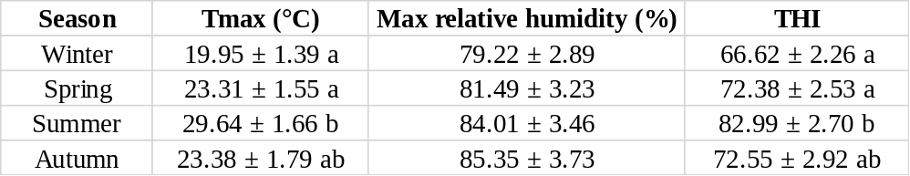
Data are expressed as mean ± SEM. ^{a,b} Different letters indicate differences (p ≤ 0.05) between seasons. Tmax: maximum temperature.

Table 2. Effect of the season on cumulus cells quality parameters in sheep.
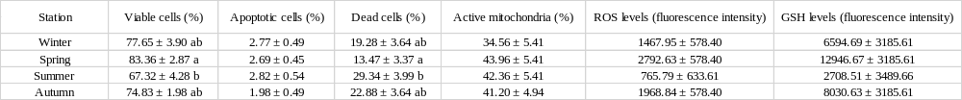
Data are expressed as mean ± SEM. ^{a,b} Different letters in the column indicate differences (p ≤ 0.05) between seasons.

Table 3. The effect of season on oocyte meiotic status, fertilization potential and embryo development in sheep.
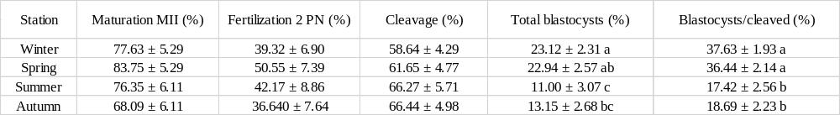
Data are expressed as mean ± SEM. ^{a,b,c} Different letters in the column indicate differences (p ≤ 0.05) between seasons.

Table 4. The effect of in vitro heat stress during ovary storage on cumulus cells quality parameters in sheep.
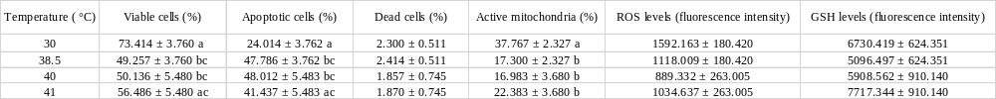
Data are expressed as mean ± SEM. ^{a,b} Different letters in columns indicate differences (p ≤ 0.05) between temperatures.

Table 5. The effect of in vitro heat stress during ovary storage on fertilization potential, embryo competence and blastocyst quality.
Data are expressed as mean ± SEM. ^{a,b} Different letters in columns indicate differences (p ≤ 0.05) between temperatures.

