The clinical use of Alzheimer’s biomarkers in patients with mild cognitive impairment: a European Alzheimer’s Disease Consortium survey
Camilla Caprioglio, MS^{1,2}; Valentina Garibotto, MD^{3,4}; Frank Jessen, MD^{5,6}; Lutz Frölich, MD⁷; Gilles Allali, MD, PhD^{8,9}; Frédéric Assal, MD⁸; Giovanni B. Frisoni, MD^{1,2}; Daniele Altomare, PhD^{1,2}; on behalf of the European Alzheimer’s Disease Consortium (EADC).

¹Laboratory of Neuroimaging of Aging (LANVIE), University of Geneva, Geneva, Switzerland.
²Geneva Memory Center, Geneva University Hospitals, Geneva, Switzerland.
³Laboratory of Neuroimaging and Innovative Molecular Tracers (NIMTlab), Geneva University Neurocenter and Faculty of Medicine, University of Geneva, Geneva, Switzerland
⁴Division of Nuclear Medicine and Molecular Imaging, Geneva University Hospitals, Geneva, Switzerland.
⁵Department of Psychiatry, University Hospital and Medical Faculty, University of Cologne, Cologne, Germany
⁶German Center for Neurodegenerative Diseases (DZNE), Bonn, Germany
⁷Department of Geriatric Psychiatry, Central Institute for Mental Health, University of Heidelberg, Mannheim, Germany
⁸Division of Neurology, Department of Clinical Neurosciences, Geneva University Hospitals, Geneva, Switzerland.
⁹Department of Neurology, Division of Cognitive & Motor Aging, Albert Einstein College of Medicine, Yeshiva University, Bronx, New York, USA.

SUPPLEMENTARY MATERIAL

● Full questionnaire used for the survey.
● Figure S1. Biomarker experts’ beliefs on the pathogenic role of amyloid and tau in AD [A] and perceived clinical utility of amyloid-PET vs tau-PET in MCI and mild dementia [B] divided by specialty (i.e. radiologists, nuclear medicine physicians, laboratory physicians).
● Figure S2. Biomarker experts’ reported additional value over neuropsychological testing and structural MRI in MCI divided by specialty (i.e. radiologists, nuclear medicine physicians, laboratory physicians).
● Figure S3. Biomarker experts’ confidence in an etiological diagnosis of AD in MCI divided by specialty (i.e. radiologists, nuclear medicine physicians, laboratory physicians).

● Full questionnaire used for the survey.

The use of biomarkers for the etiologic diagnosis of MCI
This questionnaire aims to investigate the use of biomarkers in clinical practice

Your contribution will be acknowledged in the works resulting from this survey (e.g. in the Acknowledgment section of any papers). If you don’t want that your name appears, you can express your intention by answering “No” to the last question of the first section.
Please note that the questionnaire is personal: i.e. the answers must reflect your beliefs and clinical practice. Please don’t ask anyone else to fill out the questionnaire on your behalf.
The survey takes about 10-20 minutes.
Please note that some of the following questions concern tau-PET. We are aware that while amyloid-PET tracers are well established and show similar performances, tau-PET tracers have been more recently developed and are less established. E.g., Flortaucipir is the most used tracer and has been validated against neuropathology and second-generation tracers are promising for an increased diagnostic accuracy.
For this reason we chose not to specify further which tau-PET tracer, and we would ask you to consider in answering a “theoretical” tau-PET tracer with a diagnostic accuracy deemed adequate for clinical use in AD.

Respondent’s details

Q11. Please enter your name and surname

Q12. Please enter your email address

Q13. What is your specialty?

(You can choose more than one, based on your qualifications)

Q131. Neurologist
Q132. Geriatrician
Q133. Psychiatrist
Q134. Radiologist
Q135. Nuclear Medicine physician
Q136. Laboratory physician
Q137. Psychologist / Neuropsychologist
Other (Open answer)

Q14. Which center do you work at?

Q15. Which city do you work in?

Q16. Which country are you currently practicing in?

Q17. What’s your role in the memory clinic you currently practicing in?

Q171. Head of memory clinic
Q172. Staff of memory clinic
Q173. Memory clinic collaborator from other units (e.g. radiology, nuclear medicine, other laboratories)
Other (Open answer)

Q18. How many years of experience in the field of neurodegenerative disorders do you have?

Q19. The next sections of the questionnaire ask questions about the pathogenic role of tau and amyloid, and the use of biomarkers to support etiological diagnosis in patients with mild cognitive impairment (MCI). Do you think you are competent enough in the field of neurodegenerative disorders to fulfill this questionnaire? If no, this is the last question.
[If answer = “No” the questionnaire ends]

Q20. Do you agree to that your name appears on the acknowledgment list?

Referring specialists

Q21 Please write the names and email addresses of the referring radiologist(s), nuclear medicine physician(s), and laboratory physician(s) collaborating with the memory clinic you are currently practicing in. We will ask your colleagues to fill in the same questionnaire. Please inform them that we are going to contact them.

[Reply to question Q21 only if answer to Q17 = “Head of memory clinic” or “Staff of memory clinic”]

Beliefs about the pathogenic role of amyloid and tau in Alzheimer’s disease

Q31. What is your belief/opinion about the pathogenic role of amyloid and tau in Alzheimer’s disease pathology and symptoms?
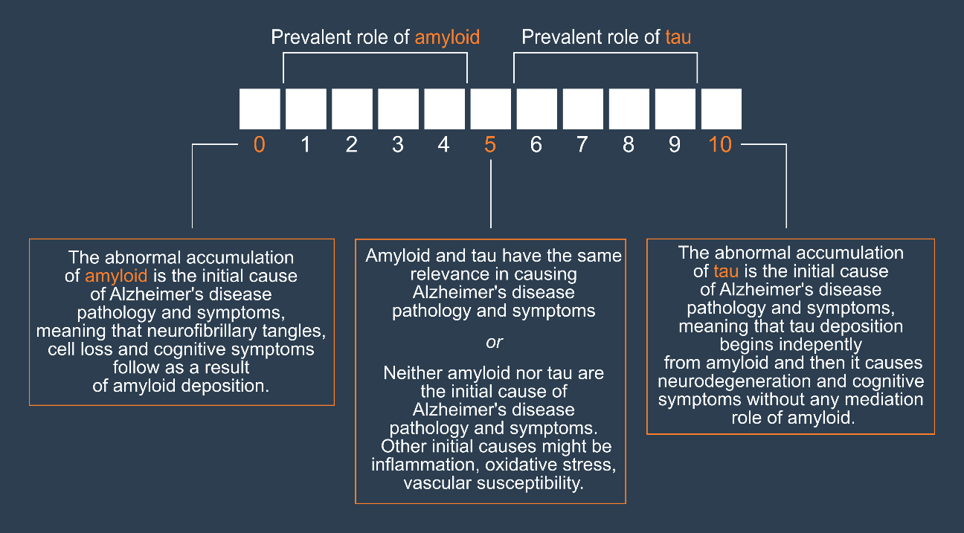
Q311. Amyloid | Tau

Respondent’s clinical work

[Reply to section Respondent’s clinical work only if answer to Q13 = “Neurologist” or “Geriatrician” or “Psychiatrist”]

Q41. Do you provide clinical consultation for patients with MCI?
Yes/No

Q41a. How many new patients with MCI do you consult in a typical month?
Please add only numerical values

[Reply to question Q41a only if answer to Q41 = “Yes”]

Biomarkers: frequency of use

[Reply to section Biomarker: frequency of use only if answer to Q13 = “Neurologist” or “Geriatrician” or “Psychiatrist”]

Q51. In MCI, in your clinical practice, please state frequency of use for:

 | Rarely  (<10%) | Regularly  (20-60%) | Frequently  (60-80%) | Always  (>80%) | Not used
Q511.  Medial temporal lobe atrophy (MRI) | □ | □ | □ | □ | □
Q512.  FDG-PET | □ | □ | □ | □ | □
Q513.  CSF (e.g. Aβ42, p-tau, t-tau) | □ | □ | □ | □ | □
Q514.  Amyloid-PET | □ | □ | □ | □ | □
Q515.  Tau-PET | □ | □ | □ | □ | □

Imaging biomarkers

[Reply to section Imaging biomarker only if answer to Q13 = “Neurologist” or “Geriatrician” or “Psychiatrist”]

Q61. Do you use imaging biomarkers to support your etiological diagnosis in MCI?
Yes/No

Q61a. Do the results of the imaging biomarker assessment go into the clinical report for the patient or referring physician?
Yes/No
[Reply to question Q61a only if answer to Q61 = “Yes”]

Q61b. Do you use any quantitative reading tool (e.g. SPM) or scale (e.g. MTA scale; Scheltens et al., 1992) for your clinical reports?
[Reply to question Q61b only if answer to Q61 = “Yes”]

Q61c. In MCI please state what kind of quantitative reading tool (e.g. SPM) or scale (e.g. MTA scale; Scheltens et al., 1992) you use for your clinical reports for the answers indicated in previous question:
[Reply to question Q61c only if answer to Q61 = “Yes” and Q61b = “Yes”]

Quantitative reading tool or scale
Q61c1. MRI
Q61c2. FDG-PET
Q61c3. Amyloid-PET
Q61c4. Tau-PET
Q61c5. Other

Biochemical biomarkers

[Reply to section Biochemical biomarker only if answer to Q13 = “Neurologist” or “Geriatrician” or “Psychiatrist”]

Q71. In MCI do you use CSF collection (e.g. Aβ42, p-tau, t-tau) to support your diagnosis?
Yes/No

Q72. In MCI do you use APOE genotyping to support your diagnosis?
Yes/No

Q73. Do the results of the biochemical biomarker assessment go into the clinical report for the patient or referring physician?
Yes/No
[Reply to question Q73 only if answer to Q71 = “Yes” OR Q72 = “Yes”]

Q73a. Which of the following biochemical biomarkers do you use as part of your biochemical measures in the clinical report?
[Reply to question Q73a only if answer to Q73 = “Yes”]

Q73a1. Aβ40
Q73a2. Aβ42
Q73a3. Aβ42/40
Q73a4. p-tau
Q73a5. t-tau
Q73a6. APOE genotype
Other (Open answer)

Biomarkers: diagnostic additional value

Q81. Assuming that clinical examination with neuropsychological testing and brain structural MRI are the most feasible procedures in most memory clinics, please rate the ADDITIONAL DIAGNOSTIC VALUE (i.e. the ability to provide diagnostic information in excess of that already provided by neuropsychological testing and brain structural MRI) in an MCI patient of:

 | None | Little | Moderately significant | Greatly significant | Decisive
Q811. FDG-PET | □ | □ | □ | □ | □
Q812. CSF markers (e.g. Aβ42, p-tau, t-tau) | □ | □ | □ | □ | □
Q813. Amyloid-PET | □ | □ | □ | □ | □
Q814. Tau-PET | □ | □ | □ | □ | □

Biomarkers: diagnostic confidence

Q91. A 75 years old person comes into your office complaining of memory deterioration in the past 6-12 months, he/she is in good physical health, has no problems in his/her daily chores, but is clearly worried. Routine labs are normal, but he/she performs 1.5 SD below the age-and education-adjusted mean on a test of verbal or non-verbal recall.

How confident would you be with a diagnosis of MCI due to AD (or prodromal AD) on the basis of: (Please note that ALONE means that only this marker is available and please also note that the question regards how confident you are, NOT what you may tell the patient)
 | Not at all comfortable | Moderately comfortable | Comfortable | Very  comfortable | Extremely comfortable
Q911. Evidence of clear-cut medial temporal lobe atrophy (either visually rated or with hippocampal volumetry) ALONE | □ | □ | □ | □ | □
Q912. Clear-cut temporoparietal and posterior cingulate hypometabolism on FDG-PET (either visually rated or with a quantitative tool) ALONE | □ | □ | □ | □ | □
Q913. Clearly abnormal CSF levels of Aβ and tau ALONE | □ | □ | □ | □ | □
Q914. Clearly positive amyloid-PET (either visually rated or with a quantitative tool) | □ | □ | □ | □ | □
Q915. Clearly positive tau-PET (either visually rated or with a quantitative tool) | □ | □ | □ | □ | □
Q916. At least one clearly positive amyloid marker (CSF Aβ42 or amyloid PET) and at least one clearly positive neuronal injury marker (medial temporal or temporoparietal and posterior cingulate hypometabolism on FDG-PET OR CSF tau or tau-PET) | □ | □ | □ | □ | □

Clinical utility of amyloid-PET vs tau-PET

Q101. Independent of any specific patient’s feature and based on your clinical experience with patients usually seen in your memory clinic, what is, in your opinion, the most clinically useful exam for etiological diagnosis of MCI and mild dementia?

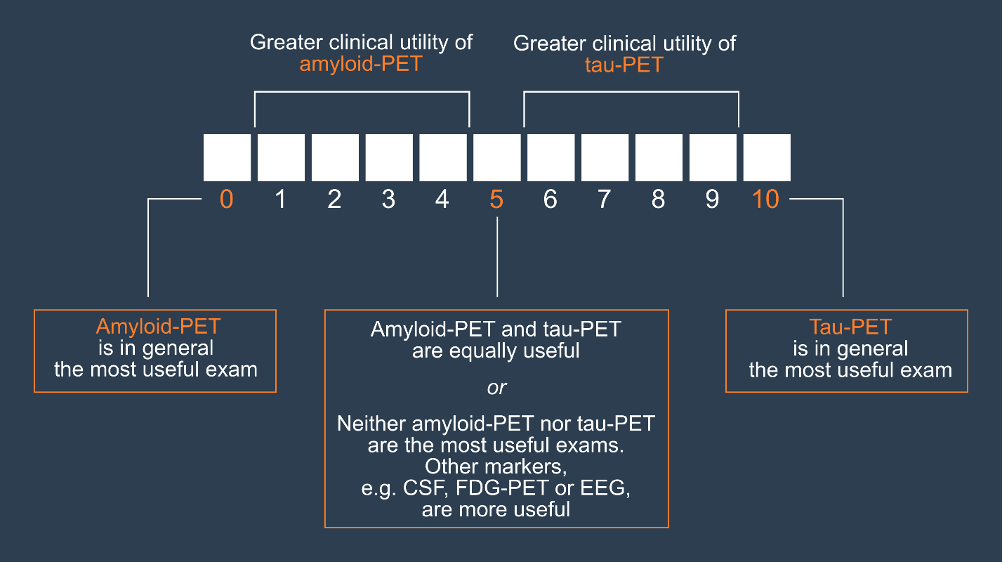

Q101a. Amyloid-PET | Tau-PET

Figure S1. Biomarker experts’ beliefs on the pathogenic role of amyloid and tau in AD [A] and perceived clinical utility of amyloid-PET vs tau-PET in MCI and mild dementia [B] divided by specialty (i.e. radiologists, nuclear medicine physicians, laboratory physicians).
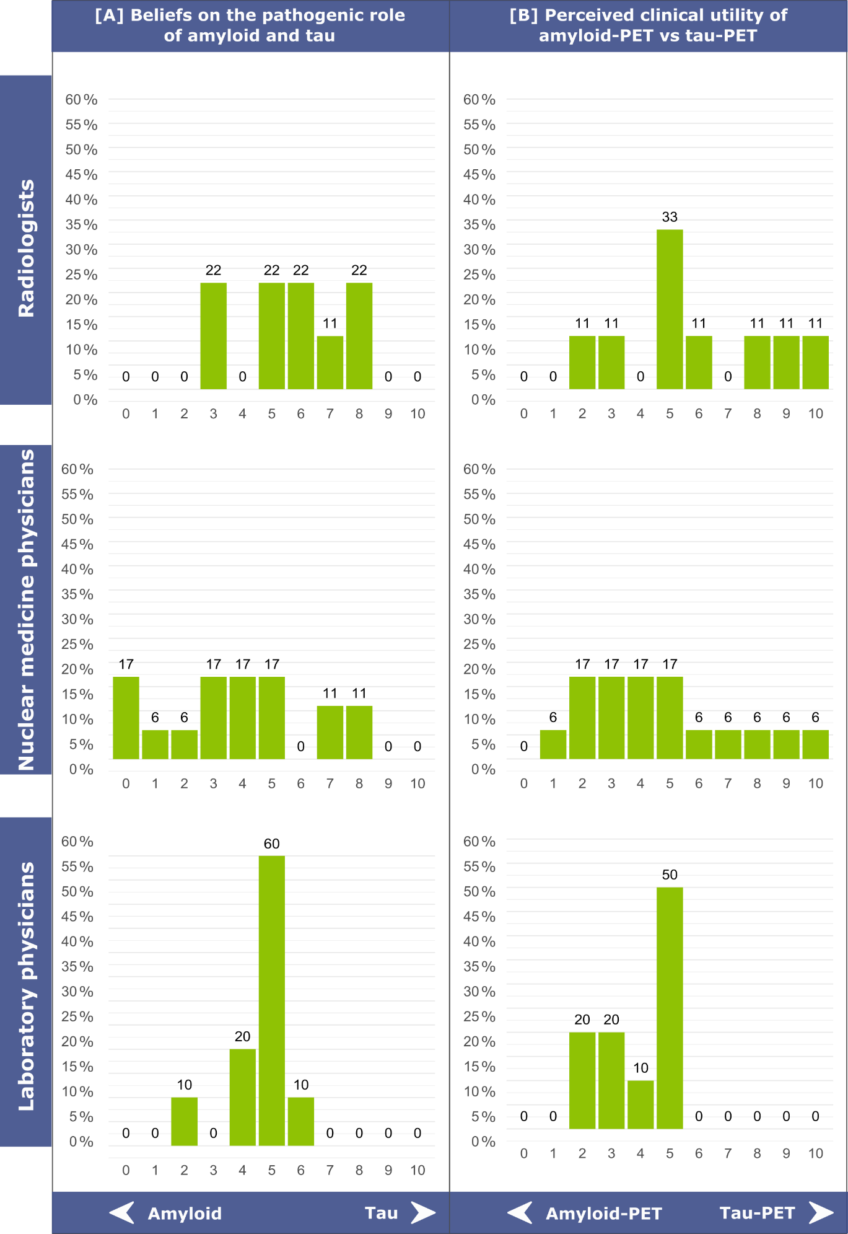
Figure S2. Biomarker experts’ reported additional value over neuropsychological testing and structural MRI in MCI divided by specialty (i.e. radiologists, nuclear medicine physicians, laboratory physicians).
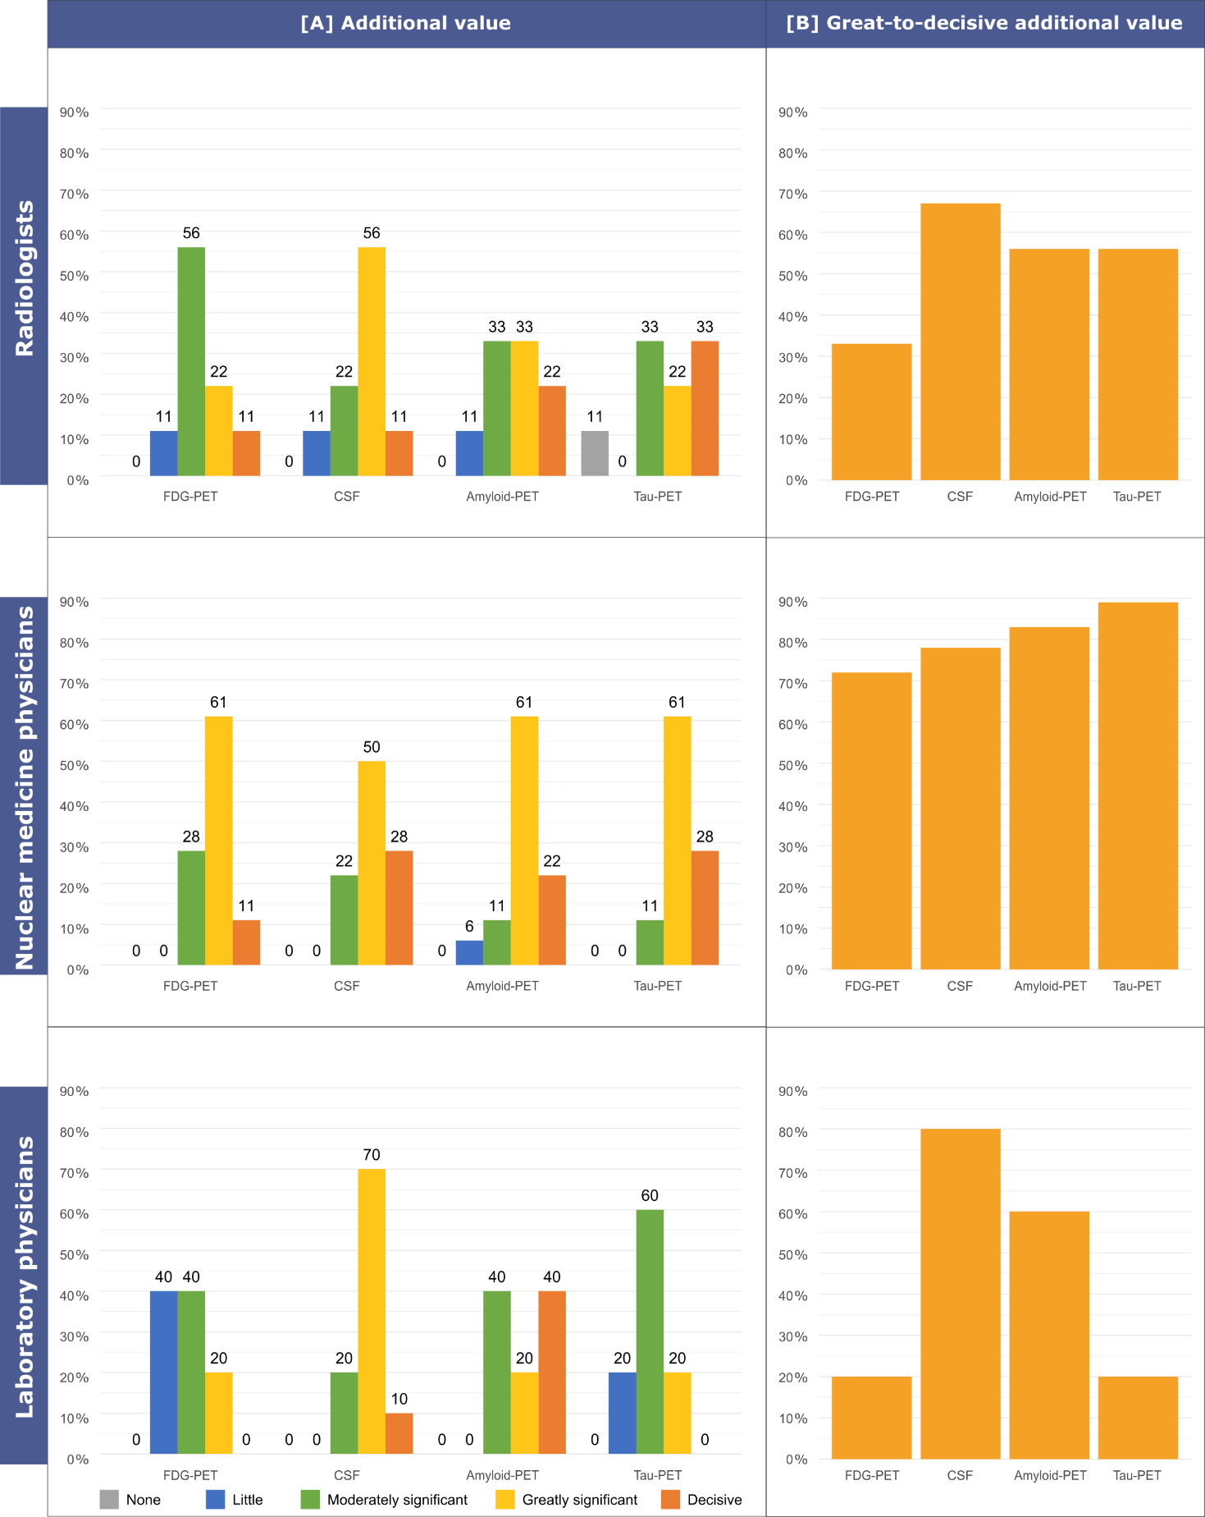

Figure S3. Biomarker experts’ confidence in an etiological diagnosis of AD in MCI divided by specialty (i.e. radiologists, nuclear medicine physicians, laboratory physicians).
