Supplementary figure 1. Correlation coefficients showing relationship between predictor variables with disease prevalence (A) and vector distribution (B)
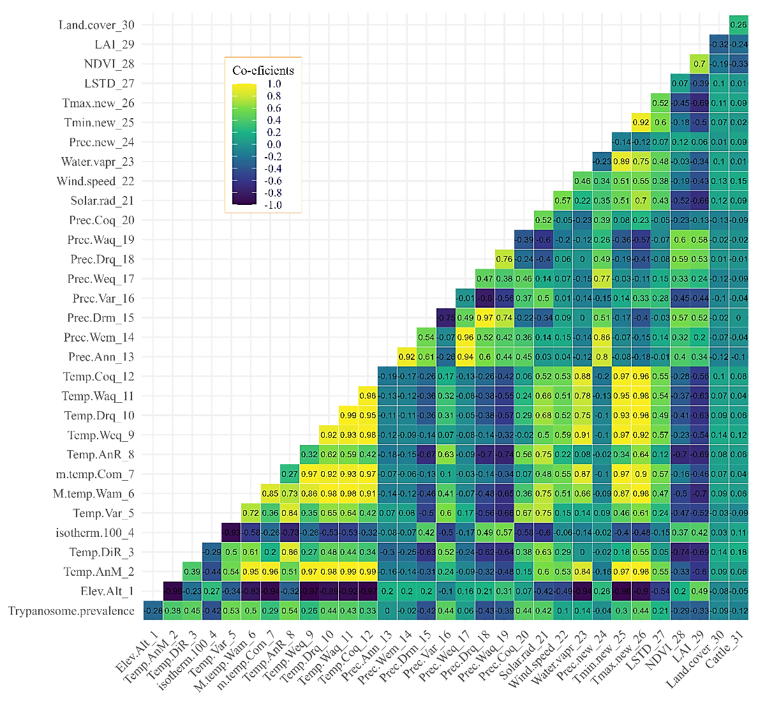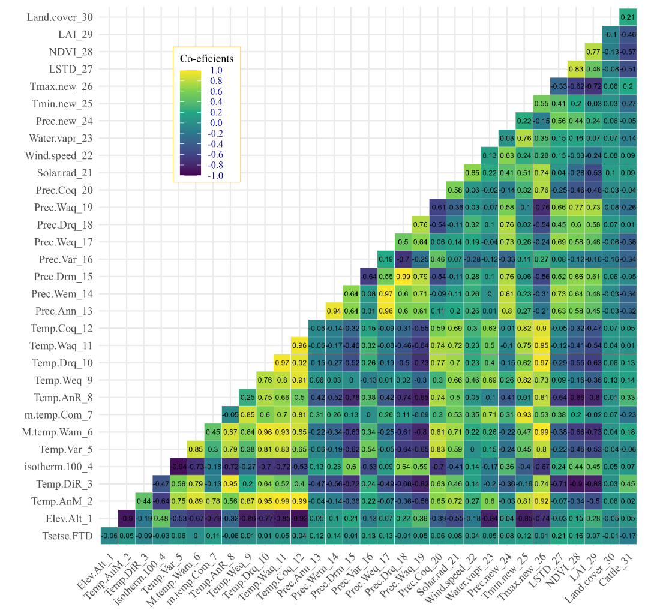
A
B

