Supplementary Information
Unlocking Ultra-stable Li₅FeO₄ in Air: Key Advances and Practical Demonstrations
Canshang Liu^{1,2}, Hao Zhang^{1,2}, Weiwei Zhou^{2,3}*, Xu Tian^{2,3}, Tiantian Zhang^{1,2}, Sicheng Niu^{2,3}, Minglei Cao^{4,5}, Qin Wang⁴, Fei Lv⁴, Tangping Peng⁴, Lijuan Tao⁴, Xiaodong Rang⁴, Zhicheng Chen⁴, Xin Su^{1,2}*
¹School of Marine Science and Technology, Harbin Institute of Technology, Weihai 264209, P. R. China.
²Advanced Battery Technology Center, Harbin Institute of Technology, Weihai 264209, P. R. China.
³School of Materials Science and Engineering, Harbin Institute of Technology, Weihai 264209, P. R. China.
⁴Hubei WanRun New Energy Technology Co., Ltd, Shiyan 442000, P. R. China.
⁵Hubei Key Laboratory of Energy Storage and Power Battery, School of Mathematics, Physics and Optoelectronic Engineering, Hubei University of Automotive Technology, Shiyan 442002, P. R. China.
*Corresponding authors: sux@hit.edu.cn; zhouweiwei@hit.edu.cn.

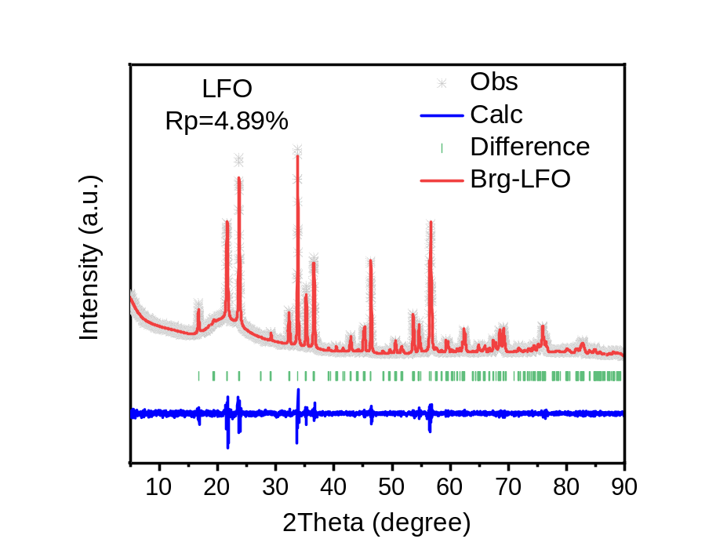
Supplementary Figure 1│ XRD refinement pattern of LFO

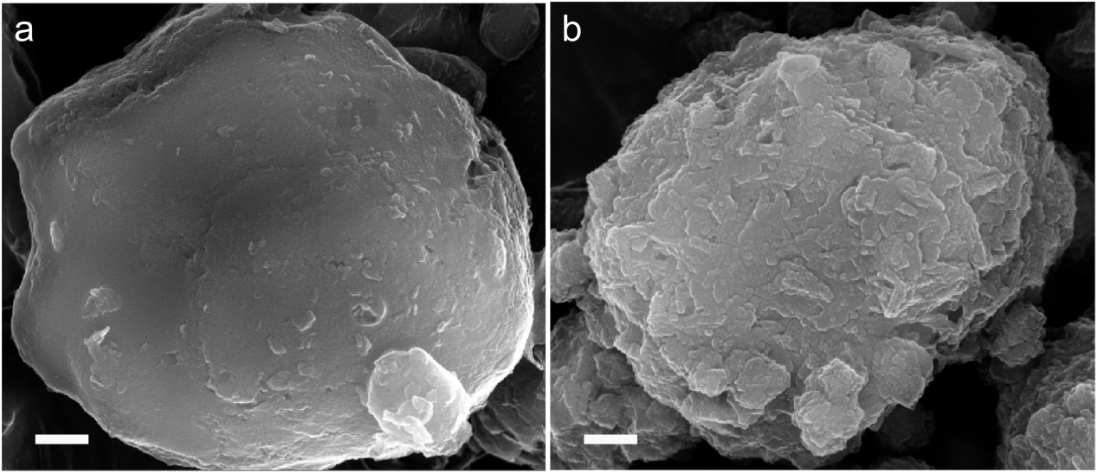
Supplementary Figure 2│SEM images of LFO@C (a) and LFO (b). Scale bars, 500 nm.

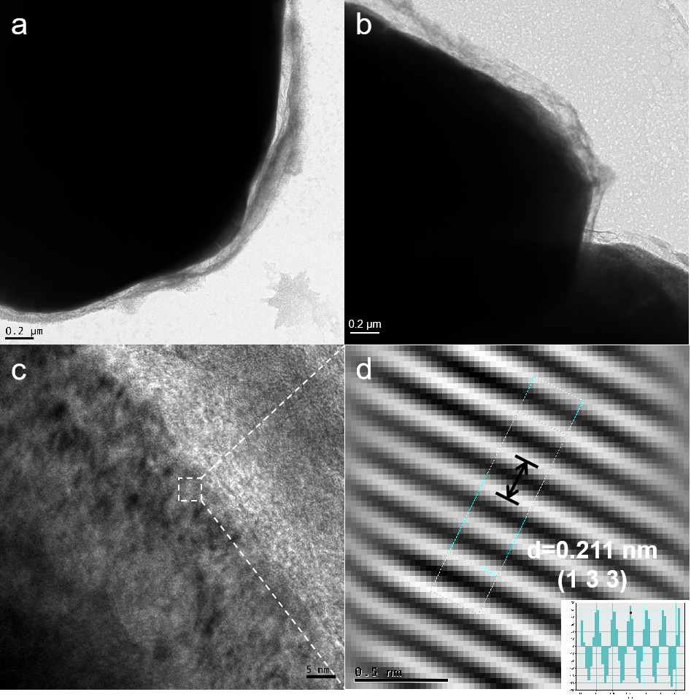
Supplementary Figure 3│TEM images of LFO@C. a, b TEM images of localized of LFO@C. c, d High-Resolution TEM images of LFO@C.

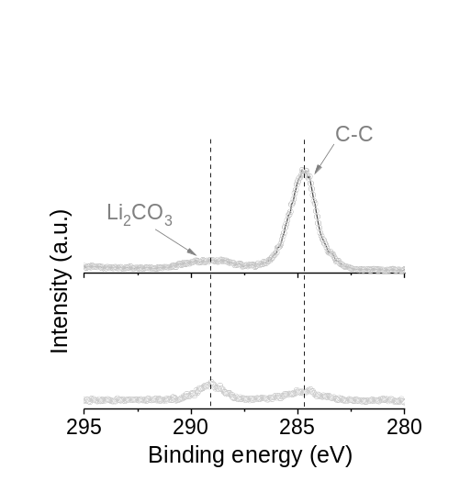
Supplementary Figure 4│XPS spectra of C 1s for LFO@C (top) and LFO (bottom).

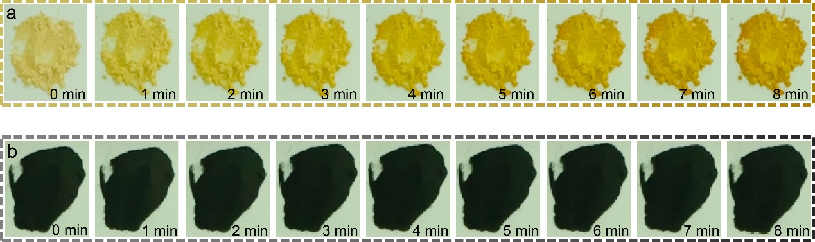
Supplementary Figure 5│Optical images of LFO and LFO@C exposed to air. Images of LFO (a) and LFO@C (b) exposed to air (25 °C, 20% RH) for 0-8 mins.

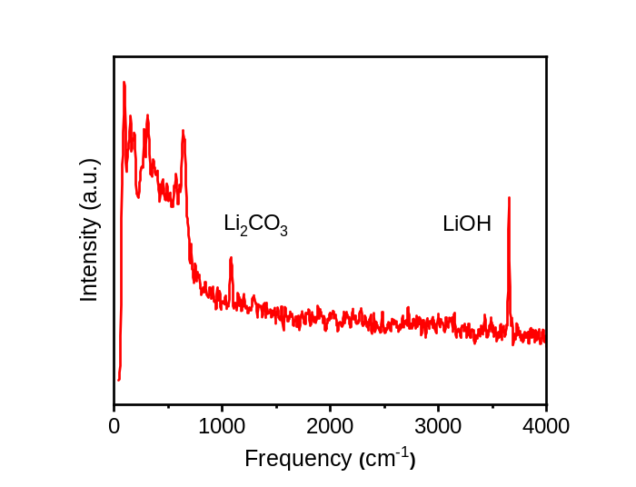
Supplementary Figure 6│Raman spectrum of LFO after 6 mins in air exposure (25 °C, 20% RH).

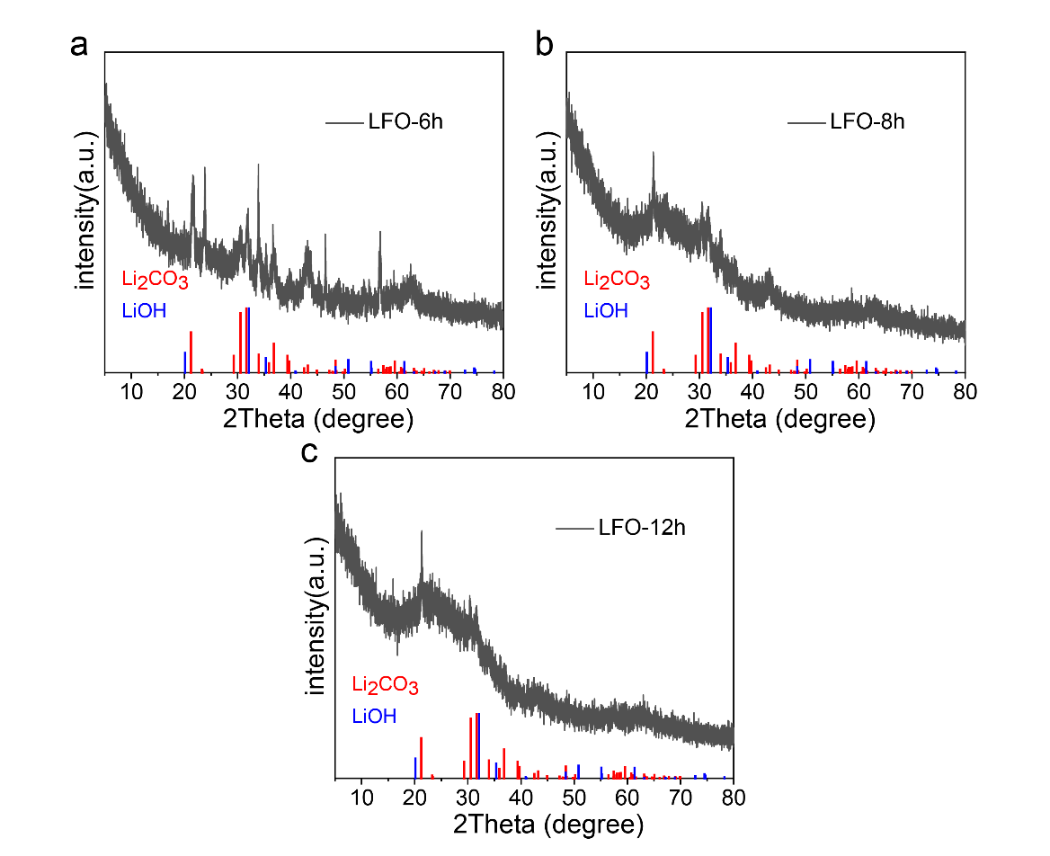
Supplementary Figure 7│XRD patterns of LFO after being placed in air. The XRD patterns of LFO after exposure to air (25 °C, 20% RH) for 6 h (a), 8 h (b), and 12 h (c).

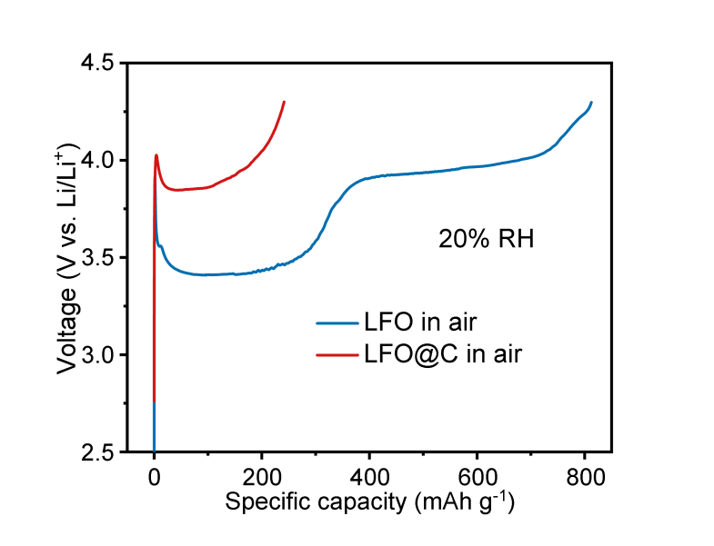
Supplementary Figure 8│Initial charge curves of half-cells with LFO and LFO@C cathodes assembled in air (25 °C, 20% RH).

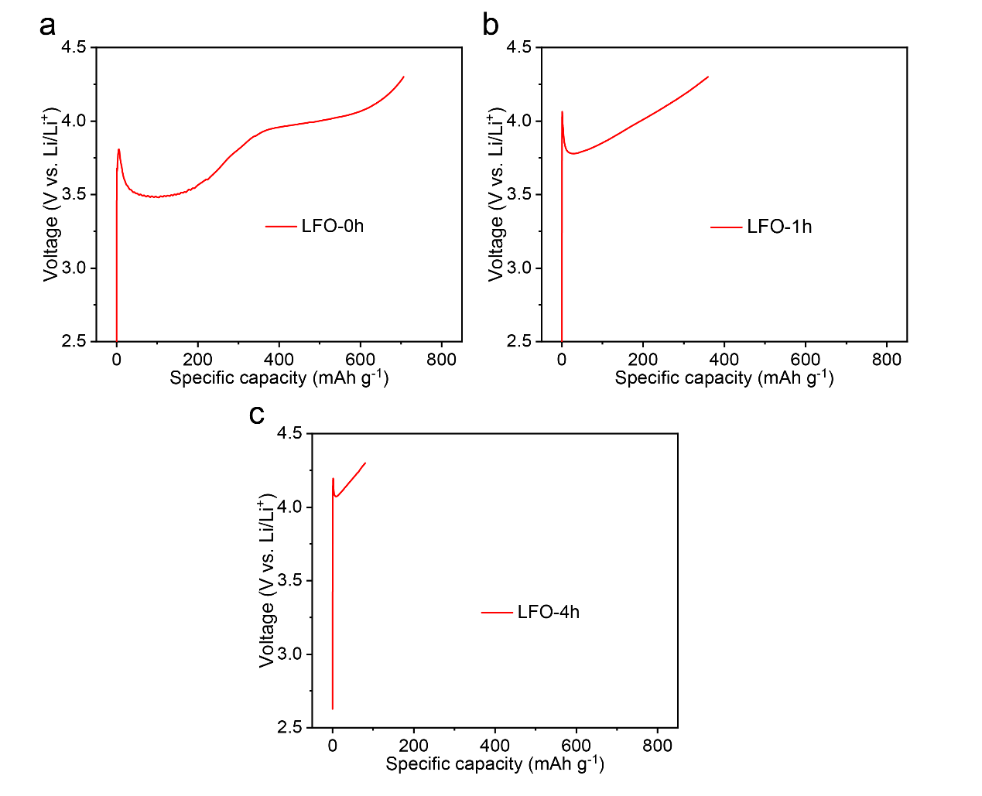
Supplementary Figure 9│Initial charge curves of LFO. Initial charge curves of LFO after being placed in air (25 °C, 20% RH) for 0 h (a), 1 h (b), 4 h (c).

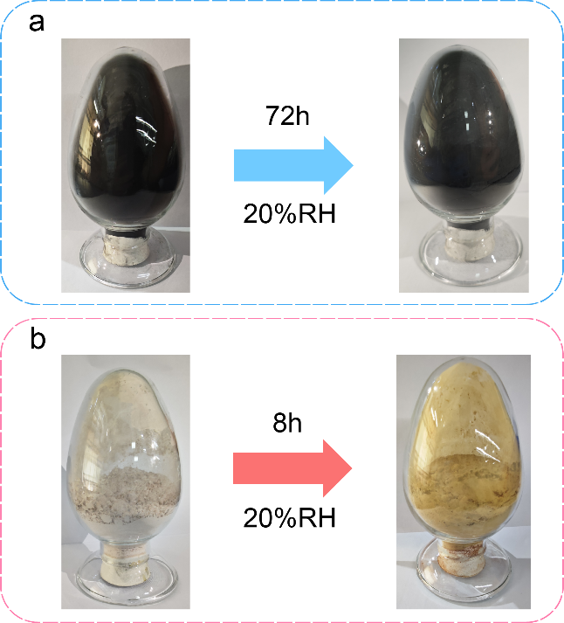
Supplementary Figure 10│Optical images of LFO@C and LFO before and after exposure to air (25 °C, 20% RH). a. LFO@C before and after 72 h of placement. b. LFO before and after 8 h of placement.

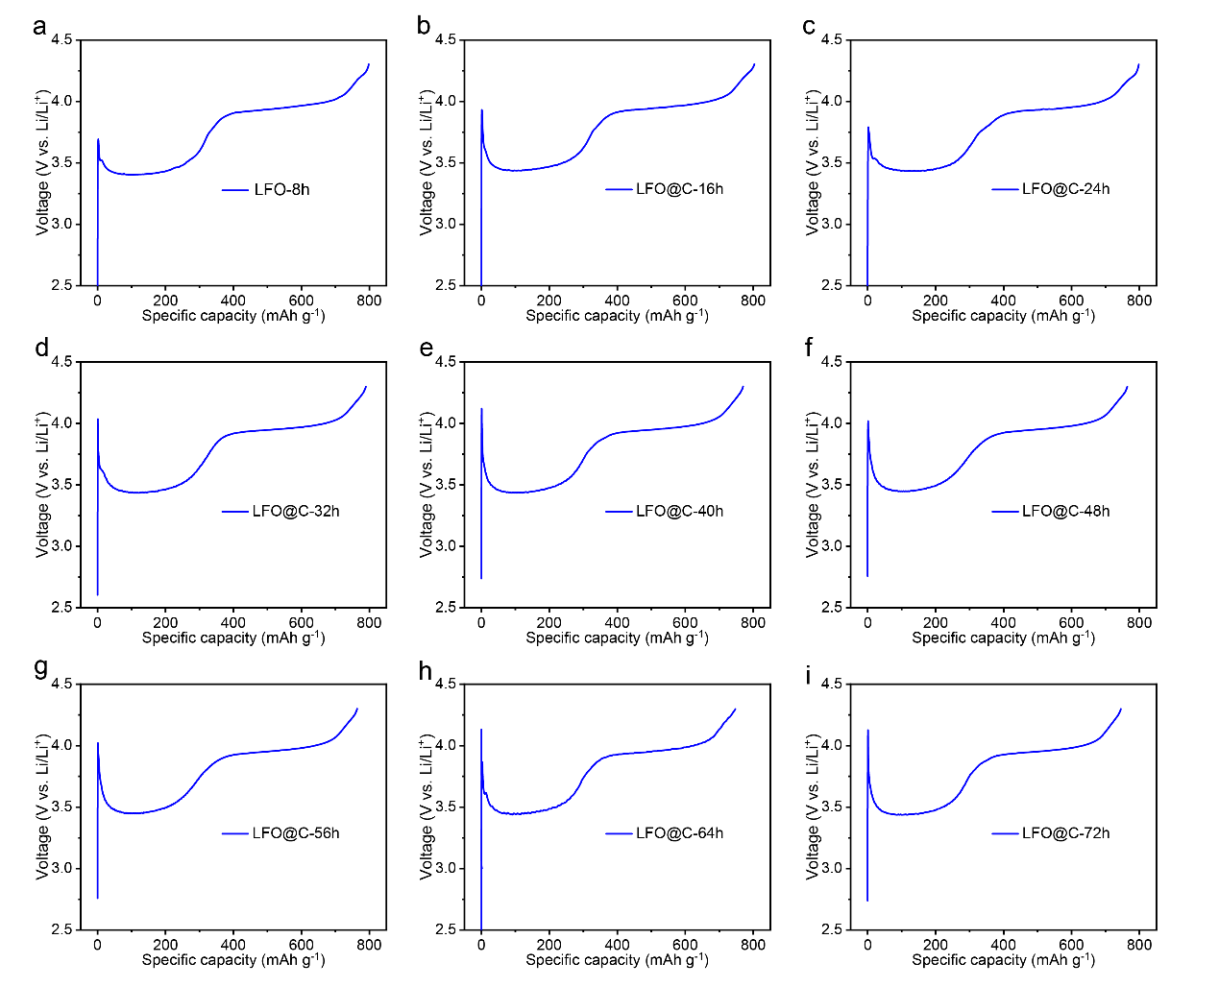
Supplementary Figure 11│Initial charge curves of LFO@C after exposure to air (25 °C, 20% RH). Initial charge curves of LFO@C after 8 h (a), 16 h (b), 24 h (c), 32 h (d), 40 h (e), 48 h (f), 56 h (g), 64 h (h), and 72 h (i) of air exposure.

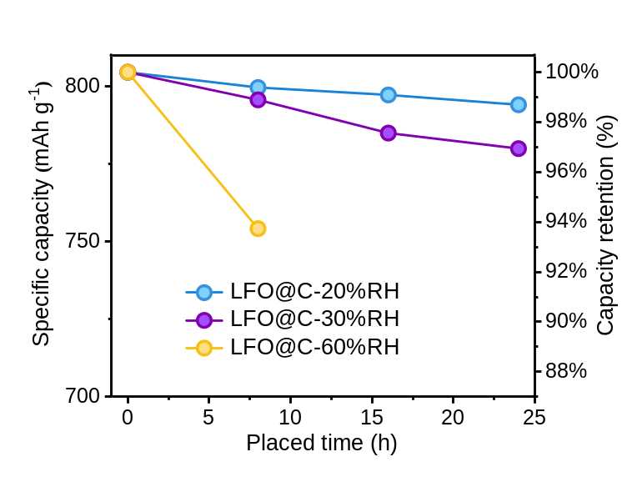
Supplementary Figure 12│The capacity retention curves of LFO@C after exposure to air for 8 h (25°C, 20%, 30%, and 60% RH), 16 h (25°C, 20%, and 30% RH), and 24 h (25°C, 20%, and 30% RH).

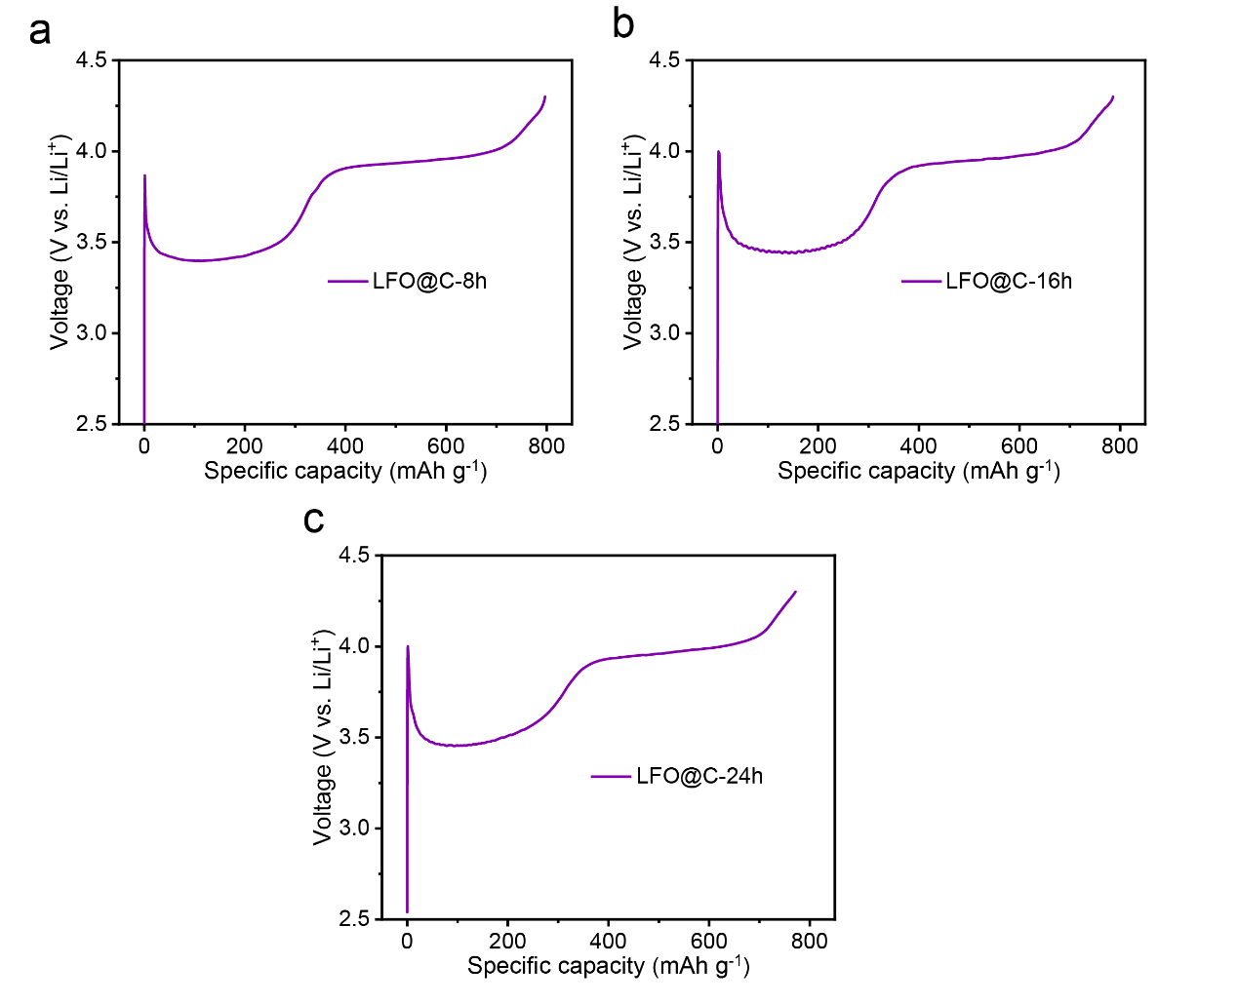
Supplementary Figure 13│Initial charge curves of LFO@C after exposure to air (25 °C, 30% RH). Initial charge curves of LFO@C after 8 h (a), 16 h (b), 24 h (c) of air exposure.

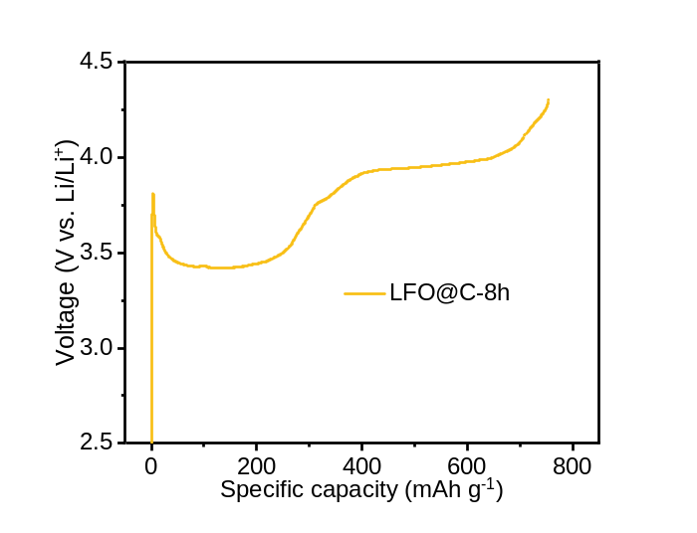
Supplementary Figure 14│Initial charge curve of LFO@C after exposure to air (25 °C, 60% RH) after 8 h.

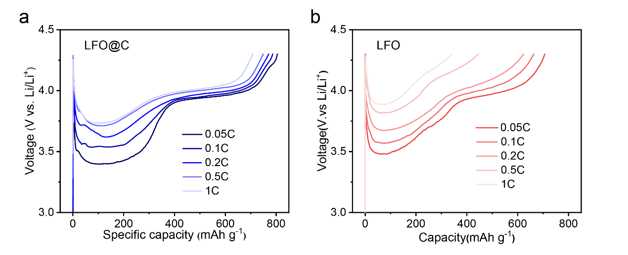
Supplementary Figure 15│The rate performance of LFO@C and LFO. Initial charge curves of LFO@C (a) and LFO (b) at different rates (0.05C, 0.1C, 0.2C, 0.5C, 1C).
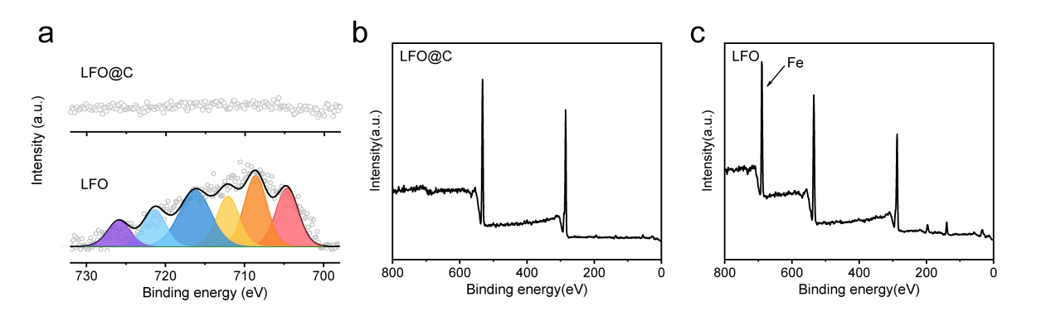
Supplementary Figure 16│XPS survey spectrum of the Li foil. a. XPS spectra of Fe 2p for Li foil in LFO@C||Li (top) and LFO||Li (bottom) half-cells. XPS survey spectrum of the Li foil in half-cells with LFO@C (b) and LFO (c).

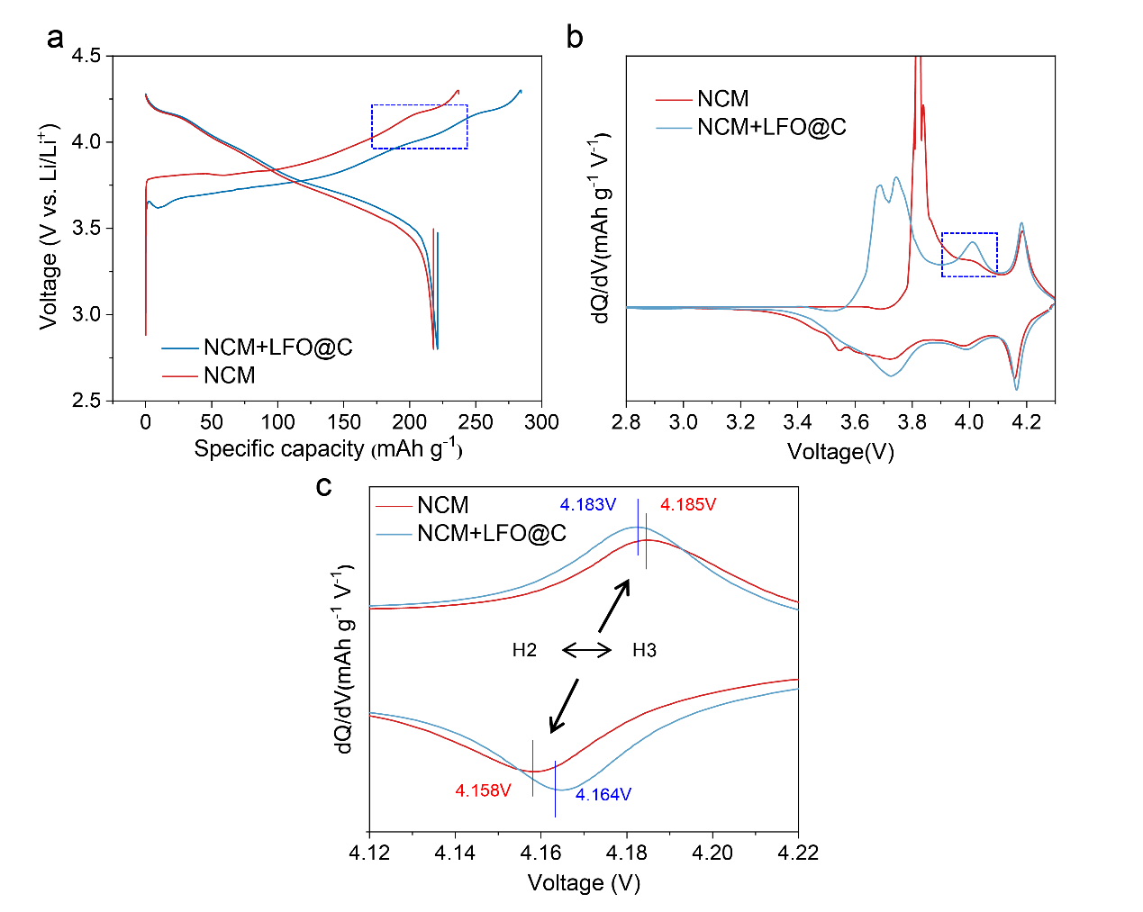
Supplementary Figure 17│Half-cell tests for NCM+LFO@C. a. GCD curves of NCM+LFO@C and NCM. b. dQ/dV curves of NCM+LFO@C and NCM. c. Magnified view of dQ/dV curves between 4.12 V and 4.22 V.

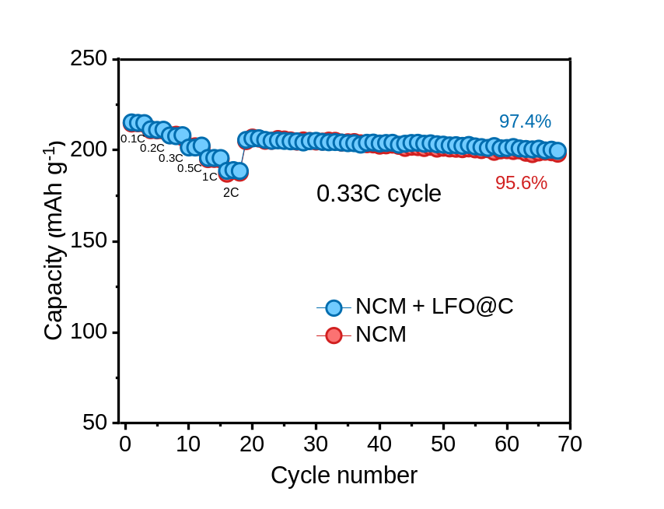
Supplementary Figure 18│Rate and cycle performance of half cells with NCM+LFO@C and NCM cathodes.

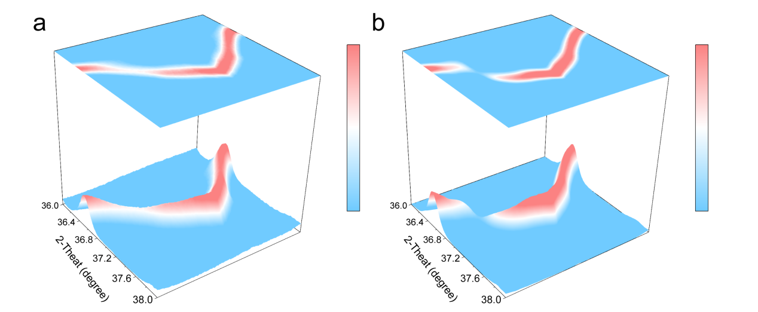
Supplementary Figure 19│In situ XRD patterns for NCM+LFO@C and NCM. Selected (101) counter plot of in situ XRD patterns for NCM+LFO@C (a) and NCM (b).

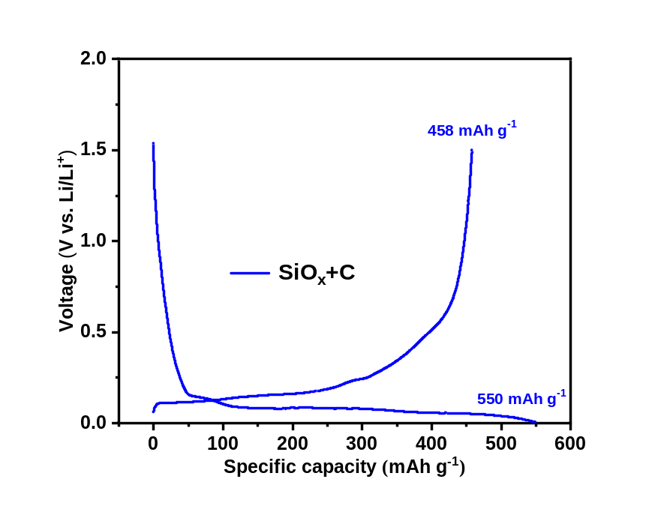
Supplementary Figure 20│GCD curve of Gr+SiO_{x}.

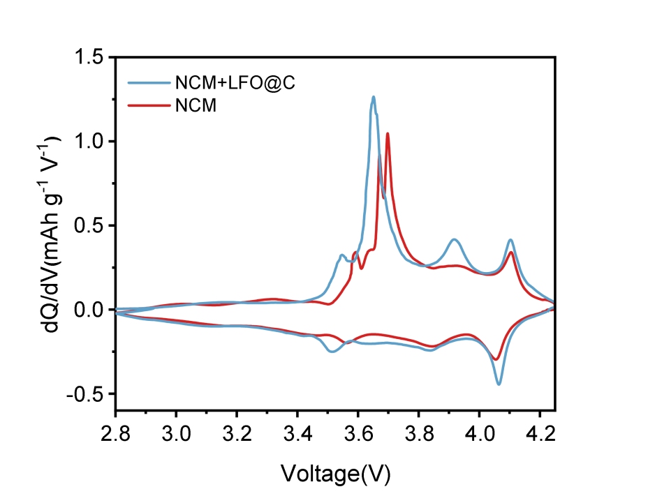
Supplementary Figure 21│dQ/dV curves for NCM||Gr+SiO_{x} and NCM+LFO@C||Gr+SiO_{x} full cells.
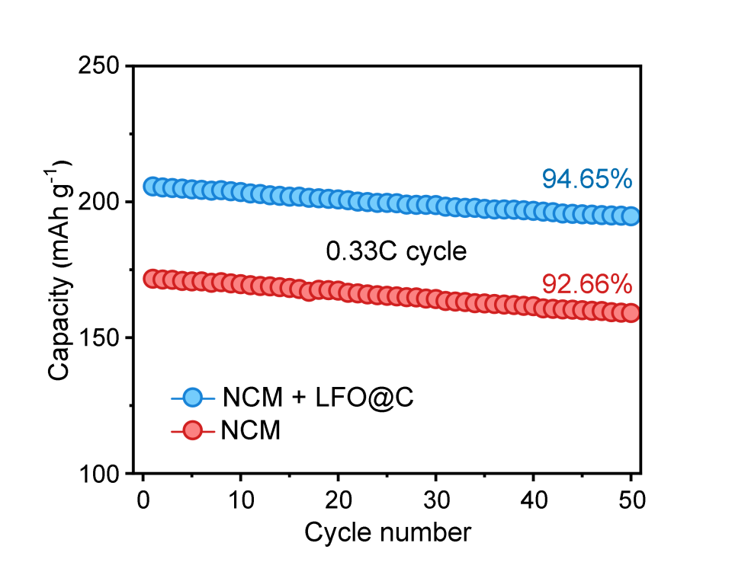
Supplementary Figure 22│Cycling performances of coin-type full cells with NCM+LFO@C and NCM cathodes under 2.8–4.25 V

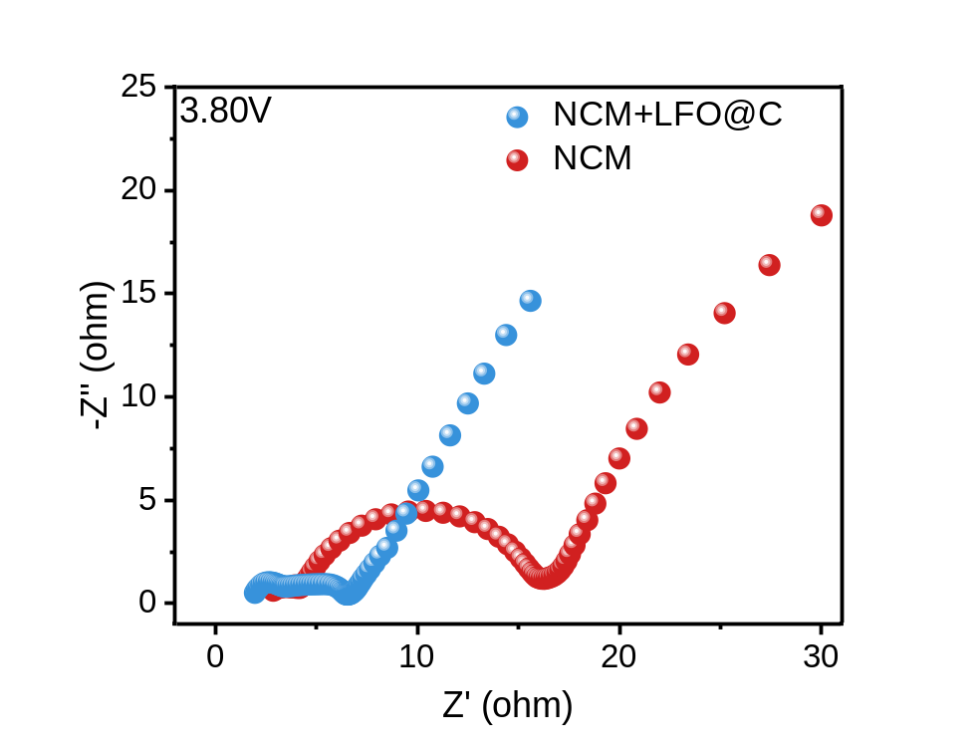
Supplementary Figure 23│EIS plots of NCM||Gr+SiO_{x} and NCM+LFO@C||Gr+SiO_{x} full cells at 3.8 V.

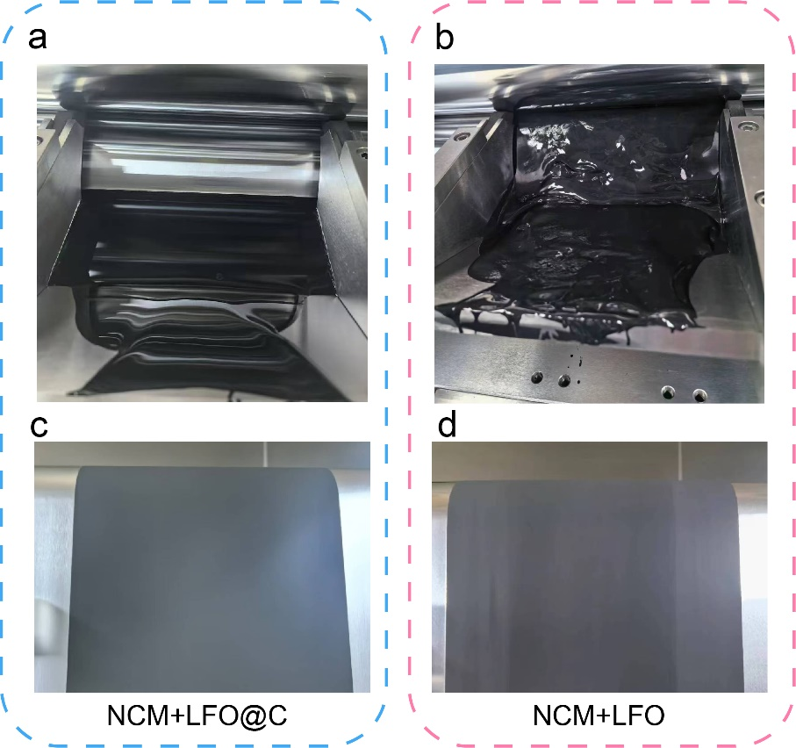
Supplementary Figure 24│Optical images of the prepared NCM+LFO@C and NCM+LFO electrodes. Electrode slurry of NCM+LFO@C (a) and NCM+LFO (b). Electrode sheets of NCM+LFO@C (c) and NCM+LFO (d).

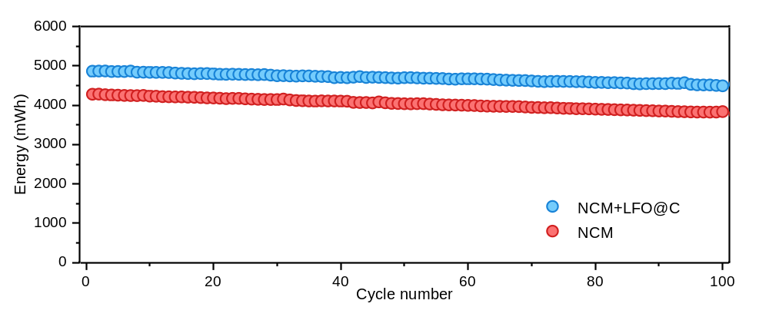
Supplementary Figure 25│Energy retention for NCM||Gr+SiO_{x} and NCM+LFO@C||Gr+SiO_{x} pouch cells.

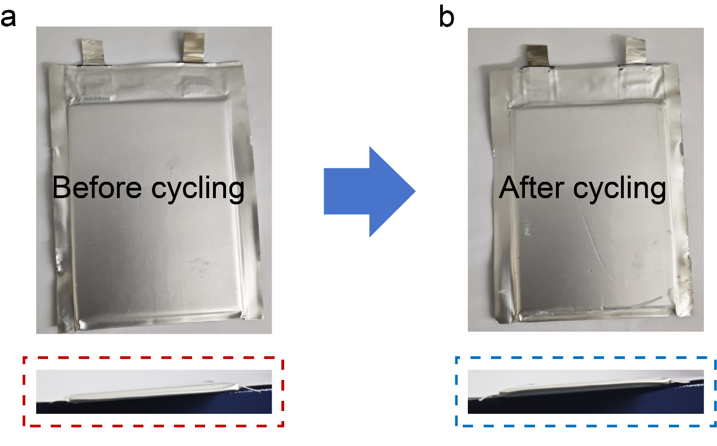

Supplementary Figure 26│Optical images of the front (top) and side (bottom) views of the NCM+LFO@C||Gr+SiO_{x} pouch cell before and after 100 cycles. a. Before cycling. b. After cycling.

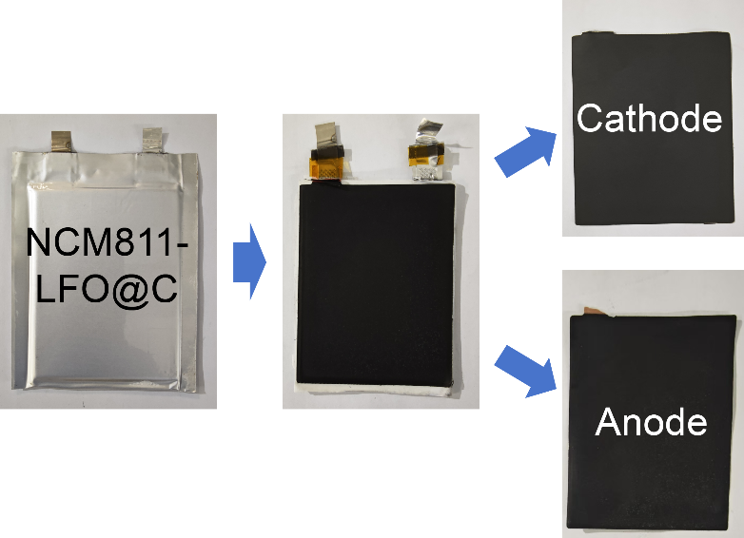
Supplementary Figure 27│Optical images of the disassembled NCM+LFO@C||Gr+SiO_{x} pouch cell.

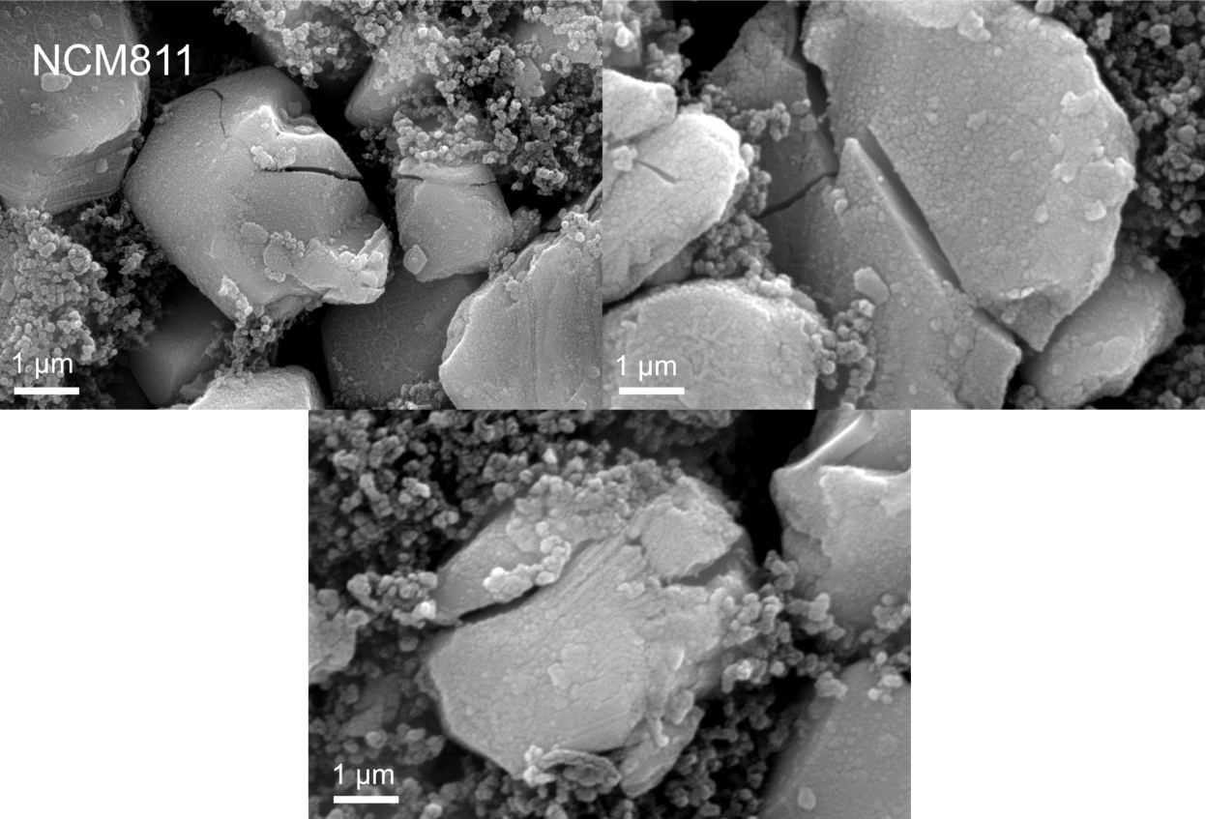
Supplementary Figure 28│SEM images of the cathode sheet of the NCM||Gr+SiO_{x} pouch cell after 100 cycles.

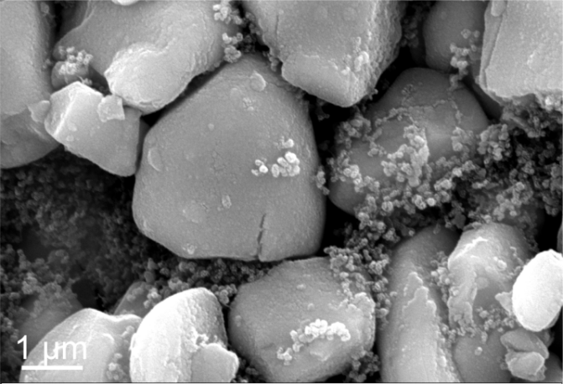
Supplementary Figure 29│SEM images of the cathode sheet of the NCM+LFO@C||Gr+SiO_{x} pouch cell after 100 cycles.

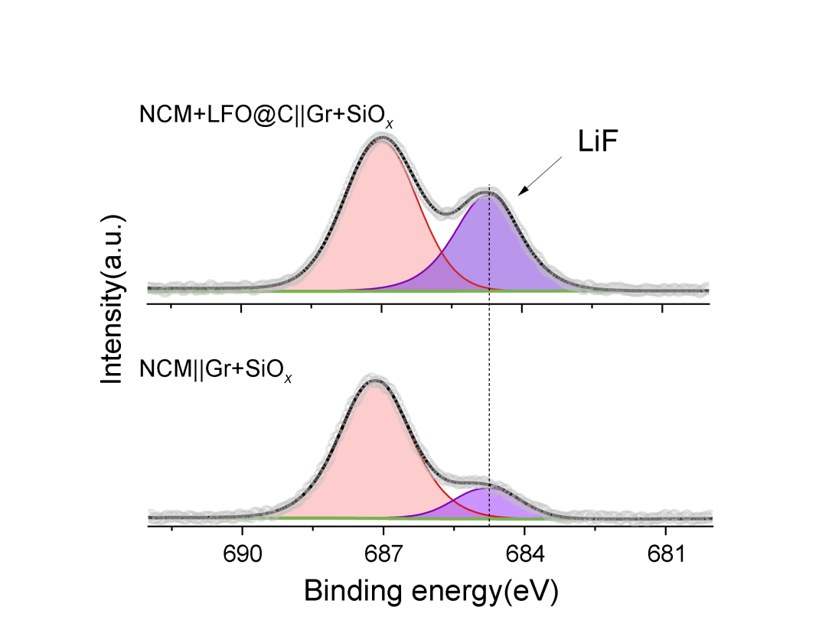
Supplementary Figure 30│XPS spectra of F 1s for Gr+SiO_{x} anode in NCM+LFO@C||Gr+SiO_{x} (top) and NCM||Gr+SiO_{x} (bottom) pouch cells after 100 cycles under 0.5C discharge rate.

Supplementary Table 1│Carbon and sulfur content for LFO@C.
 | C element content | S element content
LFO@C | 2.68% | 0.13%

Supplementary Table 2│The lithium-ion diffusion coefficients of LFO and LFO@C were determined using GITT technology.
 | Voltage (V) | t (s) | r (cm) | ΔE_{s} (v) | ΔE_{t} (v) | D (cm²/s)
LFO | 3.70 - 3.75 | 600 | 5.0 × 10⁻⁴ | 0.0129 | 0.3569 | 6.93×10⁻¹³
LFO@C | 3.70 - 3.75 | 600 | 5.3 × 10⁻⁴ | 0.1050 | 0.3244 | 6.24×10⁻¹¹
LFO | 4.05 - 4.10 | 600 | 5.0 × 10⁻⁴ | 0.0067 | 0.1435 | 1.16×10⁻¹²
LFO@C | 4.05 - 4.10 | 600 | 5.3 × 10⁻⁴ | 0.0113 | 0.1056 | 6.83×10⁻¹²

Determination of Li ion diffusion coefficient: The lithium diffusion coefficients for LFO and LFO@C were determined via the GITT technique as shown in the following equation. Since the pulse time, τ, is short and the pulse current is small, the Li⁺ ion diffusion coefficient, D, can be described by Equation:
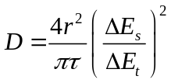 (1)

where r is the particle size of the cathode materials, ΔE_{s} is the change of the steady-state voltage of cell for this step, and ΔE_{t} is the total transient voltage change of the cell for applied current for time τ.

Supplementary Table 3│The Fe content in the pure Li foil and Li foil used in the LFO/LFO@C||Li half-cell determined by ICP-OES.
 | Li | Li||LFO | Li||LFO@C
Fe Elemental content (ppm) | 78.15 | 115.24 | 76.74

Supplementary Table 4│Full-cell specifications. (CC: constant current. CV: constant voltage.)
Full-cell specifications
 | Cathode | Anode
Sample | NCM/NCM+LFO@C | Graphite+SiO_{x}
Cell dimension | 57 mm × 75 mm | 60 mm × 78 mm
Composition | NCM811: SP: PVDF = 93: 3.5 :3.5/Active material (AM): LFO@C: SP: PVDF = 90.8: 2.2: 3.5: 3.5/ | Graphite: SiO_{x}: SP: CMC: SBR = 83.2: 10.4: 2.4: 1.8: 2.2 (CMC: carboxymethyl cellulose, SBR: styrene butadiene rubber)
One-side Loading level (mg cm⁻²) | 13.0 ± 0.1 | 7.1 ± 0.1
Two-side Loading level (mg cm⁻²) | 26.0 ± 0.2 | 14.2 ± 0.2
Electrode density (g cm⁻³) | 3.0 ± 0.02 | 1.5 ± 0.02
Negative/positive (N/P) ratio | 1.06 ± 0.01
Amount of electrolyte | 4.5 g Ah⁻¹
Cycling test condition | Voltage range: 2.8 - 4.25 V  Charge: 0.5 C (CC) – 0.05C (CV) / Discharge: 0.5C (CC)

Supplementary Table 5│DC impedances of NCM+LFO@C||Gr+SiO_{x} and NCM||Gr+SiO_{x} pouch cells.
 | NCM||Gr+SiO_{x} | NCM-LFO@C||Gr+SiO_{x}
DC internal resistance (mΩ) | 25.89 | 18.42

Supplementary Table 6│The Fe content in the Gr+SiO_{x} anode of NCM+LFO@C||Gr+SiO_{x} and NCM||Gr+SiO_{x} pouch cells determined by ICP-OES.
 | NCM | NCM-LFO@C
Gr+SiO_{x}-Fe Elemental content (ppm) | 32.64 | 32.47

