SUPPLEMENTARY INFORMATION
A spontaneous proton transfer is key for enzymatic
C-glycosylation and restricts the scope of natural C-glycosides
Lluís Raich^{1,ø,*}, David Teze^{2,ø,*}, Gonzalo Bidart², Folmer Fredslund², Mandy Hobusch²,
Sonja Kunstmann², Natalia Putkaradze², Frank Noé^{1,3,4,5,*} and Ditte H. Welner^{2,*}
¹Department of Mathematics and Computer Science, Freie Universität Berlin, Berlin, Germany.
²Novo Nordisk Foundation Center for Biosustainability, Technical University of Denmark, Kongens Lyngby, DK-2800, Denmark
³Department of Physics, Freie Universität Berlin, Berlin, Germany.
⁴Department of Chemistry, Rice University, Houston, TX, USA.
⁵Microsoft Research AI4Science, Berlin, Germany.
^{ø}L. Raich and D. Teze contributed equally.

Corresponding authors: Lluís Raich (lraich@zedat.fu-berlin.de), David Teze (david.teze@gmail.com), Frank Noé (franknoe@microsoft.com), Ditte H. Welner (diwel@biosustain.dtu.dk)

Table of Contents
Supplementary Tables 3
Supplementary Figures 8
References 31

Supplementary Tables

Supplementary Table 1- Screening of 125 glycosyl acceptors by ZmUGT708A6.
ªBinary classification to assess whether an acceptor is considered reactive or not in the specified conditions¹. ^{b}Rate of 3-chloro, 4-nitrophenolate release, based on a reverse glycosylation assay². ^{c}Yield determined by HPLC, relative to acceptor consumption³.

Acceptor name | CAS number | Reactionª | Rate (nM∙s^{‒1})^{b} | yield (%)^{c} | Acceptor concentration
(±)-Catechin | 225937-10-0 | non-reactive | 0.1 | n.d. | 50 µM
(±)-Catechin | 225937-10-0 | non-reactive | 0.1 | n.d. | 10 µM
3',4'-Dihydroxyflavone | 4143-64-0 | reactive | 10.6 | n.d. | 50 µM
3,4-Dihydroxyflavone | 4143-64-0 | reactive | 2.5 | n.d. | 10 µM
3,4-Dihydroxyphenylethanol | 10597-60-1 | non-reactive | 0.3 | n.d. | 50 µM
3,4-Dihydroxyphenylethanol | 10597-60-1 | non-reactive | 0.4 | n.d. | 10 µM
3,5-Dihydroxybenzoic acid | 99-10-5 | non-reactive | 0.2 | n.d. | 50 µM
3,5-Dihydroxybenzoic acid | 99-10-5 | non-reactive | 0.1 | n.d. | 10 µM
3'-Hydroxypterostilbene | 475231-21-1 | non-reactive | 0.6 | n.d. | 50 µM
3'-Hydroxypterostilbene | 475231-21-1 | non-reactive | 0.1 | n.d. | 10 µM
7,8-Dihydroxy-4-methylcoumarin | 2107-77-9 | reactive | 1.7 | n.d. | 50 µM
7,8-Dihydroxy-4-methylcoumarin | 2107-77-9 | reactive | 0.6 | n.d. | 10 µM
7,8-Dihydroxyflavone | 38183-03-8 | reactive | 7.0 | n.d. | 50 µM
7,8-Dihydroxyflavone | 38183-03-8 | reactive | 1.7 | n.d. | 10 µM
Bengenin | 477-90-7 | non-reactive | 0.1 | n.d. | 50 µM
Bengenin | 477-90-7 | non-reactive | 0.2 | n.d. | 10 µM
Biochanin A | 491-80-5 | non-reactive | 0.0 | n.d. | 50 µM
Biochanin A | 491-80-5 | non-reactive | 0.0 | n.d. | 10 µM
Cannabidivarin | 24274-48-4 | non-reactive | 0.1 | n.d. | 50 µM
Cannabidivarin | 24274-48-4 | non-reactive | 0.2 | n.d. | 10 µM
Daidzein | 486-66-8 | non-reactive | 0.0 | n.d. | 50 µM
Daidzein | 486-66-8 | non-reactive | 0.1 | n.d. | 10 µM
Daphnetin | 486-35-1 | reactive | 7.5 | n.d. | 50 µM
Daphnetin | 486-35-1 | reactive | 1.4 | n.d. | 10 µM
Dihydromyricetin | 27200-12-0 | non-reactive | 0.1 | n.d. | 50 µM
Dihydromyricetin | 27200-12-0 | non-reactive | 0.1 | n.d. | 10 µM
Diosmetin | 520-34-3 | reactive | 3.2 | n.d. | 50 µM
Diosmetin | 520-34-3 | reactive | 2.9 | n.d. | 10 µM
DL-Adrenaline | 329-63-5 | non-reactive | 0.3 | n.d. | 50 µM
DL-Adrenaline | 329-63-5 | non-reactive | 0.0 | n.d. | 10 µM
Dopamine | 62-31-7 | non-reactive | 0.1 | n.d. | 50 µM
Dopamine | 62-31-7 | non-reactive | 0.2 | n.d. | 10 µM
Epicatechin | 490-46-0 | non-reactive | 0.2 | n.d. | 50 µM
Epicatechin | 490-46-0 | non-reactive | 0.3 | n.d. | 10 µM
Epigallocatechin | 970-74-1 | non-reactive | 0.9 | n.d. | 50 µM
Epigallocatechin | 970-74-1 | non-reactive | 0.1 | n.d. | 10 µM
Esculetin | 305-01-1 | reactive | 14.1 | n.d. | 50 µM
Esculetin | 305-01-1 | reactive | 4.7 | n.d. | 10 µM
Ethyl gallate | 831-61-8 | non-reactive | 0.1 | n.d. | 50 µM
Ethyl gallate | 831-61-8 | non-reactive | 0.2 | n.d. | 10 µM
Fraxetin | 574-84-5 | reactive | 12.8 | n.d. | 50 µM
Fraxetin | 574-84-5 | reactive | 2.1 | n.d. | 10 µM
Gentisic acid | 490-79-9 | non-reactive | 0.1 | n.d. | 50 µM
Gentisic acid | 490-79-9 | non-reactive | 0.3 | n.d. | 10 µM
Hesperetin | 520-33-2 | non-reactive | 0.6 | n.d. | 50 µM
Hesperetin | 520-33-2 | non-reactive | 0.2 | n.d. | 10 µM
Higenamine | 11041-94-4 | non-reactive | 0.2 | n.d. | 50 µM
Higenamine | 11041-94-4 | non-reactive | 0.2 | n.d. | 10 µM
Honokiol | 35354-74-6 | reactive | 1.8 | n.d. | 50 µM
Honokiol | 35354-74-6 | reactive | 0.9 | n.d. | 10 µM
Hydrocaffeic acid | 1078-61-1 | non-reactive | 0.2 | n.d. | 50 µM
Hydrocaffeic acid | 1078-61-1 | non-reactive | 0.0 | n.d. | 10 µM
Hydroumbellic acid | 5631-68-5 | non-reactive | 0.1 | n.d. | 50 µM
Hydroumbellic acid | 5631-68-5 | non-reactive | 0.1 | n.d. | 10 µM
Liquiritigenin | 578-86-9 | reactive | 1.4 | n.d. | 50 µM
Liquiritigenin | 578-86-9 | reactive | 0.2 | n.d. | 10 µM
Magnolol | 528-43-8 | reactive | 4.9 | n.d. | 50 µM
Magnolol | 528-43-8 | reactive | 3.7 | n.d. | 10 µM
Methyl gallate | 99-24-1 | non-reactive | 0.5 | n.d. | 50 µM
Methyl gallate | 99-24-1 | non-reactive | 0.4 | n.d. | 10 µM
Methyl protocatechuate | 2150-43-8 | non-reactive | 0.2 | n.d. | 50 µM
Methyl protocatechuate | 2150-43-8 | non-reactive | 0.0 | n.d. | 10 µM
Naringenin | 480-41-1 | reactive | 1.3 | n.d. | 50 µM
Naringenin | 480-41-1 | reactive | 0.7 | n.d. | 10 µM
Octyl gallate | 1034-01-1 | reactive | 0.9 | n.d. | 50 µM
Octyl gallate | 1034-01-1 | reactive | 0.4 | n.d. | 10 µM
Olivetol | 500-66-3 | non-reactive | 0.5 | n.d. | 50 µM
Olivetol | 500-66-3 | non-reactive | 0.6 | n.d. | 10 µM
orcinol | 504-15-4 | non-reactive | 0.3 | n.d. | 50 µM
orcinol | 504-15-4 | non-reactive | 0.2 | n.d. | 10 µM
Orsellinic acid ethyl ester | 2524-37-0 | non-reactive | 0.2 | n.d. | 50 µM
Orsellinic acid ethyl ester | 2524-37-0 | non-reactive | 0.0 | n.d. | 10 µM
Phloracetophenone | 480-66-0 | reactive | 21.4 | n.d. | 50 µM
Phloracetophenone | 480-66-0 | reactive | 10.8 | n.d. | 10 µM
Phloretin | 60-82-2 | reactive | 7.2 | n.d. | 50 µM
Phloretin | 60-82-2 | reactive | 11.6 | n.d. | 10 µM
Piceatannol | 10083-24-6 | non-reactive | 0.9 | n.d. | 50 µM
Piceatannol | 10083-24-6 | non-reactive | 0.1 | n.d. | 10 µM
Pinocembrin | 480-39-7 | non-reactive | 0.6 | n.d. | 50 µM
Pinocembrin | 480-39-7 | non-reactive | 0.3 | n.d. | 10 µM
Protocatechualdehyde | 139-85-5 | non-reactive | 0.5 | n.d. | 50 µM
Protocatechualdehyde | 139-85-5 | non-reactive | 0.0 | n.d. | 10 µM
Protocatechuic acid | 99-50-3 | non-reactive | 0.1 | n.d. | 50 µM
Protocatechuic acid | 99-50-3 | non-reactive | 0.4 | n.d. | 10 µM
Pyrithioxin | 1098-97-1 | non-reactive | 0.0 | n.d. | 50 µM
Pyrithioxin | 1098-97-1 | non-reactive | 0.1 | n.d. | 10 µM
Resveratrol | 501-36-0 | non-reactive | 0.2 | n.d. | 50 µM
Resveratrol | 501-36-0 | non-reactive | 0.0 | n.d. | 10 µM
(±)-DanShenSu | 67920-52-9 | non-reactive | 0.1 | n.d. | 50 µM
(±)-DanShenSu | 67920-52-9 | non-reactive | 0.1 | n.d. | 10 µM
Taxifolin | 480-18-2 | non-reactive | 0.1 | n.d. | 50 µM
Taxifolin | 480-18-2 | non-reactive | 0.2 | n.d. | 10 µM
Usnic Acid | 7562-61-0 | non-reactive | 0.8 | n.d. | 50 µM
Usnic Acid | 7562-61-0 | non-reactive | 0.4 | n.d. | 10 µM
NADH-coupled enzyme assay
(±)-Huperzine A | 120786-18-7 | non-reactive | n.d. | n.d. | 200 µM
2,3-Dimethylbenzoic acid | 603-79-2 | non-reactive | n.d. | n.d. | 200 µM
2,6-Dimethoxyphenol | 91-10-1 | non-reactive | n.d. | n.d. | 200 µM
3,4-Dichloroaniline | 95-76-1 | non-reactive | n.d. | n.d. | 200 µM
3,4-Dichlorothiophenol | 5858-17-3 | reactive | n.d. | n.d. | 200 µM
5-Methyl-2-furanthiol | 56078-97-8 | non-reactive | n.d. | n.d. | 200 µM
6-Benzylaminopurine | 1214-39-7 | non-reactive | n.d. | n.d. | 200 µM
Abscisic acid | 21293-29-8 | non-reactive | n.d. | n.d. | 200 µM
Andrographolide | 5508-58-7 | non-reactive | n.d. | n.d. | 200 µM
Cinnamic acid | 140-10-3 | non-reactive | n.d. | n.d. | 200 µM
Cinnamyl alcohol | 104-54-1 | non-reactive | n.d. | n.d. | 200 µM
Coniferyl alcohol | 458-35-5 | non-reactive | n.d. | n.d. | 200 µM
Cyanidin | 528-58-5 | non-reactive | n.d. | n.d. | 200 µM
Forskolin | 66575-29-9 | non-reactive | n.d. | n.d. | 200 µM
Genistein | 446-72-0 | reactive | n.d. | n.d. | 200 µM
Geraniol | 106-24-1 | non-reactive | n.d. | n.d. | 200 µM
Gingerol | 23513-14-6 | non-reactive | n.d. | n.d. | 200 µM
Homovanillic acid | 306-08-1 | non-reactive | n.d. | n.d. | 200 µM
Linalool | 78-70-6 | non-reactive | n.d. | n.d. | 200 µM
Menthol | 1490-04-6 | non-reactive | n.d. | n.d. | 200 µM
Phloretin | 60-82-2 | reactive | n.d. | n.d. | 200 µM
Pinoresinol | 487-36-5 | non-reactive | n.d. | n.d. | 200 µM
Quercetin | 117-39-5 | non-reactive | n.d. | n.d. | 200 µM
Resveratrol | 501-36-0 | non-reactive | n.d. | n.d. | 200 µM
Scopoletin | 92-61-5 | non-reactive | n.d. | n.d. | 200 µM
Sesamol | 533-31-3 | non-reactive | n.d. | n.d. | 200 µM
Silibinin | 22888-70-6 | non-reactive | n.d. | n.d. | 200 µM
Thymol | 89-83-8 | non-reactive | n.d. | n.d. | 200 µM
Xanthotoxol | 2009-24-7 | reactive | n.d. | n.d. | 200 µM
Zingerone | 122-48-5 | non-reactive | n.d. | n.d. | 200 µM
α-Terpineol | 98-55-5 | non-reactive | n.d. | n.d. | 200 µM
HPLC assay
Rhapontigenin | 500-65-2 | non-reactive | n.d. | 29 | 50 µM
Genistein | 446-72-0 | non-reactive | n.d. | 15 | 50 µM
Apigenin | 520-36-5 | reactive | n.d. | 59 | 50 µM
Luteolin | 491-70-3 | non-reactive | n.d. | 23 | 50 µM
Mangiferin | 4773-96-0 | non-reactive | n.d. | 0 | 50 µM
Vitexin | 3681-93-4 | non-reactive | n.d. | 5 | 50 µM
4-Allylpyrocatechol | 1126-61-0 | non-reactive | n.d. | 8 | 50 µM
2,3,4-trihydroxybenzoic acid | 13677-79-7 | non-reactive | n.d. | 0 | 50 µM
Homogentisic acid | 451-13-8 | non-reactive | n.d. | 0 | 50 µM
5,7-dihydroxychromone | 31721-94-5 | non-reactive | n.d. | 2 | 50 µM
4,7-dihydroxycoumarin | 1983-81-9 | non-reactive | n.d. | 1 | 50 µM
2',3'-Dihydroxy-4'-methoxyacetophenone | 708-53-2 | non-reactive | n.d. | 4 | 50 µM
4-Methylesculetin | 529-84-0 | non-reactive | n.d. | 17 | 50 µM
4-Methyllimetol | 2107-76-8 | non-reactive | n.d. | 38 | 50 µM
Methyl caffeate | 3843-74-1 | non-reactive | n.d. | 16 | 50 µM
Atraric acid | 4707-47-5 | non-reactive | n.d. | 4 | 50 µM
Hydroxytyrosol Acetate | 69039-02-7 | non-reactive | n.d. | 7 | 50 µM
Propyl gallate | 121-79-9 | non-reactive | n.d. | 22 | 50 µM
2,4'-Dihydroxybenzophenone | 606-12-2 | non-reactive | n.d. | 10 | 50 µM
Equol | 531-95-3 | non-reactive | n.d. | 1 | 50 µM
4'-Methoxyresveratrol | 33626-08-3 | non-reactive | n.d. | 14 | 50 µM
Gnetol | 86361-55-9 | non-reactive | n.d. | 4 | 50 µM
7,8-Dihydroxy-4-phenylcoumarin | 842-01-3 | non-reactive | n.d. | 15 | 50 µM
5,7-Dihydroxy-4-phenylcoumarin | 7758-73-8 | reactive | n.d. | 79 | 50 µM
Isorhapontigenin | 32507-66-7 | non-reactive | n.d. | 38 | 50 µM
6,7,4'-Trihydroxyisoflavone | 17817-31-1 | non-reactive | n.d. | 0 | 50 µM
Butein | 487-52-5 | non-reactive | n.d. | 0 | 50 µM
Calycosin | 20575-57-9 | non-reactive | n.d. | 7 | 50 µM
Oroxylin A | 480-11-5 | non-reactive | n.d. | 39 | 50 µM
Caffeic Acid Phenethyl Ester | 104594-70-9 | reactive | n.d. | 55 | 50 µM
Sakuranetin | 2957-21-3 | non-reactive | n.d. | 18 | 50 µM
Eriodictyol | 552-58-9 | non-reactive | n.d. | 10 | 50 µM
Aromadendrin | 480-20-6 | non-reactive | n.d. | 21 | 50 µM
Hispidulin | 1447-88-7 | non-reactive | n.d. | 34 | 50 µM
Tectorigenin | 548-77-6 | non-reactive | n.d. | 8 | 50 µM
Flavokawain C | 37308-75-1 | non-reactive | n.d. | 14 | 50 µM
Nordihydroguaiaretic acid | 500-38-9 | non-reactive | n.d. | 0 | 50 µM
Protosappanin B | 102036-29-3 | non-reactive | n.d. | 0 | 50 µM
Dendrophenol | 108853-14-1 | non-reactive | n.d. | 1 | 50 µM
6-Methoxyluteolin | 520-11-6 | non-reactive | n.d. | 25 | 50 µM
Neobavaisoflavone | 41060-15-5 | non-reactive | n.d. | 15 | 50 µM
Bavachin | 19879-32-4 | reactive | n.d. | 55 | 50 µM
Aurantio-obtusin | 67979-25-3 | reactive | n.d. | 53 | 50 µM
Jaceosidin | 18085-97-7 | reactive | n.d. | 64 | 50 µM
Neochlorogenic acid | 906-33-2 | non-reactive | n.d. | 0 | 50 µM
Irigenin | 548-76-5 | non-reactive | n.d. | 8 | 50 µM
Polydatin | 27208-80-6 | non-reactive | n.d. | 1 | 50 µM

Supplementary Table 2- Crystallographic data collection and refinement statistics
Property  Protein name  PDB ID  Space group  Cell constants: a, b, c (Å)  Cell constants: α, β, γ  Resolution (Å)  % Data completeness  (in resolution range)  R_{merge}  R_{sym}  < I/σ(I) >  Refinement program  R, R_{free}  R_{free} test set  Wilson B-factor (Å²)  Anisotropy  Bulk solvent ksol(e/Å³), Bsol(Å²)  L-test for twinning  Estimated twinning fraction  F_{o},F_{c} correlation  Total number of atoms Average B, all atoms (Å²) | NtUGT72B82  8CHD  P 12₁1  52.31, 86.85, 100.98  90.00, 93.17, 90.00◦  50.41 – 2.34  98.6 (50.41-2.34)  89.3 (50.41-2.34)  (Not available)  (Not available)  1.13 (at 2.34Å)  PHENIX 1.20.1_4487  0.189 , 0.234  2171 reflections (5.74%)  30.2  0.149  0.42 , 46.9  < |L| > = 0.48, < L² > = 0.31  No twinning to report.  0.94  14724  51.0 | ZmUGT708A6  8CGQ  P 12₁1  51.43, 72.59, 57.02  90.00, 101.69, 90.00◦  44.26 – 2.04  96.7 (44.26-2.04)  96.8 (44.26-2.04)  0.11  (Not available)  1.55 (at 2.05Å)  PHENIX 1.17.1_3660  0.178 , 0.227  1264 reflections (5.00%)  36.4  0.578  0.38 , 37.5  < |L| > = 0.50, < L² > = 0.33  No twinning to report.  0.97  7063  51.0 | Source  Depositor  PDB  Depositor  Depositor  Depositor  EDS  Depositor  EDS  Depositor  Depositor  Xtriage  Depositor  DCC  wwPDB-VP  Xtriage  Xtriage  EDS  Xtriage  Xtriage  EDS  wwPDB-VP  wwPDB-VP

Supplementary Figures

Supplementary Figure 1- The reactions were carried out at 293 K in 70 mM Tris–Bis–Tris (TBT) buffer in a pH range from 5 to 10, in the presence of 500 μM sugar donor (UDP-Glc), 100 μM phloretin acceptor enzyme and 10 μg/mL ZmUGT708A6. The reaction was quenched by 25× dilution in 0.1% acetic acid at time points 2 and 8 min, and conversion was assessed by reversed phase HPLC, according to the ratio of areas between product and substrate.

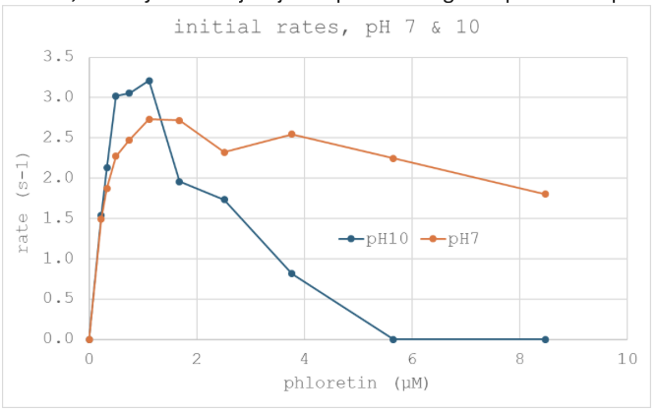

Supplementary Figure 2- Enzymatic reactions with ZmUGT708A6. Top, initial rates of phloretin C-glycosylation at pH 7 and 10 (25 mM Tris), at low concentration of both enzyme (48 ng/mL) and phloretin acceptor (0‒250 µM). Bottom, time course reactions on 50 μM polyhydroxy acetophenones in 25 mM Tris pH 7. Reactions were quenched after 0, 1, 2, 3, 4, 5, or 6h in presence of 15 µg/mL (2,4,6 trihydroxy acetophenone) or 150 µg/mL (2,4,5 trihydroxy acetophenone, 2,4 dihydroxy acetophenone, 4 hydroxy acetophenone) ZmUGT708A6 enzyme. All reactions were carried out in the presence of 500 µM UDP-Glc.

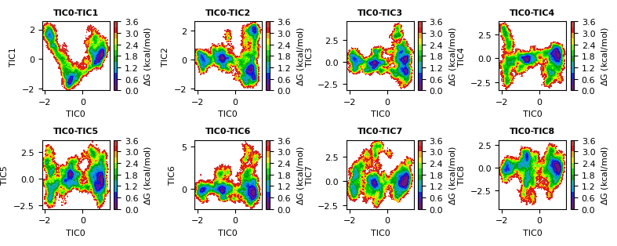

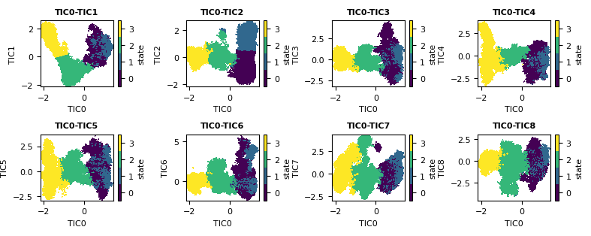
Supplementary Figure 3- Time independent component analysis (TICA) raw free energy landscapes (top) and clustered state maps (bottom). Note that the four main states are well separated in the TIC0-TIC2 projection.

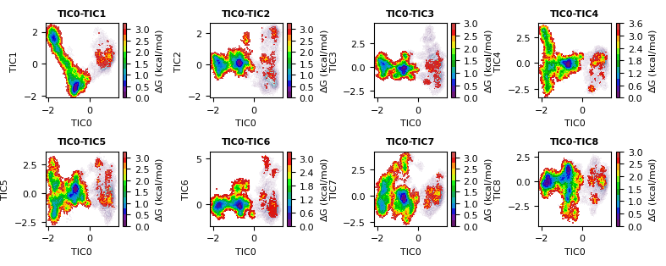
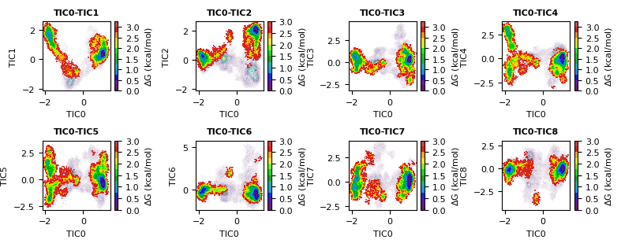
Supplementary Figure 4- Raw free energy landscape densities filtered by the simplified features that represent each of the gates. A filtering of < 0.75 nm on the acceptor gate shows that TIC0 is mostly related with the acceptor opening (top), and a filtering of > 0.75 nm on the donor gate shows that TIC1 and TIC2 are mostly related with the donor opening (bottom).
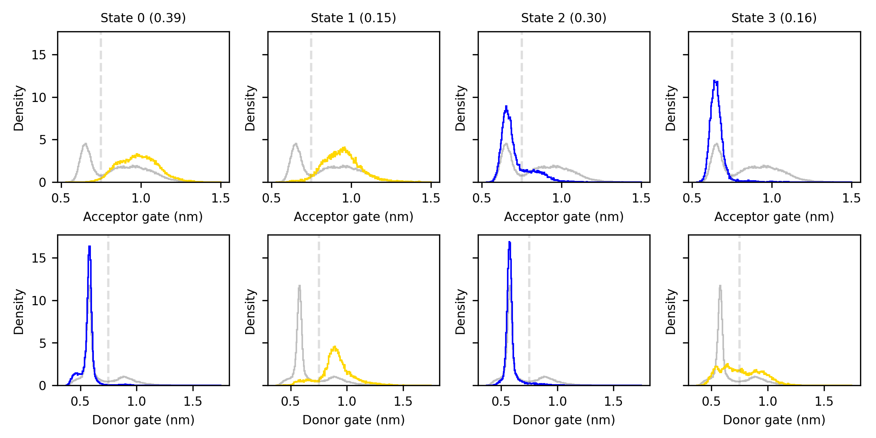
Supplementary Figure 5- Distribution of the acceptor (top) and donor (bottom) gate distances within the four clustered states. The global distributions are shown in gray. State 0 is open/closed, state 1 open/open, state 2 closed/closed, and state 3 closed/open for the acceptor and donor gates, respectively. Note that the donor gate distribution in state 3 includes both open and closed states with this projection. Empirical state populations are shown in parentheses.

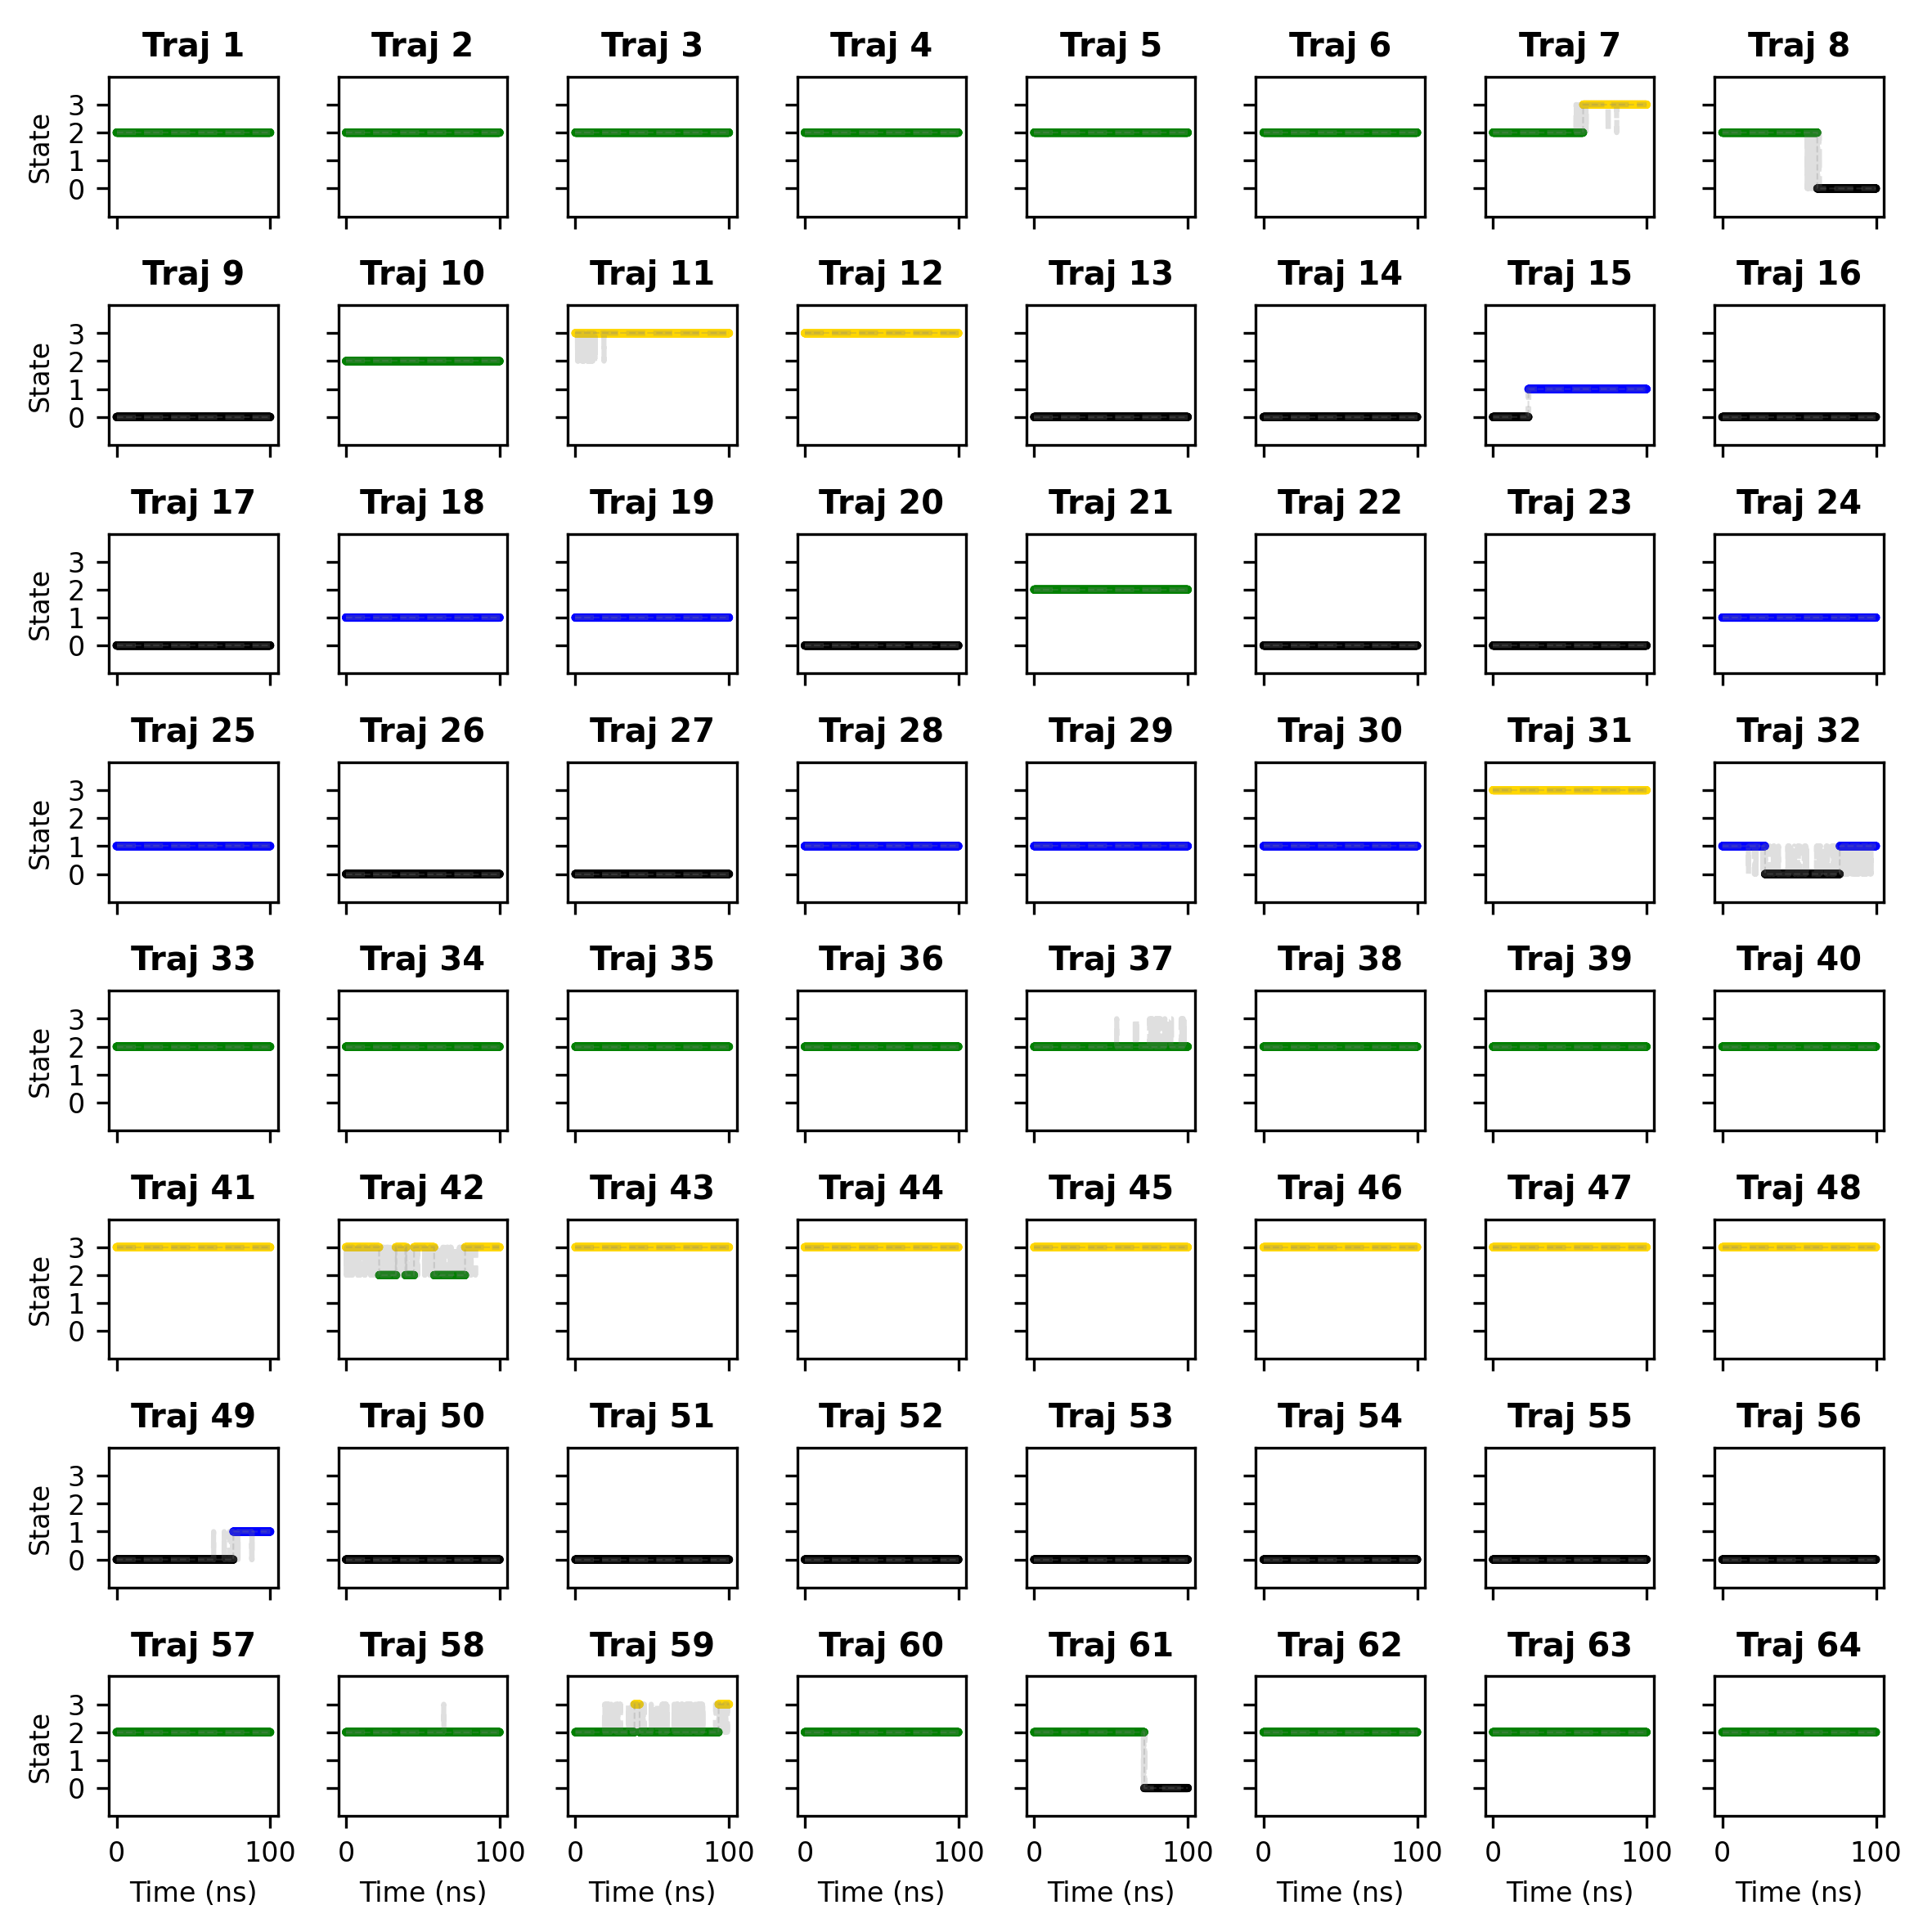
Supplementary Figure 6- Discretized trajectories (nº 1 to 64) over time. The color code corresponds to the state map shown in Supplementary Figure 3. Trajectories have been convolved with a window size of 10 ns to smooth noisy jumps (dashed gray vertical lines in e.g. trajectories 32, 42, 59).
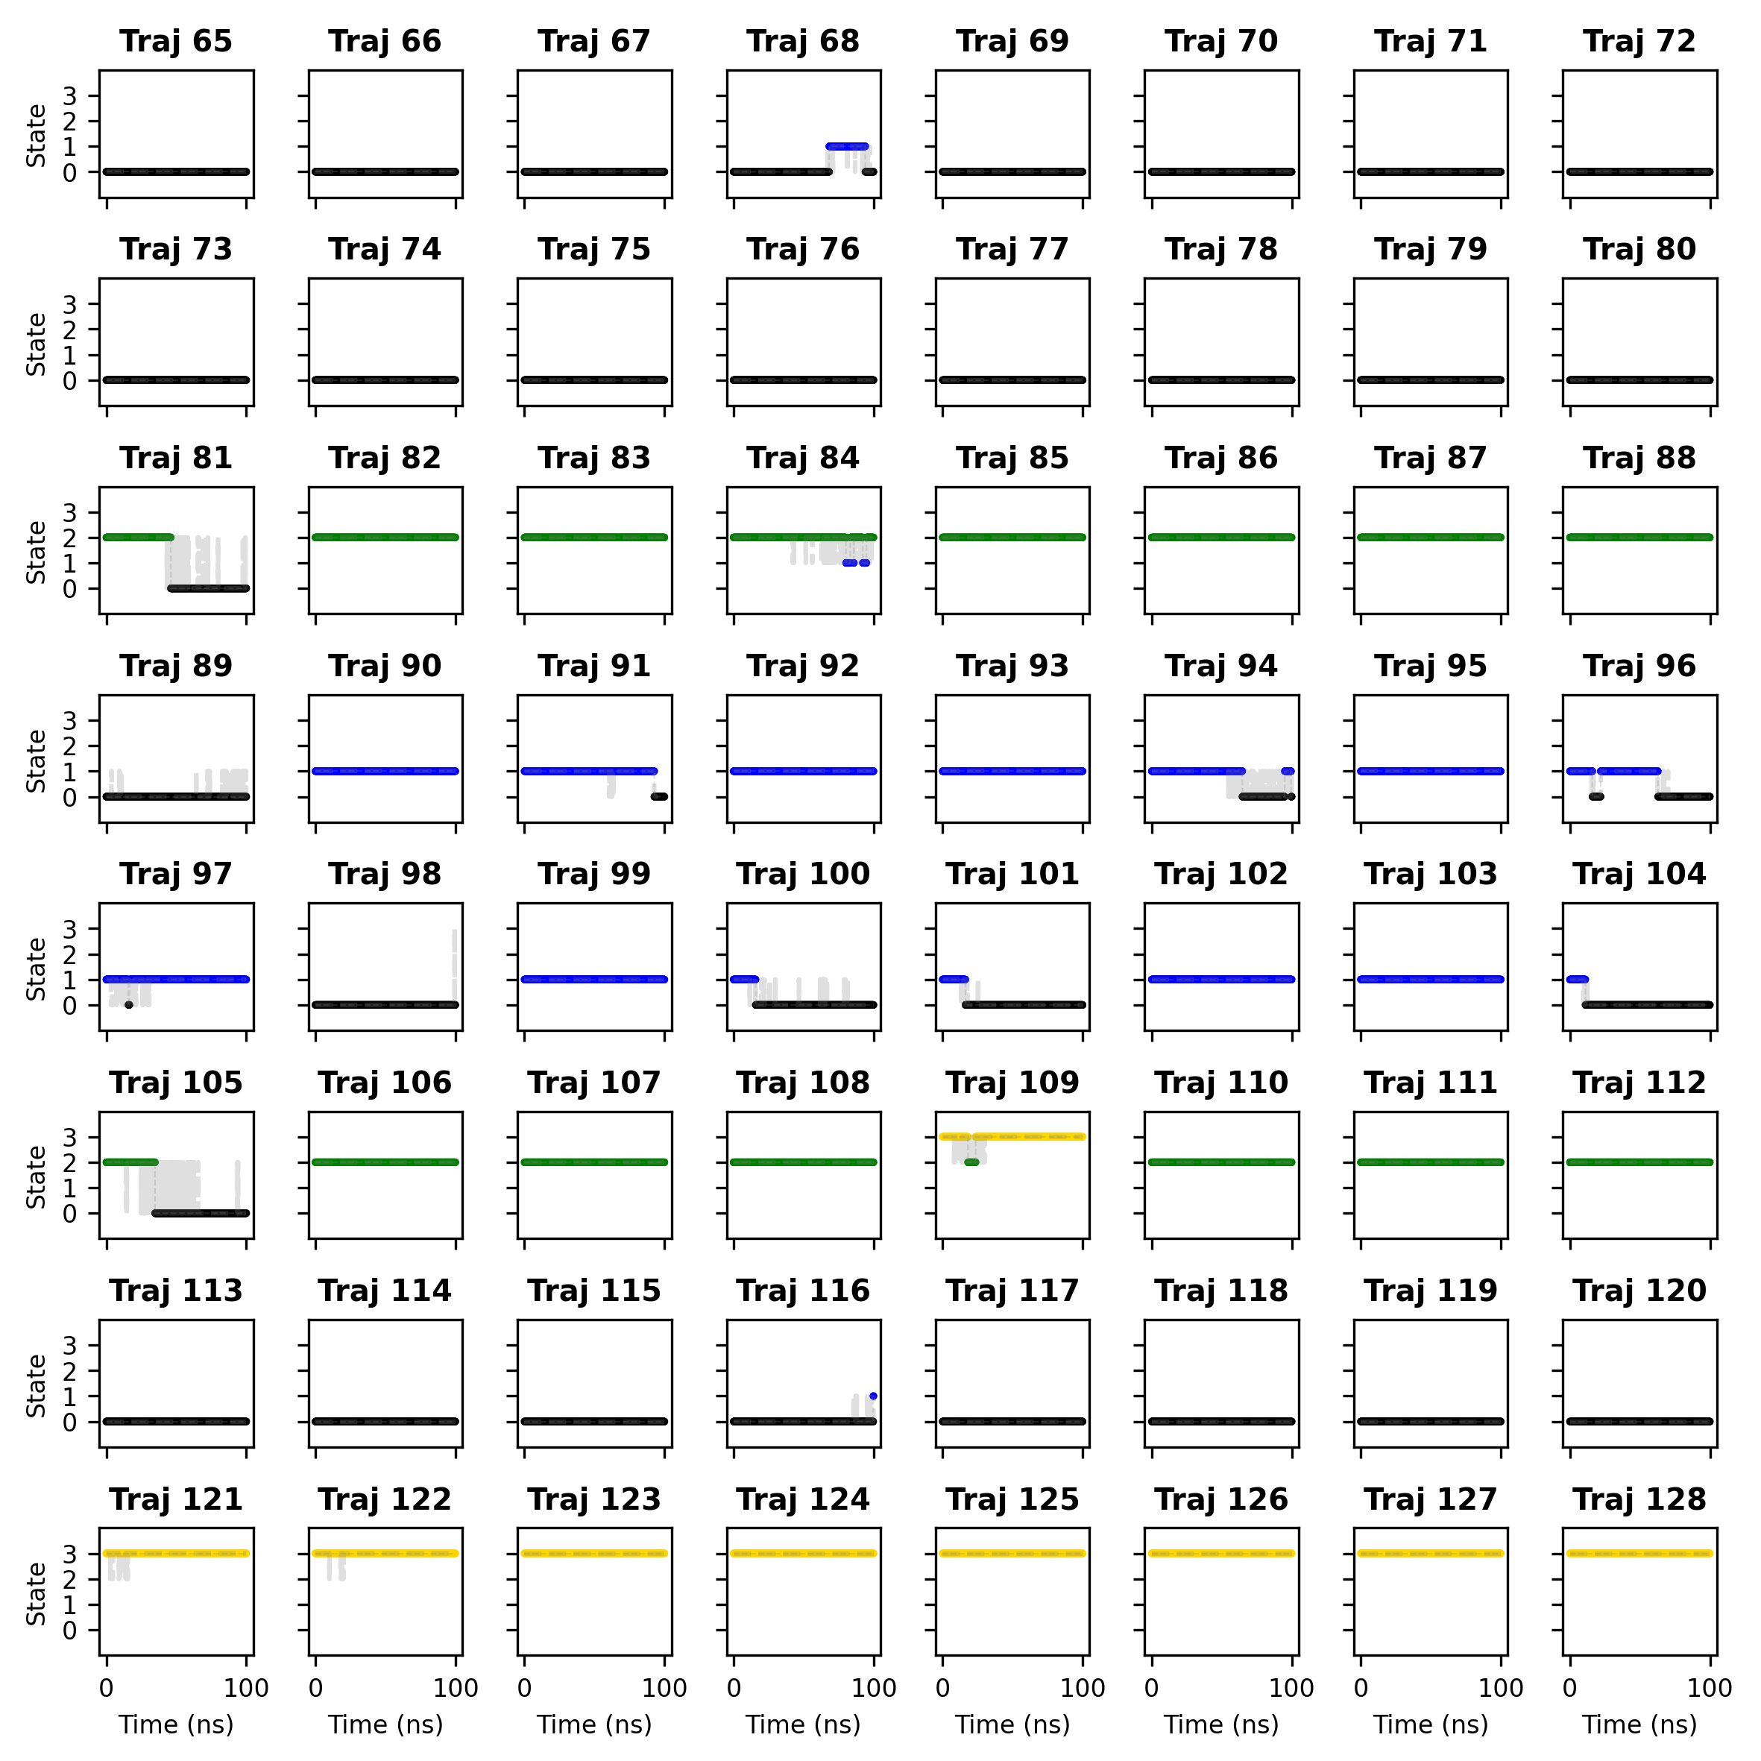
Supplementary Figure 7- Discretized trajectories (nº 65 to 128) over time. The color code corresponds to the state map shown in Supplementary Figure 3. Trajectories have been convolved with a window size of 10 ns to smooth noisy jumps (dashed gray vertical lines in e.g. trajectories 81, 94, 105).

Supplementary Figure 8- Structural renders of a transient state in which S286 shifts further from UDP and leaves it exposed to the solvent. The black dots in the free energy landscape represent the structures that are superposed in the render.

Supplementary Figure 9– Reactive criteria for C- and O-glycosylation exemplified on 2,4,6 trihydroxyacetophenone. The first condition applies to both types of reactions and is labeled as “nucleophilic attack”. It considers a reactive distance with a 0.5 nm threshold and an angle above 160º. The second condition also applies to both types of reactions and is labeled as “proton transfer”. It considers the establishment of a hydrogen bond between a hydroxyl of the acceptor and the catalytic histidine (H25), with a 0.25 nm threshold for the distance and an angle that should be above 120º. The third condition applies only to C-glycosylation and is labelled as “ring orientation”. It considers the orientation of the vector going out of the acceptor ring with respect to the vector that joins the glucose moiety and UDP. These two vectors should be parallel to make possible the approach of glucose to the π-system of the reactive ring. For C-glycosylation, two symmetric reactive centers are considered when evaluating all conditions, and for O-glycosylation the three hydroxyls. All conditions must apply to consider a state as reactive.

Supplementary Figure 10- Reactive states (C- and O-) for closed and open conformations of the acceptor gate. At the top it is shown an ensemble of at least 10 structures for each state, and at the bottom a close view of one of them. Note that when the acceptor gate is closed, the conformational freedom of phloretin is restricted and the ensemble is clean. Instead, when the acceptor gate is open the substrate can adopt many different conformations, including conformations similar to the ones we found in the closed state, but also “outward” conformations occupying the space left by the displacement of F94. Note as well that the main difference between C- and O-reactive states lies in the orientation of the phloretin ring: C-reactive states have the ring plane perpendicular to the UDP-Glc bond, while O-reactive states have it generally parallel.

Supplementary Figure 11- Comparison of the GgUGT crystals (PDBs 6L5R and 6L5P) with the open / closed states of the gates we characterized by MD simulations. Note that in 6L5P, the equivalent residue of F94 is not resolved.

Supplementary Figure 12– Mean free Mulliken charges during the equilibration of the reactant state. The NE2-H13 distance is shown in blue and shadowed blue regions represent states in which it is above 1.3 Angstroms (H13 is transferred to O5). Note that the ring atoms that are most correlated with the NE2-H13 distance are C1, C3, and C5, i.e. the ones at ortho and para positions from O5.

Supplementary Figure 13- Free energy landscapes for the three chemical steps along the C-glycosylation mechanism (top) and collective variables activated during each metadynamics simulation (bottom).

Supplementary Figure 14- Stability of the main glycoside isomers of phloroglucinol acceptor. Color bars represent the different types of reaction states: red for O-products, orange for σ-intermediates, yellow for deprotonated σ-intermediates, and blue for C-products. Values are relative to a reference σ-complex of 2,4,6-hydroxyacetophenone.

Supplementary Figure 15- Stability of the main glycoside isomers of resorcinol acceptor. Color bars represent the different types of reaction states: red for O-products, orange for σ-intermediates, yellow for deprotonated σ-intermediates, and blue for C-products. Values are relative to a reference σ-complex of 2,4,6-hydroxyacetophenone.
Supplementary Figure 16- Stability of the main glycoside isomers of phenol acceptor. Color bars represent the different types of reaction states: red for O-products, orange for σ-intermediates, yellow for deprotonated σ-intermediates, and blue for C-products. Values are relative to a reference σ-complex of 2,4,6-hydroxyacetophenone.

Supplementary Figure 17- Stability of the main glycoside isomers of 2,4,6-hydroxyacetophenone acceptor. Color bars represent the different types of reaction states: red for O-products, orange for σ-intermediates, yellow for deprotonated σ-intermediates, and blue for C-products. Values are relative to a reference σ-complex of 2,4,6-hydroxyacetophenone.

Supplementary Figure 18- Stability of the main glycoside isomers of 2,4-hydroxyacetophenone acceptor. Color bars represent the different types of reaction states: red for O-products, orange for σ-intermediates, yellow for deprotonated σ-intermediates, and blue for C-products. Values are relative to a reference σ-complex of 2,4,6-hydroxyacetophenone.

Supplementary Figure 19- Stability of the main glycoside isomers of 4-hydroxyacetophenone acceptor. Color bars represent the different types of reaction states: red for O-products, orange for σ-intermediates, yellow for deprotonated σ-intermediates, and blue for C-products. Values are relative to a reference σ-complex of 2,4,6-hydroxyacetophenone.

Supplementary Figure 20- Stability of the main glycoside isomers of apigenin acceptor. Color bars represent the different types of reaction states: red for O-products, orange for σ-intermediates, yellow for deprotonated σ-intermediates, and blue for C-products. Values are relative to a reference σ-complex of 2,4,6-hydroxyacetophenone.

Supplementary Figure 21- Stability of the main glycoside isomers of 7,4’-hydroxyflavone acceptor. Color bars represent the different types of reaction states: red for O-products, orange for σ-intermediates, yellow for deprotonated σ-intermediates, and blue for C-products. Values are relative to a reference σ-complex of 2,4,6-hydroxyacetophenone.

Supplementary Figure 22- Stability of the main glycoside isomers of 7-hydroxyflavone acceptor. Color bars represent the different types of reaction states: red for O-products, orange for σ-intermediates, yellow for deprotonated σ-intermediates, and blue for C-products. Values are relative to a reference σ-complex of 2,4,6-hydroxyacetophenone.

Supplementary Figure 23- Stability of the main glycoside isomers of phloretin acceptor. Color bars represent the different types of reaction states: red for O-products, orange for σ-intermediates, yellow for deprotonated σ-intermediates, and blue for C-products. Values are relative to a reference σ-complex of 2,4,6-hydroxyacetophenone.

Supplementary Figure 24- Stability of the main glycoside isomers of daidzein acceptor. Color bars represent the different types of reaction states: red for O-products, orange for σ-intermediates, yellow for deprotonated σ-intermediates, and blue for C-products. Values are relative to a reference σ-complex of 2,4,6-hydroxyacetophenone.

Supplementary Figure 25- Stability of the main glycoside isomers of aloesone acceptor. Color bars represent the different types of reaction states: red for O-products, orange for σ-intermediates, yellow for deprotonated σ-intermediates, and blue for C-products. Values are relative to a reference σ-complex of 2,4,6-hydroxyacetophenone.

References
1. Harding-Larsen, D. et al. GASP: A Pan-Specific Predictor of Family 1 Glycosyltransferase Acceptor Specificity Enabled by a Pipeline for Substrate Feature Generation and Large-Scale Experimental Screening. ACS Omega 9, 27278–27288 (2024).
2. Gantt, R. W., Peltier-Pain, P., Cournoyer, W. J. & Thorson, J. S. Using simple donors to drive the equilibria of glycosyltransferase- catalyzed reactions. Nat Chem Biol 7, 685–691 (2011).
3. de Boer, R. M. et al. Regioselective Glycosylation of Polyphenols by Family 1 Glycosyltransferases: Experiments and Simulations. ACS Omega 8, 46300–46308 (2023).

