Table. 1. The Optimization of the model reaction conditions.
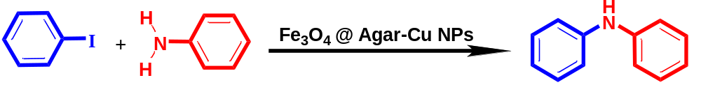
Entry | Catalyst (mol%) | Temperature (ºC) | Solvent | Time (h) | Yield (%(
1 | 0 | 110 | DMF | 10 | Trace
2 | 3 | 80 | DMF | 18 | 10
3 | 3 | 100 | DMF | 18 | 21
4 | 5 | 100 | DMF | 15 | 48
5 | 8 | 120 | DMSO | 16 | 70
6 | 8 | 100 | H₂O | 12 | 68
7 | 8 | 80 | H₂O | 15 | 55
8 | 10 | 120 | DMSO | 10 | 83
9 | 10 | 100 | Toluene | 12 | 80
10 | 10 | 100 | DMF | 12 | 94
11 | 10 | 100 | H₂O | 12 | 96

Table. 2. C-N reaction cross-coupling derivatives of Arylhalides and ArylAmines using Fe₃O₄@Agar-Cu NPs
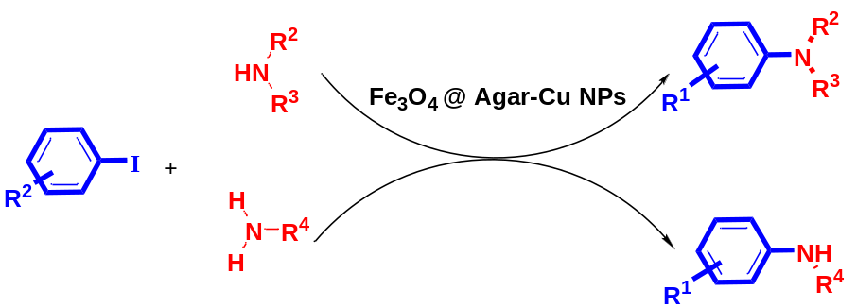

Entry | Arylhalides | ArylAmines | Product | Yield (%)
1ª | 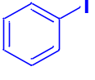 | 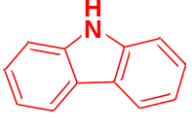 | 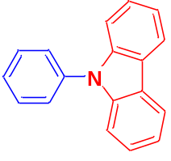 | 94
2ª | 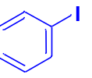 | 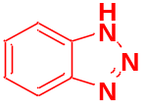 | 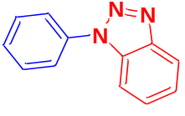 | 88
3ª | 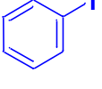 | 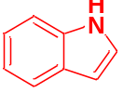 | 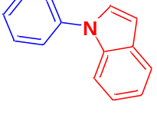 | 90
4ª | 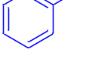 | 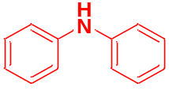 | 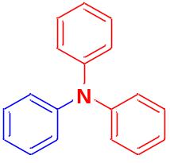 | 93
5ª | 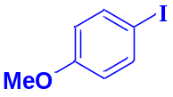 | 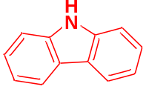 | 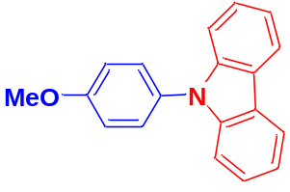 | 90
6^{b} | 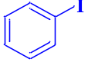 | 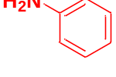 | 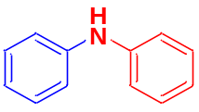 | 96
7^{b} | 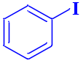 | 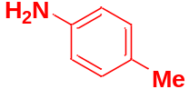 | 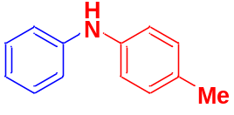 | 90
8^{b} | 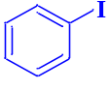 | 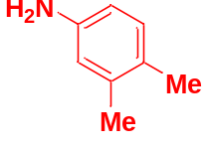 | 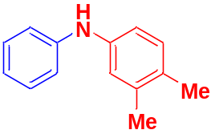 | 85
9^{b} | 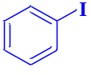 | 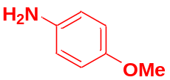 | 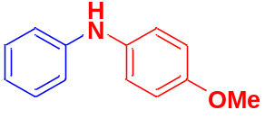 | 83
10^{b} | 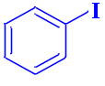 | 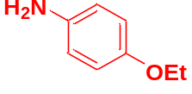 | 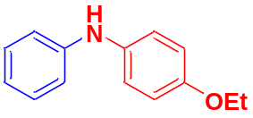 | 80
11^{b} | 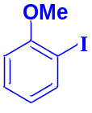 | 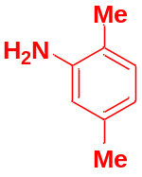 | 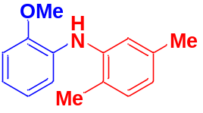 | 82
12^{b} | 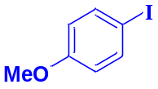 | 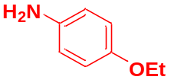 | 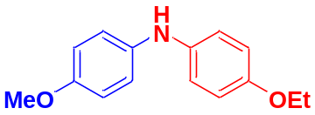 | 80
13^{b} | 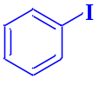 | 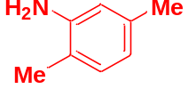 | 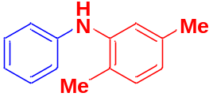 | 89
14^{b} | 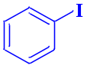 | 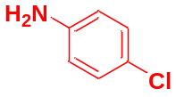 | 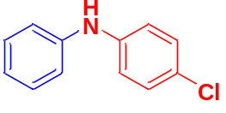 | 91
15^{b} | 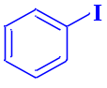 | 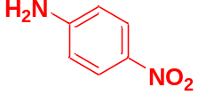 | 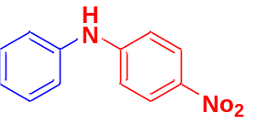 | 90
16^{b} | 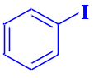 | 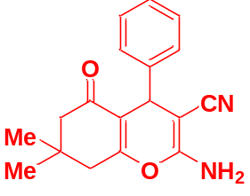 | 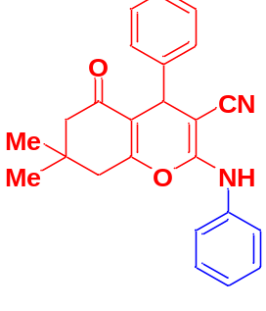 | 88
ª Reaction conditions for secondary amines: H₂O (4 ml), K₂CO₃ (2 mmol), catalyst (10 mol%), temperature (100 ºC), reaction time (12 h).
^{b} Reaction conditions for primary conditions: H₂O (0.5 ml), K₂CO₃ (1 mmol), catalyst (10 mol%), temperature (100 ºC), reaction time (12 h).

Table. 3. Comparison of catalytic activity of the Fe₃O₄@Agar-Cu NPs C-N cross-coupling of amines with aryl halides.
Entry | Condition | Time(h) | Yield(%) | Ref.
1 | Fe₃O₄@PDA/Pd(II) -Cs₂CO₃-DMF at 100 °C | 10 | 80 | [24]
2 | Pd(IPr*me)(acac)Cl- LiHMDS,1,4-dioxane 110℃ | 3 | 75-90 | [47]
3 | Toluene, ,NaOtBu, Pd/ligand 1:2, phosphonium salt: EtFluPCy₂·HBF₄, 120 °C | 12 | 48-95 | [48]
4 | Pd₂(dba)₃,XhantPhos, DBU, DMF, 100 °C | 18 | 70 | [49]
5 | Fe₃O₄@Agar-Cu NPs-K₂CO₃,H₂O,100 °C | 12 | 80-96 | current work

