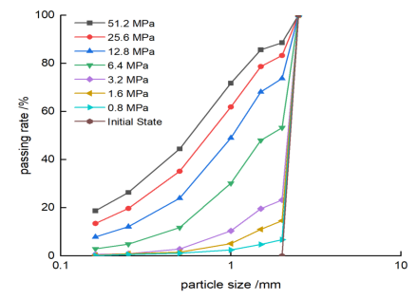
FIG. 1 Compression and Crushing Grading Curve of Calcareous Sand with a Single Particle Size (Ref. ⁷)

Compressive stress | particle size （mm） | 0.16 | 0.25 | 0.50 | 1.00 | 1.50 | 2.00 | 2.50
51.2 MPa | Passing rate(%) | 18.77 | 26.33 | 44.43 | 71.78 | 85.62 | 88.56 | 100
25.6Mpa | Passing rate(%) | 13.49 | 19.73 | 35.19 | 61.88 | 78.68 | 83.28 | 100
12.8Mpa | Passing rate(%) | 7.88 | 12.14 | 23.97 | 49.01 | 68.12 | 73.71 | 100
6.4Mpa | Passing rate(%) | 2.936 | 4.883 | 11.765 | 30.198 | 47.993 | 53.249 | 100
3.2Mpa | Passing rate(%) | 0.626 | 0.923 | 2.854 | 10.395 | 19.61 | 23.22 | 100
1.6Mpa | Passing rate(%) | 0.296 | 0.9235 | 1.534 | 5.114 | 11.029 | 14.636 | 100
0.8Mpa | Passing rate(%) | 0.113 | 0.5935 | 1.125 | 2.4749 | 4.759 | 6.715 | 100
Initial state |  | 0 | 0 | 0 | 0 | 0 | 0 | 100

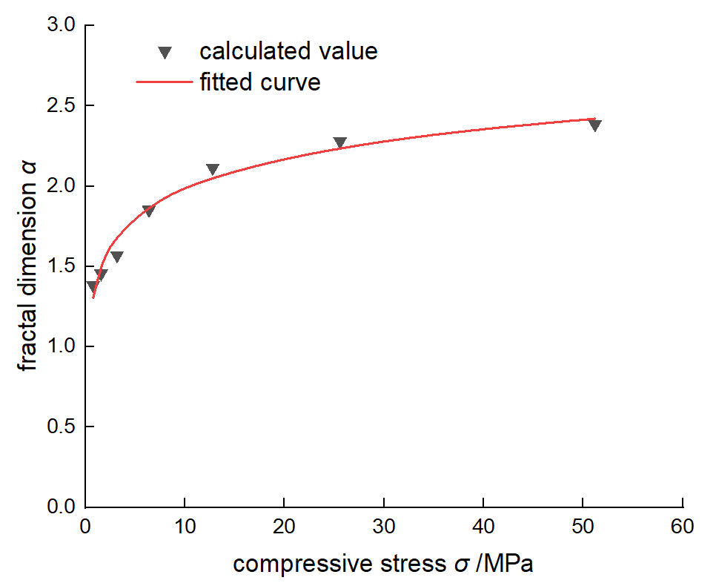

FIG. 2 Relation Curve Between Compressive Stress σ and Fractal Dimension α
Compressive stress (MPa) | Calculated values of Fractal dimension | Fitted values of fractal dimension
51.2 | 2.38575 | 2.420078195
25.6 | 2.27931 | 2.23431475
12.8 | 2.11479 | 2.048551306
6.4 | 1.85264 | 1.862787861
3.2 | 1.56936 | 1.677024417
1.6 | 1.45554 | 1.491260973
0.8 | 1.38276 | 1.305497528

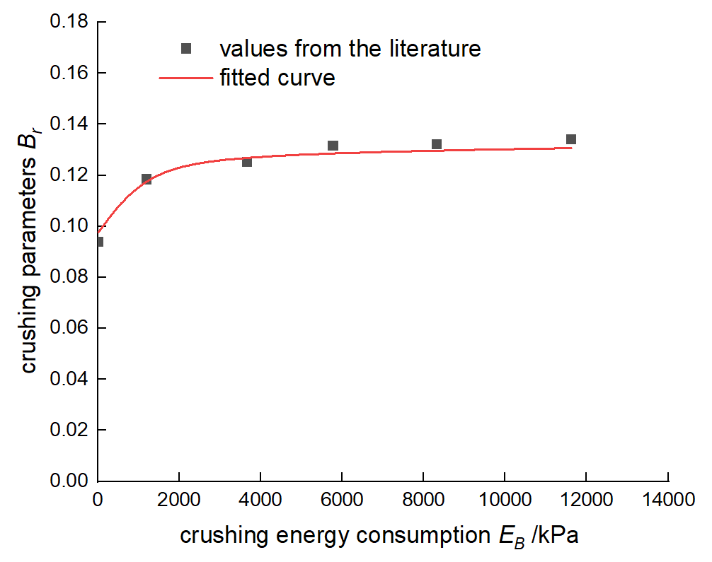

FIG. 3 Relationship Curve Between Crushing energy dissipation E_{B} and crushing parameters B_{r} (Ref. ²²)
E_{B} | B_{r} values from the literature | fitted values of B_{r}‘
19.4016 | 0.093 | 0.097
1209.99 | 0.118 | 0.123
3669.24 | 0.125 | 0.127
5781.41 | 0.131 | 0.128
8326.1 | 0.132 | 0.129
11622.9 | 0.134 | 0.130

Model Validation

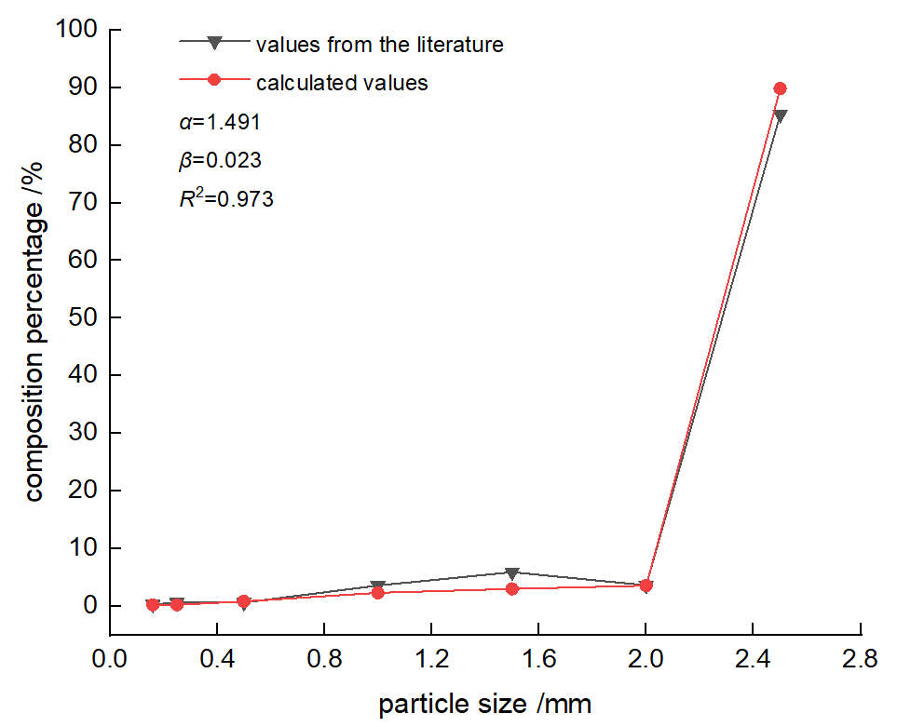
- From the initial state to the crushing state at an axial stress of 1.6 Mpa
Particle size (mm) | 0.16 | 0.25 | 0.5 | 1 | 1.5 | 2 | 2.5
Test Values from the literature | 0.30 | 0.63 | 0.61 | 3.58 | 5.92 | 3.61 | 85.36
Calculated values | 0.22 | 0.22 | 0.81 | 2.31 | 3.00 | 3.56 | 89.88

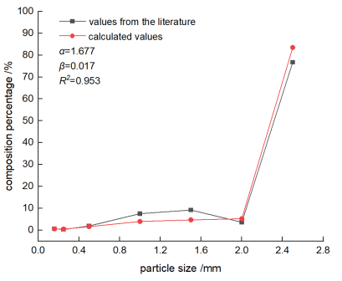
- From the initial state to the crushing state at an axial stress of 3.2MPa
Particle size (mm) | 0.16 | 0.25 | 0.5 | 1 | 1.5 | 2 | 2.5
Test Values from the literature | 0.63 | 0.30 | 1.93 | 7.54 | 9.22 | 3.61 | 76.78
Calculated values | 0.58 | 0.47 | 1.58 | 3.96 | 4.68 | 5.22 | 83.50

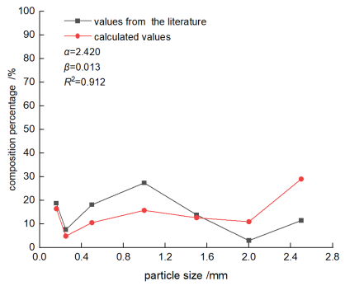
c) From the initial state to the crushing state at an axial stress of 51.2MPa

Particle size (mm) | 0.16 | 0.25 | 0.5 | 1 | 1.5 | 2 | 2.5
Test Values from the literature | 18.77 | 7.56 | 18.10 | 27.35 | 13.84 | 2.94 | 11.44
Calculated values | 16.41 | 4.85 | 10.52 | 15.72 | 12.59 | 10.91 | 29.00

Gradation data under compressive stress of 7.5 MPa, sourced from the literature of Bard
Particle size(mm) | 0.1 | 0.125 | 0.16 | 0.2 | 0.4 | 0.49 | 0.62 | 0.79 | 1 | 1.23 | 1.58 | 2 | 2.47 | 3.14 | 4 | 5 | 10
Test values from the literature | 0.020 | 0.006 | 0.007 | 0.009 | 0.035 | 0.015 | 0.026 | 0.024 | 0.028 | 0.037 | 0.041 | 0.035 | 0.076 | 0.052 | 0.101 | 0.169 | 0.290

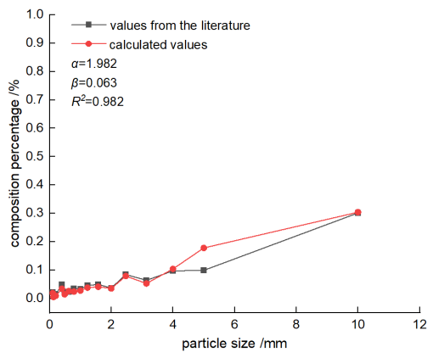
- Crushing state from 7.5MPa to 10MPa

Particle size(mm) | 0.1 | 0.125 | 0.16 | 0.2 | 0.4 | 0.49 | 0.62 | 0.79 | 1 | 1.23 | 1.58 | 2 | 2.47 | 3.14 | 4 | 5 | 10
Test values from the literature | 0.022 | 0.007 | 0.013 | 0.015 | 0.050 | 0.024 | 0.022 | 0.035 | 0.033 | 0.046 | 0.050 | 0.037 | 0.085 | 0.064 | 0.097 | 0.099 | 0.302
Calculated values | 0.019 | 0.005 | 0.007 | 0.009 | 0.034 | 0.015 | 0.026 | 0.024 | 0.028 | 0.038 | 0.041 | 0.035 | 0.079 | 0.053 | 0.104 | 0.178 | 0.304

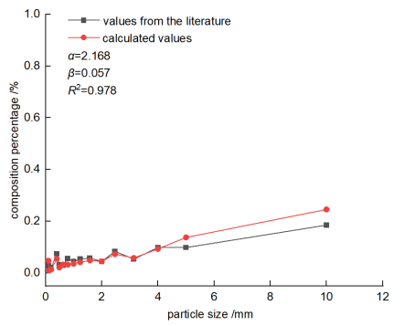
- Crushing state from 7.5MPa to 20MPa

Particle size(mm) | 0.1 | 0.125 | 0.16 | 0.2 | 0.4 | 0.49 | 0.62 | 0.79 | 1 | 1.23 | 1.58 | 2 | 2.47 | 3.14 | 4 | 5 | 10
Test values from the literature | 0.028 | 0.022 | 0.020 | 0.020 | 0.074 | 0.031 | 0.030 | 0.056 | 0.044 | 0.054 | 0.057 | 0.044 | 0.083 | 0.054 | 0.098 | 0.098 | 0.185
Calculated values | 0.047 | 0.009 | 0.012 | 0.014 | 0.055 | 0.021 | 0.032 | 0.032 | 0.036 | 0.042 | 0.049 | 0.045 | 0.073 | 0.058 | 0.093 | 0.138 | 0.246

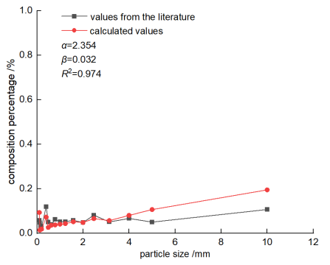
- Crushing state from 7.5MPa to 40MPa

Particle size(mm) | 0.1 | 0.125 | 0.16 | 0.2 | 0.4 | 0.49 | 0.62 | 0.79 | 1 | 1.23 | 1.58 | 2 | 2.47 | 3.14 | 4 | 5 | 10
Test values from the literature | 0.058 | 0.048 | 0.031 | 0.030 | 0.119 | 0.050 | 0.040 | 0.062 | 0.051 | 0.052 | 0.058 | 0.048 | 0.081 | 0.051 | 0.066 | 0.050 | 0.106
Calculated values | 0.093 | 0.014 | 0.017 | 0.018 | 0.072 | 0.026 | 0.036 | 0.037 | 0.040 | 0.043 | 0.051 | 0.048 | 0.066 | 0.057 | 0.080 | 0.106 | 0.195

FIG. 5 Experimental values and calculated broken state of petroleum coke in reference²³

The gradation corresponding to a shear strain of 285%, sourced from the literature of Coop

Particle size(mm) | 0.06 | 0.15 | 0.2 | 0.3 | 0.425
Test values from the literature | 11.282 | 12.562 | 8.940 | 20.896 | 46.317

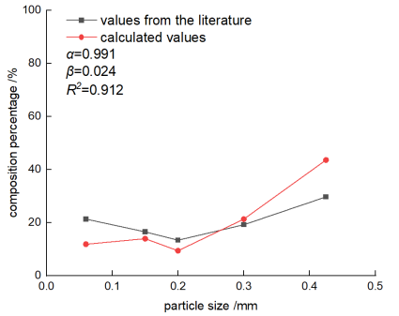
- Crushing state from a shear strain of 285% to 1180%
Particle size(mm) | 0.06 | 0.15 | 0.2 | 0.3 | 0.425
Test values from the literature | 21.30 | 16.50 | 13.35 | 19.18 | 29.68
Calculated values | 11.82 | 13.91 | 9.358 | 21.31 | 43.58

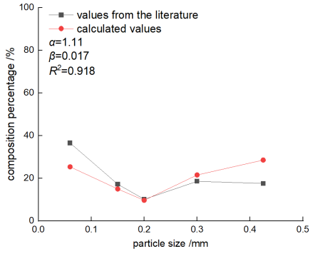
b) Crushing state from a shear strain of 285% to 13280%
Particle size(mm) | 0.06 | 0.15 | 0.2 | 0.3 | 0.425
Test values from the literature | 36.54 | 17.21 | 10.13 | 18.54 | 17.58
Calculated values | 25.34 | 14.97 | 9.65 | 21.52 | 28.51

