Supplementary Tables and Figures List

Table S1: The information of the differential gene expression associated with heat stress between S0 vs A0, S6 vs A6, and S24 vs A24.

Table S2: All of the differential gene expression identified in this study.

Table S3: The information of other differentially expressed genes involved in endoplasmic reticulum (ER) protein processing.

Table S4: The detailed information of the top candidate genes.

Fig.S1: Gene ontology (GO) functional classification of top 30 differently expressed genes. (A) S0 vs A0, (B) S6 vs A6, (C) S24 vs A24.

Fig.S2: Additional file2: The KEGG pathway enrichment of top 20 differently expressed genes. (A) S0 vs A0, (B) S6 vs A6, (C) S24 vs A24.

Fig.S3: Correlation heat map between gene modules and sample time point. Each data set on the right side indicates the correlation coefficients and significance P-value values (in parentheses) for the module and phenotype. Larger absolute values represent larger correlations, with blue indicating negative correlations and red indicating positive correlations.

Fig.S4: GO enrichment of representative response modules. (A) darkgreen module, (B)yellow module, (C)blue module, (D)turquoise module.

Fig.S1
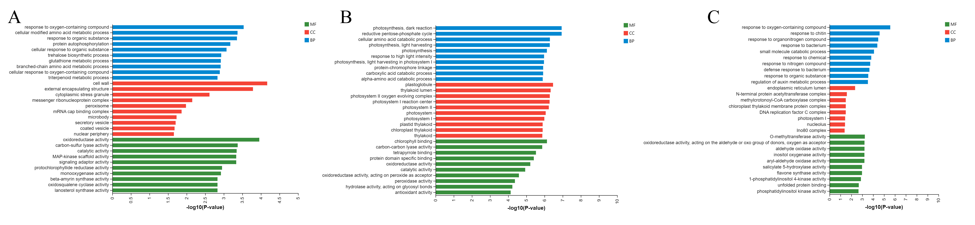

Fig.S2
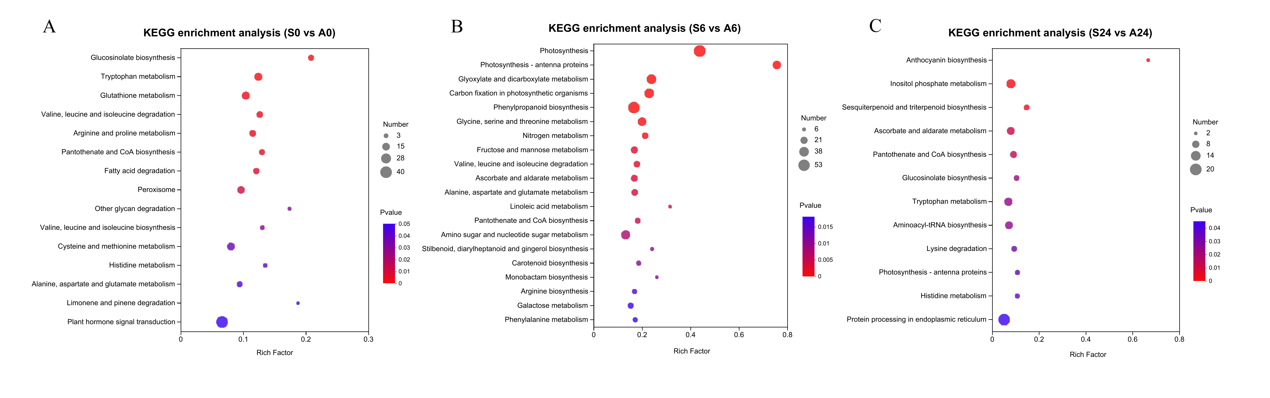

Fig.S3
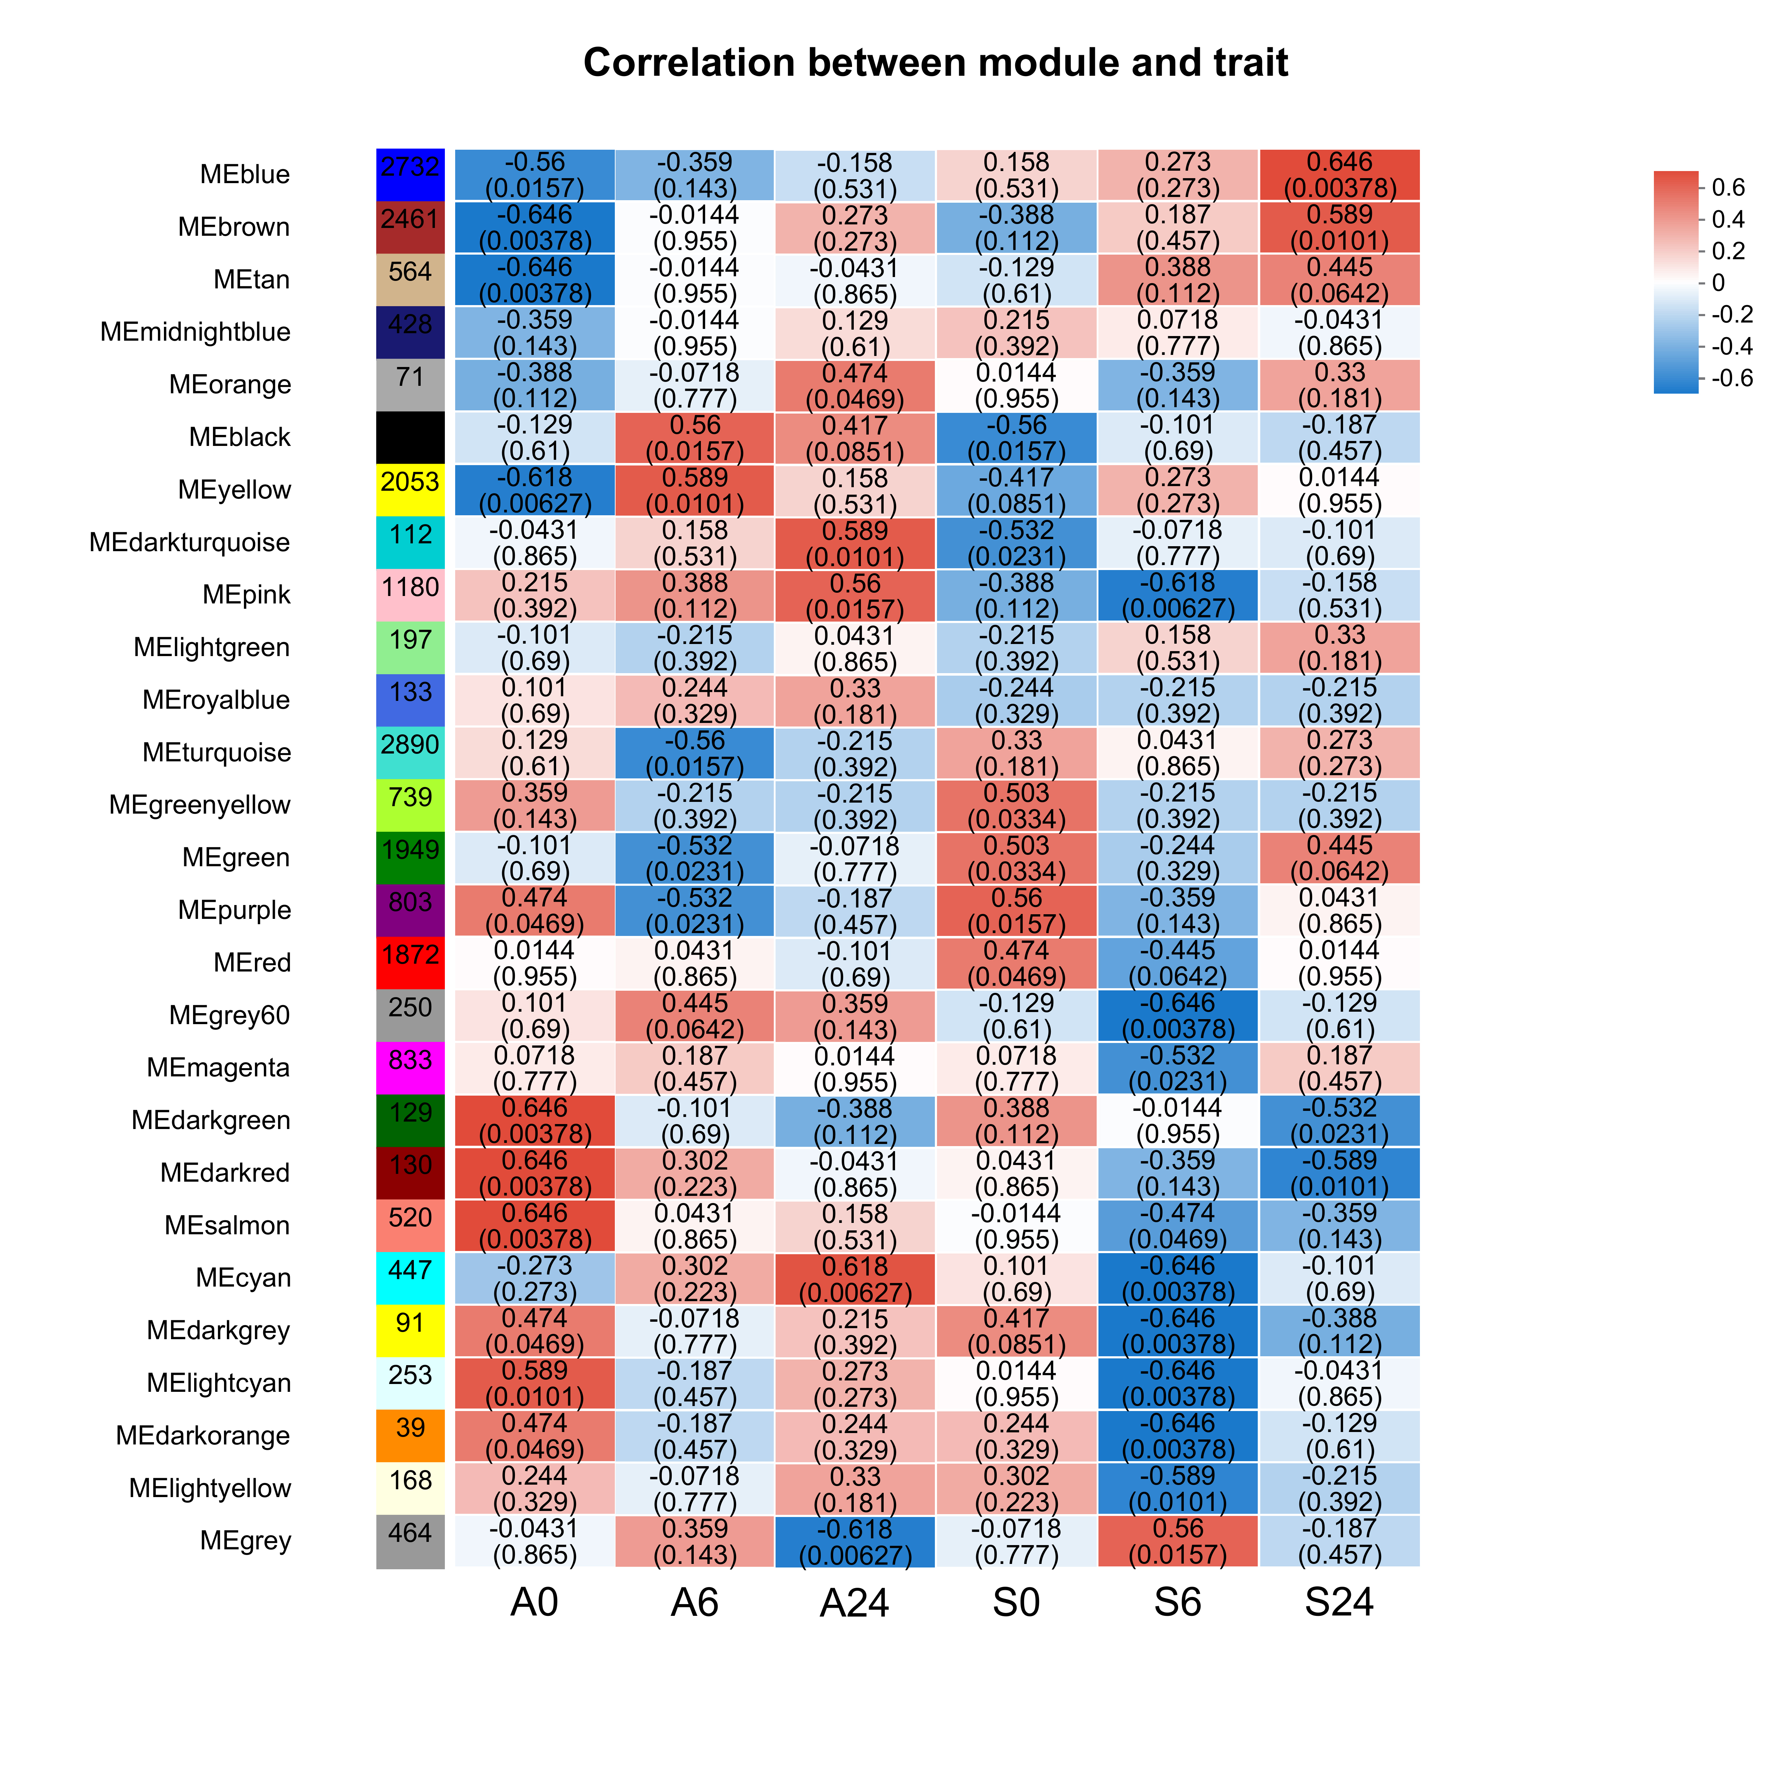

Fig.S4

