Supplemental Section

Supplementary Table 1. Environmental Microbiology Minimum Information (EMMI) for qPCR.

Environmental Sampling | qPCR
Up to 50 grams | Target genes (supplemental table 2)
Peru  Tingo María  Andabamba/Marabamba  Huánuco | Hold stage 95°C, 20 sec; Amplification Denaturation 95°C, 1 sec; Annealing 60°C, 20 sec.
August, 2023 | 2x TaqMan® Fast Advanced Master Mix (Applied Biosystems, Foster City, CA) 3.5 µl
Stored at 4°C and DNA extracted within 1 month | 2 µl of template
Exogenous DNA was used as an internal control to validate the extraction method. All samples had the internal control detect via qPCR | Primers were used at 900 nM (Thermofisher)  Probe was used at 100 nM (Thermofisher)
Sample Treatment | QS7 Pro Fast Real-time PCR System (Applied Biosystems, Waltham, Massachusetts, USA)
Soil washed with PBS and 0.05% Tween 20 | 2 µl of PCR-water was used as a negative control
Flotation with 35.6% Sodium Nitrate solution | Plasmids containing target parasite gene sequences was used as positive control
Sample Reduction | An exogenous DNA internal control was tested and all samples tested positive for the internal control Ct median  33.80 (31.94 - 37.08).
Samples are concentrated by a factor of 500 | Analysis - qPCR
Nucleic Acid Extraction | Positive control standard curves were performed in duplicate
MP fastDNA Spin kits for soil | Samples were tested in single
DNA eluent is 100 µl and stored at -20°C | All positive controls were compared to a set of known Ct values and were all within 5% range
 | Lowest standard measured was approximately 10 fg
 | Automatic baseline and a threshold of 0.40 was used for all parasites

Supplemental Table 2. Target regions, primer sequences, and probe sequences by parasites for DNA amplification.*

Parasite | Target region | Forward primer sequence (5’ to 3’)  Reverse primer sequence (5’ to 3’)  Probe sequence (5’FAM to 3’)
Acanthamoeba spp | 18S rRNA | CCCAGATCGTTTACCGTGAA TAAATATTAATGCCCCCAACTATCC  CTGCCACCGAATACATTAGCATGG
Ancylostoma duodenale | ITS-2 | GAATGACAGCAAACTCGTTGTTG ATACTAGCCACTGCCGAAACGT ATCGTTTACCGACTTTAG
Ascaris lumbricoides | ITS-1 | TGCACATAAGTACTATTTGCGCGTAT  CCGCCGACTGCTATTACATCA  GAGCCACATAGTAAATT
Cryptosporidium spp. | DNA-J like protein | AACTTCACGTGTGTTTGCCAAT  CCAATCACAGAATCATCAGAATCG  CATATGAAGTTATAGGGATACCAG
Blastocystis spp. | 16s rRNA | AGTAGTCATACGCTCGTCTCAAA  TCTTCGTTACCCGTTACTGC  CGTGTAAATCTTACCATTTAGAGGA
Entamoeba histolytica | 18S rRNA | GTTTGTATTAGTACAAAATGGCCAATTC  TCGTGGCATCCTAACTCACTTAGA  CAATGAATTGAGAAATGACA
Giardia intestinalis | 16S rRNA | CATGCATGCCCGCTCA  AGCGGTGTCCGGCTAGC  AGGACAACGGTTGCAC
Necator americanus | ITS-2 | CTGTTTGTCGAACGGTACTTGC  ATAACAGCGTGCACATGTTGC  CTGTACTACGCATTGTATAC
Strongyloides stercoralis | 18s rRNA | GAATTCCAAGTAAACGTAAGTCATTAGC  TGCCTCTGGATATTGCTCAGTTC  ACACACCGGCCGTCGCTGC
Toxocara canis | ITS-2 | GCGCCAATTTATGGAATGTGAT  GAGCAAACGACAGCSATTTCTT  CCATTACCACACCAGCATAGCTCACCGA
Toxocara cati | ITS-2 | ACGCGTACGTATGGAATGTGCT  GAGCAAACGACAGCSATTTCTT  TCTTTCGCAACGTGCATTCGGTGA
Trichuris trichiura | ITS-1 | TCCGAACGGCGGATCA  CTCGAGTGTCACGTCGTCCTT  TTGGCTCGTAGGTCGTT
Taenia solium | HSR | AGTCAGTCAGTCAGTCAGTCA  CTGTCAAGCTGTCAGGCTGT  TGTCAGTGAGGCGTGTGACAAGAC
Internal Amplification Control (IAC) | Synthetic sequence | CTAACCTTCGTGATGAGCAATCG  GATCAGCTACGTGAGGTCCTAC  TCGATGCACTCCAGTCCTCCT
*ITS = internal transcribed spacer; rRNA = ribosomal RNA
*HSR = High Sequence Repeats

Supplemental Figure 1. Contaminated houses and parks by distinct parasites.
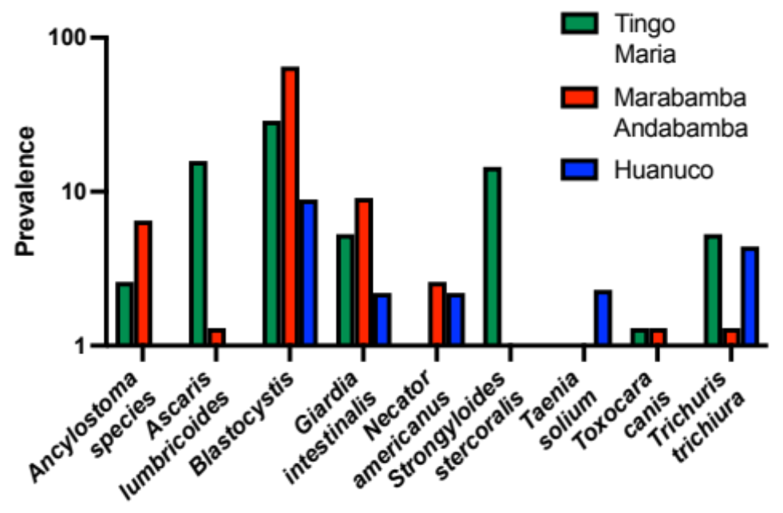

Supplemental Figure 2. Parasite DNA burden of all locations.
