Supplementary Information
Direct Electrical Stimulation of ATDC5 Cells through Graphene Foam Bioscaffolds to Control Mechanical Properties of Graphene Foam - Soft-Tissue Composites
Mone’t Sawyer¹, Amevi Semodji¹, Olivia Nielson², Attila Rektor³, Hailey Burgoyne^{3,4}, Michael Eppel¹, Joshua Eixenberger⁵, Raquel Montenegro-Brown^{3,7}, Miranda L. Nelson¹, Trevor Lujan¹, and
David Estrada^{3, 6,7*}

¹Biomedical Engineering Doctoral Program, Boise State University, Boise, ID 83725, USA
²Department of Chemical and Biological Engineering, University of Idaho, Moscow, ID 83844, USA
³Micron School for Materials Science and Engineering, Boise State University, Boise, ID 83725, USA
⁴Biomolecular Sciences Graduate Program, Boise State University, Boise, ID 83725, USA
⁵Department of Physics, Boise State University, Boise, ID 83725, USA
⁶Center for Advanced Energy Studies, Boise State University, Boise, ID 83725, USA
⁷Idaho National Laboratory, Idaho Falls, ID 83401, USA
*Corresponding author: daveestrada@boisestate.edu

Supplementary Figures
Figure S1: Bar chart illustrating the pH levels measured in cell culture media before and after 5 minutes ES on GF in ESCs at 20, 40, and 60 mVpp. The data indicate a negligible change in pH, demonstrating the stability of the cell culture media's pH when subjected to ES on GF bioscaffolds.
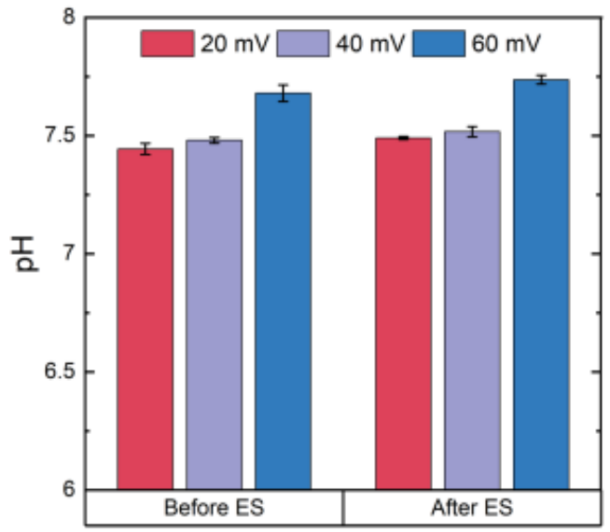
Consistent pH levels indicate that the ES does not introduce significant stress or cytotoxicity to the cells via media acidification or alkalization. This stability is crucial for ensuring that observed cellular responses are due to the ES rather than pH-induced stress. Ensuring that the pH remains within a physiological range is needed for interpreting the effects of ES accurately, as large pH gradients negatively impact cell behavior and viability^{1,2}. The figure shows the three voltage conditions used in this study, highlighting the robustness of the experimental setup across this range of stimulation intensities.

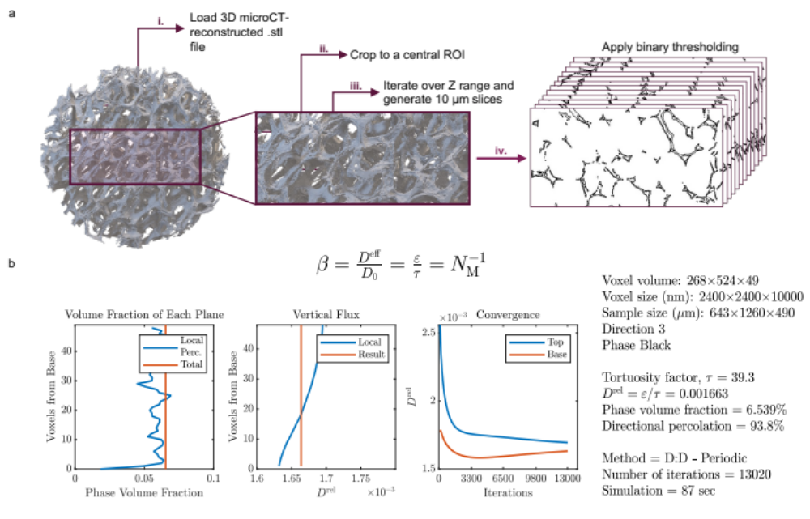
Figure S2: TauFactor analysis for estimating tortuosity in GF bioscaffolds. a) A stepwise process for preparing microCT-derived data of GF bioscaffolds for tortuosity analysis: i) 3D microCT-reconstructed .stl file loaded and processed for slicing, ii) central rectangular ROI cropped from the original structure, iii) cropped ROI is iteratively sliced across the Z-axis in 10 µm increments, and iv) binary thresholding applied to each slice, followed by conversion to .tiff format. b) TauFactor output summarizing key structural metrics of GF bioscaffolds: tortuosity factor (𝜏 = 39.3), effective diffusivity (D^{rel} = ε/𝜏 = 0.001663), phase volume fraction (6.539%), and directional percolation (93.8%). Plots include phase volume fraction per plane, vertical flux distribution per plane, and the iterative convergence of D^{rel} for top and base planes, confirming robust analysis of GF transport properties. Analyses were conducted using the Dirichlet:Dirichlet method with periodic boundary conditions (D:D – Periodic).

Figure S3: Schematic representation of the thermal CVD process used for GF synthesis. The process includes five distinct stages: (1) Ramp-up to 1000 °C under a flow of Ar (100 sccm) and H₂ (100 sccm), (2) pre-growth stabilization at 1000 °C for 30 minutes, (3) graphene growth phase maintained at 1000 °C for 50 minutes under CH₄ (600 sccm) and H₂, (4) controlled cooling to 300 °C under Ar flow, and (5) final cooling to room temperature (25 °C) under atmospheric pressure.
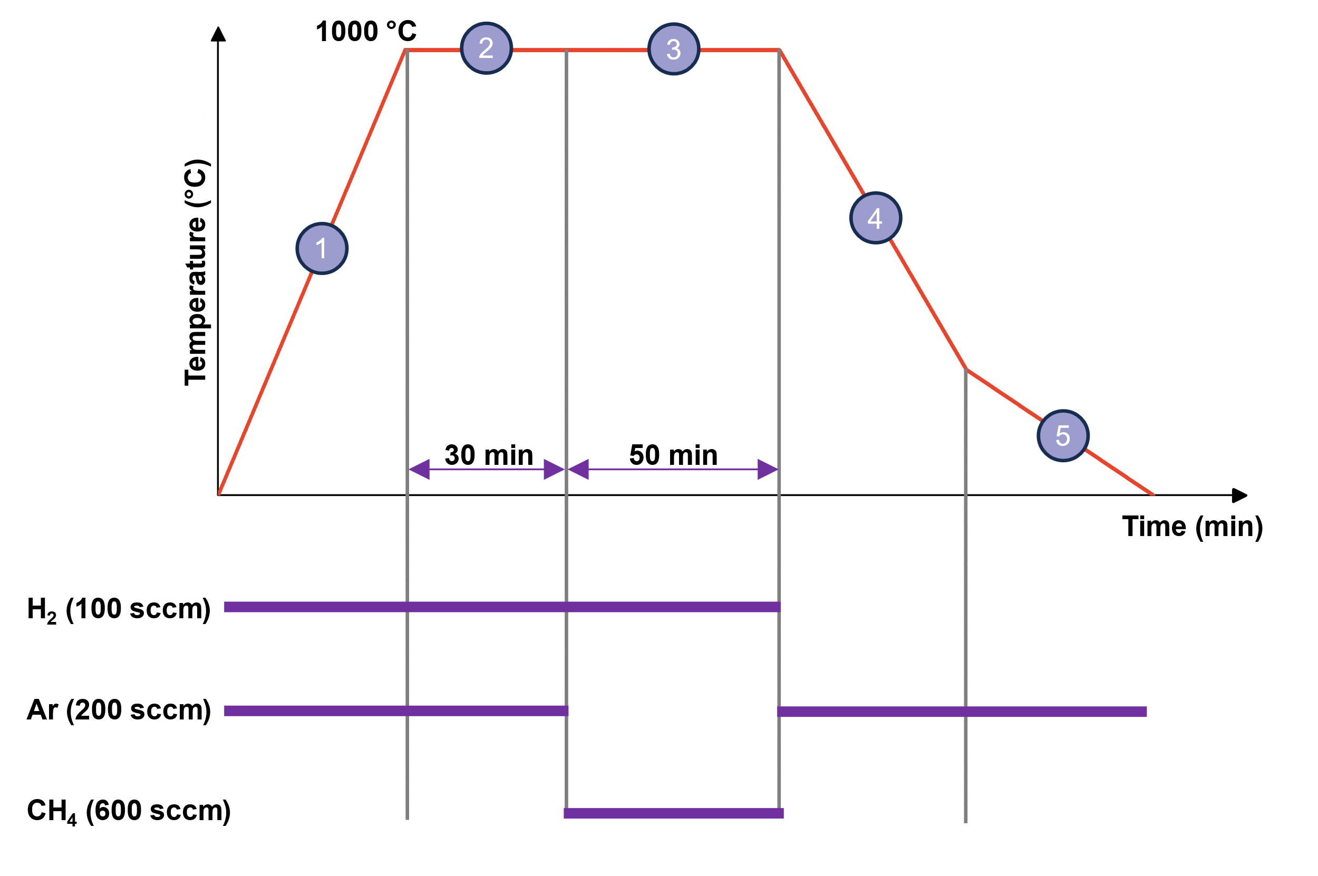
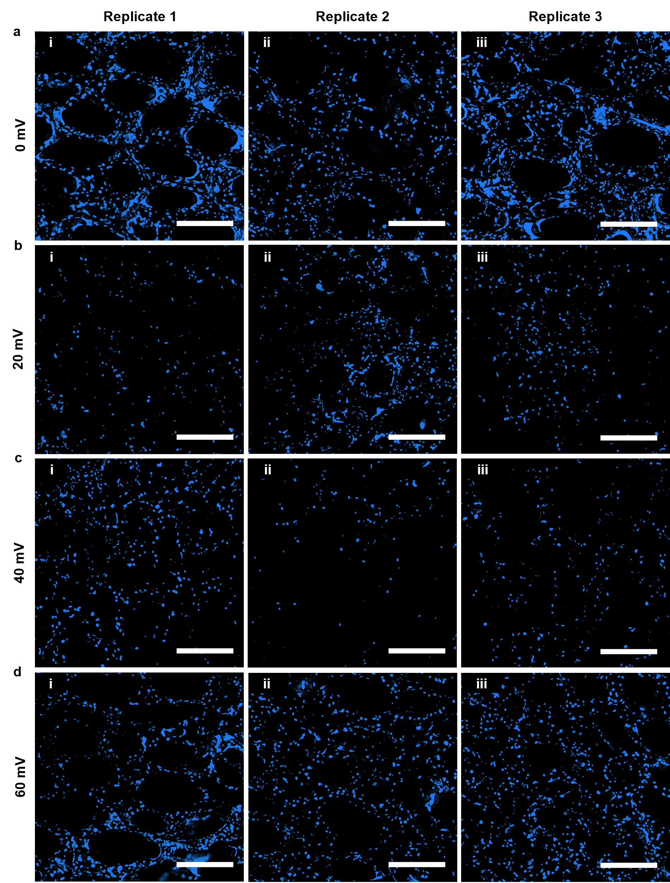
Figure S4: Proliferation analysis across ES culture conditions on GF. Nuclei are counterstained with Hoechst to visualize cellular proliferation post-stimulation. Panels represent each stimulation condition: a) 0 mV, b) 20 mV, c) 40 mV, and d) 60 mV. For each condition, three biological replicates are shown: (i) replicate 1, (ii) replicate 2, and (iii) replicate 3. The images illustrate significant differences in proliferation between experimental conditions, particularly highlighting increased proliferation in the 0 mV and 60 mV groups compared to the intermediate stimulation levels. The replicates also demonstrate the consistency of proliferation responses across samples while capturing the natural variability between replicates, emphasizing both the reproducibility of the observed trends and the inherent sample-to-sample variation. (scalebar 300 um)
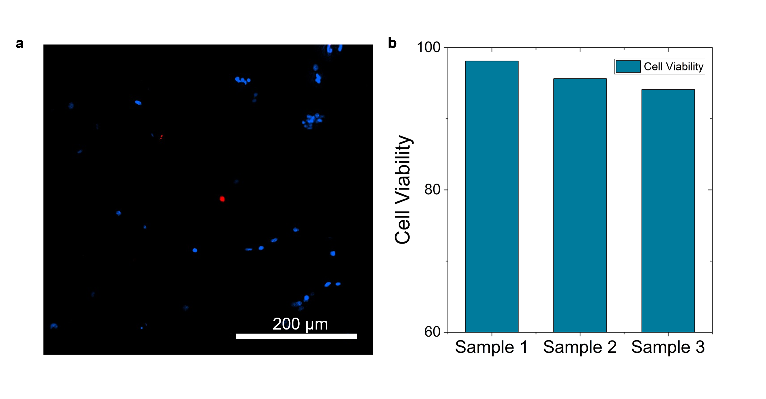
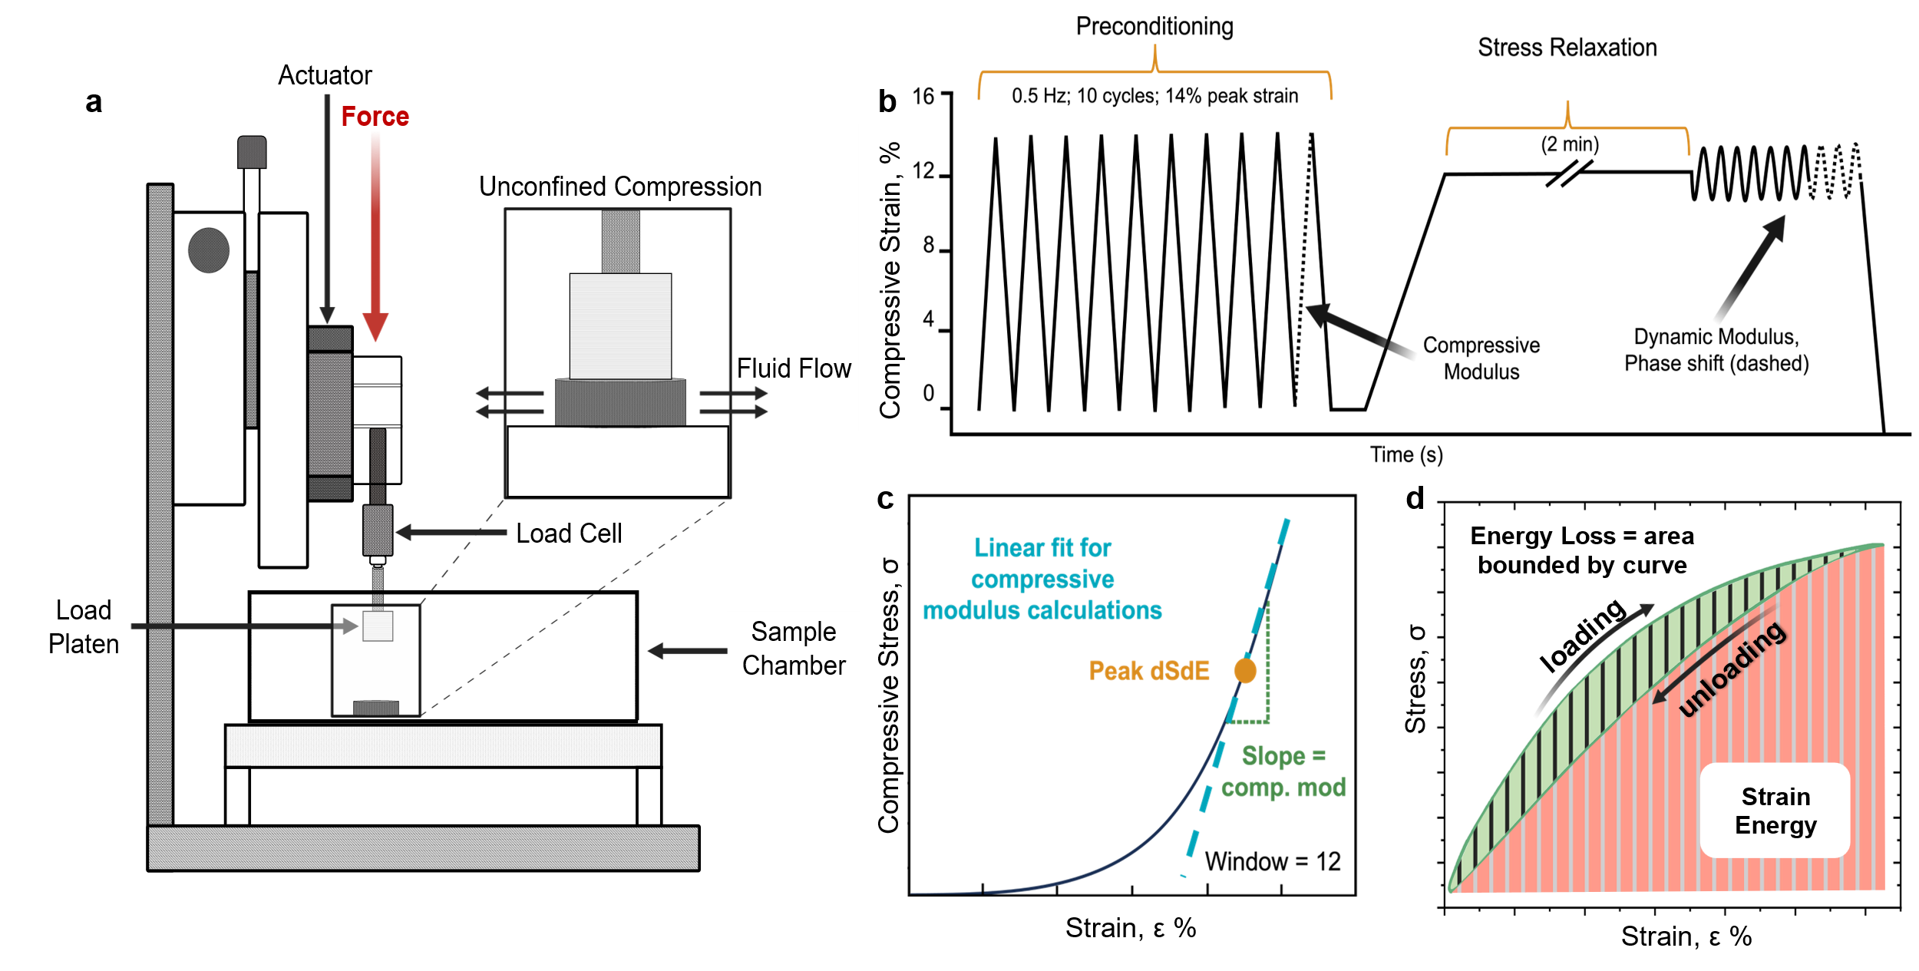
Figure S6: Protocol for DMA of GF-cell composites. a) Schematic representation of the bioreactor setup employed for unconfined compression testing. b) Detailed depiction of the testing methodology used to assess both the quasi-static and viscoelastic compressive properties within the elastic region of the material. c) Illustration of the linear regression approach for calculating compressive modulus from the peak derivative of the stress-strain curves for each sample. d) Example of a hysteresis loop with highlighted areas used to calculate energy dissipated (energy loss) within the loop and strain energy beneath the loop, estimated using the trapezoidal method to quantify mechanical energy.
Figure S5: Viability analysis of GF bioscaffolds. a) Representative live/dead imaging used for viability analysis from one GF bioscaffold after a 48-hour culture period with ATDC5 cells. b) Cell viability calculations across samples (n=3) indicating a 95.96 ± 2.01% viability.
Table S1: Root mean square error (RMSE) values for exponential decay fits of energy dissipation over low cyclic loading
Condition | A (kPa) | τ | y₀ (kPa) | R² | RMSE | F Statistic | p-value
0 mv | 5.08 ± 0.47 | 10.28 ± 2.87 | 1.8 ± 0.6 | 0.98 | 1.17 · 10⁻⁴ | 190.19 | 1.92 · 10⁻⁵
20 mv | 3.81 ± 0.30 | 3.62 ± 0.47 | 4.47 ± 0.07 | 0.98 | 7.49 · 10⁻⁵ | 218.45 | 1.36 · 10⁻⁵
40 mv | 2.75 ± 0.19 | 3.74 ± 0.45 | 4.91 ± 0.05 | 0.99 | 5.07 · 10⁻⁵ | 256.82 | 9.12 · 10⁻⁶
60 mv | 3.42 ± 0.18 | 4.12 ± 0.41 | 5.23 ± 0.06 | 0.99 | 5.24 · 10⁻⁵ | 403.55 | 2.97 · 10⁻⁶
CC | 5.09 ± 0.58 | 2.84 ± 0.41 | 3.15 ± .09 | 0.98 | 1.04 · 10⁻⁴ | 152.09 | 3.33 · 10⁻⁵
Bare GF | 4.16 ± 0.32 | 4.27 ± 0.66 | 2.37 ± 0.13 | 0.98 | 9.83 · 10⁻⁵ | 173.18 | 2.42 · 10⁻⁵

Exponential decay models were fitted to the experimental data to analyze the energy dissipation over time. The model used was of the form: $y_{fit}=Ae^{-t/τ}+y_{0}$, where A is the amplitude of initial energy dissipation, t is time in seconds, $τ$ is the decay constant, and y₀ is the steady-state energy dissipation that remains after the initial response to the applied compression cycles. The fitting was performed using Origin’s non-linear curve fitting module, which employs the Levenberg-Marquardt algorithm to minimize the sum of the squared residuals between the observed and predicted values³. The goodness of fit for the exponential models were assessed using the following criteria:
- R-Squared (R²): Measures the proportion of variance in the dependent variable that is predictable from the independent variables.
- Root Mean Squared Error (RMSE): Measures the differences between values predicted by the model and the values actually observed.
- F Statistic: A measure of the overall significance of the model
- p-value: The p-value associated with the F statistic indicates the probability that the observed F value would occur if the null hypothesis were true. A p-value < 0.05 suggests that the model provides a significantly better fit to the data than the function y=constant.
The high F-statistics and low p-values, along with the strong R² and low RMSE values, confirm that the initial amplitude, steady-state energy dissipation, and decay constant are significant predictors of energy dissipation behavior, indicating that the model fits are robust and statistically significant.
Supplementary References
- Balikov, D. A. et al. Directing lineage specification of human mesenchymal stem cells by decoupling electrical stimulation and physical patterning on unmodified graphene. Nanoscale 8, 13730–13739 (2016).
- Cooper, S. J., Bertei, A., Shearing, P. R., Kilner, J. A. & Brandon, N. P. TauFactor: An open-source application for calculating tortuosity factors from tomographic data. SoftwareX 5, 203–210 (2016)
- Williams-Godwin, L. et al. Open-source automated chemical vapor deposition system for the production of two-dimensional nanomaterials. PLoS ONE 14, (2019).
- Yocham, K. M. et al. Mechanical properties of graphene foam and graphene foam—tissue composites. Adv. Eng. Mater. 20, (2018).
- Mackenzie, C. G. D., Mackenzie, J. B. D. & Beck, P. The effect of pH on growth, protein synthesis, and lipid-rich particles of cultured mammalian cells. J Biophys Biochem Cytol 9, 141–156 (1961).

- Gavin, H. P. The Levenberg-Marquardt algorithm for nonlinear least squares curve-fitting problems. Department of Civil and Environmental Engineering, Duke University (2013). Available at https://people.duke.edu/~hpgavin/ExperimentalSystems/lm.pdf

