A cost-benefit analysis of using wastewater monitoring to guide typhoid vaccine campaigns
Aparna Keshaviah¹, Ali Akram¹, Dheeya Rizmie¹, Ian Raxter¹, Rezaul Hasan², Ziaur Rahman², Afroza Jannat Suchana², Farjana Jahan², Aninda Rahman³, Mahbubur Rahman⁴, Mahbubur Rahman², Megan B. Diamond⁵, Anthony Louis D’Agostino¹
Corresponding author: Aparna Keshaviah; akeshaviah@mathematica-mpr.com
Corresponding author address: P.O. Box 2393, Princeton, NJ 08543-2393
¹ Mathematica, Inc. Princeton, NJ, USA
² Environmental Health and WASH, Health System and Population Studies Division, International Centre for Diarrhoeal Disease Research, Bangladesh (icddr,b)
³ Communicable Disease Control (CDC) Program, Directorate General of Health Services (DGHS), Ministry of Health and Family Welfare, Bangladesh
⁴ Institute of Epidemiology, Disease Control and Research (IEDCR), Directorate General of Health Services (DGHS), Ministry of Health and Family Welfare, Bangladesh
⁵ The Rockefeller Foundation, New York, NY, USA

Figure A: Flow diagram of the compartmental typhoid model
Susceptible
Infected
Chronic carriers
Vaccinated
Recovered
Water supply
$$βSI + βSCr+ λSW$$
$$γI$$
$$ξI$$
$$ξrC$$
$$ω_{vacc}V$$
$$σ_{b}ϵ\left(S-σ_{d}δϵS\right)-σ_{d}δϵS$$
$$θI$$
$$νC$$
$$ωR$$
Note: The model contained six compartments, including five for individuals and one for the environment (the concentration of shed S. Typhi in the water supply). The flow diagram does not include the vital dynamics (that is, how birth and death were accounted for).
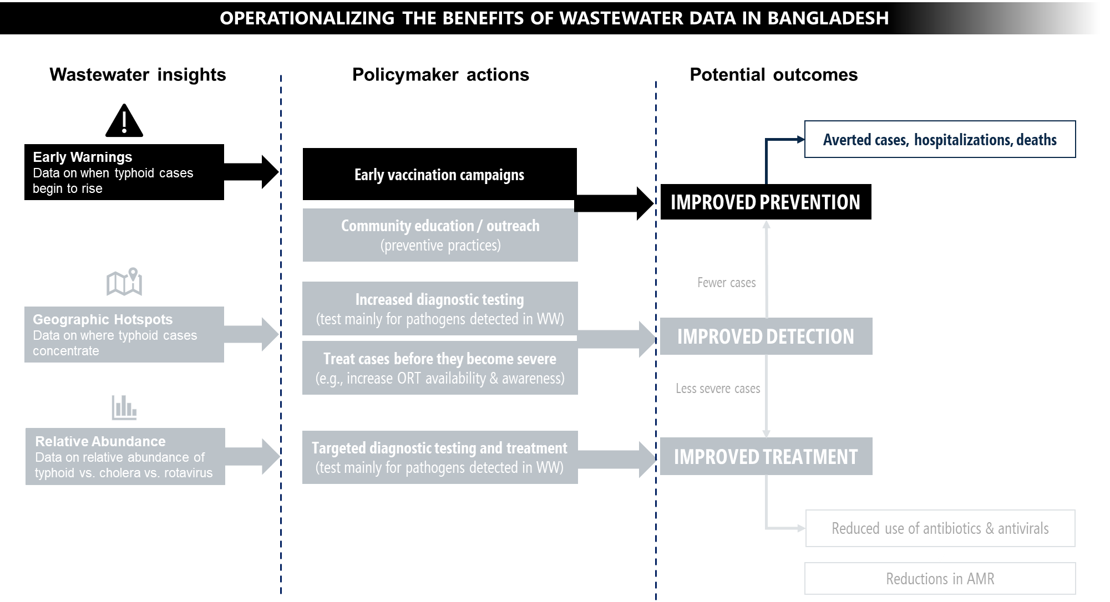
Figure B: Logic model for the uses and benefits of wastewater data in Bangladesh
Note: Figure A illustrates the many ways that wastewater data could be used by policymakers. Early warnings of new typhoid fever outbreaks, based on upticks in wastewater concentrations of S. Typhi, could prompt the early launch of vaccination or education campaigns. With granular sampling across a region, wastewater data could reveal geographic hot spots of cases, which could inform how to target diagnostic testing and where to mobilize treatment vans to increase treatment and reduce the risk of disease progression (which, in turn, could decrease the use of antimicrobial treatments). Since antimicrobials are indicated for typhoid but not rotavirus, wastewater data on the relative abundance of typhoid versus rotavirus could inform what treatments to stock and administer when confirmatory lab tests are missing[1], to reduce the unnecessary use of antimicrobial treatments.
Table B: Typhoid fever model parameter values
Model Term and Source | Symbol | Value (Notes)
Birth rate (constant) [2] | $$u_{Bi}$$ | 25.5 per 1,000 people (converted to monthly rate)
Natural mortality rate, age < 1 [3] | $$μ$$ | 2.524x10⁻³
Natural mortality rate, ages 1-4 [3] | $$μ$$ | 2.524x10⁻³
Natural mortality rate, ages 5-9 [4] | $$μ$$ | 6.68004x10⁻⁵
Natural mortality rate, ages 10-14 [4] | $$μ$$ | 5.00752x10⁻⁵
Natural mortality rate, ages 15-19 [4] | $$μ$$ | 8.35424x10⁻⁵
Natural mortality rate, ages 20-24 [4] | $$μ$$ | 1.25471x10⁻⁴
Natural mortality rate, ages 25-29 [4] | $$μ$$ | 1.42272x10⁻⁴
Natural mortality rate, ages 30-34 [4] | $$μ$$ | 1.67506x10⁻⁴
Natural mortality rate, ages 35-39 [4] | $$μ$$ | 2.26533x10⁻⁴
Natural mortality rate, ages 40-44 [4] | $$μ$$ | 3.02733x10⁻⁴
Natural mortality rate, ages 45-49 [4] | $$μ$$ | 4.39066x10⁻⁴
Natural mortality rate, ages 50-54 [4] | $$μ$$ | 6.54345x10⁻⁴
Natural mortality rate, ages 55-59 [4] | $$μ$$ | 1.013536x10⁻³
Natural mortality rate, ages 60-64 [4] | $$μ$$ | 1.663672x10⁻³
Natural mortality rate, ages 65-69 [4] | $$μ$$ | 2.630401x10⁻³
Natural mortality rate, age 70+ [4] | $$μ$$ | 4.194527x10⁻³
Typhoid induced mortality rate [4] | $$μ_{i}$$ | 0.5%
Mean duration of vaccine protection [4] | $$ω_{vacc}$$ | 19.2 years (converted to monthly rate)
Immunological waning rate (simulated from model) | $$ω$$ | Uniform Distribution (Min = 0, Max = 0.4167, initialized at 0.0001; average recovered immunity duration of 2 years converted to a monthly rate)
Short-cycle transmission coefficient (simulated from model) | $$β$$ | Normal Distribution (Mean = 3, SD = 1.5, initialized at 3.5)
Infected reporting fraction (simulated from model) | $$ρ$$ | Normal Distribution (Mean = 0.3, SD = 0.15, initialized at 0.25)
Long-cycle transmission coefficient (simulated from model) | $$λ$$ | Normal Distribution (Mean = 3, SD = 1.5, initialized at 5)
Bacterial shedding rate (scaling factor) [4] | $$ξ$$ | 1
Duration of infectiousness | $$γ$$ | 3 weeks (converted to monthly rate)
Chronic carrier relative infectiousness (simulated from model) | $$r$$ | Uniform Distribution (Min = 0.005, Max = 0.4, initialized at 0.05)
Duration of carriage [4] | $$ν$$ | 10 years (converted to monthly rate)
Chronic carrier rate, age < 1 [4] | $$θ$$ | 0.3%
Chronic carrier rate, ages 1-4 [4] | $$θ$$ | 0.3%
Chronic carrier rate, ages 5-9 [4] | $$θ$$ | 0.3%
Chronic carrier rate, ages 10-14 [4] | $$θ$$ | 0.3%
Chronic carrier rate, ages 15-19 [4] | $$θ$$ | 0.3%
Chronic carrier rate, ages 20-24 [4] | $$θ$$ | 2.1%
Chronic carrier rate, ages 25-29 [4] | $$θ$$ | 2.1%
Chronic carrier rate, ages 30-34 [4] | $$θ$$ | 4.4%
Chronic carrier rate, ages 35-39 [4] | $$θ$$ | 4.4%
Chronic carrier rate, ages 40-44 [4] | $$θ$$ | 8.8%
Chronic carrier rate, ages 45-49 [4] | $$θ$$ | 8.8%
Chronic carrier rate, ages 50-54 [4] | $$θ$$ | 10.1%
Chronic carrier rate, ages 55-59 [4] | $$θ$$ | 10.1%
Chronic carrier rate, ages 60-64 [4] | $$θ$$ | 7.8%
Chronic carrier rate, ages 65-69 [4] | $$θ$$ | 7.8%
Chronic carrier rate, age 70+ [4] | $$θ$$ | 7.8%
Duration of salmonella infectiousness in environment [4] | $$ψ$$ | 3 weeks (converted to monthly rate)
Baseline vaccine campaign coverage [5] | $$σ_{b}$$ | 85% (achieved over a 21-day period)
Daily vaccine campaign coverage (based on unpublished data from Civil Surgeon's Office in Cox's Bazar) | $$σ_{d}$$ | 4.05%
Vaccine efficacy rate, ages 0-14 [6] | $$ϵ$$ | 85%
Vaccine efficacy rate, ages 15+ [7] | $$ϵ$$ | 67%
Lead time from wastewater[8] | $$δ$$ | 1-14 days
Case-fatality rate |  | 0.5%
Case-hospitalization rate, age < 5 [9] |  | 6.22% (adjusted for health-seeking behavior)
Case-hospitalization rate, ages 5-15 [10] |  | 7.41%
Case-hospitalization rate, ages 16-25 [10] |  | 17.19%
Case-hospitalization rate, age 26+ [10] |  | 16.59%
Note: Our ordinary differential equations model included a 50-year burn-in period to ensure the model reached a steady state prior to the intervention and simulated case counts over a 5-year period after the single vaccination campaign (consistent with Lo et al.[4]). Since the model was run using a monthly timestep, but the intervention reflects changes at a daily level (a campaign launch that occurs 1 to 14 days early), we converted monthly vaccine uptake rates to daily coverage rates, which enabled us to estimate the number of additional days of vaccination achieved in the intervention month (which varied depending on the campaign launch timing) and adjust the overall monthly vaccination uptake rate accordingly.

Equations for the compartmental typhoid model
The model was comprised of the six compartments: Susceptible (S), Infected (I), Chronic carriers (C), Recovered (R), and Vaccinated (V) and the concentration of shed S. Typhi in the water supply (W).
The five fitted parameters were fit using a Markov chain Monte Carlo Metropolis-Hastings algorithm (MCMC-MH) to achieve the target steady state incidence prior to vaccination, based on the distributions and initial values used by Lo et al.[4], as reported in the table above. MCMC-MH fitting generated a parameter space of 1,000 combinations of parameters using the initial values and distributions above, the first 200 of which were discarded for burn in. Of the remaining 800 parameter combinations, each simulation run sampled 20 iterations, and results were based on the mean of each compartment at each time step across the 20 iterations. These parameter samplings were seeded so the same 20 sets of parameters were used across each of the baseline and intervention models. Distributions and sampling methods were unchanged from Lo et al.[4], who performed sensitivity analysis of their fitting method.
The susceptible population increases with new births ($u_{Bi}$), waning natural immunity ($ω$), and waning vaccination status ($ω_{vacc} where 1/ω_{vacc}$ is the average duration of vaccine-conferred immunity). It is decreased by short cycle infection ($β$) both from interactions between susceptible and infected and susceptible and chronic carriers (with reduced relative infectivity r), natural deaths ($μ$), and long cycle infection ($λ$). The susceptible population includes those for whom the vaccine is ineffective. The population was split into 16 age groups with age-specific mortality rates and interaction between all groups.
Equation 1: Susceptible Compartment
$$\frac{dS}{dt}= u_{Bi} - βSI - βSCr - λSW + ωR + ω_{vacc}V – μS$$

The infected population increases with new short and long cycle infections and decreases with natural recovery ($γ$), transition to chronic carrier status ($θ$, varies by age group), and mortality (both natural $μ$ and typhoid induced $μ_{i}$).
Equation 2: Infected Compartment
$$\frac{dI}{dt}=βSI+βSCr+λSW-γI-θI-\left(μ+μ_{i}\right)I$$
The chronic carrier population increases from the infected population and decreases by rate of chronic waning ($ν$ where 1/$ν$ was the average duration of chronic carrier status) and natural mortality.
Equation 3: Chronic Compartment
$$\frac{dC}{dt}= θI - νC – μC$$
The recovered population increases from infection and chronic carrier recovery and decreases by waning immunity and natural mortality.
Equation 4: Recovered Compartment
$$\frac{dR}{dt}= γI - ωR + νC – μR$$
The concentration of typhoid in the water supply increases with the rate of bacterial shedding ($ξ$) from infected and chronic carriers (reduced by relative infectiousness $r$) and decreases at rate ($ψ$).
Equation 5: Ambient Typhoid Compartment
$$\frac{dW}{dt}= ξI + ξrC – ψW$$
The vaccinated population decreases by vaccine waning immunity rate and natural mortality. The vaccinated population was increased by discrete events applied in the intervention month (using the events feature of the ode package in R), applying the following changes:
Equation 6: Vaccinated Compartment
$$\frac{dV}{dt}= -ω_{vacc}V – μV$$
Equation 7: Susceptible Vaccination Adjustment
$$S=S-σ_{b}ϵ\left(S-σ_{d}δϵS\right)-σ_{d}δϵS$$
Equation 8: Vaccinated Vaccination Adjustment
$$V=V+σ_{b}ϵ\left(S-σ_{d}δϵS\right)+σ_{d}δϵS$$
Here $σ_{b}$ is the baseline vaccination coverage percentage and $ϵ$ is the vaccine efficacy rate (two different age group-based values are used for $ϵ$ for pediatric and adult vaccine efficacy). The intervention-specific vaccination terms were daily vaccine coverage rate ($σ_{d}$) and number of days lead time conferred by the specific scenario ($δ$). These additional terms enabled us to simulate a 1- to 14-day early launch of a vaccination campaign, despite using a monthly timestep, by increasing vaccine coverage based on a daily vaccination rate (which we estimated from previous vaccination campaigns in Cox’s Bazaar).
Table B: Monetary benefits from averted typhoid cases, hospitalizations, and deaths
Parameter | Estimated savings | Description of methodology and assumptions
Averted cases
Wages preserved (ages 20+) | $31.26 per male;  $19.92 per female | We multiplied gender-specific modeled number of cases by respective labor force participation rates and average daily wage rates ($5.21 for males, $3.32 for females), based on data specific to Cox’s Bazaar[11]), and multiplied the result by our assumed average illness duration of 6 days to calculate wages preserved per case, which we summed across males and females.
Value of caregiver time preserved | $19.92 per person | To value caregiver time diverted for care of sick individuals (of any age), we multiplied the average duration of illness by the local average female wage rate of $3.32 per day[11], assuming adult females to be the primary caregivers for sick individuals.
Lifetime value of school days preserved (ages 5-19) | $840.90 per person | We assumed sickness leads to lost time in school, which in turn hurts lifetime earnings (given the vast literature documenting gains to lifetime earnings from time spent in school). For South Asian children, lifetime earnings are estimated to increase by 8.1% for each additional year in school.[12] To estimate lifetime earnings for children in Cox’s Bazar, we multiplied Bangladesh’s purchasing power parity-adjusted gross national income (PPP-adj. GNI) per capita of $7,690[13] by 45 (years of time spent working, assuming a retirement age of 65 and a start age of older than 20 years), which yielded $346,050. For non-hospitalized or hospitalized cases alike, we estimated 0.03 years of school preserved (assuming a 180-day school year and 6-day illness duration), which we multiplied by 8.1% of $346,050.
Averted hospitalizations only
Savings to public funds | $22.63 per person | For each hospitalization averted, we calculated savings due to avoided labor and material costs at hospitals.[14]
Averted deaths only
Value of statistical life years preserved | $5,458 per life year (totaling $13,644.46  to $384,773.69, depending on age) | We translated U.S. VSL to Bangladesh VSL using the methods of Robinson et al.[15]. We first calculated a VSL-to-GNI per capita ratio for Bangladesh of 50.39 using a U.S. VSL-to-GNI per capita ratio of 160, a Bangladesh-to-US GNI per capita ratio of $\frac{7690}{77530}$ and an income elasticity of 1.5. We then multiplied this ratio by the Bangladesh 2022 PPP-adj. GNI, yielding a Bangladesh VSL of $387,503:  $${VSL}_{Bangladesh}=7690×\left(160×{\left(\frac{7690}{77530}\right)}^{\left(1.5-1\right)}\right)=\$387,503$$  Dividing the VSL (the value of an entire life) by 71—the average male life expectancy in Bangladesh—we then calculated a per-year VSL (VSLY) of $5,458. Lastly, we calculated the expected years of life left for deaths averted in each age bracket (taking the difference between the average male life expectancy and the midpoint of the age bracket), multiplied the result by the VSLY, and summed values across age brackets to get the total adjusted VSL.
Table C: Observed and projected wastewater monitoring costs in Cox’s Bazar
Costs of wastewater monitoring in Cox’s Bazar, by activity | Total costs | Fixed or capital costs | Recurring costs | Labor costs  (FTE)
Observed costs (Year 1)
Overall (across all activities) | $237,141 | $43,039 | $107,946 | $86,157 (8.2)
Program design (e.g., travel, logistics, procurement, training, workshop, meeting) | $33,680 | $0 | $15,994 | $17,686 (4.8)
Sample collection (e.g. travel cost, logistics, consumables, training) | $53,429 | $0 | $25,314 | $28,115 (6.4)
Lab analysis (e.g. reagents, digital PCR machines, consumables, training, meeting) | $90,292 | $42,530 | $37,575 | $10,187 (2.8)
Data management, analysis, reporting (e.g. logistics, honoraria, training, workshop) | $13,538 | $509 | $7,421 | $5,608 (2.4)
Stakeholder engagement (e.g. workshop, meeting, training, travel, honoraria) | $16,024 | $0 | $12,518 | $3,506 (1.2)
Miscellaneous (overhead, electric bills, consumables, salaries) | $29,099 | $0 | $20,952 | $8,147 (1.8)
Projected costs
Total | $795,034
Year 1-2 | $414,403
Year 3-5 | $380,631
Note: FTE = Number of full-time equivalent staff needed

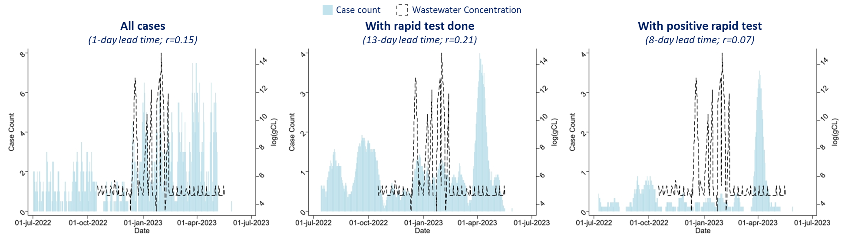
Figure C: Correlations between typhoid fever case counts and log-transformed wastewater concentrations
Note: The figures show the lag applied to case data that maximized the Spearman rank correlation coefficient (r) between log-transformed wastewater concentrations of S. Typhi and clinical case counts. The range of lags examined ranged from -14 days to 14 days.
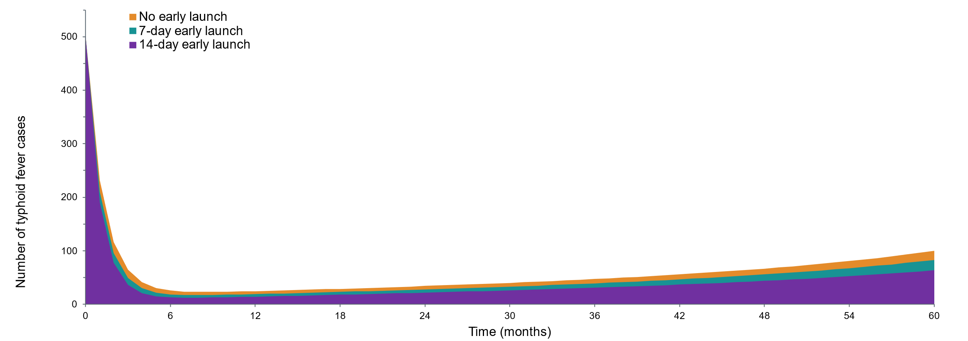
Figure D: Number of typhoid cases by month by vaccination campaign launch time
Table D: Cumulative net benefits over a 5-year period, by vaccination campaign launch time
Vaccine campaign launch | Cumulative net benefits by year end,  in 1000’s of U.S. dollars (present value)
Vaccine campaign launch | Year 1 | Year 2 | Year 3 | Year 4 | Year 5
Day -1 | -158 | -317 | -391 | -457 | -507
Day -2 | -117 | -257 | -310 | -346 | -362
Day -3 | -78 | -195 | -225 | -238 | -215
Day -4 | -39 | -139 | -146 | -128 | -68
Day -5 | -3 | -80 | -64 | -18 | 81
Day -6 | 32 | -26 | 16 | 91 | 232
Day -7 | 69 | 31 | 95 | 197 | 381
Day -8 | 104 | 86 | 172 | 305 | 530
Day -9 | 137 | 139 | 249 | 414 | 681
Day -10 | 173 | 194 | 324 | 519 | 830
Day -11 | 205 | 247 | 400 | 626 | 979
Day -12 | 240 | 297 | 475 | 728 | 1,125
Day -13 | 270 | 348 | 547 | 829 | 1,271
Day -14 | 303 | 394 | 619 | 931 | 1,416
Note: The table shows the values plotted in Figure 1. Cumulative net benefits were calculated as summed benefits minus summed costs, and were converted to present values (i.e., 2023 dollars) using a 10% discount rate. Negative values indicate that cumulative costs were higher than cumulative benefits by the end of the year shown.

References
1 Diamond MB, Keshaviah A, Bento AI, et al. Wastewater surveillance of pathogens can inform public health responses. Nat Med. 2022;28:1992–5.
2 Bangladesh Bureau of Statistics. Bangladesh Bureau of Statistics Report. 2019. https://bbs.portal.gov.bd/sites/default/files/files/bbs.portal.gov.bd/page/a1d32f13_8553_44f1_92e6_8ff80a4ff82e/2020-05-15-09-25-dccb5193f34eb8e9ed1780511e55c2cf.pdf (accessed 28 November 2023)
3 UN DESA. UN World Population Prospects: The 2022 Revision – Bangladesh. 2022. https://desapublications.un.org/file/989/download (accessed 28 November 2023)
4 Lo NC, Gupta R, Stanaway JD, et al. Comparison of Strategies and Incidence Thresholds for Vi Conjugate Vaccines Against Typhoid Fever: A Cost-effectiveness Modeling Study. J Infect Dis. 2018;218:S232–42.
5 Qayum MdO, Billah MM, Sarker MFR, et al. Oral cholera vaccine coverage evaluation survey: Forcibly Displaced Myanmar Nationals and host community in Cox’s Bazar, Bangladesh. Front Public Health. 2023;11. doi: 10.3389/fpubh.2023.1147563
6 Qadri F, Khanam F, Liu X, et al. Protection by vaccination of children against typhoid fever with a Vi-tetanus toxoid conjugate vaccine in urban Bangladesh: a cluster-randomised trial. The Lancet. 2021;398:675–84.
7 Lightowler MS, Manangazira P, Nackers F, et al. Effectiveness of typhoid conjugate vaccine in Zimbabwe used in response to an outbreak among children and young adults: A matched case control study. Vaccine. 2022;40:4199–210.
8 Olesen SW, Imakaev M, Duvallet C. Making waves: Defining the lead time of wastewater-based epidemiology for COVID-19. Water Res. 2021;202:117433.
9 Yu AT, Amin N, Rahman MW, et al. Case-Fatality Ratio of Blood Culture–Confirmed Typhoid Fever in Dhaka, Bangladesh. J Infect Dis. 2018;218:S222–6.
10 Garrett DO, Longley AT, Aiemjoy K, et al. Incidence of typhoid and paratyphoid fever in Bangladesh, Nepal, and Pakistan: results of the Surveillance for Enteric Fever in Asia Project. Lancet Glob Health. 2022;10:e978–88.
11 World Bank. Insights from the Labor Module on Work and Wages in Cox’s Bazar. Washington DC 2019. http://hdl.handle.net/10986/35774 (accessed 30 October 2023)
12 Patrinos HA, Psacharopoulos G. Returns to education in developing countries. The Economics of Education. Elsevier 2020:53–64. https://doi.org/10.1016/B978-0-12-815391-8.00004-5
13 World Bank. GNI per capita, Atlas method (current US$) – Bangladesh: World Bank national accounts data, and OECD National Accounts data files. https://data.worldbank.org/indicator/NY.GNP.PCAP.CD?locations=BD (accessed 11 November 2023)
14 Hasan MdZ, Mehdi GG, De Broucker G, et al. The economic burden of diarrhea in children under 5 years in Bangladesh. International Journal of Infectious Diseases. 2021;107:37–46.
15 Robinson LA, Hammitt JK, O’Keeffe L. Valuing Mortality Risk Reductions in Global Benefit-Cost Analysis. J Benefit Cost Anal. 2019;10:15–50.

