Supplementary Materials
Calcification depth of N. pachyderma (s) in core IS-1B and its sensitivity to surface cold water mass signal
It has been reported that modern N. pachyderma (s) calcifies between 70-250 m off the Norway coast beneath the Atlantic inflow; in contrast, further west N. pachyderma (s) prefers near surface water between 20-50 m in the Arctic domain and 70-130 m of the western Nordic Seas confined by the East Greenland Current¹. Consequently, the water depth of N. pachyderma (s) chamber formation is related to the stratification/structure of the water column and is highly variable around the study area^{2,3}. According to the youngest age control point (depth at 6 cm, 1.12 ka BP) and the calibration of the Bacon age model, we assumed that the N. pachyderma (s) in IS-1B core-top was deposited in modern times (0.22 ka BP). Then the regional gradient of the predicted equilibrium δ¹⁸O of calcite above 300m water depth was constructed from the modern vertical profile of ambient seawater oxygen isotope (δ¹⁸O_{sw}) and temperature based on Eq. 2⁴, in order to compare with the shells δ¹⁸O (δ¹⁸O_{c}) of core-top N. pachyderma (s) in IS-1B. As there are sparse instrumental δ¹⁸O_{sw} data in our study region, we calculated the δ¹⁸O_{sw} taking advantage of World Ocean Atlas 2018⁵ mean summer salinity data (considering the N. pachyderma (s) is summer bloom species^{4,6}) through Eq. 5¹. The results revealed that the core-top shell δ¹⁸O_{c} fit well with the predicted δ¹⁸O_{c} in 50 m water depth, consistent with a mean N. pachyderma (s) calcification depth of 50 m in the modern IS-1B sea area (Suppl. Fig 1). Given that the temperature amplitudes of this calcification depth clearly exist in the low temperature layer below the thermocline, and combined with the calcification depth of N. pachyderma (s) in other part of the Nordic Seas, especially in areas dominated by the Atlantic inflow, we conclude that N. pachyderma (s) in the Nordic Seas is more prone to thrive in deeper and cold habitats. Therefore, we considered the evidence in N. pachyderma (s) calcites as appropriate for converting the signal of surface cold water masses in the past Nordic Seas.
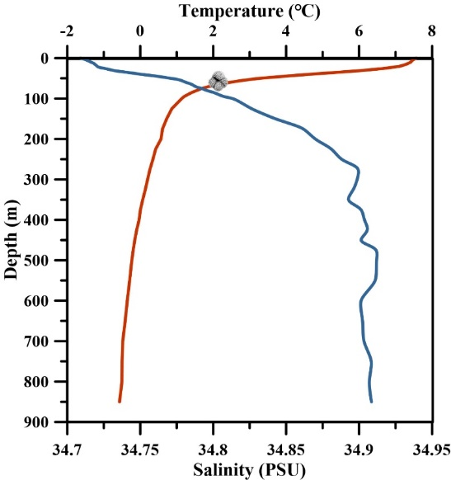
Suppl. Fig 1. Upper water column temperature, and salinity profile at the site of core IS-1B (summer of 2018). The red line and blue lines indicate temperature and salinity respectively (World Ocean Atlas, 2018^{5,7}. The foraminiferal dot indicates the temperature at the calcification depth of core-top N. pachyderma (s).
Comparison of Mg/Ca temperatures equations
At present, there is no consensus regarding Mg/Ca-temperature calibration methods for N. pachyderma (s) in previous related research on the Nordic Seas². Consequently, we used different species-specific calibrations including three equations:

Mg/Ca = 0.55 exp (0.099×T) (1)

Mg/Ca = 0.52 exp (0.10×T) (suppl. 1)

Mg/Ca = 0.13(±0.0.037)T+0.35(±0.17) (suppl. 2)
Comparison of converted core-top Mg/Ca temperature to the instrumental temperature in the calcification depth of N. pachyderma (s) allowed assessment of the most suitable equation for our study site. Eq. 1⁸ yields the minimum difference of 0.21 ℃ contrast with approaches established on Eq. suppl. 1⁹ and suppl. 2². As a result, we considered that the calibration after Eq. 1 matches best with the samples selected from core IS-1B.
TraCE Experiments
In the late stage of LGM, the climate in Nordic Seas may have been influenced remotely by climate change in the North Atlantic. To understand the role of large-scale ocean-atmosphere circulations in the evolution of the Nordic Seas and Eurasian ice sheets during this period, we refer to the results of TraCE simulations^{10,11} to elucidate the remote North Atlantic forcing, which was relevant to the solar activities.
The TraCE transient climate experiments were performed in the Community Climate System Model ver. 3^{12–14} (CCSM3), a global coupled atmosphere-ocean-sea ice-land general circulation model (AOGCM) that has a latitude–longitude resolution of ∼3.75° in the atmosphere (i.e. over land and sea) and ∼3° in the ocean and includes a dynamic global vegetation module. The prescribed forcings and boundary conditions for the all-forcing simulation included orbitally forced insolation changes, increasing atmospheric concentrations of the long-lived greenhouse gases, and retreating ice sheets and associated meltwater release to the oceans^{10,11}. Meanwhile, the transient sensitivity experiments adopt a factorized forcing scheme to allow isolating each of these forcings separately¹⁵.
We extracted the simulation results of both single isolated forcing and all forcing from 22-20ka BP. The all forcing simulations show an increase in 850 hPa wind velocity south of Iceland, along with a significant intensification of cyclonic circulation (Suppl. Fig 2A). Furthermore, by comparing isolated forcing simulations, we found that the isolated insolation forcing contributes more to the enhancement of the 850 hPa wind velocity and also notably drives a strengthen atmospheric circulation in cyclone direction (Suppl. Fig 2B). Therefore, we speculate that the changes in solar insolation are the principal factor to drive the enhanced 850 hPa cyclonic circulation in this interval.
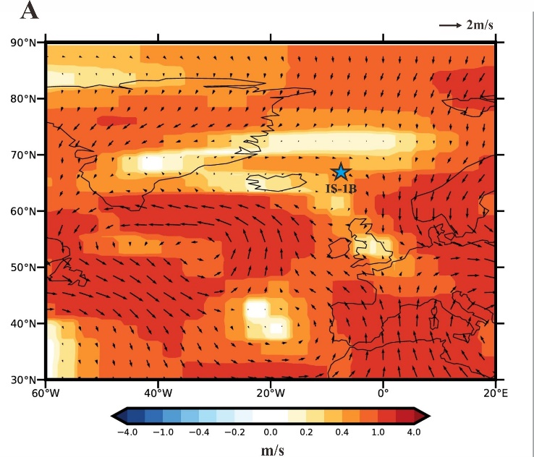 | 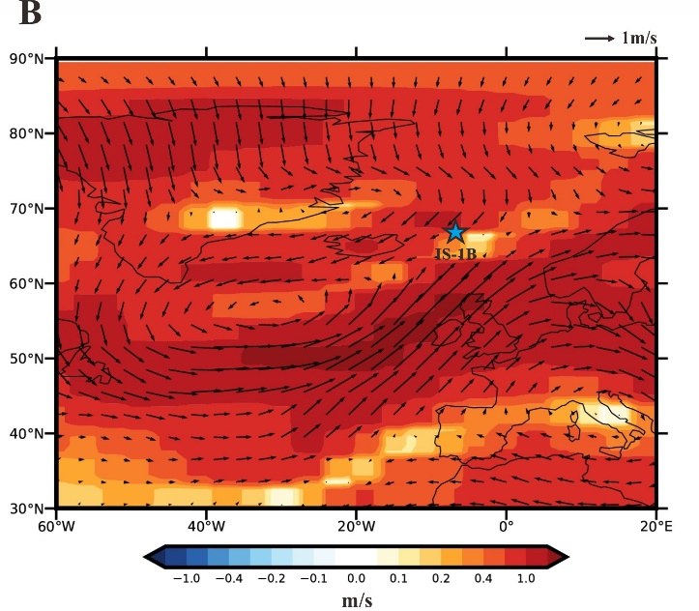
Suppl. Fig 2. Comparison of hydroclimate changes simulated by isolated forcing and all forcing in TraCE experiment. A. Winter anomaly of 850 hPa wind (20-22 ka BP) simulated by all forcing. B. Winter anomaly of 850 hPa wind (20-22 ka BP) simulated by orbital forcing only.

Supplementary References
1. Simstich, J., Sarnthein, M. & Erlenkeuser, H. Paired δ18O signals of Neogloboquadrina pachyderma (s) and Turborotalita quinqueloba show thermal stratification structure in Nordic Seas. Mar Micropaleontol 48, 107–125 (2003).
2. Kozdon, R., Eisenhauer, A., Weinelt, M., Meland, M. Y. & Nürnberg, D. Reassessing Mg/Ca temperature calibrations of Neogloboquadrina pachyderma (sinistral) using paired δ 44/40 Ca and Mg/Ca measurements. Geochemistry, Geophysics, Geosystems 10, (2009).
3. Jonkers, L., Brummer, G.-J. A., Peeters, F. J. C., van Aken, H. M. & De Jong, M. F. Seasonal stratification, shell flux, and oxygen isotope dynamics of left-coiling N. pachyderma and T. quinqueloba in the western subpolar North Atlantic. Paleoceanography 25, 1–13 (2010).
4. Nyland, B. F., Jansen, E., Elderfield, H. & Andersson, C. Neogloboquadrina pachyderma (dex. and sin.) Mg/Ca and δ 18 O records from the Norwegian Sea. Geochemistry, Geophysics, Geosystems 7, (2006).
5. Zweng, M. M. et al. World ocean atlas 2018, volume 2: Salinity. NOAA Atlas NESDIS 82, 50pp (2019).
6. Kohfeld, K. E., Fairbanks, R. G., Smith, S. L. & Walsh, I. D. Neogloboquadrina pachyderma (sinistral coiling) as paleoceanographic tracers in polar oceans: Evidence from Northeast Water Polynya plankton tows, sediment traps, and surface sediments. Paleoceanography 11, 679–699 (1996).
7. Locarnini, R. A. et al. World ocean atlas 2018, volume 1: Temperature. NOAA Atlas NESDIS 81, 52pp (2018).
8. Nuernberg, D. Magnesium in tests of Neogloboquadrina pachyderma sinistral from high northern and southern latitudes. The Journal of Foraminiferal Research 25, 350–368 (1995).
9. Elderfield, H. & Ganssen, G. Past temperature and δ18O of surface ocean waters inferred from foraminiferal Mg/Ca ratios. Nature 405, 442–445 (2000).
10. Liu, Z. et al. Transient Simulation of Last Deglaciation with a New Mechanism for Bølling-Allerød Warming. Science (1979) 325, 310–314 (2009).
11. Liu, Z. et al. Younger Dryas cooling and the Greenland climate response to CO 2. Proceedings of the National Academy of Sciences 109, 11101–11104 (2012).
12. Otto-Bliesner, B. L. et al. Climate Sensitivity of Moderate- and Low-Resolution Versions of CCSM3 to Preindustrial Forcings. J Clim 19, 2567–2583 (2006).
13. Collins, W. D. et al. The Community Climate System Model Version 3 (CCSM3). J Clim 19, 2122–2143 (2006).
14. Yeager, S. G., Shields, C. A., Large, W. G. & Hack, J. J. The Low-Resolution CCSM3. J Clim 19, 2545–2566 (2006).
15. He, C. et al. Hydroclimate footprint of pan-Asian monsoon water isotope during the last deglaciation. Sci Adv 7, 1–11 (2021).

