SUPPLEMENTARY INFORMATION

Human miRNome profiling and functional analysis reveal hsa-miR-1246 involvement in adenoma-carcinoma sequence via WNT signaling pathway
Juzenas et al.

SUPPLEMENTARY FIGURES

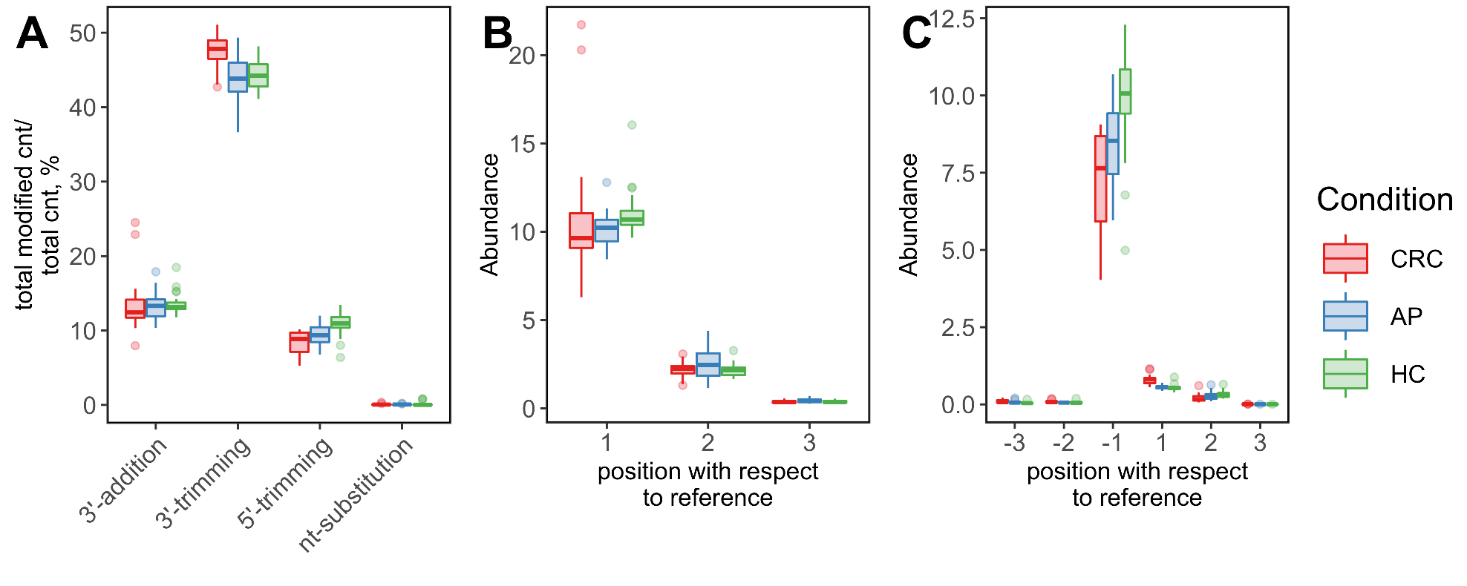
Supplementary Fig. 1. Distributions of isomiR modification types across colorectal cancer (CRC), adenomatous polyps (AP) patients and healthy controls (HC). Boxplots showing: A) abundance of modification types; B) abundance of 3’ addition modification; C) abundance of 5’ trimming modification.

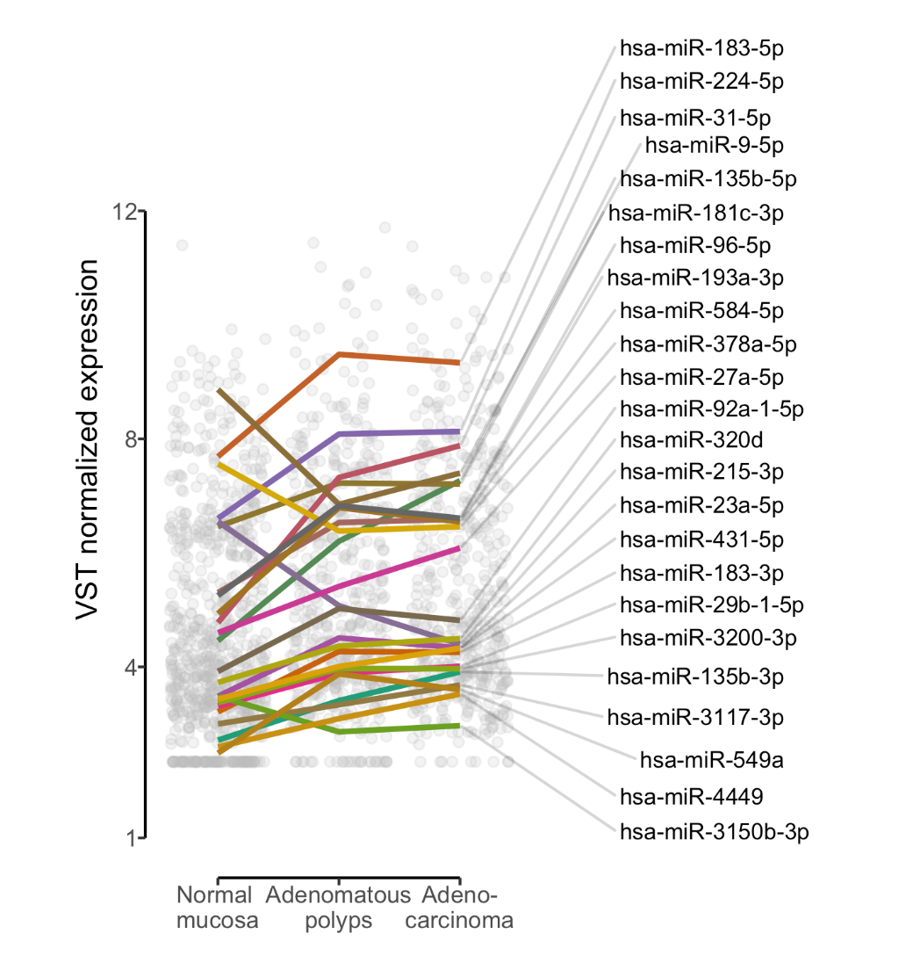
Supplementary Fig. 2. Gradual expression of miRNAs in polyp-to-cancer sequence. Moderately correlating (Sprearman’s 0.5 < r < 0.7) miRNAs with the stages of healthy-to-polyp-to-cancer sequence. Spearman correlation analysis was performed on variance stabilization transformed (VST) counts.
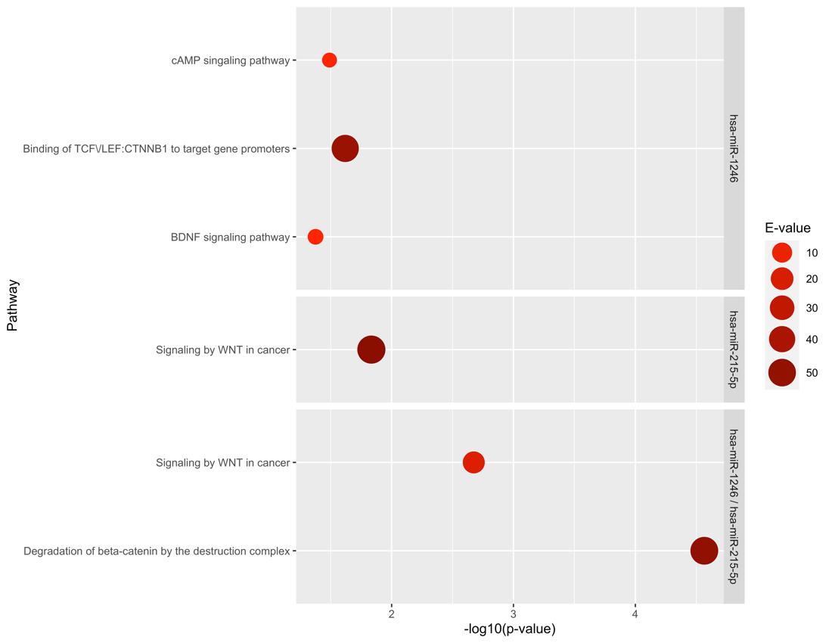
Supplementary Fig. 3. Target gene set enrichment analysis (GSEA) results. Analysis was performed using miTALOS v2 using default settings. Pathways with P_{FDR} < 0.05 and enrichment score (E-value) > 1 were considered as significantly overrepresented among hsa-miR-1246 and/or hsa-miR-215 target genes.

