Supplementary Material:
Space-based Reflectors for Night-time Illumination and Enhancing Solar Power Generation over India
Sai Krishna V. S. Sakuru¹ • M.V. Ramana^{1,}*
¹National Remote Sensing Centre, Hyderabad, India

This file includes:
Supplementary Figures: 5
Supplementary Tables: 1
Supplementary Figure 1
Reflected solar power density and size of reflector. Relation between the solar power density of reflected radiation at the surface and the diameter of a space-based orbiting solar reflector is illustrated for (a) low-earth orbits, and (b) higher orbits including geostationary orbit.
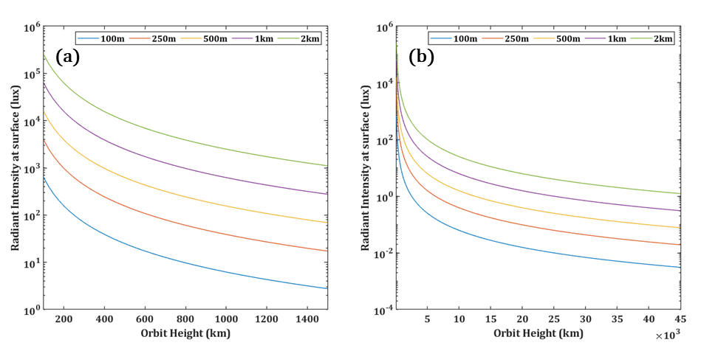
Supplementary Figure 2
Reflected solar power density and size of illuminated spot. Relation between the solar power density of reflected radiation at the surface and diameter of the illuminated spot at the surface for a space-based orbiting solar reflector with 1 km diameter is illustrated for (a) low-earth orbits, and (b) higher orbits including geostationary orbit.
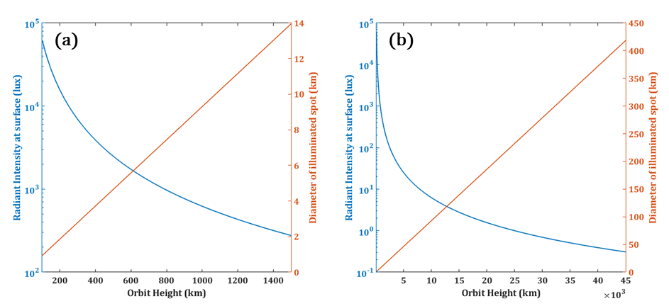

Supplementary Figure 3
Illumination at equator and New Delhi. Diurnal variations in the illumination / solar power density from sunlight reflected by a constellation of orbiting solar reflectors with diameter of 1 km and in geostationary orbit, optimized for illumination at (a) equator (0° N, 77.1787° E), and (b) New Delhi (28.6529° N, 77.1787° E), are depicted for the summer equinox and summer solstice of 2024. Blue and red lines respectively indicate illumination from the baseline (minimum of 2 lux for clear-sky conditions) and desired (minimum of 8 lux for clear-sky conditions) constellations.
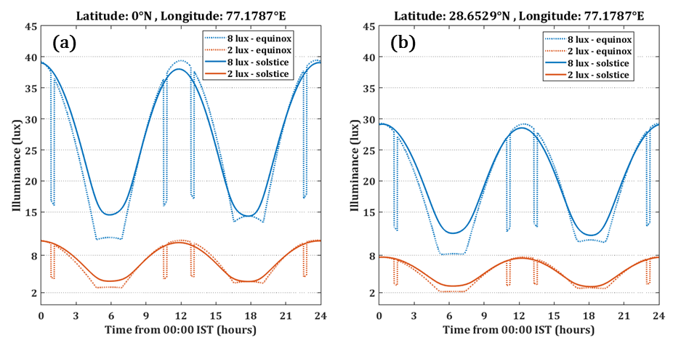
Supplementary Figure 4
Profiles of reflected solar power density, elevation and slant range at Equator. Profiles of the (a) Power density, (b) Elevation, and (c) Slant Range, for an orbiting solar reflector with diameter of 1 km and in a sun-synchronous orbit at 1000 km altitude, reflecting solar energy to different positions of a solar power park.
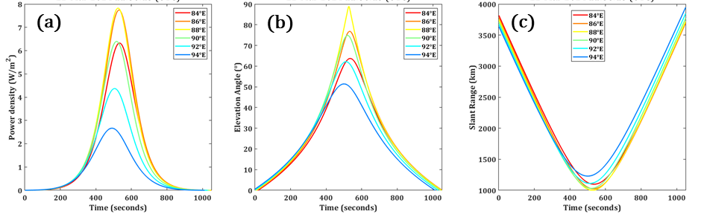
Supplementary Figure 5
Profiles of reflected solar power density at major solar power sites in India. Profiles of the power density of solar radiation reflected from an orbiting solar reflector with diameter of 1 km and in a sun-synchronous orbit at 1000 km altitude, are depicted for dusk pass over solar power parks located at (a) Gujarat (23° N, 71° E), (b) Rajasthan (28° N, 72.5° E), and (c) Andhra Pradesh (14.75° N, 78° E).
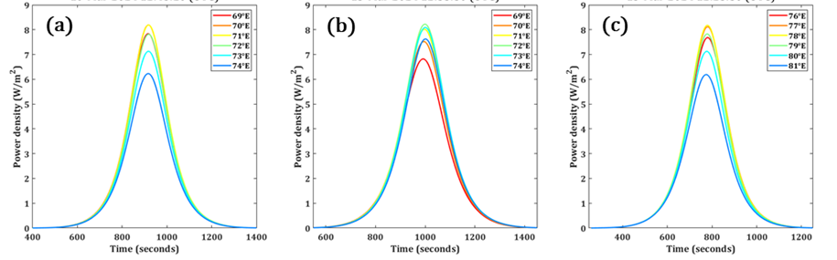
Supplementary Table 1
Solar Capacity from Solar Parks / UMREPPs in India. Status of the installed capacity for solar power through development of Solar Parks / Ultra Mega Renewable Energy Power Projects (UMREPPs) as of April, 2024 [52].
S. No. | State | Total  Capacity (MW) | Capacity  Commissioned (MW)
1 | ALL INDIA | 39,785 | 11,316
2 | Andhra Pradesh | 4,200 | 3,050
3 | Chhattisgarh | 100 | 100
4 | Gujarat | 12,150 | 975
5 | Himachal Pradesh | 53 | 0
6 | Jharkhand | 1,089 | 0
7 | Karnataka | 2,500 | 2,000
8 | Kerala | 155 | 100
9 | Madhya Pradesh | 4,780 | 1,550
10 | Maharasthra | 1,100 | 0
11 | Mizoram | 20 | 20
12 | Odisha | 340 | 0
13 | Rajasthan | 9,658 | 3,091
14 | Uttar Pradesh | 3,730 | 430

