Supplementary figures

Figure S1: Gating strategy for Treg identification by Flow cytometry. Liver and spleen cells were isolated from their respective organs and stained with a viability dye and various lineage markers. Gating strategy aimed at quantifying the presence of FoxP3+ CD25+ T cells is illustrated.
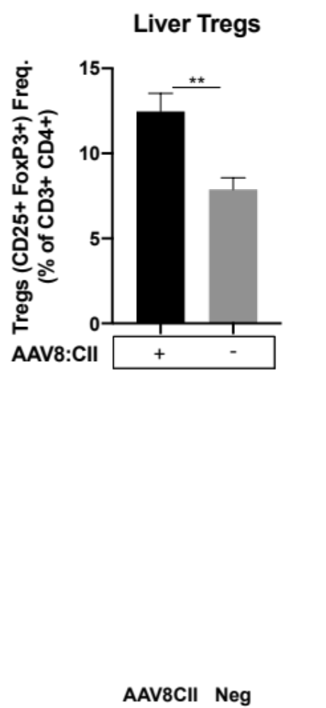

Figure S2: Treg depletion efficiency following PC61 administration. Mice (n=3/group) were injected intraperitoneally with 0.75mg of PC61 antibody or an equivalent volume of phosphate buffered saline. 10 days after the injection, splenocytes were isolated and the quantities of CD25+ FoxP3+ Tregs in the population of CD4+ CD3+ T cells were compared. Mean Treg frequency +/- SEM are depicted.

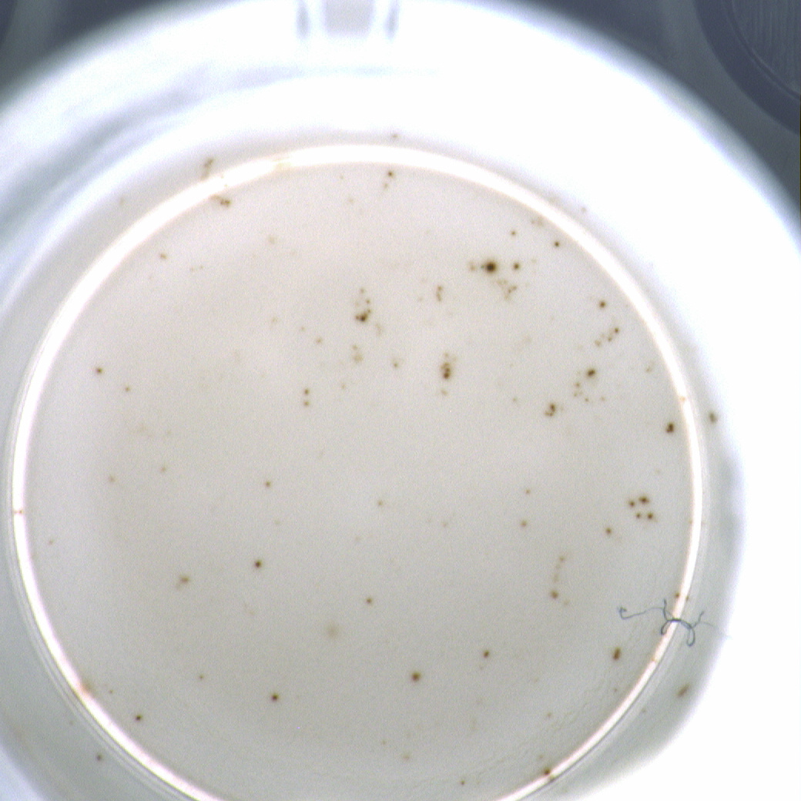
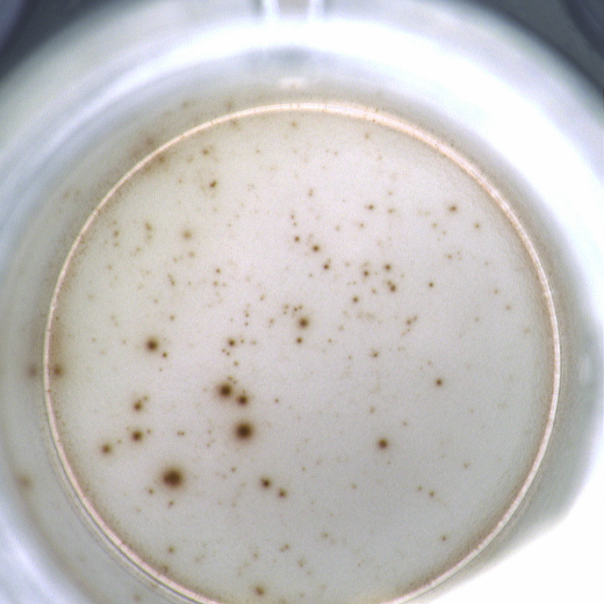
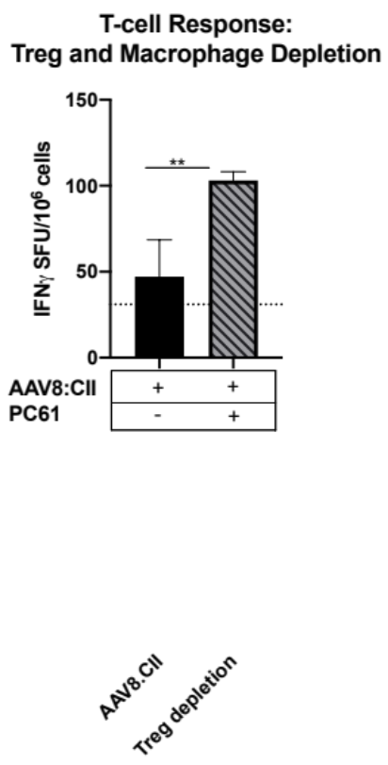
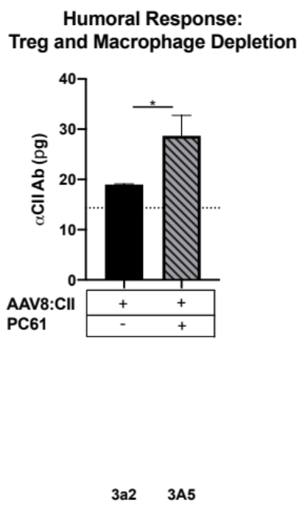
AAV8.CII
PC61
Treg Depletion:
AAV8.GFP/CII
Euthanasia
10/28 days
PC61
7 days

Figure S3: Treg depletion increased cellular and humoral responses against CII. (A) Mice (n=3/group) were injected intravenously with 10¹¹ VG of AAV8.CII. At Day 7 Mice were injected intraperitoneally with saline or 0.75 mg of PC61 anti-CD25 antibody. (B) 10 days after PC61 injection liver non-parenchymal cells were isolated and stimulated with CII and IFN𝛄 production was measured by ELISPOT (C) 28 days post PC61 injection, anti-CII IgG levels were measured using ELISA. Background values are indicated by a horizontal dashed line. Mean +/- SEM is illustrated for both assays.

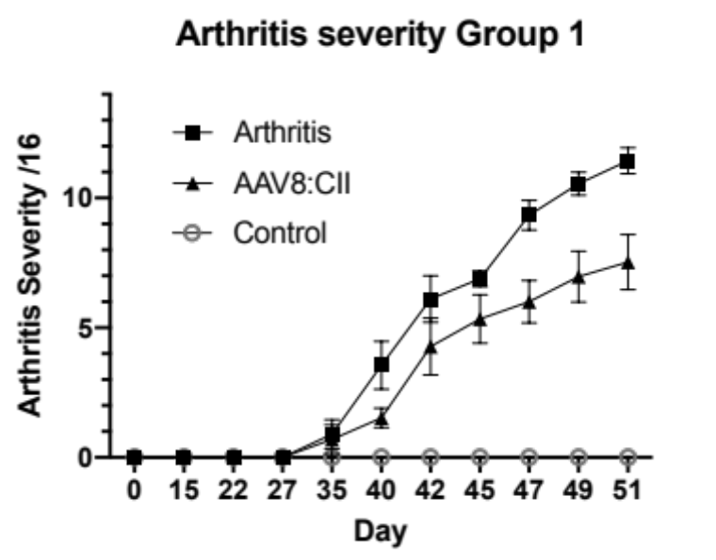

Figure S4: AAV8.CII Prophylaxis reduced severity of arthritis. Peripheral inflammation was measured in the paws of arthritis mice (n=5/group) every 2-3 days. Data presented is the summation of the four paws to a maximum inflammation score of 16 per day.

