Supplementary Information
A Tungsten Polyoxometalate Mediated Aqueous Redox Flow Battery with High Voltage of 2 V

- CV curves of H-PW₁₂, 1Na-PW₁₂ and 2Na-PW₁₂ for different test potential windows at a scan rate of 50 mV s⁻¹.

- CV curves of 0.1 mol l⁻¹ nNa-PW12(n=4, 5, 6, 7, 8, 9) at scan rate of 50 mV s⁻¹.

- The UV-Vis spectrum of 0.00033 mol l⁻¹ H-PW₁₂, 1Na, 2Na and 3Na-PW₁₂.

- Raman spectrums of nNa-PW₁₂(n=4, 5, 6, 7, 8, 9).
nNa-PW12 (n=4, 5, 6, 7, 8, 9) was prepared based on the mole ratio of NaOH and PW₁₂.

- The decomposition pathway of PW₁₂.
- Subunit structure of 0e⁻ PW₁₂.

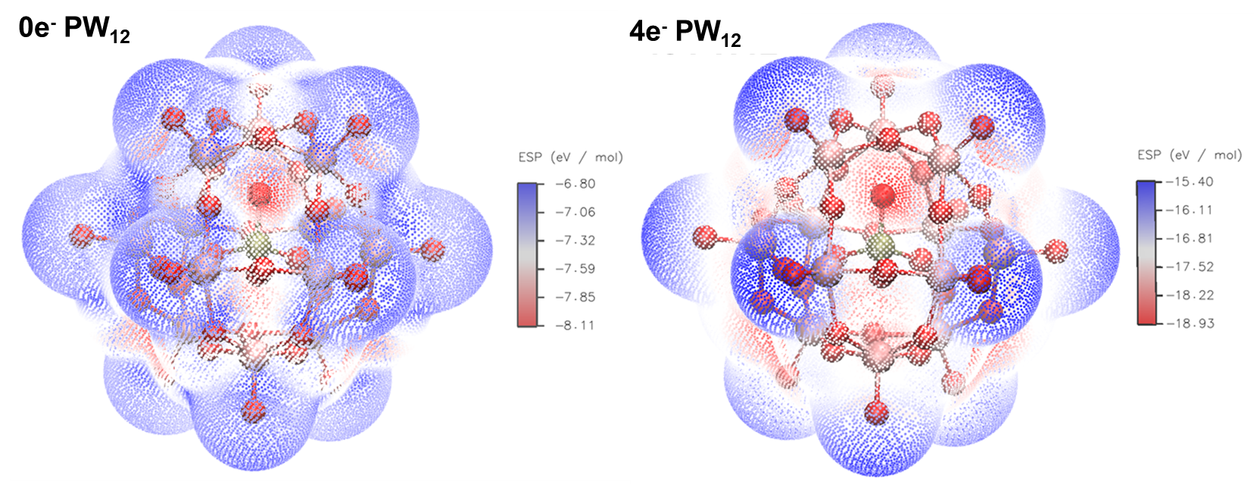
- Electron static potential (ESP) distribution of 0e⁻ PW₁₂ and 4e⁻ PW₁₂.

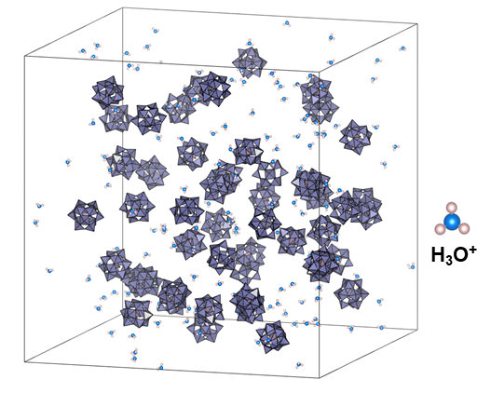
- Snapshot of a representative 3D-periodic simulation box for 0e⁻ PW₁₂ MD simulations.

- POM-Na⁺ radial distribution functions (RDFs) computed from classical MD simulations taking as reference the center of mass of each PW₁₂.

- POM-POM radial distribution functions (RDFs) computed from classical MD simulations taking as reference the center of mass of each PW₁₂.

- The peak current density as a function of square root of scan rate obtained from Fig. 5a. a, the first oxidation peak. b, the first reduction peak.

- Electrochemical kinetics of H-PW₁₂. a) CV curves of 0. 1 mol l⁻¹ H-PW₁₂ with different scan rate. b) RDE test with different rotation speed, c) Levich plot, d) Koutecky–Levich plots and e) Butler–Volmer plot of 0.01 mol l⁻¹ H-PW₁₂ f) diffusion coefficient of 0.01 mol l⁻¹ H-PW₁₂ and 3Na-PW₁₂

- GCD curve of 0.3 mol l⁻¹ H-PW₁₂-I₂ at current density of 25 mA cm⁻²

- Discharge polarization curve of 0.3 mol l⁻¹ H-PW₁₂-I₂.

- The GCD curves of cycle performance (0.1 mol l⁻¹ 3Na-PW12-I₂) at current density of 50 mA cm⁻².

- a, UV-Vis of 0.00033 mol l⁻¹ H, 1Na, 2Na, 3Na and 4Na-SiW₁₂. b, Raman spectrums of H, 1Na, 2Na, 3Na and 4Na-SiW₁₂.

- CV curve of 0.1 mol l⁻¹ reduced 4Na-SiW12 at scan rate of 50 mV s⁻¹.

- Electrochemical performance of 4Na-SiW₁₂ Flow battery. a, GCD curve of 0.1 mol l⁻¹ 4Na-SiW₁₂- I₂ at 25 mA cm⁻². b) pH changes of 4Na-SiW₁₂ in the GCD process.

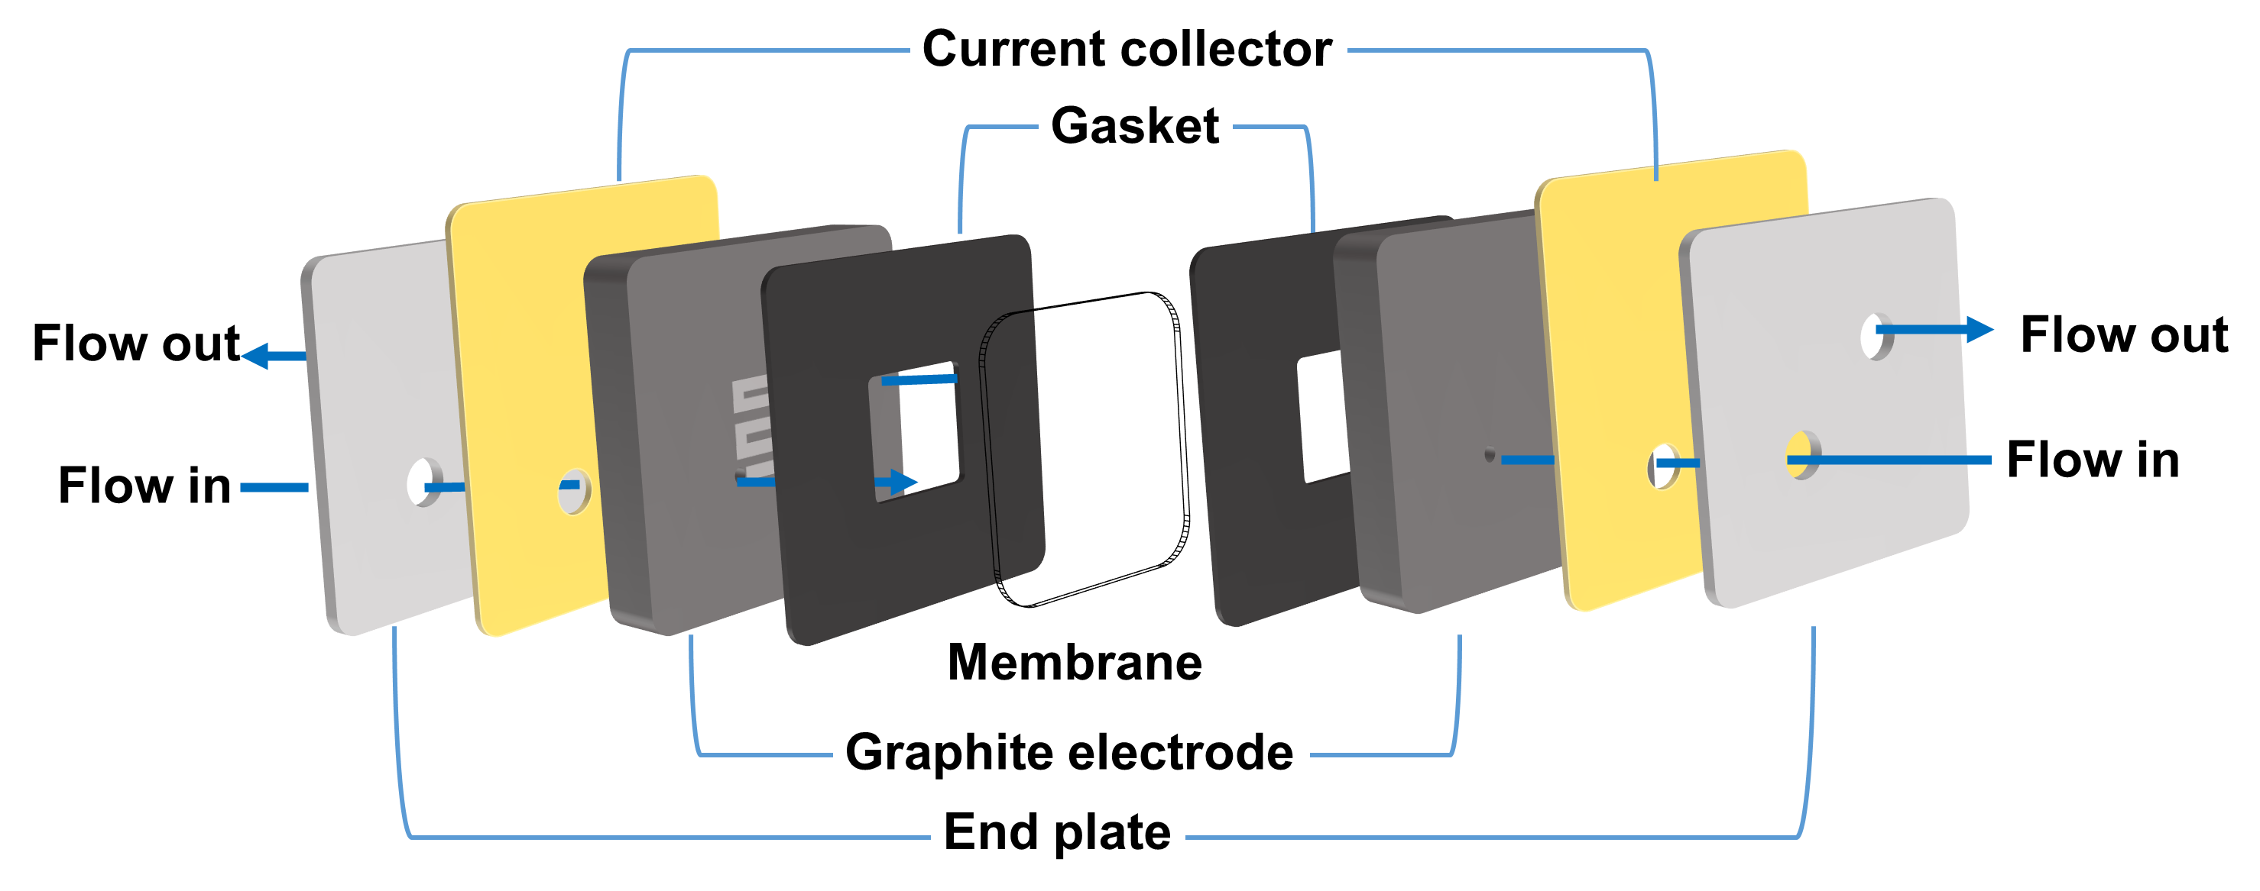
- The structure of the flow battery.
The flow battery used in experiment was homemade with engraving machine. The battery was assembled with membrane, gasket, graphite electrode (10 mm thick), current collector (Cu, 1.5 mm thick) and end plate (PP, 5 mm thick). The flow field is 1 mm deep ‘S' type field. Two different flow field sizes 9 cm⁻² and 16 cm⁻² were prepared. Nafion 117 was used as the membrane in the experiment without pretreatment.

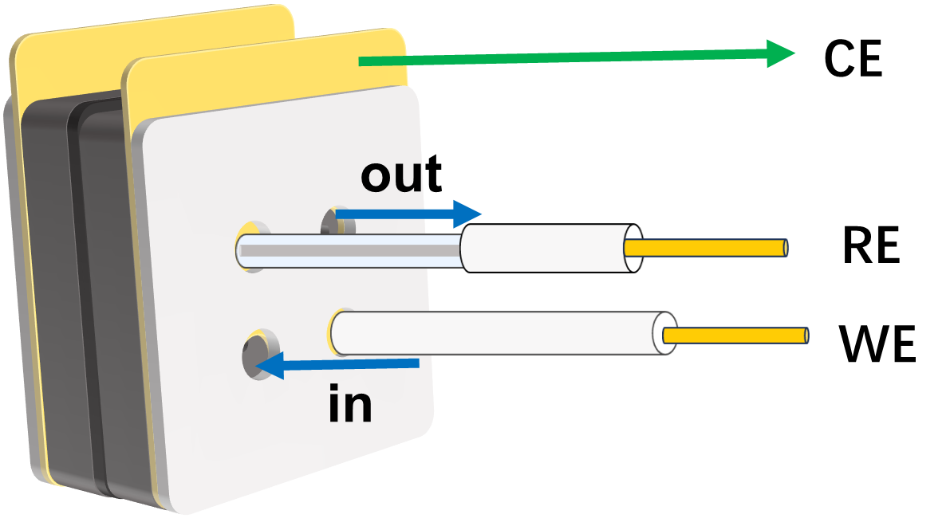
- The Structure of flow battery for in-suit electrochemical monitor.
The CV and electrode potential monitor were carried out using Ag/AgCl (saturated KCl) electrode and GC electrode as reference electrode and working electrode. The test was carried out at current density of 25 mA cm⁻² in 0.1 mol l⁻¹ 3Na-PW₁₂. 1 mol l⁻¹ NaI was used as catholyte.

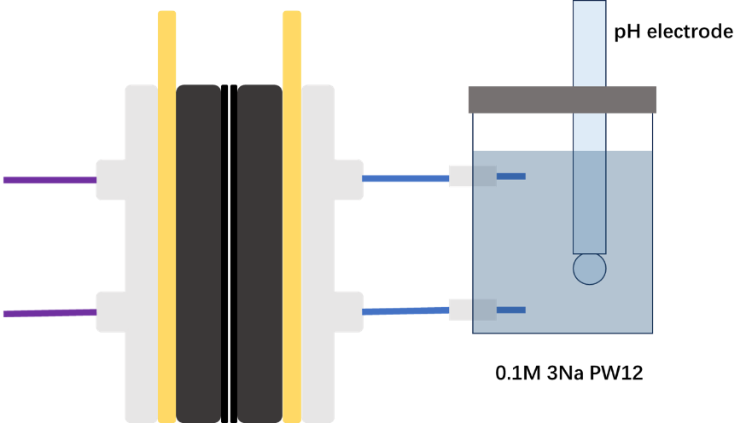
- The illustration of pH monitor.
The test was carried out in 0.1 mol l⁻¹ 3Na-PW₁₂ solution at current density of 25 mA cm⁻².1 mol l⁻¹ NaI (pH 1.35) was used as catholyte.

Potential of redox pairs.
Redox pair |  | Potential (V vs. SHE) | Condition | Reference
PW₁₂⁴⁻/PW₁₂⁵⁻ | -0.07 |  | Acid | ¹
SiW₁₂⁵⁻/SiW₁₂⁶⁻ | -0.25 |  | Acid | ²
V²⁺/V³⁺ | -0.27 |  | Acid | ³
P₂W₁₈¹⁰⁻/P₂W₁₈¹²⁻ | -0.31 |  | Acid | ³
Fe/Fe²⁺ | -0.44 |  | near neutral | ⁴
BW₁₂⁶⁻/BW₁₂⁷⁻ | -0.46 |  | pH 1-8 | ⁵
CoW₁₂⁸⁻CoW₁₂¹⁰⁻ | -0.47 |  | pH4 | ⁶
PW₁₂⁵⁻/PW₁₂⁶⁻ | -0.51 |  | near neutral | This work
SiW₁₂⁶⁻/SiW₁₂⁷⁻ | -0.70 |  | near neutral | This work
Zn/Zn²⁺ | -0.76 |  | near neutral | ⁷
PW₁₂⁶⁻/PW₁₂⁷⁻ | -0.78 |  | near neutral | This work
SiW₁₂⁷⁻/SiW₁₂⁸⁻ | -0.99 |  | near neutral | This work
PW₁₂⁷⁻/PW₁₂⁸⁻ | -1.1 V |  | near neutral | This Work

pH of 0.1 mol l⁻¹ 1Na, 2Na and 3Na -PW₁₂.
 | pH
1Na-PW₁₂ | 0.8
2Na-PW₁₂ | 1.0
3Na-PW₁₂ | 1.3

The viscosity of the electrolyte.
 | kinematic viscosity (cm² s²)
0.01 mol l⁻¹ H-PW₁₂ | 0.00879
0.01 mol l⁻¹ 3Na-PW₁₂ | 0.00904

Electron numbers of POMs redox pair in flow battery.
POM | Electron numbers | Atomic utilization(%) | Reference
PW₁₂ | 2 | 16.7 | ¹
BW₁₂ | 2 | 16.7 | ⁵
SiW₁₂ | 2 | 16.7 | ²
PV₁₄ | 4 | 28.6 | ²
P₂W₁₈ | 18 | 100 | ⁸
CoW₁₂ | 4 | 33.3 | ⁶
SiW₉V₃ | 3 | 25.0 | ⁹
3Na PW₁₂ | 5 | 41.7 | This work
4Na SiW₁₂ | 4 | 33.3 | This work

Rate performance of 0.1 mol l⁻¹ 3Na-PW₁₂ : 1 mol l⁻¹ NaI
Current density  (mA cm⁻²) | Specific Capacity (Ah L⁻¹) | Columbic efficiency (%)
20 | 8.3 | 95.65
30 | 7.8 | 97.15
40 | 7.2 | 97.76
50 | 6.4 | 98.22
60 | 5.5 | 98.65
100 | 2.3 | 98
(Electrolyte: 15 ml 1 mol l⁻¹ NaI: 15ml 0.1 mol l⁻¹ 3Na-PW₁₂)

References
1. Feng, T. et al. A redox flow battery with high capacity retention using 12-phosphotungstic acid/iodine mixed solution as electrolytes. Journal of Power Sources 436, 226831 (2019).
2. Friedl, J. et al. Asymmetric polyoxometalate electrolytes for advanced redox flow batteries. Energy Environ. Sci. 11, 3010–3018 (2018).
3. Ai, F. et al. Heteropoly acid negolytes for high-power-density aqueous redox flow batteries at low temperatures. Nat Energy 7, 417–426 (2022).
4. Song, Y. et al. Simultaneous Regulation of Solvation Shell and Oriented Deposition toward a Highly Reversible Fe Anode for All-Iron Flow Batteries. Small n/a, 2204356.
5. Yang, L. et al. POM Anolyte for All‐Anion Redox Flow Batteries with High Capacity Retention and Coulombic Efficiency at Mild pH. Advanced Materials 34, 2107425 (2022).
6. Yang, L. et al. Tuning the inner- and outer-sphere electron transfer behavior of aqueous {CoW12} polyoxometalate clusters for redox flow batteries exceeding 1.5V. Energy Storage Materials 65, 103149 (2024).
7. Xie, C., Liu, Y., Lu, W., Zhang, H. & Li, X. Highly stable zinc–iodine single flow batteries with super high energy density for stationary energy storage. Energy & Environmental Science 12, 1834–1839 (2019).
8. Chen, J.-J., Symes, M. D. & Cronin, L. Highly reduced and protonated aqueous solutions of [P2W18O62]6− for on-demand hydrogen generation and energy storage. Nature Chem 10, 1042–1047 (2018).
9. Pratt, H. D., Hudak, N. S., Fang, X. & Anderson, T. M. A polyoxometalate flow battery. Journal of Power Sources 236, 259–264 (2013).

