Supplementary

S1. Materials for custom picture description tasks
The stimuli were divided into 4 blocks of 100 drawings each, with a break provided after each block. The custom picture description task comprised 4 colored scene images, each containing a subset of 100 items. Figures 1-4 present these 4 scene images, and Tables 1-4 list the corresponding 100 target items in each scene.

Participants were presented with the pictures one by one and were given 5 minutes to describe what is happening in the picture using full sentences. Participants responses were audio-recorded and the audio was encoded as transcripts. These formatted transcripts served as inputs in FLAT (Zimmerer et al., 2018, 2020).

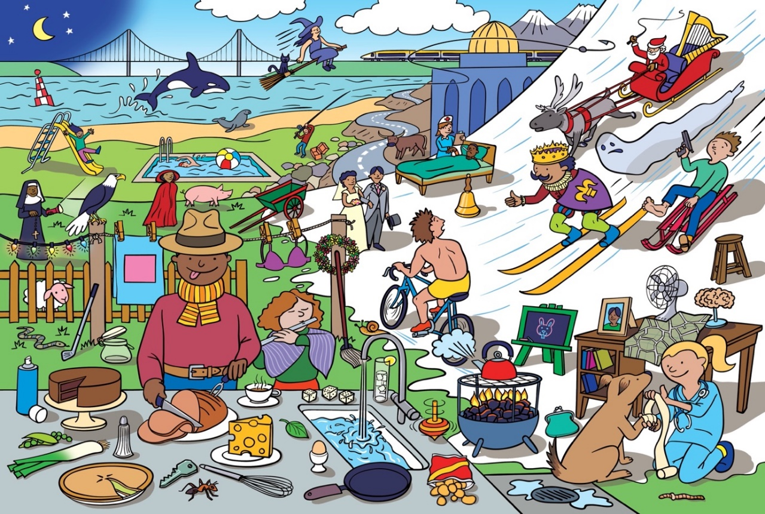
Figure 1. Picture 1 of 4 used in the custom picture description task.

Table 1. Target words embedded in Picture 1.
Picture 1: 100 items
ant | coal | hat | pig | spray
back | crisps | hook | pool | square
ball | cup | ice | purse | steam
beak | desk | jar | road | stool
bed | dice | key | rock | swim
bell | dome | king | rope | tap
belt | drain | knee | salt | thumb
bike | egg | knife | scarf | toe
board | fan | leaf | seal | tongue
bra | fence | leek | shawl | top
brain | fire | lights | sheep | torch
bride | flute | map | shelves | towel
bull | frame | moon | shield | train
buoy | ghost | mop | sink | vet
cake | girl | nun | skis | whale
cape | groom | nurse | sled | whip
cart | gun | pan | sleigh | whisk
cheese | ham | peas | slide | witch
claw | hand | peg | snail | worm
club | harp | pie | snake | wreath

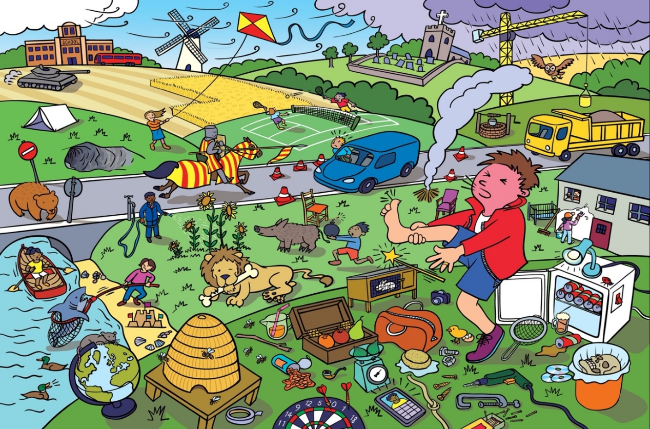
Figure 2. Picture 2 of 4 used in the custom picture description task.

Table 2. Target words embedded in Picture 2.
Picture 2: 100 items
bag | cone | hive | pear | smoke
beach | cot | hose | phone | sponge
bean | court | hutch | pin | stalk
bear | crane | jail | pipe | stick
bee | cross | jug | plant | straw
beer | dart | kite | rain | suit
bin | disc | knight | rat | switch
boar | drill | knot | ring | tank
bomb | duck | lamp | roof | tape
bone | ear | lens | scale | tent
box | fig | lion | school | tire
broom | foot | match | screen | tree
bug | fridge | mill | screw | truck
can | fruit | mouth | seat | van
cap | glass | net | shark | wall
cave | globe | nut | shell | wand
chair | grass | oar | shoe | well
chick | grave | owl | sieve | wheat
clamp | head | paint | sign | wind
coach | hinge | paw | skull | zip

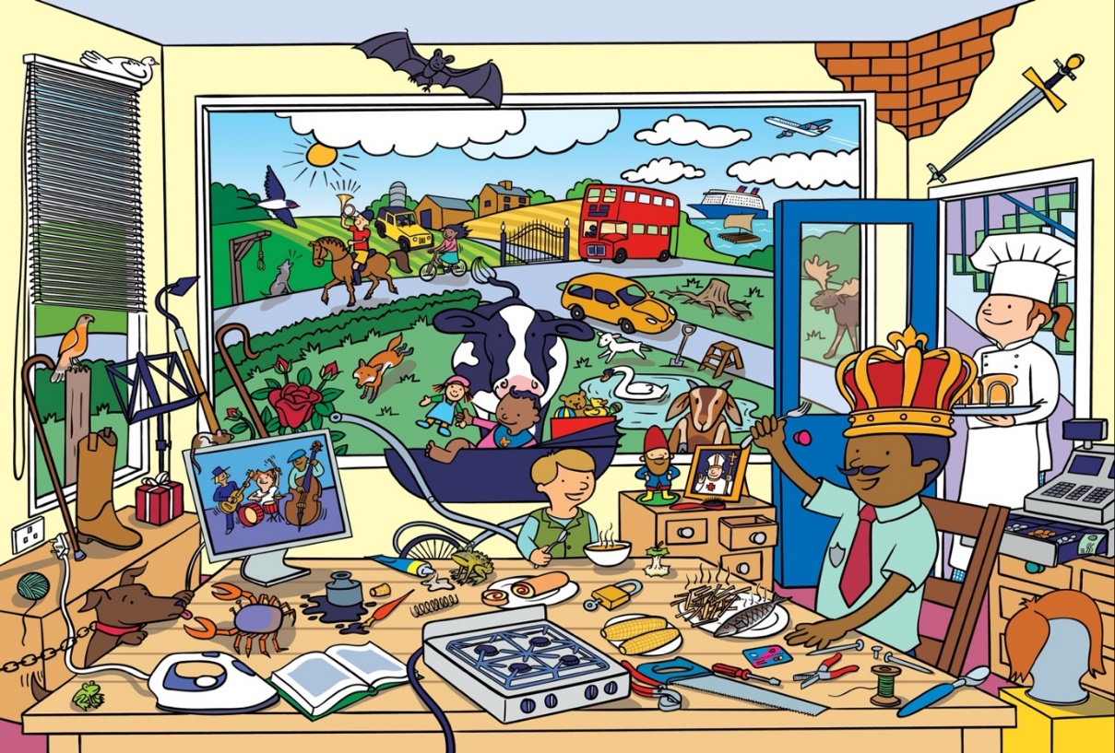
Figure 3. Picture 3 of 4 used in the custom picture description task.

Table 3. Target words embedded in Picture 3.
Picture 3: 100 items
arm | cloud | gnome | plane | stand
badge | core | goat | plate | step
band | cork | hawk | pliers | stove
bat | corn | hedge | plug | stump
bib | cow | hoe | pope | sun
bird | crab | hoof | pram | swan
blind | crook | horn | raft | sword
book | crown | ink | roll | thread
boot | dog | iron | root | tie
bowl | doll | jeep | rose | till
boy | door | knob | saw | toad
bricks | dove | lamb | scoop | toast
brush | farm | leg | ship | tools
bus | fish | lock | shorts | toys
cane | fork | man | skirt | vest
car | fox | moose | soup | wheel
card | frog | mouse | spade | wig
chain | gate | nail | spoon | wolf
chef | gift | noose | spring | wood
chips | glue | nose | stairs | wool


Figure 4. Picture 4 of 4 used in the custom picture description task.

Table 4. Target words embedded in Picture 4.
Picture 4: 100 items
arch | coat | heart | pills | sock
axe | coins | heel | pot | sole
bath | comb | horse | pound | space
beard | crutch | house | priest | stamp
bench | deer | jeans | queen | star
block | drawers | judge | rake | stork
blouse | dress | kilt | ramp | sweet
boat | drum | lips | rod | swing
bow | eye | log | rug | tail
branch | face | lungs | sack | tear
bread | film | maid | safe | teeth
bride | fist | mask | sail | tile
bulb | flag | maze | sand | tin
bun | fly | mug | scroll | tray
cage | gas | neck | shed | tube
case | glove | nest | shirt | vase
cat | golf | note | shop | watch
church | grapes | park | skate | wave
clock | hair | peach | sleeve | wine
clown | hay | pen | snow | wing

S2. Normative data: demographic and connected speech FLAT measurement-frequency, collocation and connectivity
Individual FLAT scores of 18 healthy participants on the tailor-made picture description tasks and their demographic data can be found in Table 5 and Table 6.
Table 5. Healthy participants’ demographic characteristics
Participant | Gender | Age (in years) | Highest Level of Education | Handedness | First language
1 | female | 69 | MA | right | English
2 | male | 61 | BA | right | English
3 | female | 79 | BA | right | English
4 | male | 74 | MA | right | English
5 | female | 80 | BA | right | English
6 | female | 71 | MSc | right | English
7 | male | 81 | BA | right | English
8 | male | 63 | Phd | right | English
9 | male | 72 | BA | right | English
10 | female | 64 | BA | right | English
11 | male | 63 | MA | right | English
12 | female | 77 | highscool | right | English
13 | female | 61 | MA | right | English
14 | male | 66 | Phd | right | English
15 | male | 61 | BA | irght | English
16 | male | 52 | ----- | right | English
17 | male | 63 | HNC | right | English
18 | male | 58 | BA | right | English

Table 6. FLAT measurement in 18 healthy participants
Participant | Bigram frequency | Bigram collocation | Connectivity
1 | 691.97 | 6.06 | 0.82
2 | 2293.52 | 21.12 | 0.70
3 | 1237.68 | 11.54 | 0.77
4 | 1368.81 | 12.19 | 0.77
5 | 1109.39 | 11.00 | 0.83
6 | 1044.59 | 10.23 | 0.80
7 | 763.82 | 7.29 | 0.83
8 | 763.81 | 7.55 | 0.83
9 | 972.13 | 8.75 | 0.76
10 | 1067.58 | 8.17 | 0.83
11 | 1045.17 | 10.19 | 0.78
12 | 858.12 | 8.41 | 0.79
13 | 1058.65 | 9.37 | 0.77
14 | 769.49 | 7.26 | 0.85
15 | 1273.34 | 11.20 | 0.78
16 | 1136.69 | 10.29 | 0.81
17 | 1218.42 | 10.99 | 0.78
18 | 999.89 | 8.87 | 0.88
Avg (SD)  range | 1092.94 (356.10)  691 - 2293 | 10.02 (3.25)  6 - 21 | 0.79 (0.04)  0.7-0.88

S3. Parcellation of functional ROIs
Figure 5 shows the functional ROIs from the language network and the multiple demand (MD) network defined by Fedorenko et al. (2010, 2012). These ROIs were used as input masks for the Lesion Quantification Toolkit (Griffis et al., 2021) with the AAL parcellation (Tzourio-Mazoyer et al., 2002). Table 7 lists all the parcels with corresponding proportion included in the analyses.

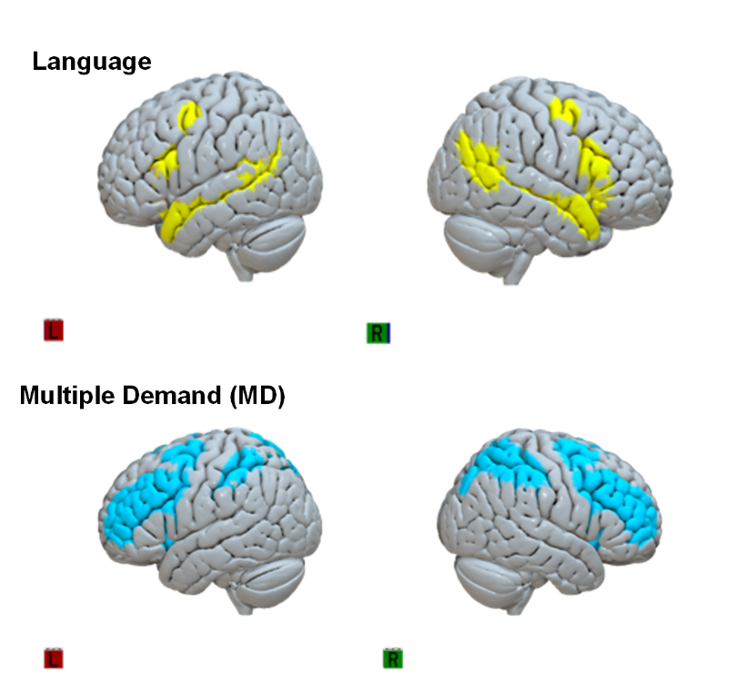

Figure 5. Cortical surface rendering of two fROIs (rendered in Surf Ice), language network and multiple demand (MD) network.

Table 7 – Language and MD networks ROIs and corresponding AAL parcels
Functional ROI mask | AAL parcels included
​  Language ​ | ​  Precentral_L (15.14%), Precentral_R (10.09%) ​  Frontal_Inf_Oper_L (30.23%), Frontal_Inf_Oper_R (31.64%) ​  Frontal_Inf_Tri_L (31.05%), Frontal_Inf_Tri_R (28.98%)  Frontal_Inf_Orb_L(15.95%), Frontal_Inf_Orb_R ​(14.49%)  Occipital_Mid_L (10.09%), Occipital_Mid_R ​(15.36%)  SupraMarginal_L ​(16.46%)  Angular_L (37.13%), Angular_R ​(26.61%)  Temporal_Sup_L (33.02%), Temporal_Sup_R ​(38.55%)  Temporal_Pole_Sup_L (26.47%), Temporal_Pole_Sup_R (24.72%) ​  Temporal_Mid_L(65.57%), Temporal_Mid_R (61.50%)​  Temporal_Pole_Mid_L (22.76%), Temporal_Pole_Mid_R ​(19.55%)  ​
​  Multiple Demand (MD) ​ |  | ​  Precentral_L (45.85%), Precentral_R (31.86%)  Frontal_Sup_L (26.95%), Frontal_Sup_R ​(32.63%)  Frontal_Sup_Orb_L ​(11.81%)  Frontal_Mid_L (65.14%), Frontal_Mid_R ​(64.24%)  Frontal_Mid_Orb_L (20.39%), Frontal_Mid_Orb_R ​(16.23%)  Frontal_Inf_Oper_L (52.53%), Frontal_Inf_Oper_R (54.30%) ​  Frontal_Inf_Tri_L (43.41%), Frontal_Inf_Tri_R (32.61%)  Supp_Motor_Area_L (28.71%), Supp_Motor_Area_R (20.83%)  Frontal_Sup_Medial_L ​(15.80%)  Insula_L (26.79%), Insula_R (24.46%) ​  Cingulum_Ant_L (14.20%), Cingulum_Ant_R ​(12.29%)  Cingulum_Mid_L (11.36%), Cingulum_Mid_R ​(19.00%)  Cuneus_R ​(23.37%)  Occipital_Sup_L (26.20%), Occipital_Sup_R (38.08%)  Occipital_Mid_L (11.62%), Occipital_Mid_R (10.72%)​  Postcentral_L (13.04%), Postcentral_R ​(12.60%)  Parietal_Sup_L (82.65%), Parietal_Sup_R ​(80.60%)  Parietal_Inf_L (86.76%), Parietal_Inf_R (84.47%) ​  SupraMarginal_L (20.13%), SupraMarginal_R (39.44%)​  Angular_L (18.02%), Angular_R ​(28.60%)  Precuneus_L (41.05%), Precuneus_R (39.51%)​  ​
Note: Functional ROIs of language-selective and domain-general network are defined by Fedorenko et al. (2010, 2012). Parcels names are defined as the same in AAL (Tzourio-Mazoyer et al., 2002).

We included overlapping AAL regions when using functional regions of interest (fROIs), excluding only those parcels that comprised less than 10% of the total area. For Language, we excluded five small regions Frontal_Mid_L (1.29%), Insula_R (1.77%), Postcentral_L (0.19%), Temporal_Inf_L (1.3%), and SupraMargnial_R (5.6%). For the Multiple Demand (MD) network, we excluded eight regions: Putamen_L (0.48%), Cuneus_L (6.31%), Frontal_Inf_Orb_L (6.89%), Frontal_Inf_Orb_R (4.91%), Rolandic_Oper_L (2.21%), Rolandic_Oper_R (2.45%), Frontal_Sup_Orb_R (7.77%), and Frontal_Sup_Medial_R (8.10%). All region names follow AAL labels.

S4. Materials for reproducibility
Lesion quantification was conducted using the same script provided in Lesion Quantification Toolkit (Griffis et al., 2021) in MATLAB. Python codes of analyse, structural connectivity data and behaviour excel files can be found in UCL-NT/SNE-repo (github.com). Patient raw data are available under restricted access and can be obtained by direct request to J.C.

References
Fedorenko, E., Duncan, J., & Kanwisher, N. (2012). Language-Selective and Domain-General Regions Lie Side by Side within Broca’s Area. Current Biology, 22(21), 2059–2062. https://doi.org/10.1016/J.CUB.2012.09.011
Fedorenko, E., Hsieh, P. J., Nieto-Castañón, A., Whitfield-Gabrieli, S., & Kanwisher, N. (2010). New method for fMRI investigations of language: Defining ROIs functionally in individual subjects. Journal of Neurophysiology, 104(2), 1177–1194. https://doi.org/10.1152/JN.00032.2010/SUPPL_FILE/DESCRIPTIONS.DOCX
Griffis, J. C., Metcalf, N. V., Corbetta, M., & Shulman, G. L. (2021). Lesion Quantification Toolkit: A MATLAB software tool for estimating grey matter damage and white matter disconnections in patients with focal brain lesions. NeuroImage: Clinical, 30, 102639. https://doi.org/10.1016/J.NICL.2021.102639
Tzourio-Mazoyer, N., Landeau, B., Papathanassiou, D., Crivello, F., Etard, O., Delcroix, N., & Joliot, M. (2002). TECHNICAL NOTE Automated Anatomical Labeling of Activations in SPM Using a Macroscopic Anatomical Parcellation of the MNI MRI Single-Subject Brain. https://doi.org/10.1006/nimg.2001.0978
Zimmerer, V. C., Hardy, C. J. D., Eastman, J., Dutta, S., Varnet, L., Bond, R. L., Russell, L., Rohrer, J. D., Warren, J. D., & Varley, R. A. (2020). Automated profiling of spontaneous speech in primary progressive aphasia and behavioral-variant frontotemporal dementia: An approach based on usage-frequency. Cortex, 133, 103–119. https://doi.org/10.1016/J.CORTEX.2020.08.027
Zimmerer, V. C., Newman, L., Thomson, R., Coleman, M., & Varley, R. A. (2018). Automated analysis of language production in aphasia and right-hemisphere damage: frequency and collocation strength. Aphasiology, 32(11), 1267–1283. https://doi.org/10.1080/02687038.2018.1497138

