Supplementary Information (on-line only)

Table of contents

Supplementary Methods.......................................................................................................................2-4

Supplementary Figure 1. ......................................................................................................................... 5
Supplementary Figure 2 .......................................................................................................................... 6
Supplementary Figure 3 .......................................................................................................................... 7

Supplementary Table 1 ........................................................................................................................... 8
Supplementary Table 2 ........................................................................................................................... 8
Supplementary Table 3 ........................................................................................................................... 9
Supplementary Table 4 ........................................................................................................................... 9

supplementary METHODS
Human tumour samples
Training groups: COHORTS 1-3
After approval from the Institutional Review Board, formalin-fixed and paraffin-embedded (FFPE) tumour samples obtained from 1999-2017 were randomly collected from three different cohorts of patients at Keio University Hospital (Tokyo, Japan) based on histological type, pathological T stage, and systemic therapy. The UICC TNM system was used for tumour staging, and nuclear grading was carried out according to the WHO/International Society of Urological Pathology grading system. The details of the three groups are as follows: COHORT 1, primary ccRCC tumours treated surgically (n = 105, Table 1); COHORT 2, ccRCC tumour metastases diagnosed histologically (n = 47: lung, 8; bone, 18; viscera, 11, brain, 4, and others, 6; Supplementary Table 1); and COHORT 3, primary non-ccRCC tumours (n = 41: papillary, 12; chromophobe, 12; sarcomatoid, 8; Xp11.2 translocation, 7; and collecting duct, 2; Supplementary Table 2). The 3-mm cores were punched out from optimal tumour areas.

Validation group: COHORT 4
COHORT 4, primary ccRCC tumours treated surgically (n = 96, Supplementary Table 3), was independently collected as an external validation cohort and compared with the training cohort from the same institution. COHORT 4 differs from COHORTS 1-3 in that an alcohol-based PAXgene (Qiagen) was used for fixation prior to paraffin embedding, and 4-mm cores were punched out from optimal tumour areas.

No statistical methods were used to predetermine the sample size. All samples were deciphered with numbers to avoid investigator bias during tissue preparation and data analysis. No human samples were excluded from the analysis. All procedures were performed in compliance with the 1964 Helsinki Declaration and present ethical standards, and informed consent for experimental use of the samples was obtained from the patients according to the hospital's ethical guidelines.

Immunohistochemistry
Tissue microarray samples were cut into 5-μm-thick sections and placed onto silane-coated glass slides. After deparaffinization, the sections were processed for antigen retrieval and blocking. Thereafter, all sections were incubated overnight with primary antibodies (Supplementary Table 4), followed by incubation with secondary antibodies conjugated to a peroxidase-labelled dextran polymer. Colour development for immunohistochemistry was achieved using 3,3’-diaminobenzidine in 50 mM Tris-HCl (pH 5.5) containing 0.005% hydrogen peroxidase. Finally, sections treated with 3,3’-diaminobenzidine were counterstained with haematoxylin.

Automated single-cell analysis
All stained sections were scanned using a high-resolution digital slide scanner (NanoZoomer-XR C12000; Hamamatsu Photonics, Hamamatsu, Shizuoka, Japan). Then, both immunohistochemical signals and nuclei were separately segmented by a computerized image analysis system (HistoQuest software, TissueGnostics, Vienna, Austria). Finally, cells with both overlapping segmented immune signals and nuclei were automatically counted. Positive cell density was defined as the mean number of positive cells in the defined areas harbouring all punched cores. The CD34 (to label blood vessels) and D2-40 (to label lymph vessels) immunosignals in tumours were calculated in each core as the percentage of the positive area after automated signal segmentation. Individual positive cell density data were normalized in the range 0 to 1, with the bottom 10% as the lower limit and the top 10% as the upper limit, and then used for hierarchical clustering by Ward's linkage methods in R software.

DNA extraction and sequencing
Genomic DNA was extracted from fresh-frozen tissue samples from the selected tumour areas with a DNeasy Blood & Tissue Kit (Qiagen) according to the manufacturer’s protocol. The DNA integrity number was 4.0, which was calculated using the Agilent 2000 TapeStation (Agilent Technologies, Waldbronn, Germany). A genomic DNA library was constructed using the GeneRead DNAseq Targeted Panel V2 (Human Comprehensive Cancer Panel), which covers more than 95% of the total exon region in 160 cancer-related genes (1). The library was amplified using a GeneRead DNA I Amp Kit (Qiagen) and sequenced using MiSeq (Illumina). The FastQ files obtained from MiSeq (Illumina) were analysed using an original bioinformatics pipeline called GenomeJack (Mitsubishi Space Software, Tokyo, Japan) (1).

RNA-sequencing dataset analysis
We analysed the TCGA dataset for kidney renal clear cell carcinoma (2), for which RNA-sequencing data were downloaded from cBioPortal (https://www.cbioportal.org/study/summary?id=kirc_tcga_pan_can_atlas_2018
; access date: April, 2020) (3). Additionally, we used the Sato dataset consisting of RNA-sequencing data from ccRCC patients (4). The mRNA expression z-score data for LAG-3, TIM-3 and TIGIT were used for hierarchical clustering in the same manner as described above.

Statistics
Values are presented as the means with standard errors or medians with interquartile ranges for continuous variables and frequencies with percentages for categorical variables. Variables between groups were compared using the Mann–Whitney U-test. We performed receiver operating characteristic (ROC) curve analysis using the data from the training group (COHORT 1) to define a potential cut-off cell number that discriminates the phenotypic signatures of the IRs LAG-3, TIM-3, and TIGIT in ccRCCs. An area under the curve (AUC) value of 1.0 represents perfect discrimination, and a value of 0.5 represents no discrimination. Uni- and multivariate Cox regression models with stepwise selection were used to evaluate variables associated with overall mortality. Survival curves were estimated using the Kaplan–Meier method and compared using the log-rank test. The hclust R package (version 3.6.1) was used for hierarchical clustering of tumour samples. Statistical significance was accepted for p < 0.05. All analyses were performed using R statistical language version 3.6.1 (R Foundation for Statistical Computing, Vienna, Austria), SPSS version 24.0 (IBM-SPSS Inc., Tokyo, Japan) and JMP version 15.0 (SAS Institute Inc., Cary, NC, USA).

REFERENCES
1. Watanabe K, Kosaka T, Aimono E, Hongo H, Mikami S, Nishihara H, et al. Japanese Case of Enzalutamide-Resistant Prostate Cancer Harboring a SPOP Mutation With Scattered Allelic Imbalance: Response to Platinum-Based Therapy. Clin Genitourin Cancer. 2019;17(5):e897-e902.
2. Cancer Genome Atlas Research N. Comprehensive molecular characterization of clear cell renal cell carcinoma. Nature. 2013;499(7456):43-9.
3. Cerami E, Gao J, Dogrusoz U, Gross BE, Sumer SO, Aksoy BA, et al. The cBio cancer genomics portal: an open platform for exploring multidimensional cancer genomics data. Cancer Discov. 2012;2(5):401-4.
4. Sato Y, Yoshizato T, Shiraishi Y, Maekawa S, Okuno Y, Kamura T, et al. Integrated molecular analysis of clear-cell renal cell carcinoma. Nat Genet. 2013;45(8):860-7.

Supplementary Fig 1. Relationship of LAG-3-, TIM-3-, and TIGIT-Positive Cell Distribution in Human RCC Tumours. a-c Scatter plots show the density of LAG-3⁺ versus TIM-3⁺ cells (a), LAG-3⁺ versus TIGIT⁺ cells (b), and TIM-3⁺ versus TIGIT⁺ cells (c) in 105 primary ccRCC samples (COHORT 1). d-f Scatter plots show the density of LAG-3⁺ versus TIM-3⁺ cells (d), LAG-3⁺ versus TIGIT⁺ cells (e), and TIM-3⁺ versus TIGIT⁺ cells (f) in 47 metastatic ccRCC samples (COHORT 2). g-i Scatter plots show the density of LAG-3⁺ versus TIM-3⁺ cells (g), LAG-3⁺ versus TIGIT⁺ cells (h), and TIM-3⁺ versus TIGIT⁺ cells (i) in 41 non-ccRCC samples (COHORT 3). r, Spearman's correlation coefficient.

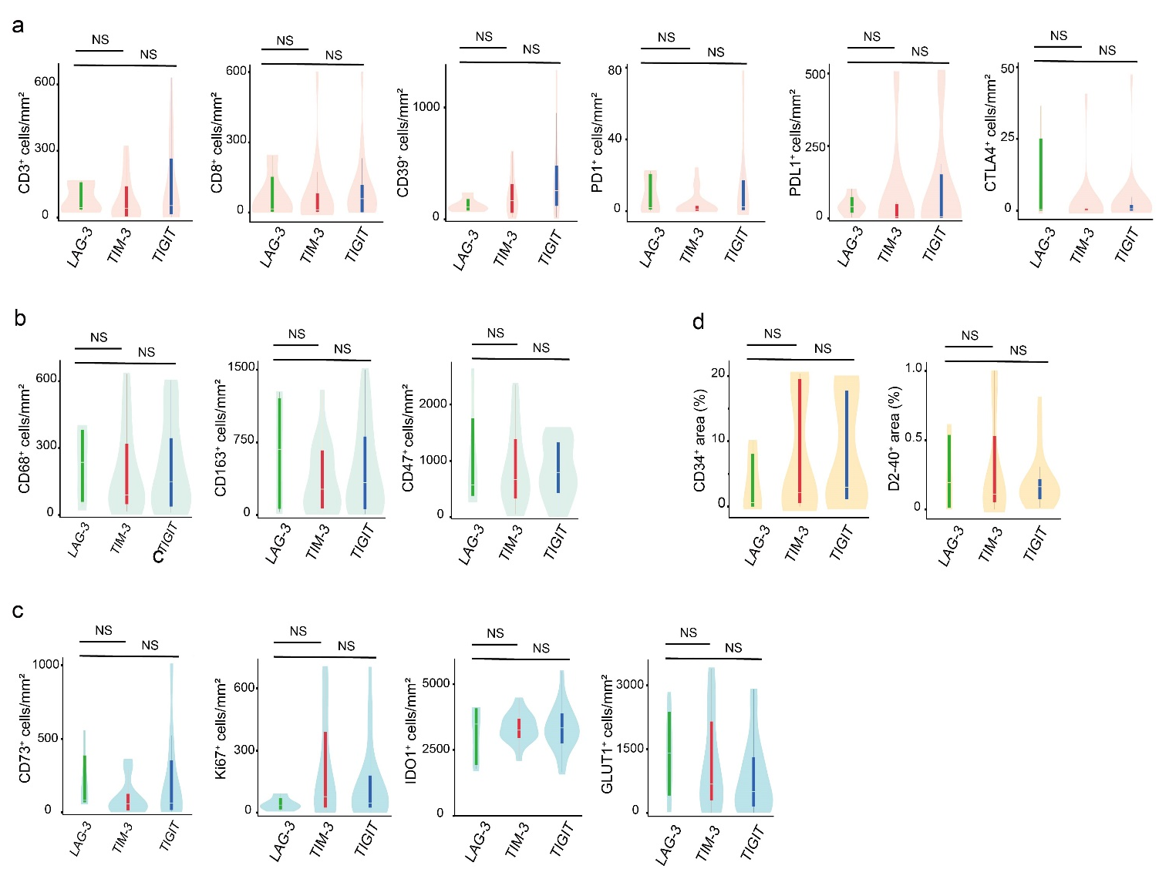

Supplementary Fig 2. Phenotypic Signatures of the New IRs (LAG-3, TIM-3, and TIGIT) and the Tumour Immune Microenvironment in Human non-ccRCC Tumours. a-d Violin and box plots of acquired immunity (a), innate immunity (b), inhibitory tumour metabolism (c), and vascular attributes (d) signatures from 41 human non-ccRCC samples. The line within the box represents the median, the upper and lower ends of the box represent the upper and lower quartiles, and the bars represent the minimum and maximum values. p values were determined with a two-tailed Mann–Whitney U-test.

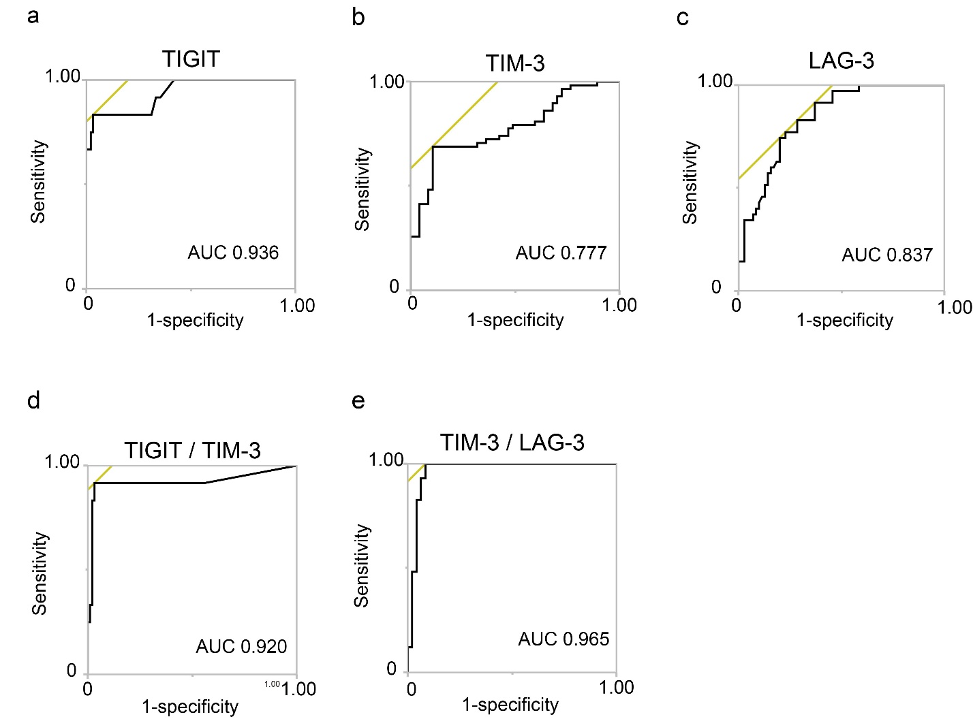

Supplementary Fig 3. a-e ROC-AUC Analysis Discriminating the Phenotypic Signatures of the New IRs (LAG-3, TIM-3, and TIGIT) by Immunohistochemistry in COHORT 1.

