Supplementary Data
Table S1. Composition of S. cordifolia aqueous fractions (SCAF).
Fractions | Fraction composition (dry weight)
SCAF0 | crude polysaccharide fraction of S. cordifolia (SCAQ)
SCAF1 | low ionic strength and <100kDa
SCAF2 | medium ionic strength and between 10-100kDa
SCAF 3 | medium ionic strength and < 100kDa
SCAF 4 | high ionic strength (2 mol/l) and between 10kDa-100kDa
SCAF 5 | high ionic strength and <100kDa
The crude aqueous extract (SCAQ) was precipitated using ethanol (EXAP) and then further fractionated on the basis of ionic strength and size.

Table S2. Primers sequences (forward and reverse) used for quantification of cytokine mRNA expression in splenocytes and RAW246.7 macrophage cell line.
Gene | Forward | Reverse | Reference
IL-1a | GGAAGATTCTGAAGAAGAGACGG | TGAGATTTTTAGAGTAACAGG | (67)
IL-1b | TGTCTGAAGCAGCTATGGCAAC | CTGCCTGAAGCTCTTGTTGATG | (68)
IL-6 | TCTTGGGACTGATGCTGGTG | CAGAATTGCCATTGCACAACTC | (68)
IL-10 | AATTCCCTGGGTGAGAAGCTG | CATGGCCTTGTAGACACCTTG | (68)
1L-12 p35 | TGG ACC TGC CAG GTG TCT TAG | CAATGTGCTGGTTTGGTCCC | (69)
IL-12 p40 | AAGAAGGAAAATGGAATTTGGTCC | ATGTCACTGCCCGAGAGTCAG | (69)
TNF - α | CTCAGCCTCTTCTCATTCCTGC | CCATAGAACTG ATGAGAGGG | (68)
IFN-γ | AGCAACAGC AAG GCG AAA A | CTGGACCTGTGGGTTGTTGA | (67)
IFN-β | CGTGGGAGATGTCCTCAACT | AAGATCTCTGCTCGGACCAC | (67)
iNOS | CAG CTG GGC TGT ACA AAC CTT | CAT TGG AAG TGA AGC GTT TCG | (69)
HPRT1 | GAGGAGTCCTGTTGATGTTGCCAG | GGCTGGCCTATAGGCTCATAGTGC | (70)
HPRT1 was used as the reference gene for the normalisation of all RT-qPCR assays.

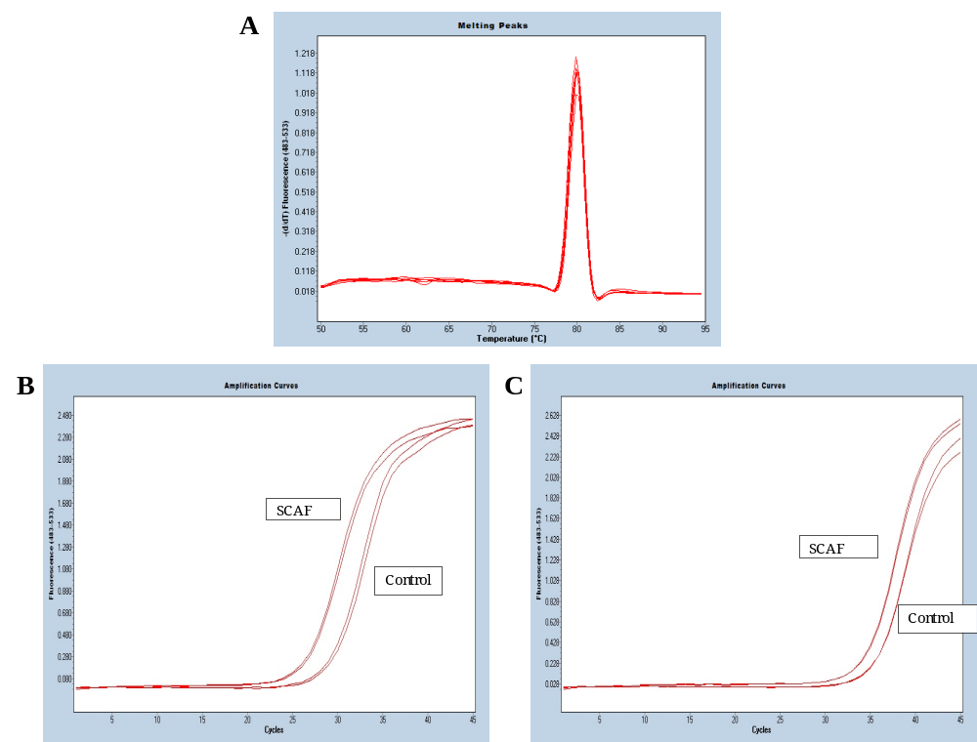
Figure S1. (A) Typical melt curve for murine inducible nitric oxide synthase (iNOS) (B) Amplification curve of iNOS following incubation of RAW 264.7 cells with SCAF 5 showing untreated control versus treatment with SCAF 5. (C) Amplification for IL-6 following incubation of splenocytes with SCAF 5. Lines show untreated control versus treatment with SCAF 5.
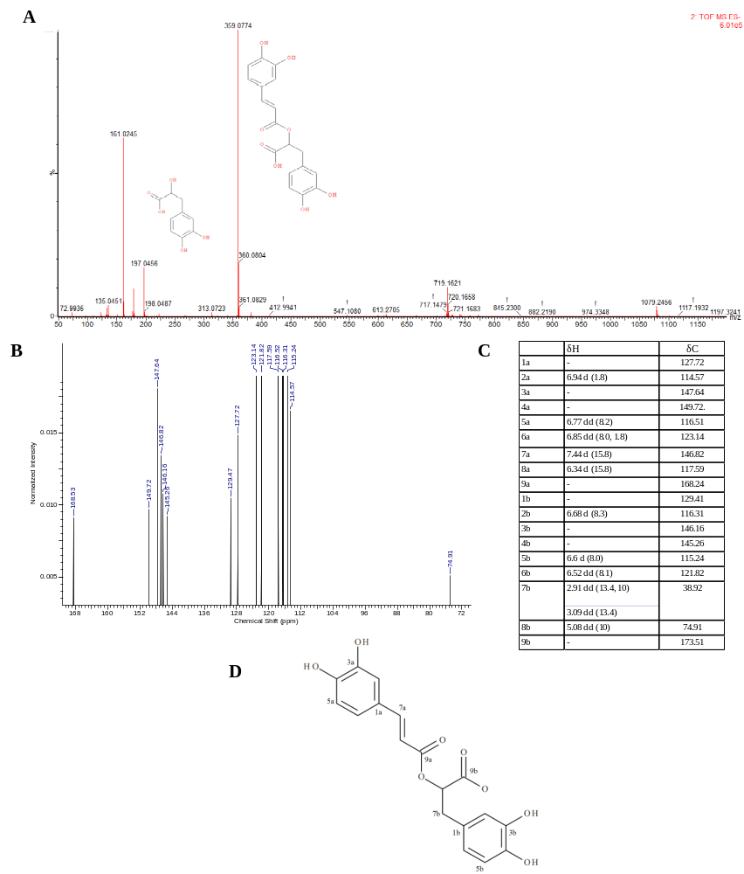
Figure S2. Mass Spectrum of SC2 (A) Mass Fragmentation patterns obtained for SC2 were suggestive of rosmarinic acid. (B) ¹³C NMR spectra of SC2. (C) Table summarising chemical shifts of both ¹³C NMR and ¹H NMR spectra for SC2. ¹³C NMR and ¹H NMR shifts and proposed structure of SC2 were highly suggestive of rosmarinic acid. (D) The proposed structure of SC2 (rosmarinic acid).
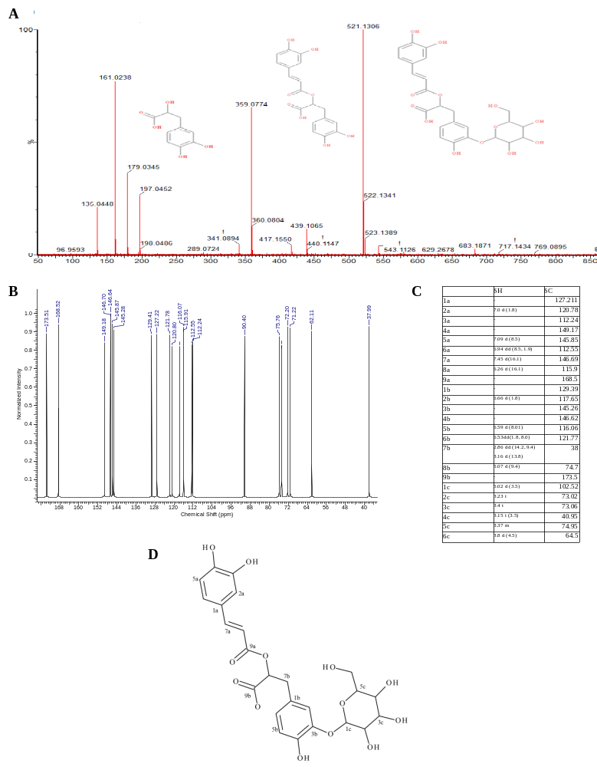
Figure S3. Mass Spectrum of SC1 (A) Mass Fragmentation patterns obtained for SC1 were suggestive of rosmarinic acid 4-O-β-d-glucoside (Rosmarinyl glucoside). (B) ¹³C NMR spectra of SC1. (C) Table summarising chemical shifts of both ¹³C NMR, and ¹H NMR. ¹³C NMR, and ¹H NMR shifts were highly suggestive of rosmarinic acid 4-O-β-d-glucoside. and the (D) proposed structure of SC1 (rosmarinic acid 4-O-β-d-glucoside).
Table S3: MIC and MBC (mg/ml) of Sephadex LH-20 fractions (SCMEXBu) compared to crude methanol extract (MEX).
 | MRSA ATCC43300 | MRSA ATCC33591 | SA ATCC29213 | SE ATCC 35984 | MRSE NCTC11964 | EF DZMZ25390
 | Mean Inhibitory Concentration (MIC) (mg/ml)
SCMEX | 1 | 0.5 | 1 | 2 | 4 | 2
SCMEXBu1 | > 4 | > 4 | > 4 | > 4 | > 4 | > 4
SCMEXBu2 | > 4 | > 4 | > 4 | > 4 | > 4 | > 4
SCMEXBu3 | > 4 | >4 | >4 | > 4 | > 4 | > 4
SCMEXBu4 | > 4 | > 4 | > 4 | > 4 | > 4 | > 4
SCMEXBu5 | 0.125 | 0.125 | 0.25 | 0.25 | 0.5 | 0.125
SCMEXBu6 | > 4 | > 4 | > 4 | > 4 | > 4 | > 4
SCMEXBu7 | > 4 | > 4 | > 4 | > 4 | > 4 | > 4
 | Mean Bactericidal Concentration (MBC) (mg/ml))
SCMEX | 0.5 | 0.5 | 1 | 2 | 2 | > 4
SCMEXBu1 | > 4 | > 4 | > 4 | > 4 | > 4 | > 4
SCMEXBu2 | > 4 | > 4 | > 4 | > 4 | > 4 | > 4
SCMEXBu3 | > 4 | >4 | >4 | > 4 | > 4 | > 4
SCMEXBu4 | > 4 | > 4 | > 4 | > 4 | > 4 | > 4
SCMEXBu5 | 0.25 | 0.25 | 0.5 | 1 | 1 | 0.25
SCMEXBu6 | > 4 | > 4 | > 4 | > 4 | > 4 | > 4
SCMEXBu7 | > 4 | > 4 | > 4 | > 4 | > 4 | > 4
MRSA: Methicillin-Resistant Staphylococcus aureus, SA: Staphylococcus aureus, EF: Enterococcus faecalis and SE: Staphylococcus epidermidis.

