Supporting Information
Yifang Zhang¹, Xuehua An¹, Shanlei Sun^{1*}, Qianrong Ma^{2,3*}, Pengcheng Yan⁴, Botao Zhou¹

1. Key Laboratory of Meteorological Disaster, Ministry of Education (KLME)/Joint International Research Laboratory of Climate and Environment Change (ILCEC)/Collaborative Innovation Center on Forecast and Evaluation of Meteorological Disasters (CIC-FEMD), Nanjing University of Information Science and Technology, Nanjing 210044, China.
2. State Key Laboratory of Severe Weather, Chinese Academy of Meteorological Sciences.
3. College of Physical Science and Technology, Yangzhou University, Yangzhou 225012, China.
4. Key Laboratory of Arid Climatic Change and Reducing Disaster of Gansu Province/Key Laboratory of Arid Climatic Change and Reducing Disaster of China Meteorological Administration, Institute of Arid Meteorology of China Meteorological Administration, Lanzhou 730030, China.

Corresponding author: Shanlei Sun & Qianrong Ma
Email: sun.s@nuist.edu.cn & maqianron_g@163.com
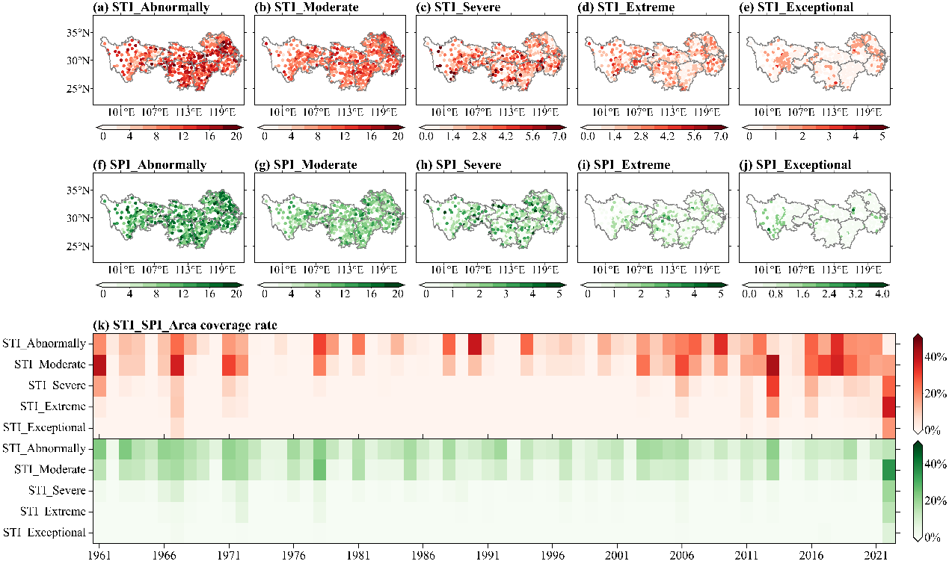
Figure S1. Spatial distribution of summer STI frequency (unit: %) across five categories: (a) abnormal, (b) moderate, (c) severe, (d) extreme, and (e) exceptional CHDEs. (f)–(j) are the same as (a)–(e), but for SPI. (k) Area coverage percentage (unit: %) of summer STI and SPI in the YRV across five categories from 1961 to 2022.
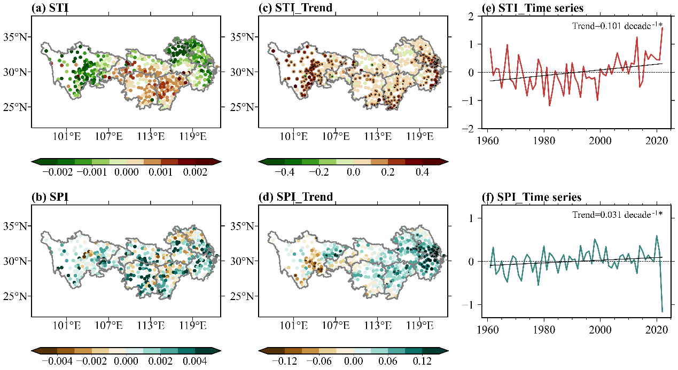
Figure S2. Spatial distribution of summer (a) ST1 and (b) SPI. Linear trends of summer (c) STI (unit: decade⁻¹) and (d) SPI (unit: decade⁻¹). Black dots in (c)–(d) indicate the 95% confidence level. Time series of area-averaged (e) STI and (f) SPI over the YRV for the period 1961–2022.
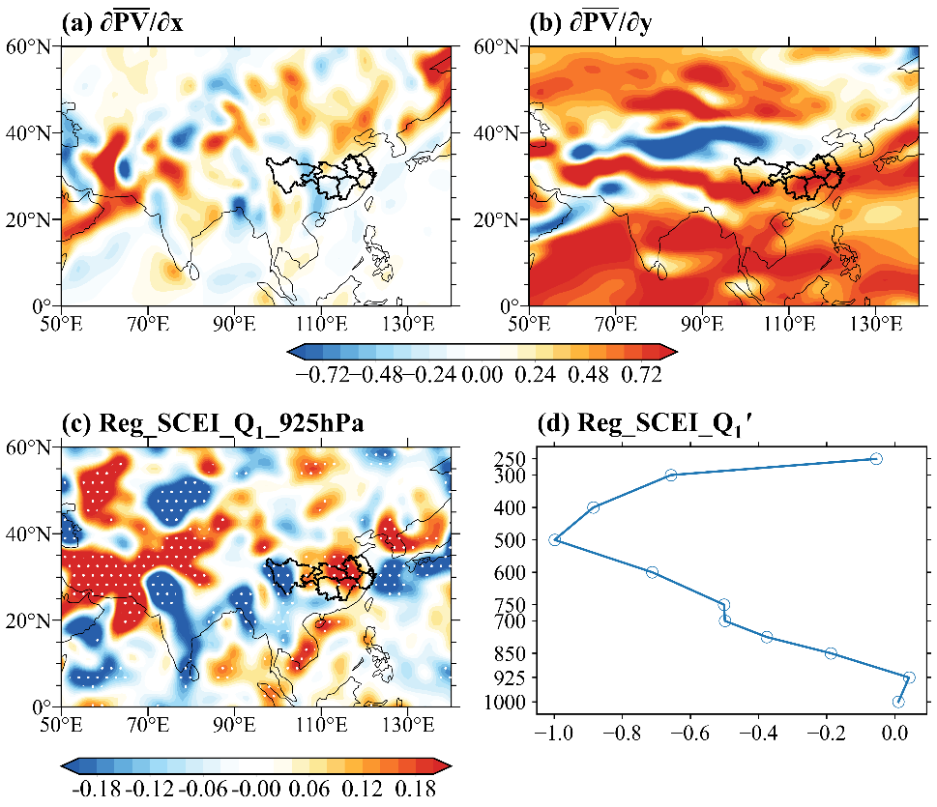
Figure S3. Spatial distributions of (a) the zonal gradient of climatological PV$\text{(∂}\overline{\text{PV}}\text{/∂x)}$ (shading; unit: 10⁻⁴ PVU m⁻¹) and (b) the meridional gradient of climatological PV$\text{(∂}\overline{\text{PV}}\text{/∂y)}$ (shading; unit: 10⁻⁴ PVU m⁻¹). (c) Spatial pattern of regressed 925-hPa diabatic heating anomalies (shading; unit: K day⁻¹), and (d) vertical profile of regressed diabatic heating anomalies (unit: K day⁻¹) against the SCEI from 1961 to 2022. The black shape outlines the YRV.
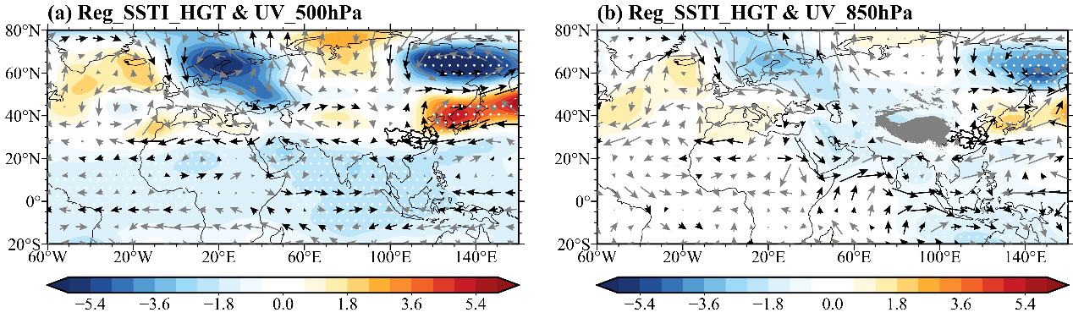
Figure S4. Regression maps against MJJ SSTI from 1961 to 2022. Geopotential height (shading; unit: gpm) and wind fields (vectors; unit: m s⁻¹) at (a) 500 hPa, (b) 850 hPa. Dots and black vectors indicate areas above the 95% confidence level. The black shape outlines the YRV.
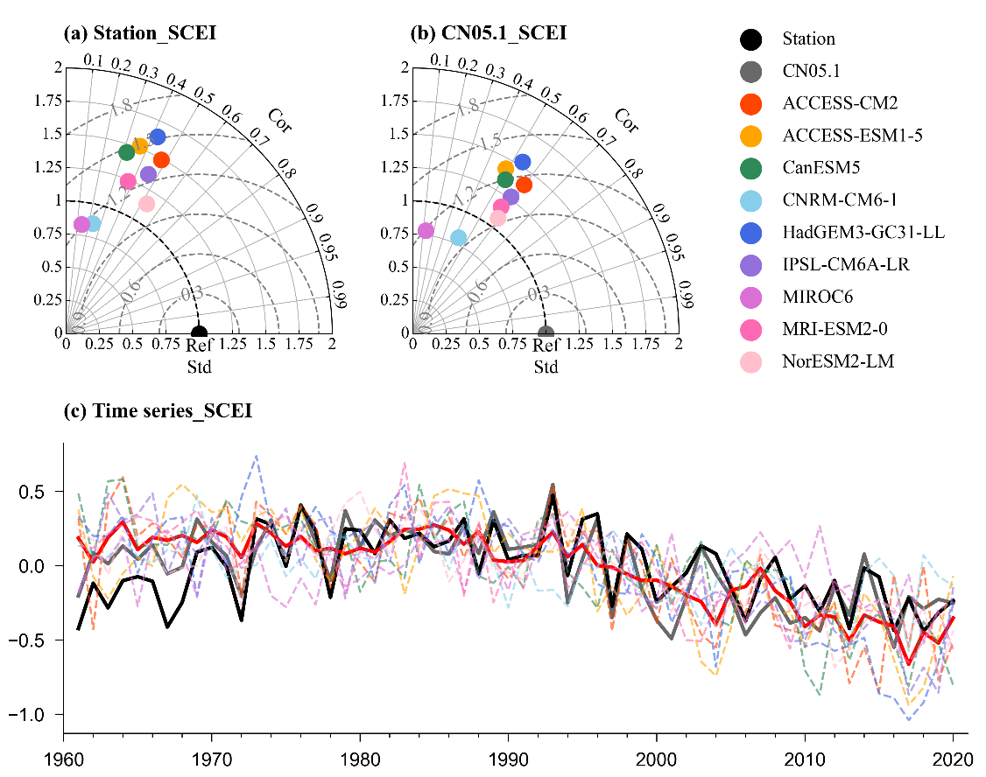
Figure S5. Taylor diagrams of spatially averaged SCEI from (a) station observation, (b) CN05.1 and CMIP6 models. (c) Time series of SCEI from station observation, CN05.1, and CMIP6 models during 1961–2020.

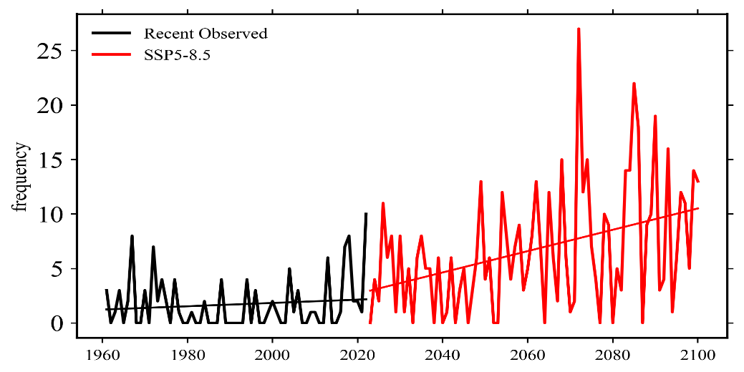
Figure S6. Time series of frequency of similar 500 hPa geopotential height anomalies: Observed (1961–2022) (black line) and multi-model ensemble mean projections for the future period (2023–2100) under the SSP5-8.5 scenario (red line).

Table S1. The information of CMIP6 models in this study
Models | Institutes | Ensembles | Spatial resolution  (lon × lat)
ACCESS-CM2 | CSIRO (Commonwealth Scientific and Industrial Research Organisation, Australia), ARCCSS (Australian Research Council Centre of Excellence for Climate System Science) | r1i1p1f1 | 192 × 144
ACCESS-ESM1-5 | CSIRO (Commonwealth Scientific and Industrial Research Organisation, Australia) | r1i1p1f1 | 192 × 145
CanESM5 | Canadian Centre for Climate Modelling and Analysis, Environment and Climate Change Canada, Canada | r1i1p1f1 | 128 × 64
CNRM-CM6-1 | CNRM (Centre National de Recherches Meteorologiques, France), CERFACS (Centre Europeen de Recherche et de Formation Avancee en Calcul Scientifique, France) | r1i1p1f2 | 256 × 128
HadGEM3-GC31-LL | Met Office Hadley Centre, Fitzroy Road, Exeter, UK | r1i1p1f3 | 192 × 144
IPSL-CM6A-LR | Institut Pierre Simon Laplace, France | r1i1p1f1 | 144 × 143
MIROC6 | JAMSTEC (Japan Agency for Marine-Earth Science and Technology), AORI (Atmosphere and Ocean Research Institute), NIES (National Institute for Environmental Studies), R-CCS (RIKEN Center for Computational Science), Japan | r1i1p1f1 | 256 × 128
MRI-ESM2-0 | Meteorological Research Institute, Japan | r1i1p1f1 | 320 × 160
NorESM2-LM | NorESM Climate modeling Consortium consisting of CICERO, MET- Norway, NERSC, NILU, UiB, UiO, and UNI, Norway | r1i1p1f1 | 144 × 96

Table S2. Categories of compound hot-drought conditions based on SCEI. Each category corresponds to its chance of occurrence in one year out of 100 years.
Category | Compound hot-drought conditions | Percentile chance | SCEI
CE0 | Abnormal | 20 to ≤30 | -0.5 to -0.7
CE1 | Moderate | 10 to ≤20 | -0.8 to -1.2
CE2 | Severe | 5 to ≤10 | -1.3 to -1.5
CE3 | Extreme | 2 to ≤5 | -1.6 to -1.9
CE4 | Exceptional | ≤2 | -2.0 to less

