2.6. Characterization
2.6.1. Gel permeation chromatography
Gel permeation chromatography (GPC, PL-GPC 220 system, USA) analysis was conducted in trichlorobenzene + 0.04% butyrated hydroxytoluene (after drying with 0.1% CaCl₂) at a flow rate of 1.0mL/min at 160°C. The chromatograph was equipped refractive index detector and a Plgel mixed-b column. Polystyrene standards were employed for molecular weight calibration. The sample injection volume and sample concentration were 200μL and 2mg/mL, respectively, and the molecular weight data were analyzed using Agilent GPC/SEC software. The number average molecular weight (M_{n}), weight average molecular weight (M_{w}), and polydispersity index (PDI) were calculated relative to polystyrene standards. The PDI was calculated using the following equation.
····························································································(1)
2.6.2. Mechanical properties of the polyethylene precursor fibers
The mechanical properties of the fully drawn and partially drawn precursor fibers were investigated using a tensile test. The experiments were conducted using the ASTM D-2256 standard procedure. The equipment used to measure the properties was a universal testing machine (UTM, OTT-05, Oriental, Korea). The gauge length of the test specimens was 250mm, and the crosshead speed was 300mm/min; 20 specimens were measured. The tensile strength, tensile modulus, and elongation at break of the polyethylene fiber were calculated using Hooke's law as follows:
$\frac{F}{A}$ = E$ε$ ··································································································· (2)
where F, A, E, and ε are the tensile load, cross-sectional area of the precursor fiber acting perpendicular to the tensile load, initial tensile modulus of the precursor fiber, and elongation at break of the precursor fiber, respectively.
2.6.3. Fourier transform nuclear magnetic resonance (FT-NMR) analysis
¹H NMR spectra were recorded at 600MHz using an FT-NMR spectrometer (VNMR 600MHz, Agilent technologies, USA). Dimethyl sulfoxide (DMSO-d6) was used as a deuterated solvent. The polyethylene precursor fiber and sulfonated polyethylene fiber were dissolved in DMSO-d6 in a vacuum oven at 100°C for three days. Subsequently, 600μL of a solution was placed into a 5mm diameter glass tube using a micro-pipette, and the analysis was performed.
2.6.4. Scanning electron microscopy (SEM)
The morphology of the polyethylene precursor fibers, sulfonated fibers, and polyethylene-based carbon fibers was analyzed by SEM (S-4100, Hitachi, LTD., Japan) at × 500 magnification. All specimens were coated with platinum before the SEM observations. SEM was performed to observe the influence of the sulfonation time and pressure conditions on sulfur cross-linking.
2.6.5. Wide-angle X-ray diffraction (WAXD)
Wide-angle X-ray diffraction (WAXD, D8 ADVANCE, Bruker, USA) was used to determine the orientation of the polyethylene precursor fiber and sulfonated polyethylene fiber using Cu Kα radiation (λ = 0.154nm) at 40kV and 40mA.
2.6.6. Differential scanning calorimetry (DSC) analysis
The melting enthalpy and melting temperature were measured by DSC (Diamond DSC, Perkin Elmer, Inc. USA). The specimens (2∼3 mg) were encapsulated in aluminum pans and treated at a heating rate of 10°C/min. The atmosphere was nitrogen with a flow rate of 45 mL/min. The influence of cross-linking by sulfuric acid on the fully drawn and partially drawn polyethylene fibers was examined. The analytical temperature range was set between 40°C and 140°C.

2.6.7. Mechanical properties of the sulfonated fibers and polyethylene-based carbon fibers
The mechanical properties of the sulfonated polyethylene fibers and polyethylene-based carbon fibers were investigated using a tensile test. The experiments were conducted using the ASTM D-3379 standard procedure. The equipment used to measure the properties was a universal testing machine (UTM, OTT-05, Oriental, Korea). The gauge length of the test specimens was 25 mm, and the crosshead speed was 0.1mm/min; 20 specimens were measured. The tensile strength, tensile modulus, and elongation at break value of sulfonated polyethylene fiber were calculated using Hooke's law (equation 2).
2.6.8. Fourier transform infrared (FTIR) analysis
FTIR spectroscopy was performed to observe the changes in the chemical structure of the fully drawn and partially drawn fibers, such as HDPE and LLDPE fibers, according to the sulfonation time. FT-IR (Perkin Elmer Co. model spectrum 100, USA) spectroscopy was performed from 500 to 3000 cm⁻¹. The LLDPE and HDPE fibers were sulfonated for 2.5 and 3.5 hours, respectively, and analyzed. The chemical structure was compared with pristine polyethylene fibers without the sulfonation process.
2.6.9. Elemental analysis of the precursor fibers, sulfonated polyethylene fibers, and polyethylene-based carbon fibers
Elemental analysis was performed using an EA 2000 elemental analyzer (EA 2000, Thermo Fisher Scientific Co., USA). The presence of C, H, O, N, and S was analyzed in the polyethylene-based carbon fiber using a tungstic anhydride catalyst at 1000°C. The O concentration was analyzed using a nickel-plated carbon catalyst at 1060°C. BBOT, L-cystine, and sulfanilamide were used as standard materials.

2.6.10. Thermogravimetric analysis (TGA)
TGA (Q500, TA Instruments, USA) was performed to measure the thermal properties of the sulfonated polyethylene fiber and polyethylene-based carbon fiber. The heating rate was 10°C/min under a nitrogen atmosphere. The analytical temperature range was set between room temperature and 800°C.

Table S1. Specifications of the HDPE pellets and LLDPE pellets.

Materials | HDPE | HDPE | HDPE | LLDPE | LLDPE | LLDPE
Manufacturer | LG  Chem | LOTTE Chem | LOTTE Chem | LOTTE Chem | LOTTE Chem | LOTTE Chem
Product number | SP380 | 2210J | 2600F | UN324 | UL614 | UL814
Melting index (g/10min) | 0.6 | 7 | 18 | 1.1 | 10 | 20
Density (g/cm³) | 0.952 | 0.959 | 0.959 | 0.923 | 0.924 | 0.924
Tensile strength (MPa) | 10 | 22.6 | 20 | 39.2 | 10.3 | 10.3
Elongation at break (%) | 1000 | 500 | 300 | 750 | 500 | 500
Melting temperature ($°$C) | 134 | 132 | 130 | 125 | 123 | 106
Softening point ($°$C) | 127 | 122 | 120 | 94 | 93 | 92

Table S2. Spinning conditions of the polyethylene precursor fibers and drawing conditions of the polyethylene precursor fibers.
Spinning conditions of the precursor fiber
Materials | HDPE0.6 | HDPE7 | HDPE10 | LLDPE1.1 | LLDPE10 | LLDPE20
Spinning distance (mm) | 530
Spinning speed (m/min) | 0.1
Spinning temperature ($°$C) | 160 |  |  | 150
1st roller speed (m/min) | 10 | 10 | 10 | 10 | 10 | 10
2nd roller speed (m/min) | 20 | 20 | 20 | 20 | 20 | 20
Take-up speed (m/min) | 33 | 35 | 40 | 33 | 35 | 40
Spinning nozzle diameter (mm) | 2 | 2 | 2 | 2 | 1 | 1
Fiber diameter ($μ$m) | 60 | 40 | 30 | 34 | 27 | 22
Drawing conditions of the precursor fiber
Materials | HDPE0.6 | HDPE7 | HDPE10 | LLDPE1.1 | LLDPE10 | LLDPE20
Drawing temperature ($°$C) | 80
Heat treatment time at 80$°$C before and after drawing (min) | 10
Drawing speed (m/min) | 0.021
Draw ratio | 4.1 |  | 5.2 | 4.4 | 5.2
Fiber diameter ($μ$m) | 40 | 26 | 20 | 28 | 20 | 18

Table S3. Specimen code of the polyethylene precursor fibers, sulfonated polyethylene fibers and carbonized polyethylene fibers.
Specimen code of the polyethylene precursor fibers
Specimen code | PH0.6 | PH7 |  | PH18 | FH0.6 | FH7 | FH18 | PL1.1 | PL10 |  | PL20 | FL1.1 | FL10 | FL20
Materials | HDPE fiber |  |  |  |  |  |  | LLDPE fiber
MI value | 0.6 | 7 |  | 18 | 0.6 | 7 | 18 | 1.1 | 10 |  | 20 | 1.1 | 10 | 20
Degree of drawing | Partially drawn fiber |  |  |  | Fully drawn fiber |  |  | Partially drawn fiber |  |  |  | Fully drawn fiber
Specimen code of the sulfonated polyethylene fibers
Specimen code | PSH0.6 | PSH7 |  | PSH18 | FSH0.6 | FSH7 | FSH18 | PSL1.1 | PSL10 |  | PSL20 | FSL1.1 | FSL10 | FSL20
Materials | Sulfonated HDPE fiber |  |  |  |  |  |  | Sulfonated LLDPE fiber
MI value | 0.6 | 7 |  | 18 | 0.6 | 7 | 18 | 1.1 | 10 |  | 20 | 1.1 | 10 | 20
Degree of drawing | Partially drawn fiber |  |  |  | Fully drawn fiber |  |  | Partially drawn fiber |  |  |  | Fully drawn fiber
Specimen code of the carbonized polyethylene fibers
Specimen code | CH0.6 |  |  | CH7 |  | CH18 |  | CL1.1 |  | CL10 |  |  | CL20
Materials | HDPE based carbon fiber |  |  |  |  |  |  | LLDPE based carbon fiber
Melt flow index | 0.6 |  | 7 |  |  | 18 |  | 1.1 |  | 10 |  |  | 20
Carbonized conditions | 1000$°$C, 5$°$C/min, 5min

Table S4. Diameter, length, and weight values of the HDPE and LLDPE fibers according to the sulfonation time under 1 bar pressure.
 |  | Partially drawn fiber |  |  |  |  | Fully drawn fiber
 |  | 0h | 2h | 2.5h | 3.5h | 5h | 2.5h | 3.5h
HDPE 0.6 | Diameter ($μ$m) | 60 | 70 | - | 80 | 98 | - | 71
HDPE 0.6 | Length (mm) | 500 | 431 | - | 354 | 297 | - | 332
HDPE 7 | Diameter ($μ$m) | 40 | 47 | - | 52 | 60 | - | 47
HDPE 7 | Length (mm) | 500 | 443 | - | 374 | 314 | - | 351
HDPE 18 | Diameter ($μ$m) | 30 | 37 | - | 40 | 45 | - | 31
HDPE 18 | Length (mm) | 500 | 451 | - | 398 | 334 | - | 381
LLDPE 1.1 | Diameter ($μ$m) | 34 | 37 | 41 | - | 44 | 39 | -
LLDPE 1.1 | Length (mm) | 500 | 457 | 419 | - | 364 | 397 | -
LLDPE 10 | Diameter ($μ$m) | 27 | 29 | 33 | - | 35 | 31 | -
LLDPE 10 | Length (mm) | 500 | 464 | 421 | - | 371 | 401 | -
LLDPE 20 | Diameter ($μ$m) | 22 | 24 | 25 | - | 28 | 24 | -
LLDPE 20 | Length (mm) | 500 | 478 | 432 | - | 394 | 413 | -

Table S5. Diameter, length, and weight values of the HDPE and LLDPE fibers according to the sulfonation time under 5 bar pressure.
 |  | Partially drawn fiber |  |  |  |  | Fully drawn fiber
 |  | 0h | 2h | 2.5h | 3.5h | 5h | 2.5h | 3.5h
HDPE 0.6 | Diameter ($μ$m) | 60 | 63 | - | 67 | 70 | - | 59
HDPE 0.6 | Length (mm) | 500 | 472 | - | 451 | 432 | - | 430
HDPE 7 | Diameter ($μ$m) | 40 | 43 | - | 45 | 50 | - | 40
HDPE 7 | Length (mm) | 500 | 478 | - | 462 | 442 | - | 447
HDPE 18 | Diameter ($μ$m) | 30 | 32 | - | 33 | 35 | - | 28
HDPE 18 | Length (mm) | 500 | 484 | - | 472 | 457 | - | 467
LLDPE 1.1 | Diameter ($μ$m) | 34 | 35 | 36 | - | 37 | 34 | -
LLDPE 1.1 | Length (mm) | 500 | 494 | 487 | - | 481 | 473 | -
LLDPE 10 | Diameter ($μ$m) | 27 | 28 | 29 | - | 30 | 27 | -
LLDPE 10 | Length (mm) | 500 | 496 | 490 | - | 487 | 484 | -
LLDPE 20 | Diameter ($μ$m) | 22 | 23 | 24 | - | 25 | 24 | -
LLDPE 20 | Length (mm) | 500 | 496 | 492 | - | 490 | 487 | -

Table S6. Compositions of C, H, O, N, and S of carbon fibers prepared from partially drawn HDPE fiber and fully drawn LLDPE fiber.
Specimen code | Element | Composition (%)
CH0.6 | N (Nitrogen) | -
CH0.6 | C (Carbon) | 72.95
CH0.6 | H (Hydrogen) | 10.92
CH0.6 | S (Sulfur) | 3.50
CH0.6 | O (Oxygen) | -
CH7 | N (Nitrogen) | -
CH7 | C (Carbon) | 85.15
CH7 | H (Hydrogen) | 1.56
CH7 | S (Sulfur) | 2.75
CH7 | O (Oxygen) | -
CH18 | N (Nitrogen) | -
CH18 | C (Carbon) | 86.70
CH18 | H (Hydrogen) | 1.57
CH18 | S (Sulfur) | 2.59
CH18 | O (Oxygen) | -
CL1.1 | N (Nitrogen) | -
CL1.1 | C (Carbon) | 87.93
CL1.1 | H (Hydrogen) | 1.59
CL1.1 | S (Sulfur) | 2.60
CL1.1 | O (Oxygen) | -
CL10 | N (Nitrogen) | -
CL10 | C (Carbon) | 90.26
CL10 | H (Hydrogen) | 1.56
CL10 | S (Sulfur) | 2.05
CL10 | O (Oxygen) | -
CL20 | N (Nitrogen) | -
CL20 | C (Carbon) | 90.43
CL20 | H (Hydrogen) | 1.59
CL20 | S (Sulfur) | 1.88
CL20 | O (Oxygen) | -

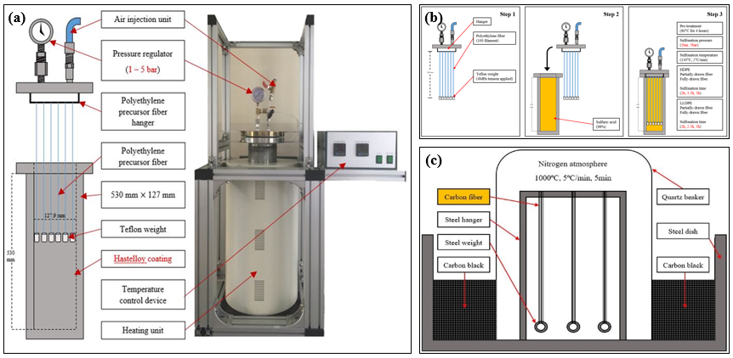
Figure S1. Schematic diagram of the sulfonation equipment and polyethylene based carbon fiber manufacturing process (a) A self-designed sulfonation equipment, (b) Schematic diagram of the hydrostatic sulfonation process, (c) Schematic diagram of the carbonization process.

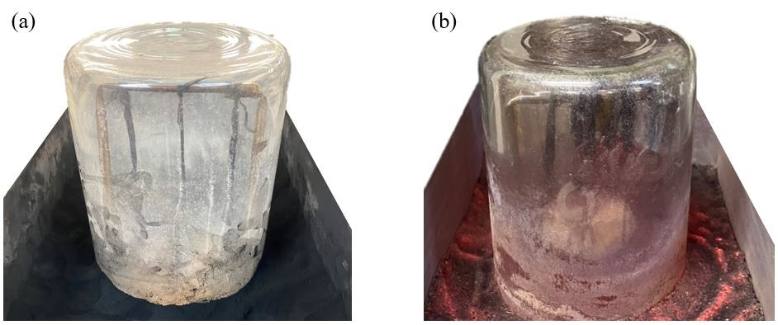
Figure S2. Photographs of the carbonization process (a) Before carbonization, (b) After carbonization.

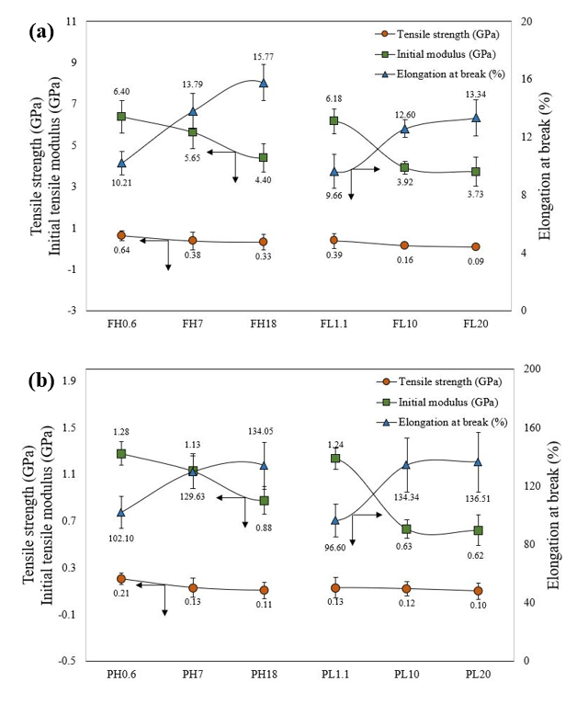
Figure S3. Tensile strength, initial tensile modulus, and elongation at break values of polyethylene precursor fiber with different draw ratio (a) Fully drawn polyethylene precursor fibers (b) Partially drawn polyethylene precursor fibers.

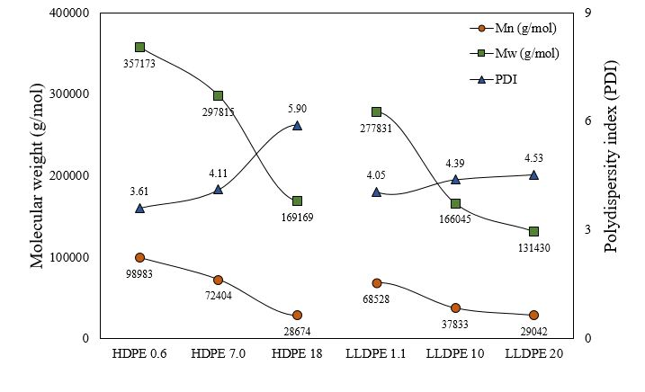 Figure S4. Number average molecular weight, weight average molecular weight and polydispersity index of the polyethylene pellets.

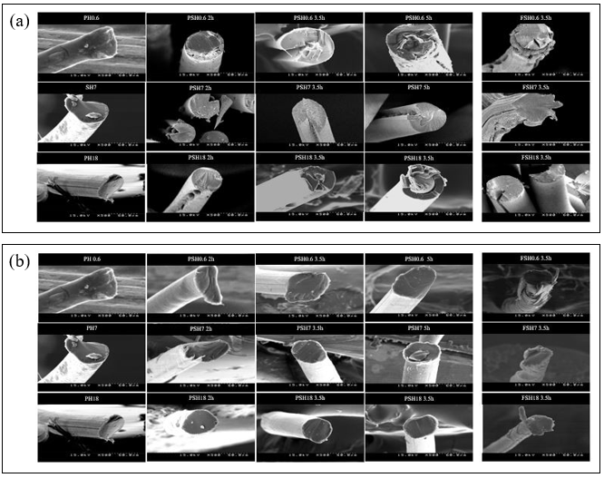
Figure S5. SEM images of the cross-sectional surface of the HDPE fibers with melt flow index of 0.6, 7, and 18 according to the sulfonation time under a pressure of 1 bar, 5bar and temperature of 130°C (a) Sulfonated fiber under 1bar pressure, (b) Sulfonated fiber under 5bar pressure.

Figure S4 shows the cross-section SEM images of the sulfonated HDPE fibers. Figure S4 (a) shows cross-section SEM images of the HDPE fibers with a melt flow index of 0.6, 7, and 18 according to the various sulfonation time under a pressure of 1 bar and a temperature of 130°C. After the sulfonation treatment, the diameters of all HDPE fibers increased gradually with increasing sulfonation time. This increase in fiber diameter was attributed to the shrinkage of the longitudinal direction of the HDPE fiber due to prolonged exposure to sulfuric acid during the sulfonation process at 130°C. The HDPE fibers formed a sheath-core structure or cracks formed in the fiber axial direction under all sulfonation time conditions. The failure mechanism changed gradually from plastic deformation to elastic deformation as HDPE fibers cross-link through the sulfonation process. In this process, when shrinkage occurs in the fiber axial direction, residual stress remains in the fiber. Owing to this stress, the fiber with elastic properties does not maintain its original shape and expands, thereby forming cracks. The formation of the core structure of the fiber was attributed to the molecular structure of the HDPE without branches, and the sulfuric acid cannot penetrate the fibers with large diameters during the sulfonation process. HDPE with a molecular structure without side chains (branches) means that it takes a long time to sulfonate the fibers because of the poor cross-linking efficiency. In the case of the fully drawn HDPE fibers, phenomena, such as the core structure of cracks occurring in the fiber axial direction, were more prominent than that of partially drawn HDPE fiber. This is because sulfuric acid cannot penetrate the fiber because of the increase in the crystalline region of the highly oriented fiber. On the other hand, the same type of HDPE fiber specimens, such as PH0.6, PH7, and PH18, exhibited completely different tendencies when sulfonation was performed under a relatively high pressure of 5 bar (Figure S4(b)). After the sulfonation treatment, the diameters of all HDPE fibers increased gradually with increasing sulfonation time, but the degree of the increase in diameter was relatively low compared to the fibers sulfonated under a 1 bar pressure. This is because the hydrostatic pressure prevents the fiber shrinkage phenomenon. In addition, although the partially drawn polyethylene fiber was treated for a long time, such as 5 h, a clean surface without a -core structure was formed, and no cracks were observed in the fiber axial direction. This is because of the faster diffusion rate of the sulfuric acid into the HDPE fiber under a 5 bar hydrostatic pressure than at 1 bar so that residual stress is decreased. In the case of fully drawn HDPE fibers, phenomena, such as the core structure of cracks occurring in the fiber axial direction, were more prominent than the partially drawn HDPE fibers. This is because sulfuric acid could not penetrate the fiber because of the increase in the crystalline region of the highly oriented fiber. In the case of fully drawn HDPE fiber, phenomena, such as the core structure of cracks occurring in the fiber axial direction, still exist. Overall, the degree of crystallinity of the fibers due to the stretching of the HDPE fibers significantly affected the sulfonation process. In contrast to the HDPE fiber specimens, the LLDPE fiber specimens generally did not show cores because the diameter of the fiber was relatively small. Hence, sulfuric acid can penetrate the LLDPE fibers easily. LLDPE with a molecular structure with side chains (branches) allows sulfonation of the fibers within a short time due to good cross-linking efficiency. In the case of fully drawn LLDPE fibers, cracks occurring through the fiber axial direction were more prominent than those of partially drawn LLDPE fibers. Fiber expansion occurred because of the increased residual stress during the change in properties of the LLDPE fiber from plastic behavior to elastic behavior during the sulfonation process.

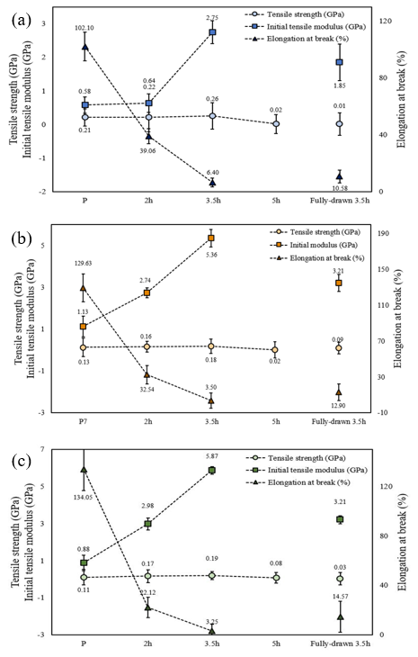
Figure S6. Tensile strength, initial tensile modulus, and elongation at break values of the sulfonated HDPE fiber with various sulfonation time under a pressure of 5 bar and temperature of 130°C (a) Sulfonated HDPE fiber with 0.6 melt flow index, (b) Sulfonated HDPE fiber with 7 melt flow index, (c) Sulfonated HDPE fiber with 18 melt flow index.

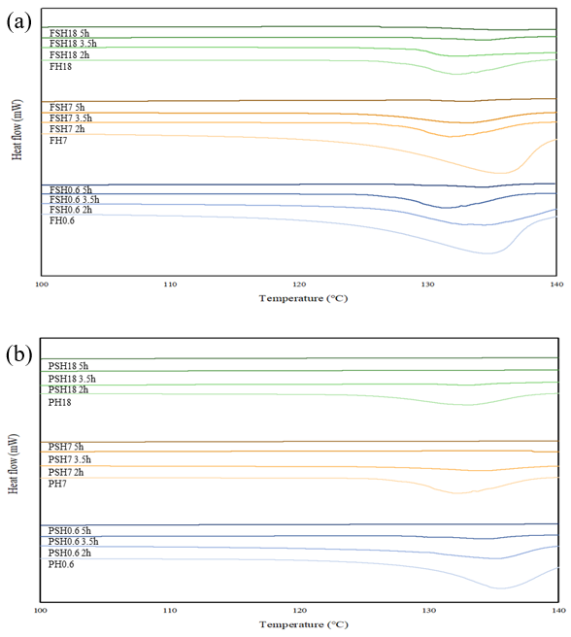
Figure S7. DSC curves of the HDPE fibers with melt flow index of 0.6, 7, and 18 according to the sulfonation time under a pressure of 5 bar and temperature of 130°C (a) Fully drawn sulfonated HDPE fiber, (b) Partially drawn sulfonated HDPE fibers.

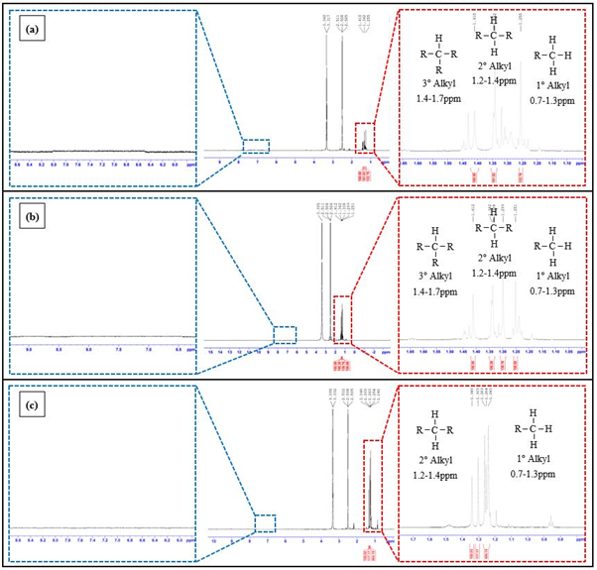
Figure S8. ¹H NMR spectrum and hydrogen peak assignments of partially drawn LLDPE precursor fibers (a) PL1.1, (b) PL10, (c) PL20.

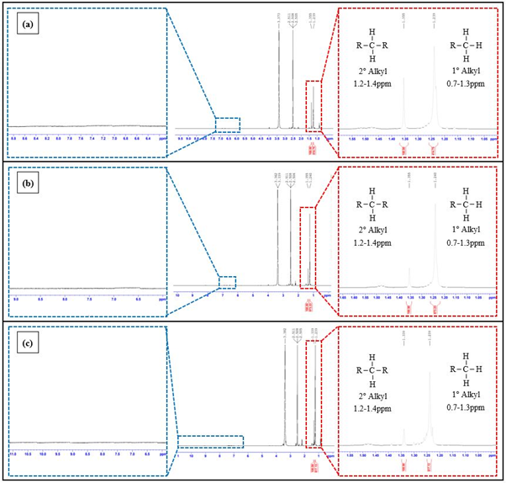
Figure S9. ¹H NMR spectrum and hydrogen peak assignments of partially drawn HDPE precursor fibers (a) PH0.6, (b) PH7, (c) PH18.
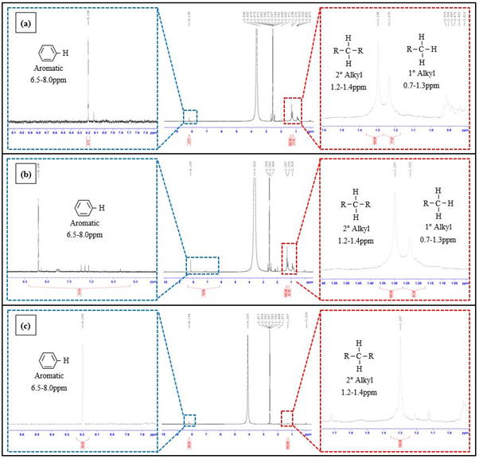
Figure S10. ¹H NMR spectrum and hydrogen peak assignments of sulfonated partially drawn HDPE fibers under sulfonation conditions of 1 bar for 3.5h (a) PSH0.6, (b) PSH7, (c) PSH18.

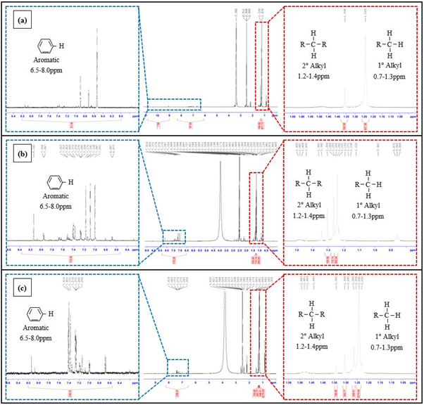
Figure S11. ¹H NMR spectrum and hydrogen peak assignments of sulfonated partially drawn LLDPE fibers under sulfonation conditions of 1 bar for 2.5h (a) PSL1.1, (b) PSL10, (c) PSL20.

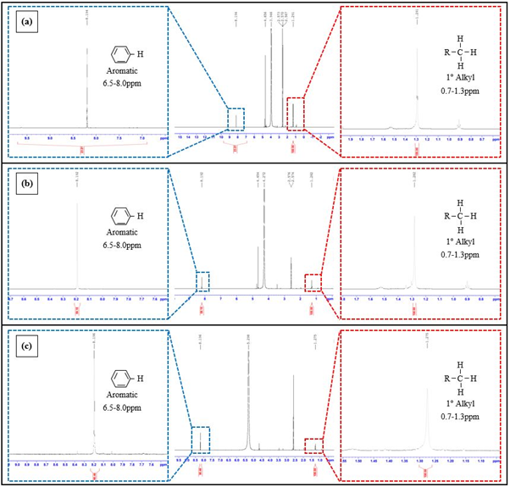
Figure S12. ¹H NMR spectrum and hydrogen peak assignments of sulfonated partially drawn HDPE fibers under sulfonation conditions of 5 bar for 3.5h (a) PSH0.6, (b) PSH7, (c) PSH18.

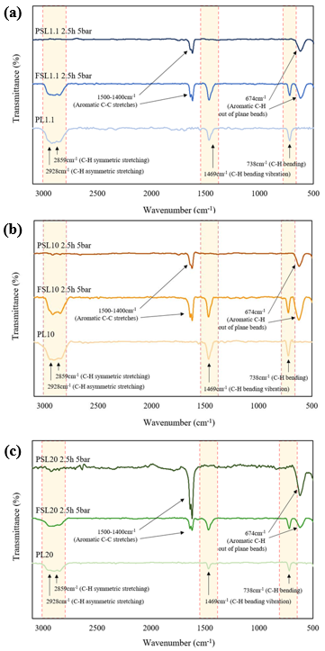
Figure S13. FT-IR spectra of sulfonated LLDPE fibers with a melt flow index of 1.1, 10, and 20 at a sulfonation time of 2.5h under a pressure of 5 bar and temperature of 130°C and draw ratio (a) Sulfonated LLDPE fibers with a melt flow index of 1.1, (b) Sulfonated LLDPE fibers with a melt flow index of 10, (c) Sulfonated LLDPE fibers with a melt flow index of 20.
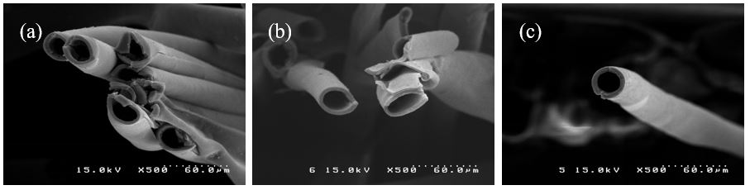
Figure S14. Polyethylene-based carbon fibers prepared from partially drawn LLDPE fibers with a sulfonation pressure of 1 bar at 130°C for 2.5h (a) CL1.1, (b) CL10, (c) CL20.

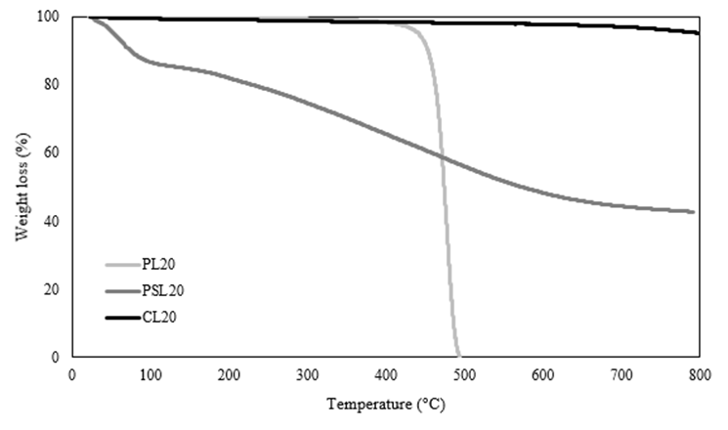
Figure S15. TGA weight loss curves of the partially drawn polyethylene fibers, partially drawn sulfonated polyethylene fibers, and carbon fiber based LLDPE fibers.

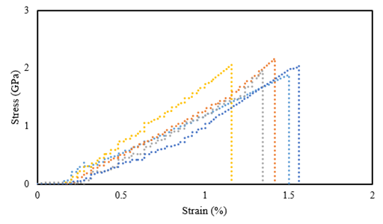
Figure S16. Stress-strain curves of the polyethylene-based carbon fibers prepared from partially drawn LLDPE fibers.
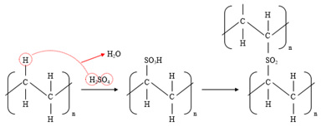
Figure S17. Suggested chemical transformation mechanism of polyethylene by sulfuric acid.

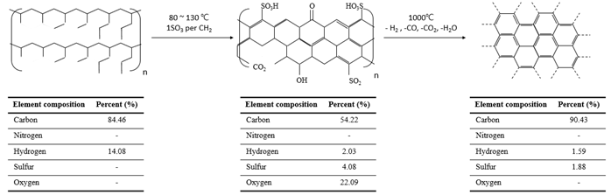
Figure S18. Suggested cross-link mechanism and carbonization mechanism of the LLDPE fibers.

