Supplementary Information

Ultra-tough and super-robust hydrogel constructed through carbon dots induced crystallization domains integrated orientation regulation based on “pinning effect”

Huanxin Huo^{a,b,#}, Jingjie Shen^{a,b,#}, Haoran Shi^{a,b}, Hongxing Yang^{a,b}, Xin Duan^{a,b}, Yihong Gao^{a,b}, Yumeng Chen^{a,b}, Feng Kuang^{a,b}, Hongshan Li^{a,b}, Jianyong Wan^{a,b,}*, Guanben Du^{a,b,c,}*, Long Yang^{a,b,c,}*

ª Yunnan Province Key Lab of Wood Adhesives and Glued Products, Southwest Forestry University, Kunming 650224, China
^{b} Yunnan International Joint R&D Center of Wood and Bamboo Biomass Materials, Southwest Forestry University, Kunming 650224, China
^{c} International Joint Research Center for Biomass Materials, Southwest Forestry University, Kunming 650224, China
# These two authors contributed to this work equally
*Corresponding Authors
Corresponding: jywan@swfu.edu.cn (J. Wan); guanben@swfu.edu.cn (G. Du); lyang@swfu.edu.cn (L. Yang)

Materials
PVA (PVA-1799), citric acid (CA), sodium citrate, malic acid, and tannic acid were obtained from Shanghai Adamas Reagent Co., Ltd. Eucalyptus bark was obtained from a local market.
Preparation of citric acid carbon dots (CDs)
Citric acid CDs were prepared using a hydrothermal method. First, citric acid (1 g) was dissolved in 100 mL of deionized water and reacted at 180 ℃ for 8 hours. The solution was then allowed to cool to room temperature to obtain the CDs.
Preparation of PVA hydrogel
PVA was dissolved in deionized water and stirred at 90 ℃ for 3 hours to obtain PVA solutions with different concentrations. The homogeneous solution was then poured into silica molds, frozen at -20 ℃ for 12 hours, thawed at room temperature for 2 hours, and subjected to three freeze-thaw cycles to obtain the PVA hydrogel.
Preparation of PVA-CA hydrogel
PVA was dissolved in the CA solution and stirred at 90 ℃ for 3 hours to obtain PVA-CA solutions with different concentrations. The homogeneous solution was then poured into silica molds, frozen at -20 ℃ for 12 hours, thawed at room temperature for 2 hours, and subjected to three freeze-thaw cycles to obtain the PVA-CA hydrogel.
Preparation of PVA-CDs hydrogel
PVA was dissolved in the CDs solution and stirred at 90 ℃ for 3 hours to obtain PVA-CDs solutions with different concentrations. The homogeneous solution was then poured into silica molds, frozen at -20 ℃ for 12 hours, thawed at room temperature for 2 hours, and subjected to three freeze-thaw cycles to obtain the PVA-CDs hydrogel.
Preparation of PVA-CDs-S hydrogel
The PVA-CDs hydrogels were soaked in a 2 mol L⁻¹ sodium citrate solution for 12 h to obtain PVA-CDs-S hydrogel.
Preparation of PVA-CDs-SP hydrogel
PVA-CDs-S hydrogel was then gradually stretched to 300% of its original length and subsequently soaked in a sodium citrate solution for another 12h to obtain PVA-CDs-SP hydrogel. The hydrogel codes and the weight fractions of each component in the hydrogels were summarized in Supplementary Table 1. Different CDs prepared with malic acid, tannic acid and eucalyptus bark to verify the universality. All parameters were consistent with those used in the preparation of PVA-CDs-SP hydrogels.

Mechanical performance test
The mechanical properties of the hydrogels were evaluated using an ETM-10B Universal Mechanical Testing Machine (Shenzhen Vance Testing Machine Co., Ltd.) equipped with a 500 N load cell, at a room temperature of 25 ± 3 ℃ and a relative humidity of 70 ± 5%. The ends of the samples were wrapped in newspaper to minimize slippage, and the tensile speed was set to 100 mm min⁻¹ unless otherwise specified. For cyclic tensile testing, the hydrogel samples were stretched to a fixed strain at a rate of 80 mm min⁻¹, followed by immediate unloading at the same rate, without waiting for the sample to equilibrate before the next cycle. Young's modulus was determined from the initial slope of the stress-strain curve, toughness was estimated from the area under the curve, and energy dissipation was calculated from the area between the loading and unloading curves.
Electrochemical property test
The electrical and sensing properties of the hydrogels were evaluated using an electrochemical workstation (CHI660E, Shanghai, China). The impedance spectrum was recorded over a frequency range of 0.1 to 100,000 Hz, and the relative change in resistance was calculated as (R₀ - R)/R₀, where R and R₀ represent the resistance after applying strain and the initial resistance, respectively. Conductivity (σ) was calculated as:
σ = I/ (R × S)
where I, R, and S represent the current, resistance, and cross-sectional area of the hydrogel, respectively.
Fourier-transform infrared (FT-IR)
Characterization was performed using a Thermo Scientific iN10 Fourier transform infrared spectrometer.
Raman Spectroscopy Analysis
Raman spectra of the samples were acquired using a Thermo Fisher DXR 2xi confocal Raman spectrometer with a 532 nm laser at 5 mW laser intensity.
X-ray Diffraction (XRD) Analysis
X-ray diffraction (XRD) analysis of the samples on the slides was performed using a Bruker D8 Advance XRD system with Cu Kα radiation (λ = 1.5418 Å) at a scanning speed of 10°/min.
Small-Angle X-ray Scattering (SAXS) Measurements
SAXS measurements were conducted using an Anton Paar SAXSpoint2.0 with a Cu target (Kα radiation, λ = 0.154184 nm) and an X-ray wavelength (λ) of 1.53 nm. The sample-to-detector distance was 300 mm, and the signal was collected using a 2D hybrid photon counting detector (EIGER R 1M). The scattered data were analyzed using Fit 2D software, and the SAXS 2D patterns were integrated over a fan-shaped region to obtain the one-dimensional scattering profile. The scattering vector (q) was calculated using the equation:
q = 4πsinθ/ λ
where, λ is the X-ray wavelength and θ is the scattering angle. The one-dimensional curve was integrated, and the average distance between adjacent crystalline domains was then calculated using Bragg's law:
L = 2π/q_{max}
Where, q_{max} is the value of q at the maximum scattering intensity.

X-ray photoelectron spectroscopy (XPS)
PVA, PVA-CA, PVA-CDs, PVA-CDs-S and PVA-CDs-SP were measured by X-ray photoelectron spectroscopy (XPS) using an X-ray photoelectron spectrometer (Thermo Fisher Scientific, USA).
Low-field Nuclear Magnetic Resonance (NMR) Analysis
The proton spin-spin relaxation time (T₂) of the hydrogel was measured using a MesoMR23-060H-I nuclear magnetic resonance imaging analyzer, with a proton resonance frequency of 21 MHz (0.5 T), a resonance frequency of 23 MHz, a coil diameter of 25 mm, and a magnet temperature of 32 ℃. The correlation time (𝜏c) of water molecular motion was calculated using the Bloembergen-Purcell-Pound equation, thus enabling the quantitative analysis of water dynamics:
$$\frac{1}{T_{2}}=\frac{C}{2}\left(3τ_{c}+\frac{5τ_{c}}{1+ω_{0}^{2}τ_{c}^{2}}+\frac{2τ_{c}}{1+4ω_{0}^{2}τ_{c}^{2}}\right)$$
Here, C is the water constant (5.33 × 10⁹ S⁻²), and 𝜔₀ is the Larmor frequency.
Differential Scanning Calorimetry (DSC) Analysis
The gelation point, melting peak of the crystallization domain, and enthalpy change of the hydrogels were determined using a NETZSCH DSC 3500. First, the mass (M) of the freeze-dried sample was measured, and the sample was then heated from -80 ℃ to 250 ℃ at a rate of 10 ℃ min⁻¹ in a nitrogen atmosphere. The peak observed between 200 ℃ and 250 ℃ was the melting peak of the hydrogel crystallization domain, and the area under this peak was denoted as H_{crystalline}. The crystallinity of the crystallization domain can be calculated as:
m_{crystalline} = M H_{crystalline} /$H_{crystalline}^{0}$
where, $H_{crystalline}^{0}$= 168.6 J g⁻¹, represents the 100 wt% enthalpy of melting. The crystallinity (X_dry) of the dry sample can then be calculated as:
X_{dry} = m_{crystalline}/ M
Transmission electron microscope (TEM) test
TEM images were acquired using a transmission electron microscope, the FEI Talos F200S (USA), at an accelerating voltage of 200 kV.

Supplementary Table 1. The compositions of the PVA, PVA-CA and PVA-CDs hydrogels.
Sample | PVA (g) | CA (g) | CDs (g) | Water (g)
PVA | 10 |  |  | 90
PVA-CA | 10 | 8 |  | 72
PVA₁₅-CDs₁₀ | 15 |  | 8.5 | 76.5
PVA₂₀-CDs₁₀ | 20 |  | 8 | 72
PVA₂₅-CDs₁₀ | 25 |  | 7.5 | 67.5
PVA-CDs₁ | 20 |  | 0.8 | 79.2
PVA-CDs₅ | 20 |  | 4 | 76
PVA-CDs₁₅ | 20 |  | 12 | 68

Supplementary Movie 1. The hydrogel bundle can support the weight of an adult male.
Supplementary Movie 2. The hydrogel bundle is capable of pulling a car.

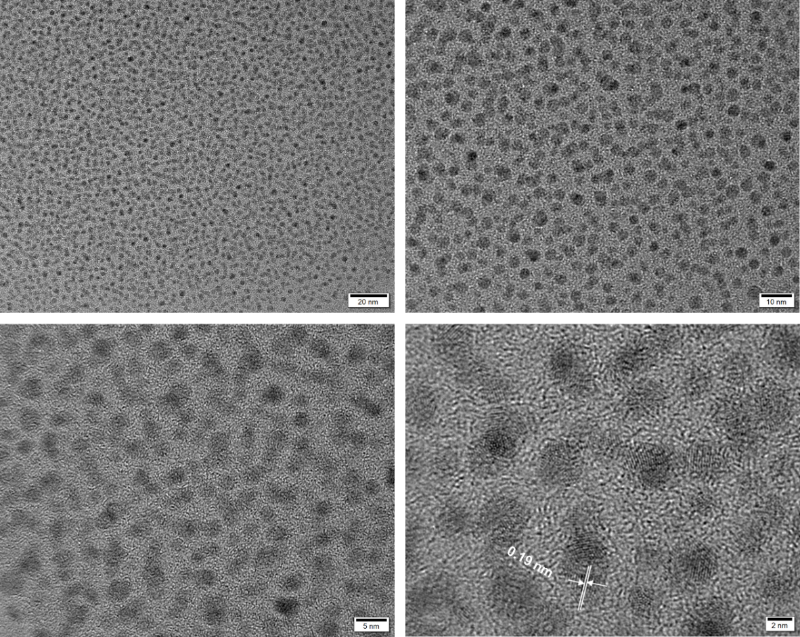
Supplementary Figure 1. The TEM images of CDs.

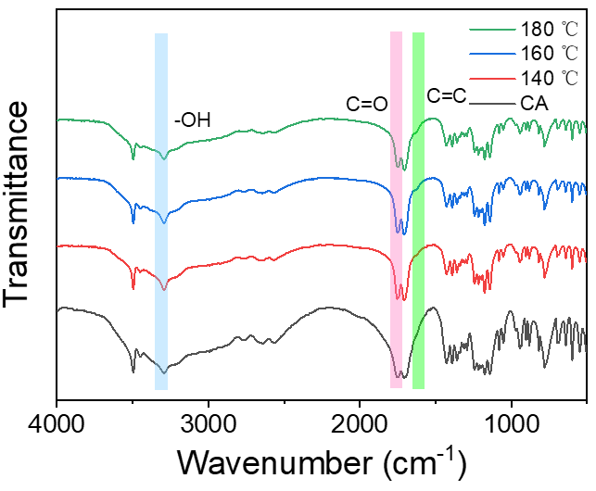
Supplementary Figure 2. FT-IR spectra of CA and CDs prepared at different temperatures.
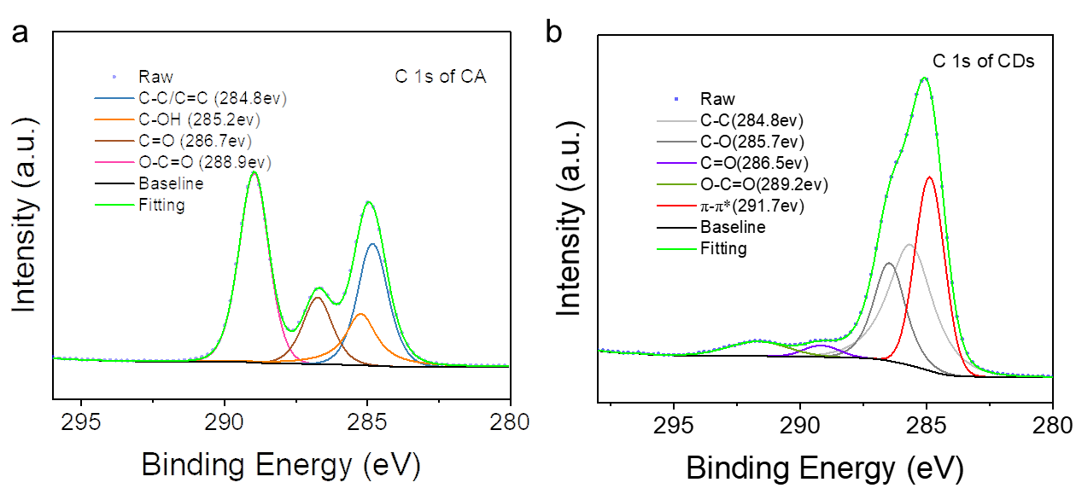
Supplementary Figure 3. XPS analysis of CA and CDs. a C1s scan of CA. b C1s scan of CDs. (C) O1s scan of CDs.

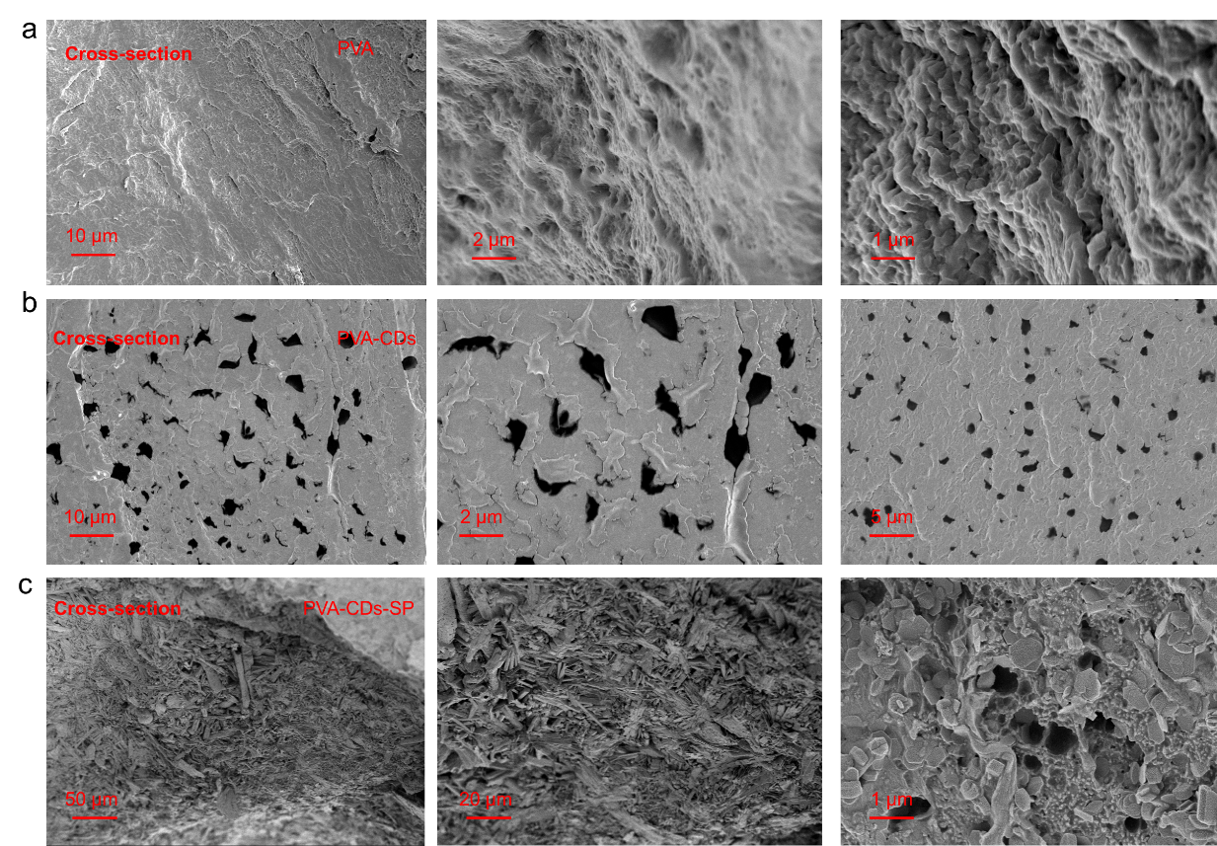
Supplementary Figure 4. SEM of the cross-section of hydrogel. a PVA. B PVA-CDs. c PVA-CDs-SP.

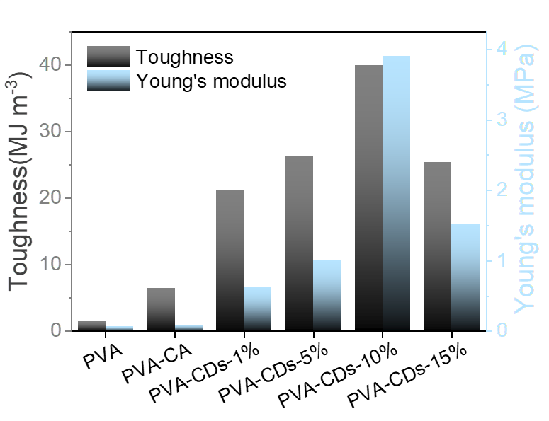
Supplementary Figure 5. Toughness and Young's modulus of PVA, PVA-CA and PVA-CDs at different concentrations of CDs.

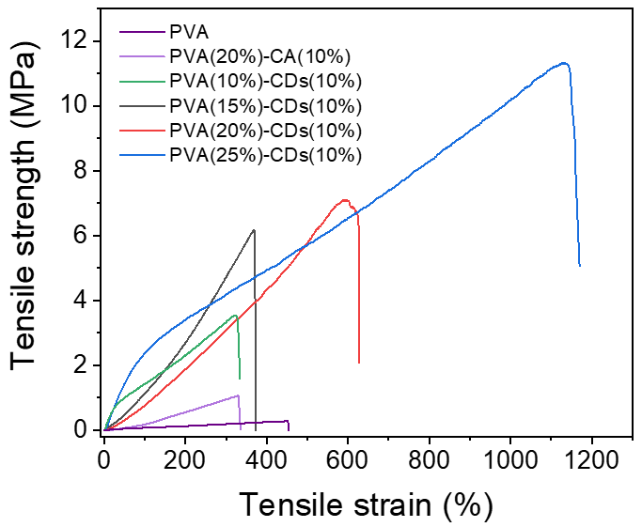
Supplementary Figure 6. Stress-strain curves of polyvinyl alcohol (PVA), PVA-citric acid (PVA-CA), and PVA-carbon dots (PVA-CDs) at different concentrations of PVA.

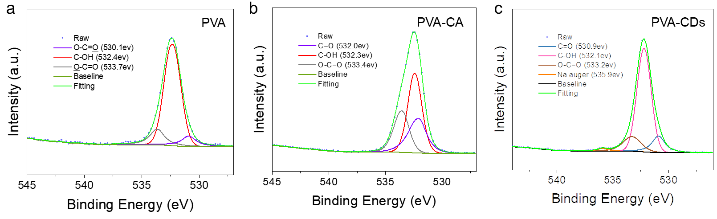
Supplementary Figure 7. XPS analysis of O1s scan. a PVA, b PVA-CA and c PVA-CDs.

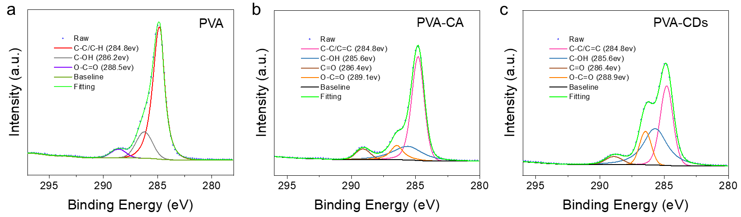
Supplementary Figure 8. XPS analysis of C1s scan. a PVA, b PVA-CA and c PVA-CDs.

Supplementary Figure 9. XRD profiles of the PVA, PVA-CA and PVA-CDs hydrogel.
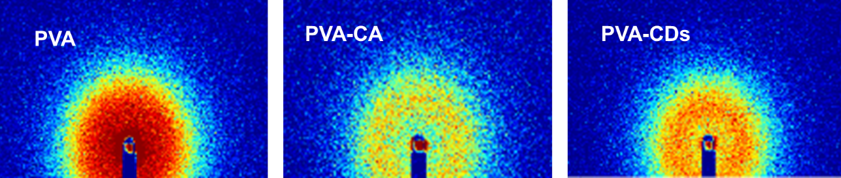
Supplementary Figure 10. 2D-SAXS patterns of the PVA, PVA-CA and PVA-CDs hydrogels.

Supplementary Figure 11. Average distances between neighboring crystalline domains in PVA-CDs, PVA-CDs-S and PVA-CDs-SP hydrogels.

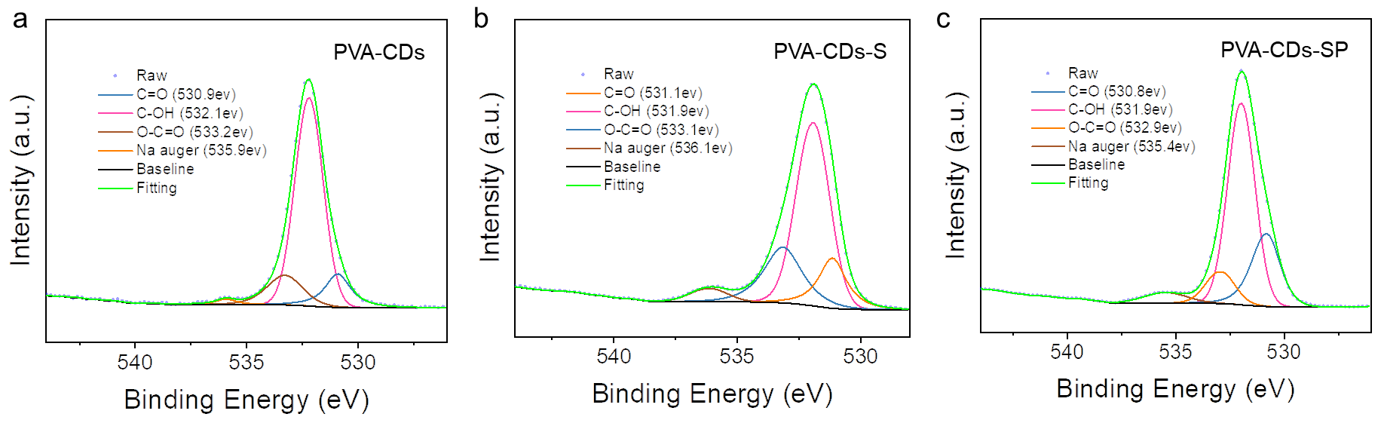
Supplementary Figure 12. XPS analysis of O1s scan. a PVA-CDs, b PVA-CDs-S and c PVA-CDs-SP hydrogels.

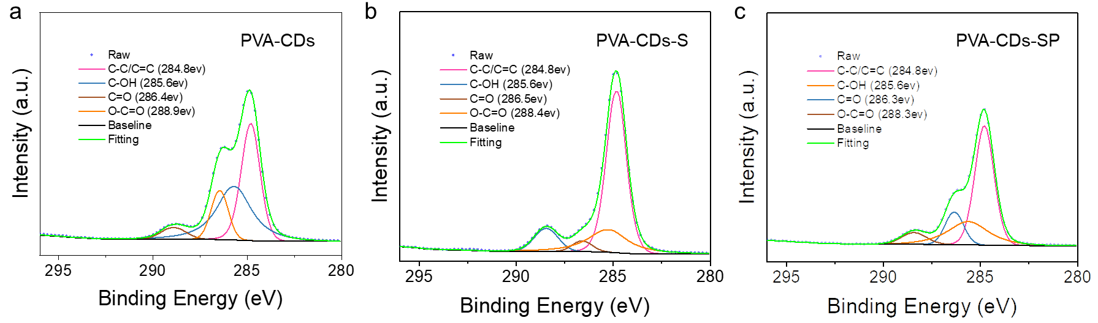
Supplementary Figure 13. XPS analysis of C1s scan. a PVA-CDs, b PVA-CDs-S and c PVA-CDs-SP hydrogels.

Supplementary Figure 14. XRD profiles of the PVA-CDs, PVA-CDs-S and PVA-CDs-SP hydrogels.

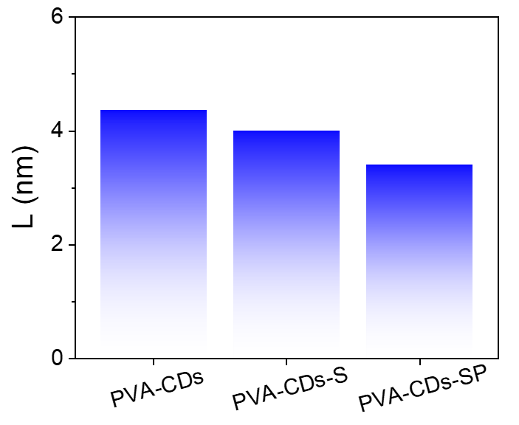
Supplementary Figure 15. The average distance between neighboring crystalline domains in the PVA-CDs, PVA-CDs-S and PVA-CDs-SP hydrogels.

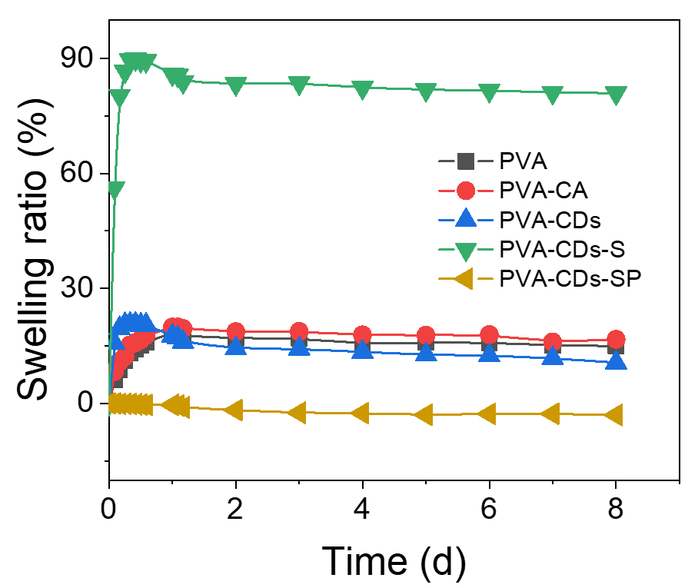
Supplementary Figure 16. Swelling kinetics of PVA, PVA-CA, PVA-CDs, PVA-CDs-S and PVA-CDs-SP hydrogels.

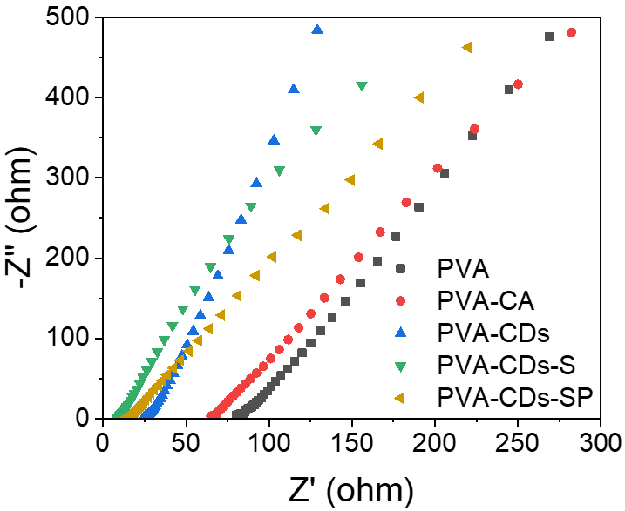
Supplementary Figure 17. Nyquist diagrams at PVA, PVA-CA, PVA-CDs, PVA-CDs-S and PVA-CDs-SP hydrogels.

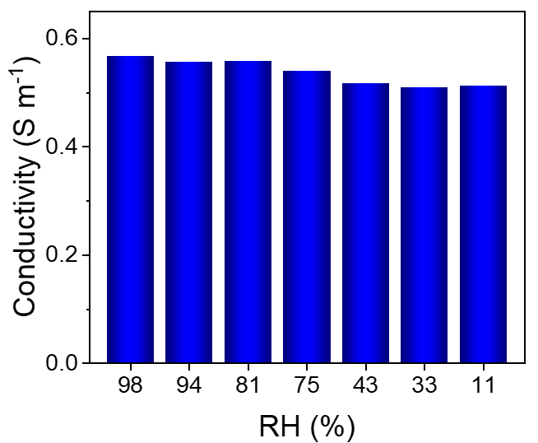
Supplementary Figure 18. Conductivity of PVA-CDs-SP hydrogels at various humidity levels.

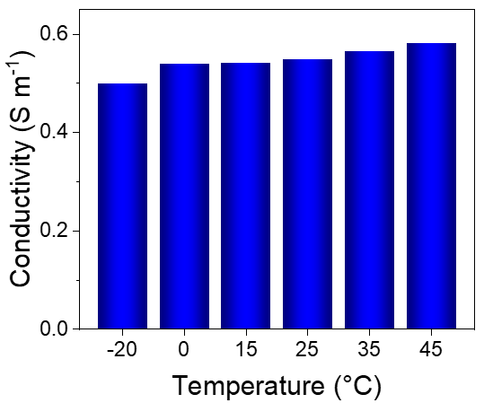
Supplementary Figure 19. Conductivity of PVA-CDs-SP hydrogels at varying temperatures.

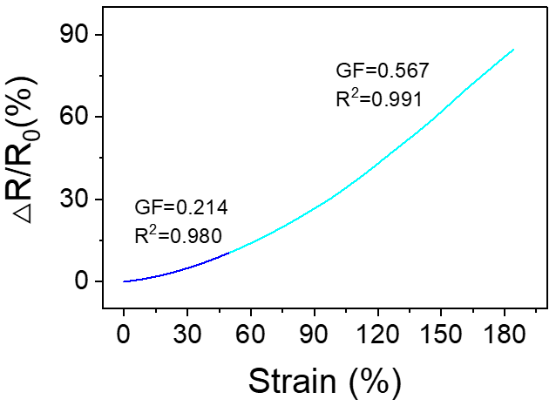
Supplementary Figure 20. Gauge factor of the PVA-CDs-SP hydrogels within the 970% strain range.

