SUPPLEMENTARY INFORMATION

Biological effect of alkaloid enriched fractions and reticuline from the Stephania dielsiana Y. C. Wu on promyelocyte HL-60 cell line
Petya Dimitrova^{1*}, Tsvetelina Doncheva², Nadezhda Kostova², Iveta Uzunova¹, Nikol Latinova¹, Vanya Gerasimova², Nguyen Tien Dat³, Do Hoang Giang³, Nguyen Thi Luyen³

¹Department of Immunology, Stephan Angeloff Institute of Microbiology, Bulgarian Academy of Sciences, Akad. G. Bonchev St, Bl. 26, 1113 Sofia, Bulgaria;
²Institute of Organic Chemistry with Centre of Phytochemistry, Bulgarian Academy of Sciences, Akad. G. Bonchev St, Bl. 9, 1113 Sofia, Bulgaria;
³Center for High Technology Research and Development, Vietnam Academy of Sciences and Technology, 18-Hoang Quoc Viet, Cau Giay, Hanoi, Vietnam;

*Corresponding author:
Assoc. Prof. Petya Dimitrova
Laboratory of Experimental Immunotherapy
Department of Immunology,
Stephan Angeloff Institute of Microbiology,
Bulgarian Academy of Sciences,
Akad. G. Bonchev St, Bl. 26,
1113 Sofia, Bulgaria
Tel: +359 2 9793131
e-mail: petya_dimitrova@web.de

Authors’ e-mail:
Tsvetelina Doncheva: tsvetelina.doncheva@orgchm.bas.bg
Nadezhda Kostova: nadezhda.kostova@orgchm.bas.bg
Iveta Uzunova: ivetauzunova1010@gmail.com
Nikol Latinova: nikol.latinova00@abv.bg
Vanya Gerasimova: vanya.gerasimova@orgchm.bas.bg
Nguyen Tien Dat: ntdat@chtd.vast.vn
Do Hoang Giang: giangdh.91@gmail.com
Nguyen Thi Luyen: luyen.svtn@gmail.com

Suppl. Material S1. HPLC analysis:
  - HPLC reagents and reference compounds
Ammonium acetate anhydrous, glacial acetic acid (100 %), triethylamine (TEA), methanol and acetonitrile were supplied by Fisher Scientific UK, (Loughborough, UK). All the used reagents were of an HPLC grade. The deionized water with a resistivity ≤ 0.55 µs/cm used for the HPLC analysis was generated by the water purification system Smart2Pure 12UV/UF (Thermo Electron LED GmbH, Langenselbold, Germany). The isoquinoline alkaloids 1-11, isolated from the S. dielsiana root extract (90-98 % purity), were used as reference compounds for the quantitative analysis.
  - Standard and sample preparation procedure
The samples and the standard substances, weighted at proper amounts, were dissolved in 100 % methanol and subsequently diluted fivefold with a mobile phase A, immediately before the analysis. Previously being injected into the column, the sample and the standard solutions were filtered through an Olimpeak™ PTFE (polytetrafluoroethylene) membrane syringe filters (25 mm diameter; 0.20 μm pore size), purchased from Teknokroma Analitica SA (Barcelona, Spain). Prior the analysis the mobile phases were filtered through 0.22 μm Millipore membrane filters (Merck KGaA, Darmstadt, Germany). All gravimetric measurements were carried out using a semi-micro balance from Precisa (Series 390 HE 225 SM-DR, Zug, Switzerland) with a precision of ±0.01 mg. The pH of the mobile phase A was measured by pH meter Seven Compact S220 (Mettler Toledo, Greifensee, Switzerland).
  - Method development
To achieve well-shaped peak areas of references (1-11), different mobile phases, including orthophosphoric, acetic, and trichloroacetic acids (within a pH range of 2.0 to 6.5) were evaluated. Additionally, TEA was used as an additive at a concentration of 2 mL/L, although it was not included in every instance. Notably, some trials have exhibited insufficient separation between crebanine and tetrahydropalmatine, as well as among crebanine, tetrahydropalmatine, and stephanine. Typically for improving the alkaloid separation a water solution of ammonium acetate, which is an easily accessible, is often employed as an ion-pair reagent. The peak separation optimization continued with mobile phases containing 10 to 100 mM ammonium acetate in water, basified with triethylamine (TEA), and adjusted to various pH levels (3.0, 4.0, 5.0) using acetic acid. Furthermore, optimization of different gradient elution programs led to the successful separation of all targeted peaks within 70 minutes using a mobile phase of 100 mM ammonium acetate with 0.2 % TEA (pH adjusted to 5.0 with acetic acid) and a 100 % acetonitrile as organic modifier. Finally, the method is deemed well-developed because the peak’s asymmetry does not exceed 2, the resolution between all studied alkaloids was more than 1.5. Additionally, a very low variation in the compound’s retention times from run to run was observed (RSD < 2%). This is an important criterion in method validation studies, ensuring the quality of the method and the success of subsequent validation efforts.

  - Method validation study
The developed HPLC method was specifically validated for the quantitative estimation of the isoquinoline alkaloids (1-11) in the extract of S. dielsiana (St-extr.) and the fractions St-1, St-2, and St-3. Calibration curves were constructed (6 points) by plotting the peak area against the concentration of standard solutions (μg/mL). The system suitability test was carried out by comparing the mobile phase blank and the sample solutions’ chromatograms. Method precision was established by sequentially injecting six standard solutions within a single analysis for intra-day precision and on three different days for inter-day precision. The LOD and LOQ were determined based on a signal-to-noise (S/N) ratio. Identification of alkaloids was achieved by comparing their UV spectra and retention times with those of individually injected reference substance solutions.
According to the validation results, the method was considered selective for all studied compounds (1-11). Furthermore, it was evaluated as linear (R² > 0.999) across each examined analyte range, with low deviations for intra- and inter-day precision (RSD < 2%). Notably, o-me-bulbcapnine (2), dehydrocrebanine (6) and crebanine (3) exhibited excellent sensitivity, with LODs of 0.0001, 0.02, and 0.03 µg/mL, and LOQs of 0.003, 0.05, and 0.09 µg/mL, respectively. Detailed peak characteristics of the compounds (1-11) and the HPLC method validation results, including regression equations derived from the selected concentration compound ranges, determination coefficients (R²), and the limits of detection (LOD) and quantification (LOQ) values for the compounds are presented in Table S1.4.
Based on the validation results the proposed and developed HPLC-UV method for simultaneous separation of the compounds 1-11 was suitable, selective, sensitive, linear, accurate and precise.

Table S1.4. The peak characteristics of the compounds (1-11) and the HPLC method validation results.
Reference compound | λmax/nm | RT, min | Regression equation | R² | Range  μg/ml | LOD (μg/ml) | LOQ  (μg/ml)
Oxostephanine (1) | 224.98/246.98/271.67/310.87/359.11 | 35.3 | y = 6053.6x - 5072.4 | 0.9992 | 1.0 – 15.0 | 0.20 | 0.61
O-Me-bulbcapnine (2) | 225.19/282.31 | 42.7 | y = 6197x - 1439.1 | 0.9998 | 0.1 – 120.0 | 0.0001 | 0.003
Crebanine (3) | 225.37/280.96 | 47.5 | y = 78889x - 24281 | 0.9999 | 2.5 – 120.0 | 0.03 | 0.09
Tetrahydropalmatine (4) | 227.39/281.66 | 49.3 | y = 3872x + 198.83 | 0.9997 | 0.5 – 15.0 | 0.13 | 0.39
Stephanine (5) | 225.87/271.67 | 50.5 | y = 7149.4x + 3055.4 | 0.9997 | 0.7 – 50.0 | 0.20 | 0.61
Dehydrocrebanine (6) | 270.96/339.75 | 62.0 | y = 26990x - 209.18 | 0.9999 | 1.0 – 15.0 | 0.02 | 0.05
Reticuline (7) | 229.96/282.88 | 18.1 | y = 6455.6x - 1715 | 0.9999 | 10.0 – 150.0 | 0.10 | 0.31
Ushinsunine (8) | 232.04/271.67/318.93 | 30.5 | y = 3757.5x - 2536.8 | 0.9999 | 1.5 – 40.0 | 1.15 | 3.41
Ayutianine (9) | 272.73/303.77 | 33.3 | y = 308.63x + 1426.7 | 0.9990 | 4.0 – 100.0 | 1.57 | 3.80
Liriodenine (10) | 246.81/268.98/313.83 | 39.3 | y = 2990x + 342.34 | 0.9996 | 0.25 – 10.0 | 0.25 | 0.25
Stesakine (11) | 225.77/260.93/337.64/389.77 | 64.7 | y = 2013.58x + 262.1 | 0.9994 | 1.0 – 10.0 | 0.30 | 0.91

  - Statistical analysis
Data processing, including graphical and tabular analyses, along with result calculations, was conducted using Excel (Microsoft Office Professional Plus 2021, USA). The chromatographic data processing and all into-account integration results, as well as the construction of the calibration curves and the calculation of the regression coefficients, were carried out using LabSolutions software (Shimadzu, DB version 5.114, Kyoto, Japan). In addition, the characteristic ultraviolet (UV) maxima and retention times (Rt) of the analytes (Table S1.4) are presented as average values of six sequential mixed standard solution injections (n=6).
The representative chromatogram of the main extract is presented in Figure S1.5.1, while the typical chromatograms of the derived fractions St-1, St-2 and St3 are shown at Figure S1.5.2, S1.5.3 and S1.5.4, respectively.
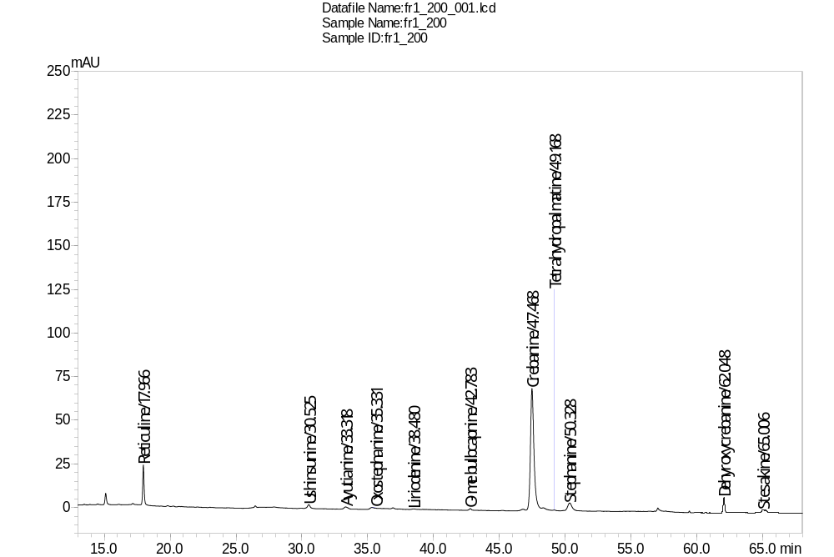
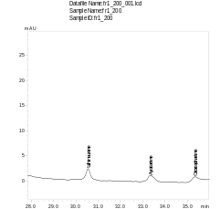
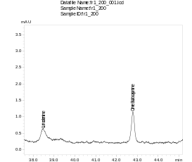
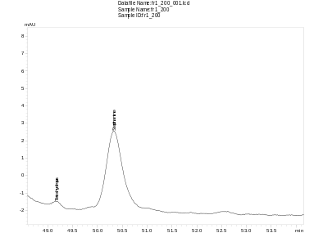
Suppl. Figures
S. dielsiana root extract
A
B
C

Fig. S1.5.1. HPLC-UV chromatogram (at 280 nm) of the S. dielsiana root extract, with a zoomed-in view of the chromatogram area: A) ushinsunine (8), ayutianine (9) and oxostephanine (1); B) liriodenine (10) and O-me bulbocapnine (2); C) tetrahydropalmatine (4) and stephanine (5)
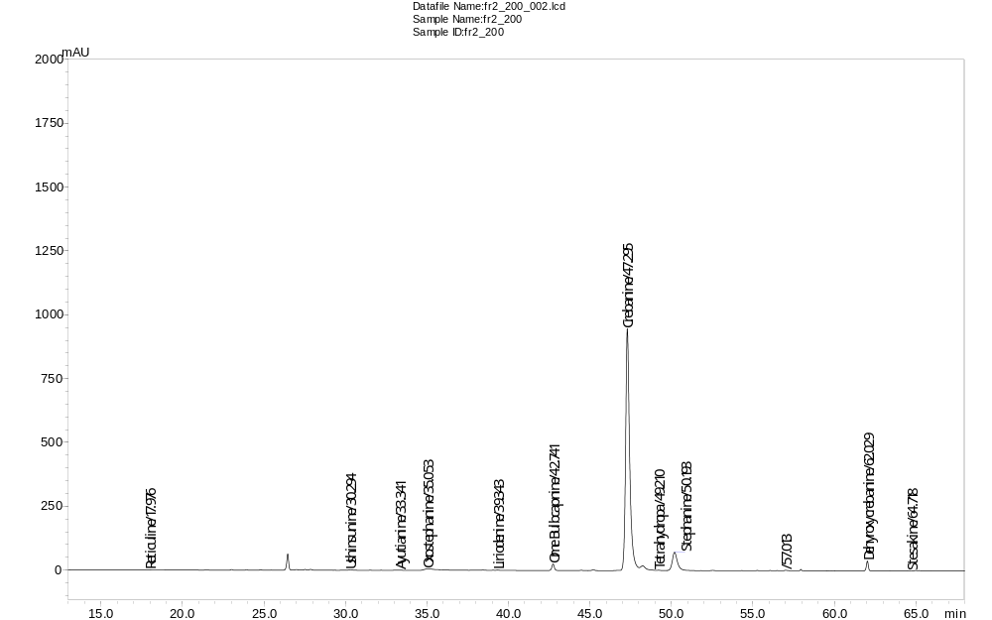
St-1
A
Fig. S1.5.2. HPLC-UV chromatogram (at 280 nm) of the S. dielsiana fraction St-1.
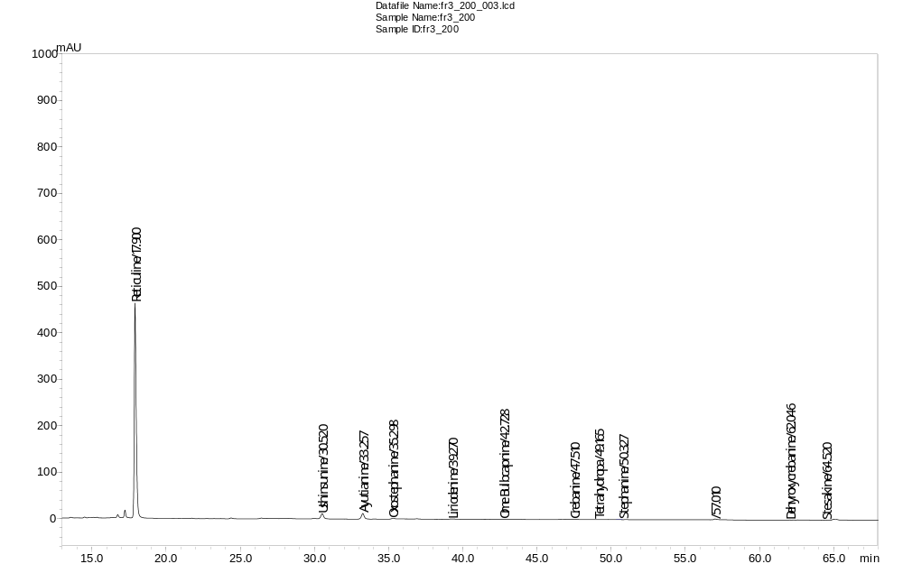
St-2
B

Fig. S1.5.3. HPLC-UV chromatogram (at 280 nm) of the S. dielsiana fraction St-2.

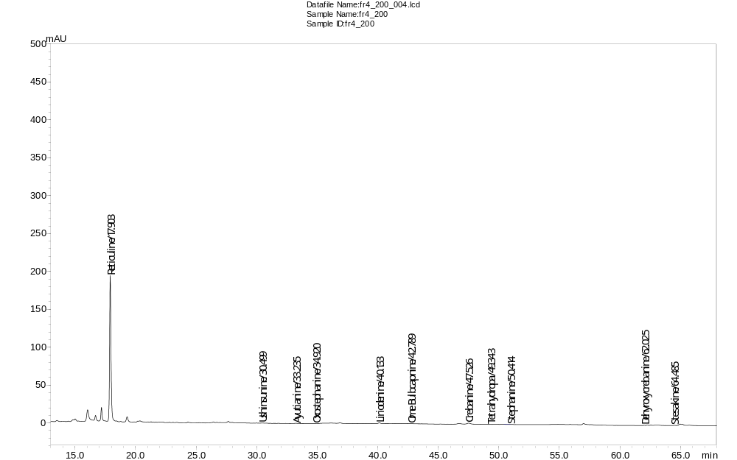
St-3
C
Fig. S1.5.4. HPLC-UV chromatogram (at 280 nm) of the S. dielsiana fraction St-3.

Fig. S2.1. Dose-dependent effect of the isolated compounds from S. dielsiana extract on growth of HL-60 cell line. Cells were cultured in the presence of the oxostephanine (1), O-Me-bulbocapnine (2), crebanine (3), tetrahydropalmitine (4), stephanine (5), dehydrocrebanine (6), reticuline (7) at concentration varied from 2 to 2000 µg/ml. Cell growth was evaluated by colorimetric MTT assay after 48 hours of culture and was presented as a % of the control cultures incubated with 0.02% DMSO/PBS. Data represent mean ± standard deviation (SD) of 3 repeats from 2 individual experiments.
Fig. S2.2. Representative experiment showing MytoSpy staining. A. Gating strategy showing gating of live cells and negative and positive controls. B. Representative histograms showing the intensity of staining with the MytoSpy dye.

