Combining enzymatic antioxidant overexpression and short-term low oxygen conditioning hormesis to improve performance of gamma-irradiated Anastrepha suspensa males
Vanessa S. Dias^{1,2*}, Carlos Cáceres¹, Andrew G. Parker¹, Rui Pereira¹, Güler Demirbas-Uzel¹, Adly M. M. Abd-Alla¹, Nicholas M. Teets^{2,3}, Marc F. Schetelig⁴, Alfred M. Handler⁵ & Daniel A. Hahn²
¹Insect Pest Control Subprogramme, Joint Food and Agriculture Organization (FAO)/ International Atomic Energy Agency (IAEA) Programme of Nuclear Techniques in Food and Agriculture, Vienna, A-1400, Austria
²Department of Entomology and Nematology, University of Florida, Gainesville, 32611, USA
³Department of Entomology, University of Kentucky, Lexington, 40546, USA
⁴Department of Insect Biotechnology in Plant Protection, Justus-Liebig-University Gießen, Gießen, 35394, Germany
⁵USDA/ARS, Center for Medical, Agricultural and Veterinary Entomology, Gainesville, 32608, USA
*V.Dias-de-Castro@iaea.org / vanessasidias@hotmail.com

Supplementary information
SI Figures:
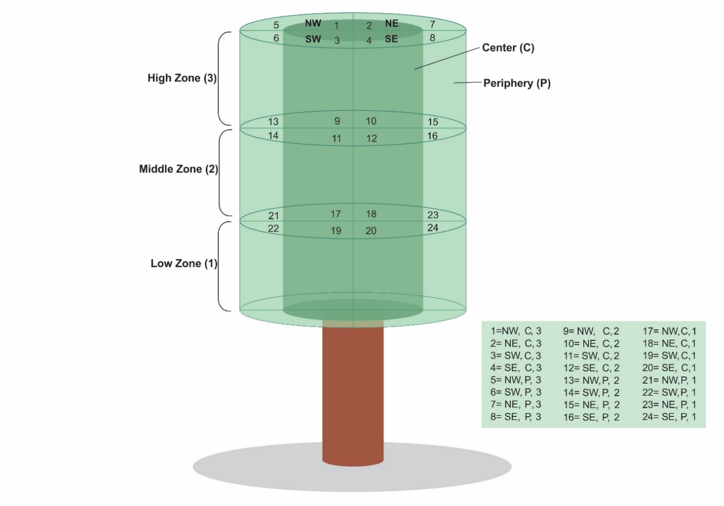
Fig. S1. Three-dimensional arrangement of the tree canopy used to classify the positioning of lekking Anastrepha suspensa males that mated in field cage tests. Males that mated were considered sexually successful. The location of each successful male within the leks was classified into 24 sectors, as follow: I) four cardinal quadrants, named as NE (northeast), NW (northwest), SE (southeast), and SW (southwest); II) three different height zones, numbered as 1 (bottom), 2 (middle), and 3 (top); III) two sectors describing depth in the tree canopy, represented as P (peripheral leaves situated approximately 5 cm from the edge of the canopy) and C (central leaves). Three different trees were used in the field cages tests. Thus, to account for the effect of tree configuration (e.g., foliage density and configuration) on male distribution, we categorize the distribution of the successful males in leks as dispersed (for males that mated in sectors with a single copulation) and clustered (for males that mated in sectors with two or more copulations).

SI Tables:
Table S1. Results of generalized linear mixed model (GLMM) testing for the total antioxidant capacity of non-irradiated and irradiated WT and SOD2 5.2 Anastrepha suspensa males under normoxia, hypoxia, and severe hypoxia. Fixed effects: line, atmosphere, radiation, and their interaction (×). Random effect = temporal cohort (block).

Response | Predictors | d.f (n, d)ª | F | P
Total antioxidant capacity | Line | 1, 51 | 0.16 | 0.6900
Total antioxidant capacity | Radiation | 1, 51 | 0.12 | 0.7400
Total antioxidant capacity | Atmosphere | 2, 51 | 8.23 | 0.0008***
Total antioxidant capacity | Line × Radiation | 1, 51 | 0.05 | 0.8200
Total antioxidant capacity | Line × Atmosphere | 2, 51 | 0.31 | 0.7300
Total antioxidant capacity | Radiation × Atmosphere | 2, 51 | 13.47 | <0.0001***
Total antioxidant capacity | Line × Radiation × Atmosphere | 2, 51 | 0.80 | 0.4500
ª Degrees of freedom (numerator, denominator)
* Statistical significance (GLMM, P < 0.05)

Table S2. Results of GLMM testing for quality control parameters (emergence, deformation, rate of fliers) of WT and SOD2 5.2 males of Anastrepha suspensa treated or not with radiation under normoxia, hypoxia, and severe hypoxia. Fixed effects: line, atmosphere, radiation, and their interactions (×). Random effect = temporal cohort (block).

Response | Predictors | d.f (n, d)ª | F | P
(A) Emergence | Line | 1, 83 | 28.07 | <0.0001*
(A) Emergence | Radiation | 1, 83 | 1.82 | 0.1800
(A) Emergence | Atmosphere | 2, 83 | 15.16 | <0.0001*
(A) Emergence | Line × Radiation | 1, 83 | 3.29 | 0.0700
(A) Emergence | Line × Atmosphere | 2, 83 | 5.36 | 0.0060*
(A) Emergence | Radiation × Atmosphere | 2, 83 | 7.36 | 0.0010*
(A) Emergence | Line × Radiation × Atmosphere | 2, 83 | 0.55 | 0.5800
(B) Deformation | Line | 1, 83 | 5.42 | 0.0220*
(B) Deformation | Radiation | 1, 83 | 0.0001 | 0.9900
(B) Deformation | Atmosphere | 2, 83 | 0.89 | 0.4100
(B) Deformation | Line × Radiation | 1, 83 | 3.43 | 0.0600
(B) Deformation | Line × Atmosphere | 2, 83 | 2.74 | 0.0700
(B) Deformation | Radiation × Atmosphere | 2, 83 | 4.37 | 0.0100*
(B) Deformation | Line × Radiation × Atmosphere | 2, 83 | 1.55 | 0.2200
(C) Rate of fliers | Line | 1, 83 | 0.92 | 0.3400
(C) Rate of fliers | Radiation | 1, 83 | 0.60 | 0.1300
(C) Rate of fliers | Atmosphere | 2, 83 | 5.57 | <0.0050*
(C) Rate of fliers | Line × Radiation | 1, 83 | 1.82 | 0.1800
(C) Rate of fliers | Line × Atmosphere | 2, 83 | 0.12 | 0.8900
(C) Rate of fliers | Radiation × Atmosphere | 2, 83 | 3.98 | 0.0200*
(C) Rate of fliers | Line × Radiation × Atmosphere | 2, 83 | 2.86 | 0.0600
ª Degrees of freedom (numerator, denominator)
* Statistical significance (GLMM, P < 0.05)

Table S3. GLMM testing for the effect of SOD2 overexpression, radiation and low oxygen treatments on male mating success of Anastrepha suspensa. Line and temporal cohort (block) were modeled as fixed and random effects, respectively.

Crosses | n |  | Line
Crosses |  |  | df |  |  | F | P
Normoxia (Nx): air
(1) 0 Gy WT-Nx vs 0 Gy SOD2 5.2-Nxª | 8 |  | 1 |  |  | 10.54 | 0.0070*
(2) 0 Gy WT-Nx vs 70 Gy SOD2 5.2-Nxª | 8 |  | 1 |  |  | 13.37 | 0.0040*
(3) 70 Gy WT-Nx vs 0 Gy SOD2 5.2-Nxª | 8 |  | 1 |  |  | 23.94 | 0.0004*
(4) 70 Gy WT-Nx vs 70 Gy SOD2 5.2-Nxª | 8 |  | 1 |  |  | 3.96 | 0.0730
(5) 0 Gy WT-Nx vs 0 Gy SOD2 5.2-Nx vs 70 Gy WT-Nx vs 70 Gy SOD2 5.2-Nx^{b} | 6 |  | 3 |  |  | 6.47 | 0.0910
Hypoxia (Hx): O₂= 7.3% (4.6 to 10%), CO₂=4.5% (2.5 to 6.4%)
(6) 70 Gy WT-Hx vs 70 Gy SOD2 5.2-Hxª | 9 |  | 1 |  |  | 0.98 | 0.3400
(7) 0 Gy WT-Nx vs 70 Gy WT-Hxª | 6 |  | 1 |  |  | 0.57 | 0.4730
(8) 0 Gy WT-Nx vs 70 Gy SOD2 5.2-Hxª | 6 |  | 1 |  |  | 0.46 | 0.5150
Severe hypoxia (SHx): O₂= 0.4% (0.1 to 0.7%), CO₂=0.8% (0.3 to 1.4%)
(9) 70 Gy WT-SHx vs 70 Gy SOD2 5.2-SHxª | 9 |  | 1 |  |  | 1.51 | 0.2410
(10) 0 Gy WT-Nx vs 70 Gy WT-SHxª | 6 |  | 1 |  |  | 0.23 | 0.6352
(11) 0 Gy WT-Nx vs 70 Gy SOD2 5.2-SHxª | 6 |  | 1 |  |  | 0.01 | 0.9050
*Statistical significance (GLM, P < 0.05)
ª Low (2:1) male: female ratio
^{b} High (4:1) male: female ratio

Table S4. Proportion of mating, copulation latency, and copulation duration for WT and SOD2 males of Anastrepha suspensa competing in field cages, treated or not with radiation under normoxia, hypoxia, and severe hypoxia.

Mating comparison |  | PMª ± SE |  | Copulation parameters
 |  |  |  | Male | CL^{b} ± SE (min) | CD^{c} ± SE (min)
Normoxia
(1) | 0 Gy WT vs  0 Gy SOD2 5.2 | 74% ± 4% |  | 0 Gy WT | 36 ± 3 | 30 ± 1
(1) | 0 Gy WT vs  0 Gy SOD2 5.2 |  |  | 0 Gy SOD | 31 ± 4 | 31 ± 2
(2) | 0 Gy WT vs  70 Gy SOD2 5.2 | 81% ± 3% |  | 0 Gy WT | 33 ± 3* | 31 ± 1**
(2) | 0 Gy WT vs  70 Gy SOD2 5.2 |  |  | 70 Gy SOD | 49 ± 5* | 25 ± 1**
(3) | 70 Gy WT vs  0 Gy SOD2 5.2 | 67% ± 4% |  | 70 Gy WT | 65 ± 6 | 29 ± 1
(3) | 70 Gy WT vs  0 Gy SOD2 5.2 |  |  | 0 Gy SOD | 61 ± 3 | 30 ± 1
(4) | 70 Gy WT vs  70 Gy SOD2 5.2 | 82% ± 4% |  | 70 Gy WT | 34 ± 3 | 29 ± 1
(4) | 70 Gy WT vs  70 Gy SOD2 5.2 |  |  | 70 Gy SOD | 36 ± 3 | 31 ± 1
(5) | 0 Gy WT vs | 85% ± 3% |  | 0 Gy WT | 19 ± 3 | 32 ± 2
(5) | 0 Gy SOD2 5.2 vs |  |  | 0 Gy SOD2 5.2 | 19 ± 2 | 33 ± 2
(5) | 70 Gy SOD2 5.2 vs |  |  | 70 Gy WT | 19 ± 3 | 26 ± 2
(5) | 70 Gy WT vs |  |  | 70 Gy SOD2 5.2 | 19 ± 3 | 27 ± 3
Hypoxia
(6) | 70 Gy WT-Hx vs  70 Gy SOD2 5.2-Hx | 79% ± 3% |  | 70 Gy WT-Hx | 27 ± 1 | 41 ± 3
(6) | 70 Gy WT-Hx vs  70 Gy SOD2 5.2-Hx |  |  | 70 Gy SOD2 5.2-Hx | 30 ± 2 | 38 ± 3
(7) | 0 Gy- WT-Nx vs  70 Gy WT-Hx | 80% ± 5% |  | 0 Gy WT-Nx | 30 ± 2 | 31 ± 3
(7) | 0 Gy- WT-Nx vs  70 Gy WT-Hx |  |  | 70 Gy WT-Hx | 31 ± 2 | 35 ± 3
(8) | 0 Gy WT-Nx vs  70 Gy SOD2 5.2-Hx | 65% ± 4% |  | 0 Gy WT-Nx | 34 ± 2 | 38 ± 4
(8) | 0 Gy WT-Nx vs  70 Gy SOD2 5.2-Hx |  |  | 70 Gy SOD2 5.2-Hx | 35 ± 2 | 33 ± 4
Severe hypoxia
(9) | 70 Gy WT-SHx vs  70 Gy SOD2 5.2-SHx | 75% ± 6% |  | 70 Gy WT-SHx | 33 ± 2 | 31 ± 3
(9) | 70 Gy WT-SHx vs  70 Gy SOD2 5.2-SHx |  |  | 70 Gy SOD2 5.2-SHx | 29 ± 1 | 32 ± 3
(10) | 0 Gy WT-Nx vs  70 Gy WT-SHx | 74% ± 5% |  | 0 Gy WT-Nx | 34 ± 2 | 37 ± 4
(10) | 0 Gy WT-Nx vs  70 Gy WT-SHx |  |  | 70 Gy WT-SHx | 35 ± 2 | 40 ± 4
(11) | 0 Gy WT-Nx vs  70 Gy SOD2 5.2-SHx | 85% ± 4% |  | 0 Gy WT-Nx | 32 ± 2 | 40 ± 4
(11) | 0 Gy WT-Nx vs  70 Gy SOD2 5.2-SHx |  |  | 70 Gy SOD2 5.2-SHx | 33 ± 2 | 39 ± 4
ª Proportion of mating
^{b} Copulation latency
*Statistical significance (Mann-Whitney test, W = 3885.5, P < 0.0032)
**Statistical significance (GLMM, F = 9.31, P = 0.0027)

