Proteomic profiling of the serological response to a chemically-inactivated nodavirus vaccine in European sea bass Dicentrarchus labrax

Nadia Chérif^{1*}, Kais Ghedira², Houda Agrebi¹, Semah Najahi³, Hiba Mejri³, Saifeddine Azouz⁴, Mélodie Kielbasa⁵, Jean Armengaud⁵, Richard Thiga Kangethe⁶, Viskam Wijewardana⁶, Balkiss Bouhaouala-Zahar^{3,7*}, Haitham Sghaier^{8,9*}

¹Disease of Aquatic organism service, Aquaculture Laboratory (LR16INSTM03), National Institute of Sea Sciences and Technologies, 2025 Salammbô, Tunisia.
²Laboratory of Bioinformatics, Biomathematics and Biostatistics - LR16IPT09, Institut Pasteur de Tunis, Université de Tunis El Manar, Tunis 1002, Tunisia.
³Laboratory of Venoms and Therapeutic Molecules (LR16IPT08), Institut Pasteur Tunis, University Tunis El Manar, 1002 Tunis, Tunisia.
⁴Genomic Platform, Institut Pasteur de Tunis, Université de Tunis El Manar, Tunis, 1086. Tunisia.
⁵Université Paris-Saclay, CEA, INRAE, Département Médicaments et Technologies pour la Santé (DMTS), SPI, 30200 Bagnols sur Cèze, France.
⁶Animal Production and Health Laboratory, Joint FAO/IAEA Centre of Nuclear Techniques in Food and Agriculture, International Atomic Energy Agency, 2444 Seibersdorf, Austria.
⁷Medical School of Tunis, University Tunis El Manar, 1007 Tunis, Tunisia
⁸Laboratory ″Energy and Matter for Development of Nuclear Sciences″ (LR16CNSTN02), National Center for Nuclear Sciences and Technology (CNSTN), Sidi Thabet Technopark 2020, Tunisia.
⁹Univ. Manouba, ISBST, BVBGR-LR11ES31, Biotechpole Sidi Thabet, 2020, Ariana, Tunisia.

*Corresponding authors:
Nadia Chérif. E-mail: nadia.cherif@instm.rnrt.tn
Balkiss Bouhaouala-Zahar. E-mail : balkiss.bouhaouala@pasteur.utm.tn
Haitham Sghaier. E-mail: haitham.sghaier@cnstn.rnrt.tn

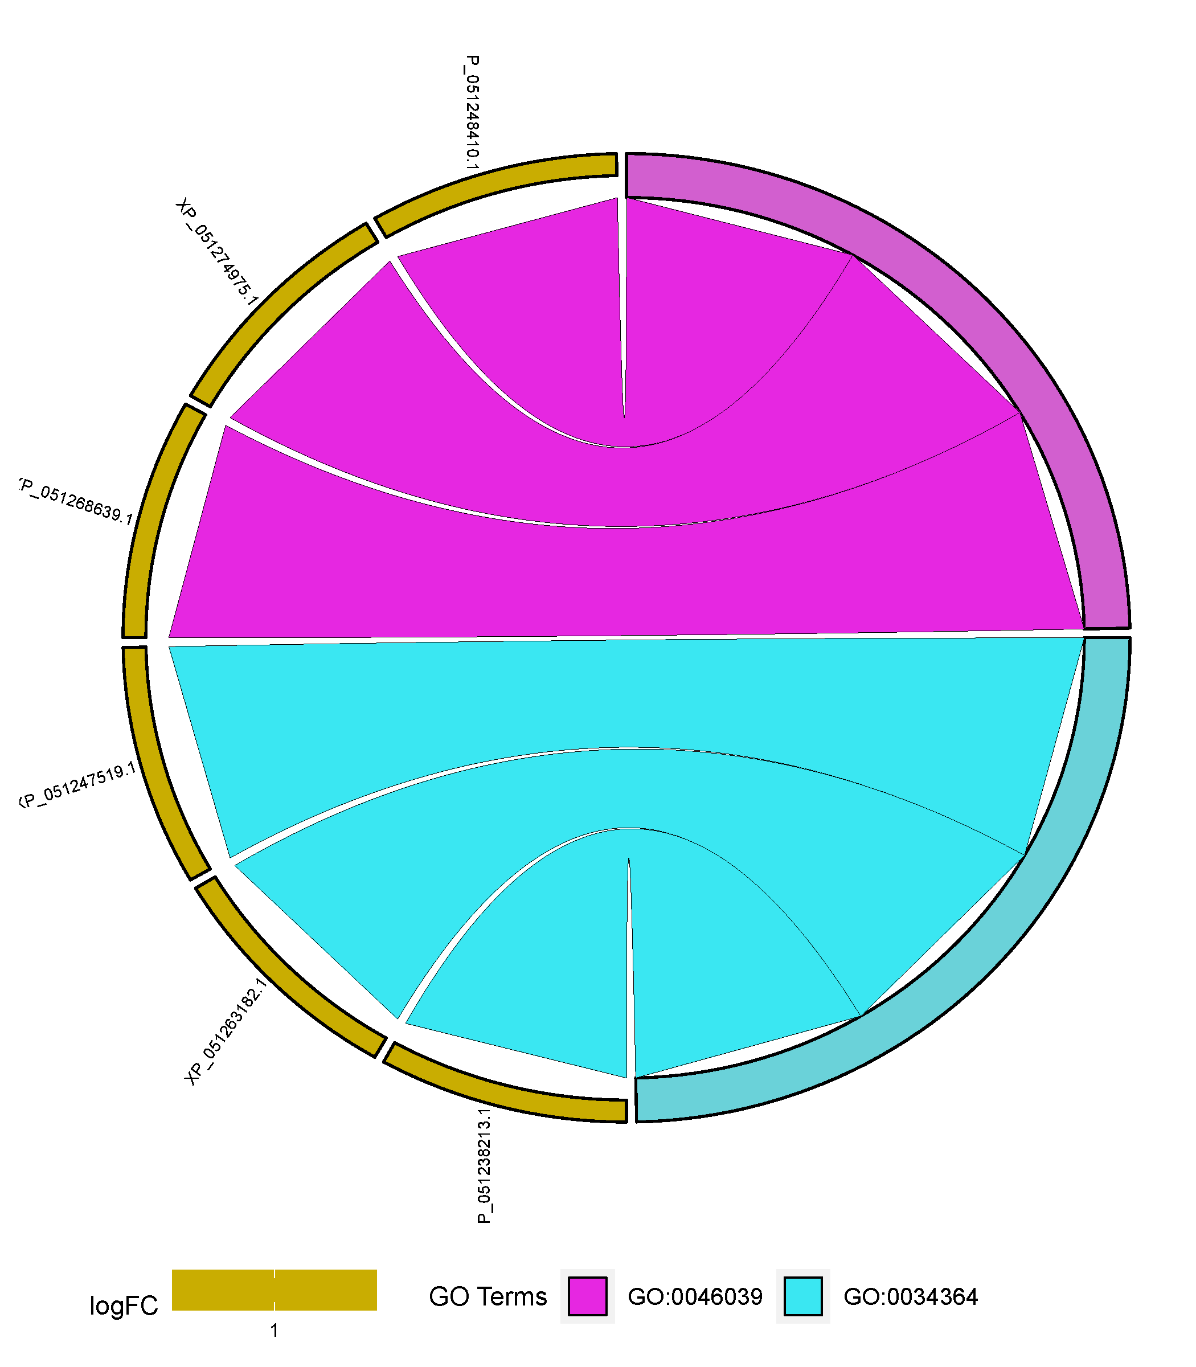

Supplementary Figure S1.A. GOChord plot showing assignment of orange-class proteins to their most enriched biological processes.
Orange-class proteins from the European sea bass (on the left) are linked to enriched GO terms (on the right) by chords. Coloured rectangles denote fold change.
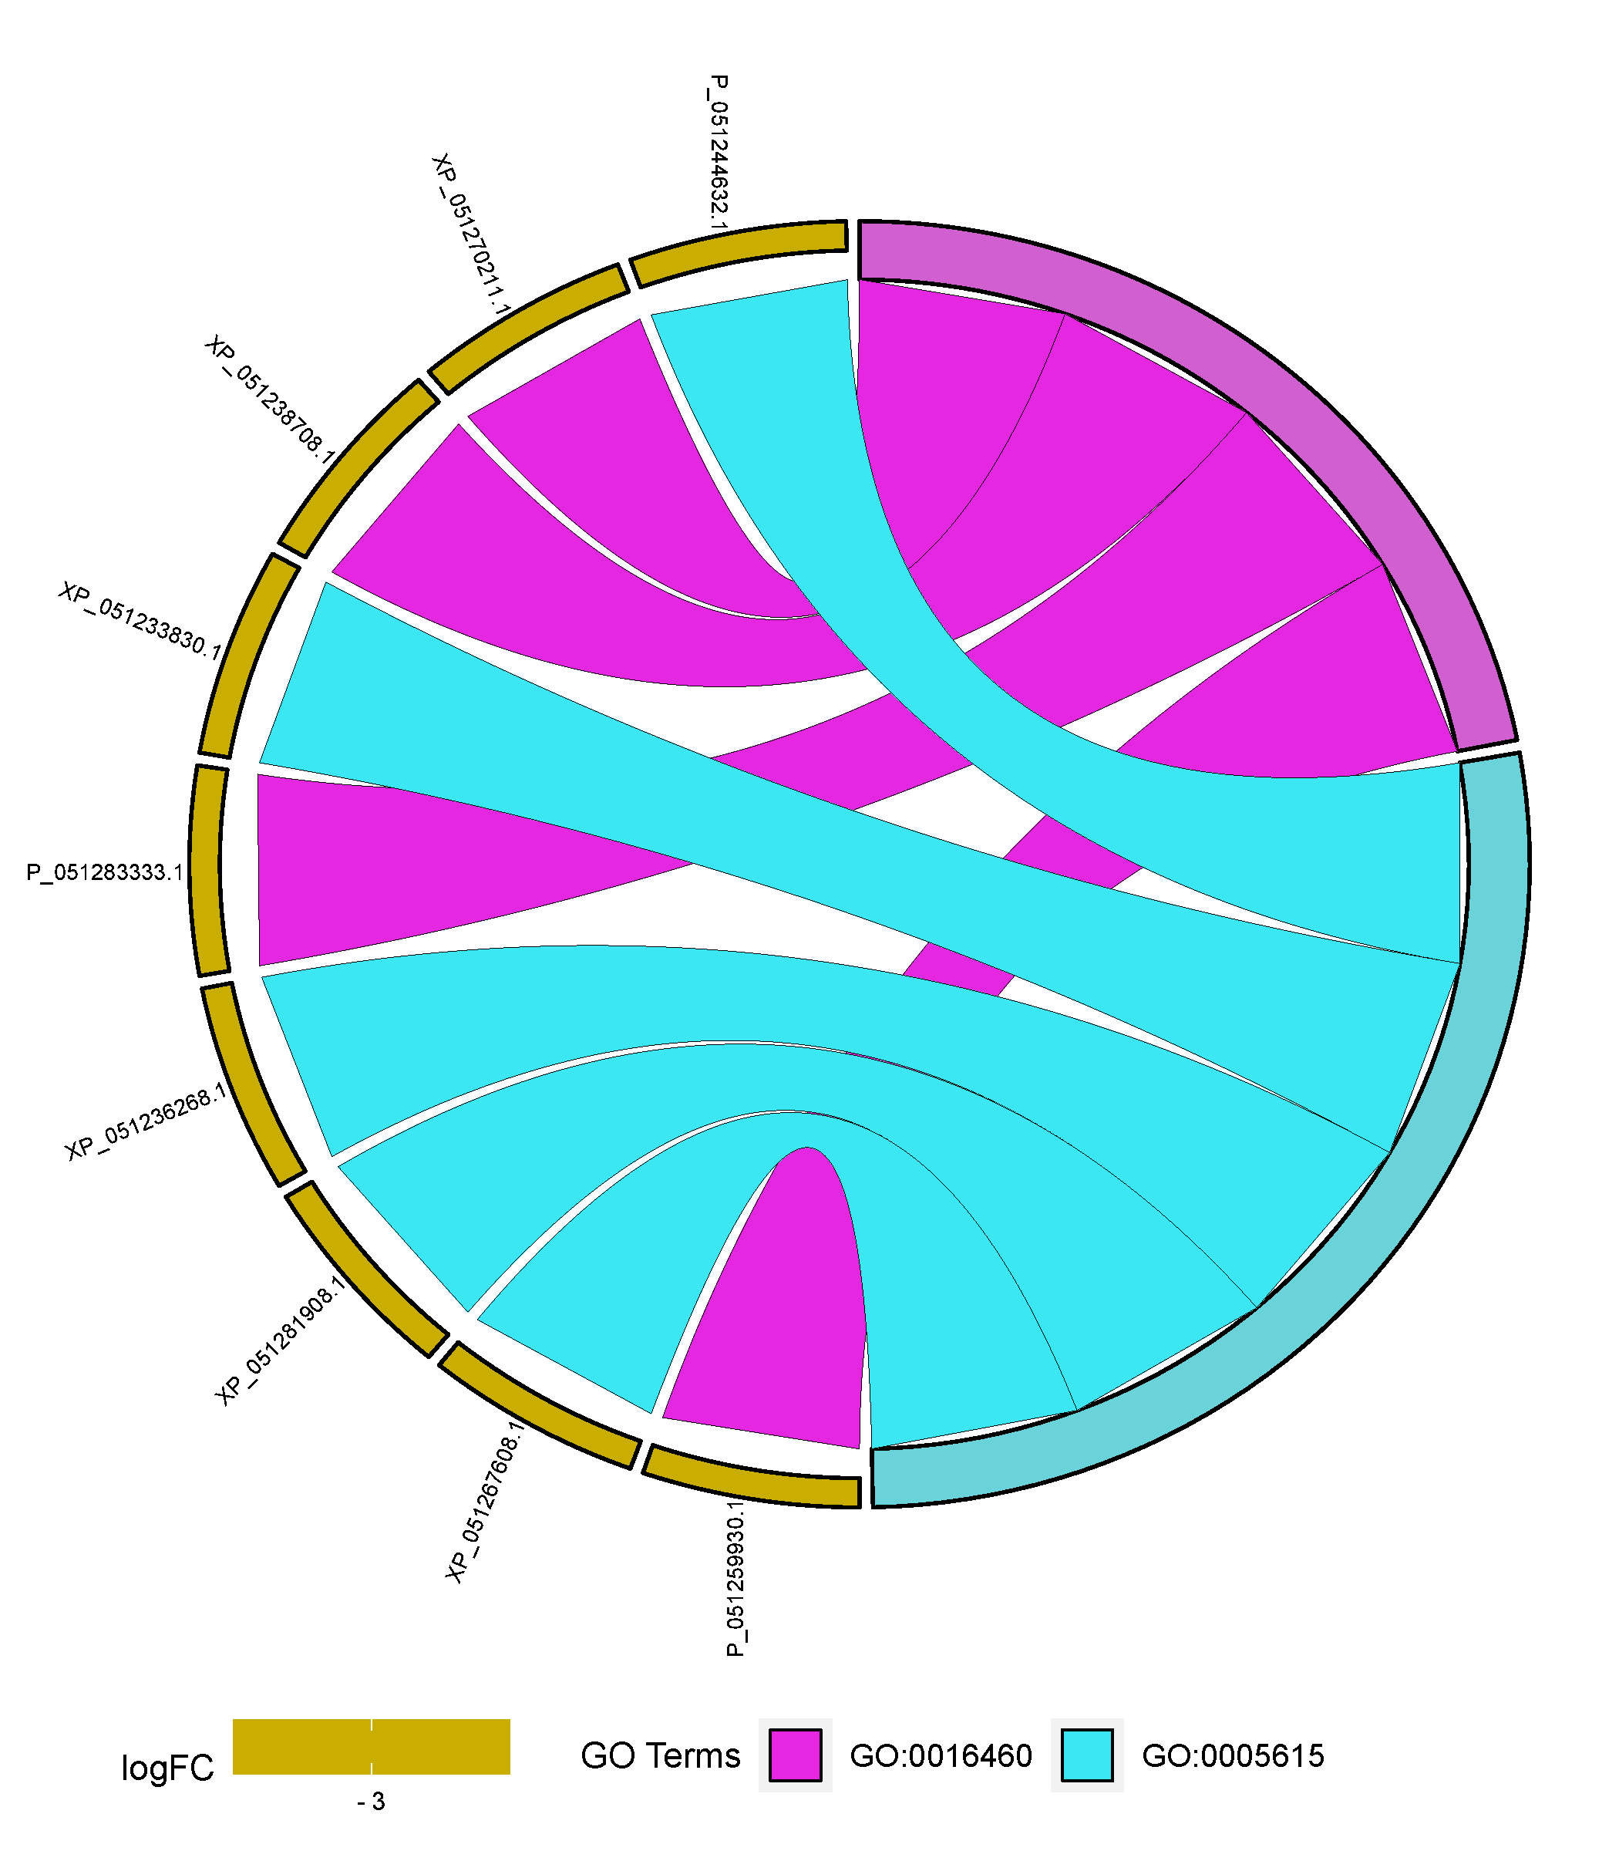

Supplementary Figure S1.B. GOChord plot showing assignment of green-class proteins to their most enriched biological processes.
Green-class proteins from the European sea bass (on the left) are linked to enriched GO terms (on the right) by chords. Coloured rectangles denote fold change.
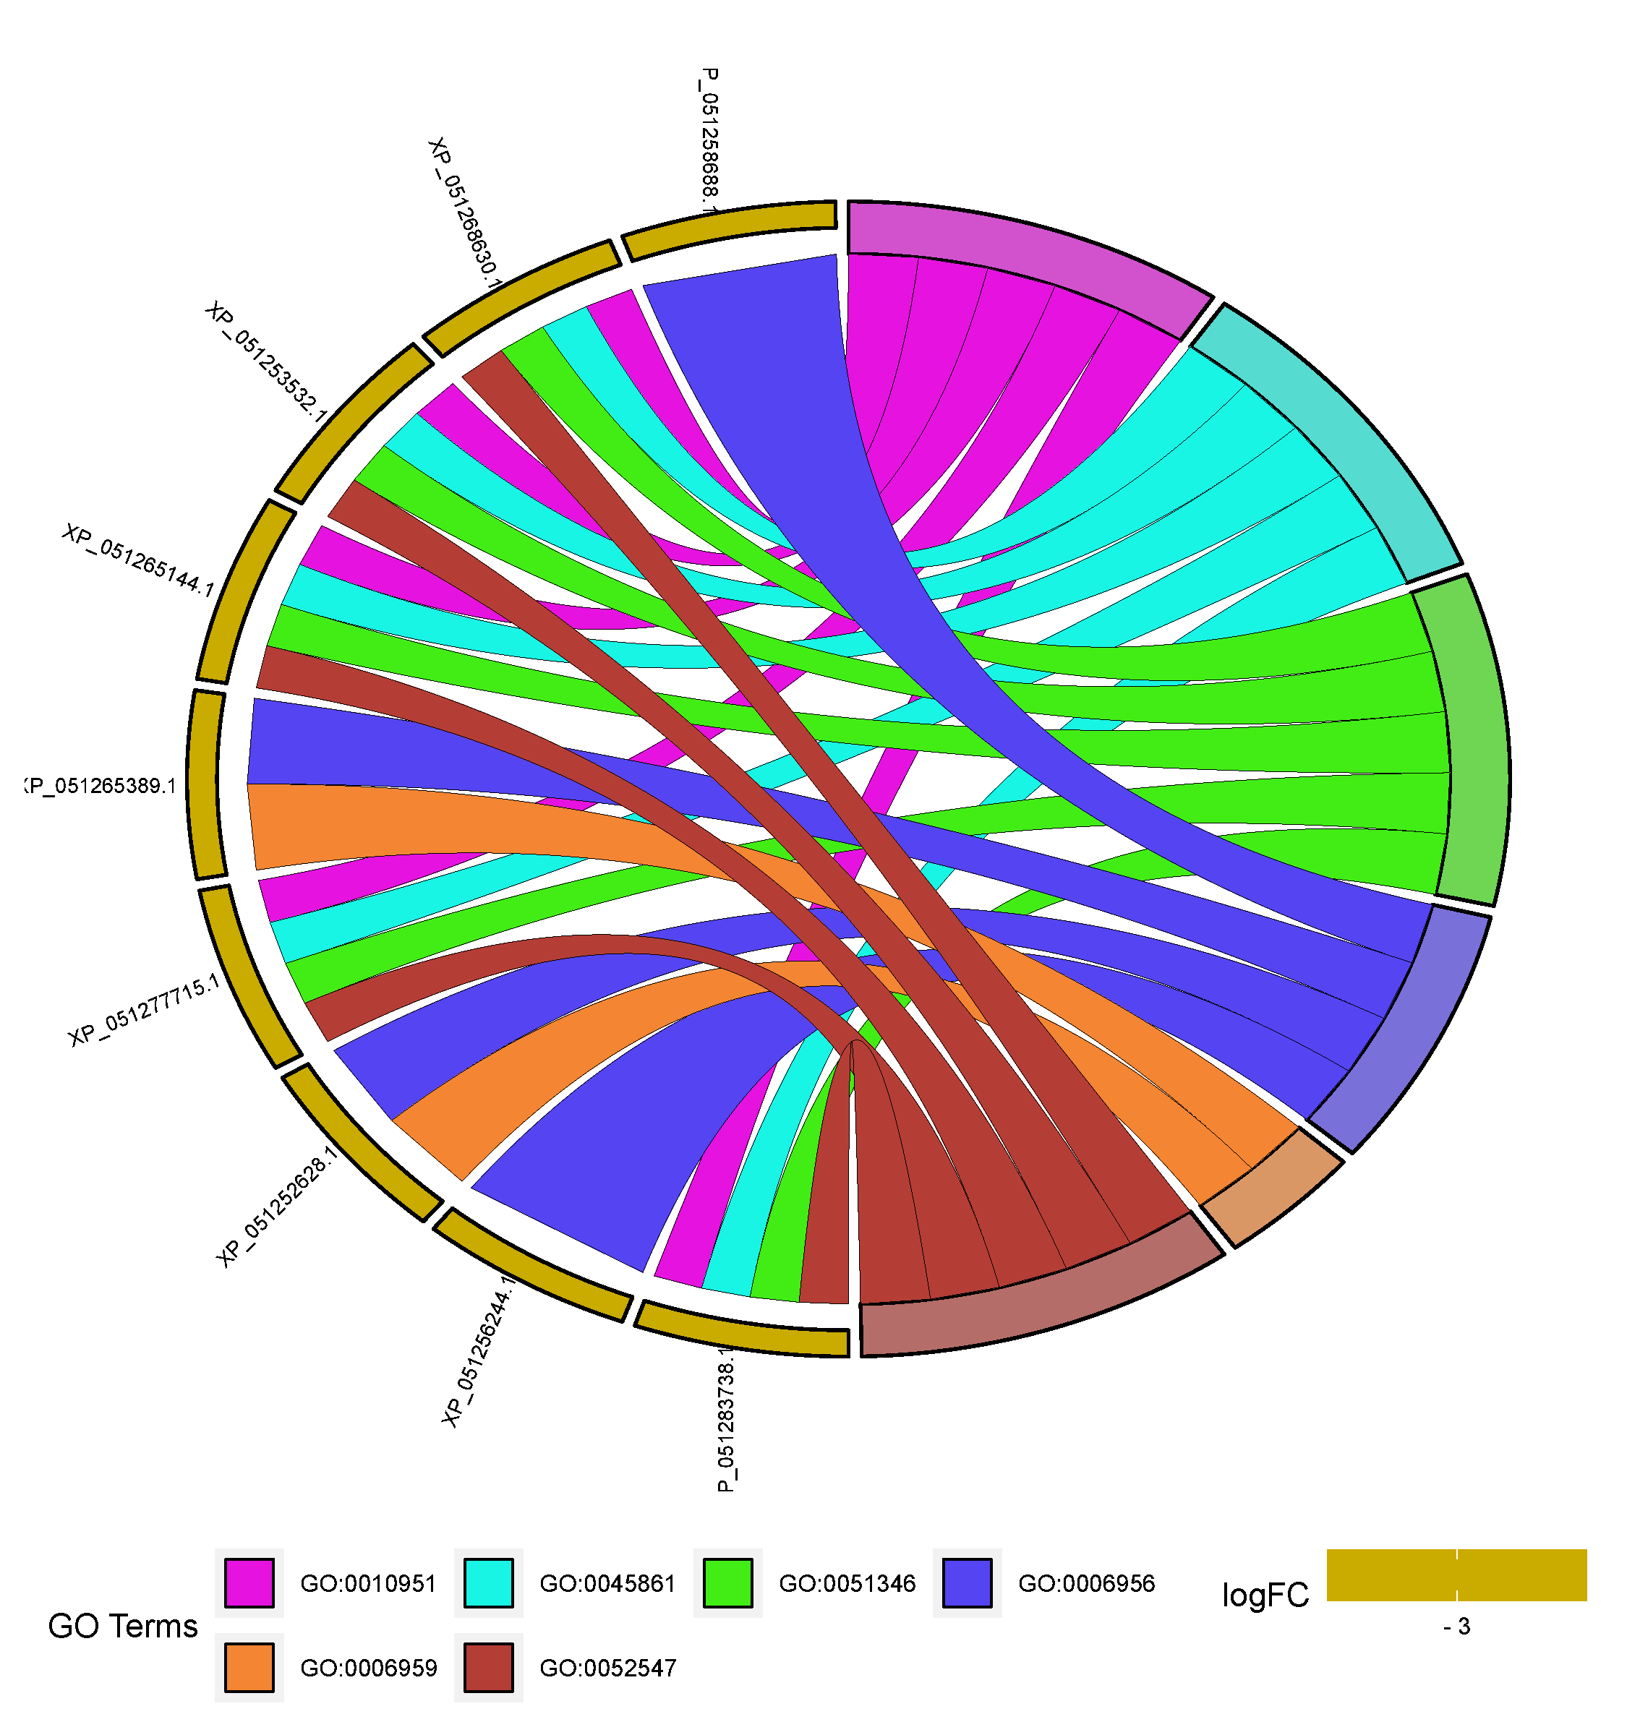

Supplementary Figure S1.C. GOChord plot showing assignment of red-class proteins to their most enriched biological processes.
Red-class proteins from the European sea bass (on the left) are linked to enriched GO terms (on the right) by chords. Coloured rectangles denote fold change.

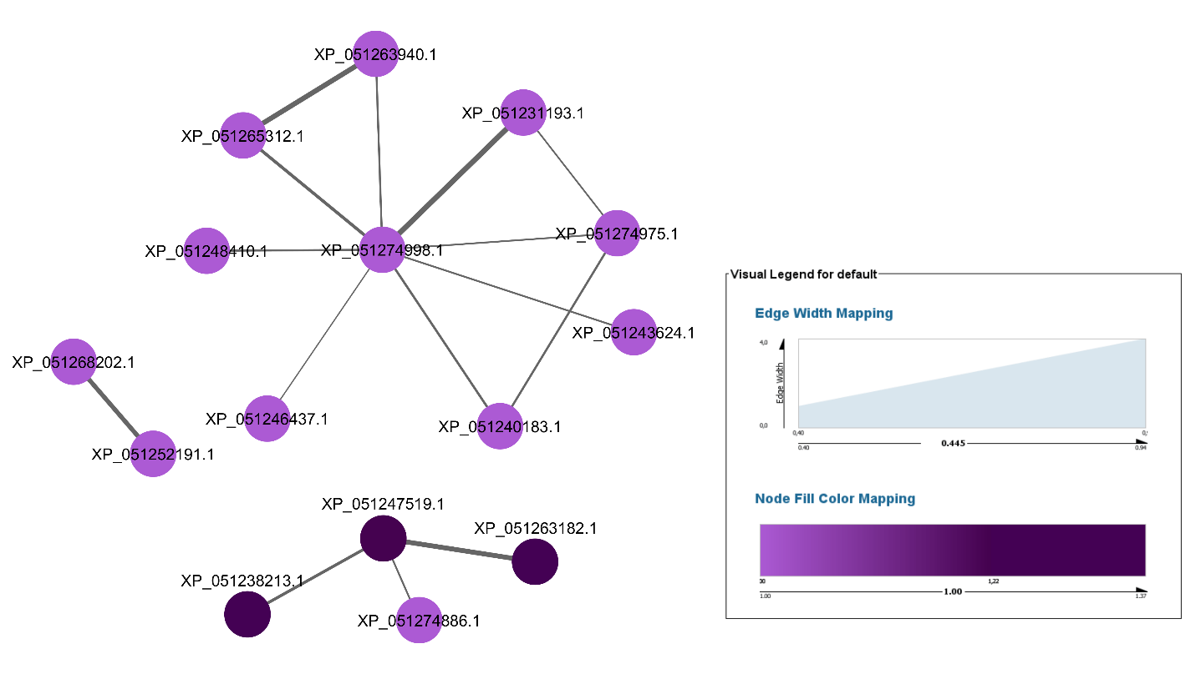

Supplementary Figure S2.A. Protein-protein interaction (PPI) network of orange-class proteins.
Edge widths represent the strength of the interaction, while node colours indicate the fold change.

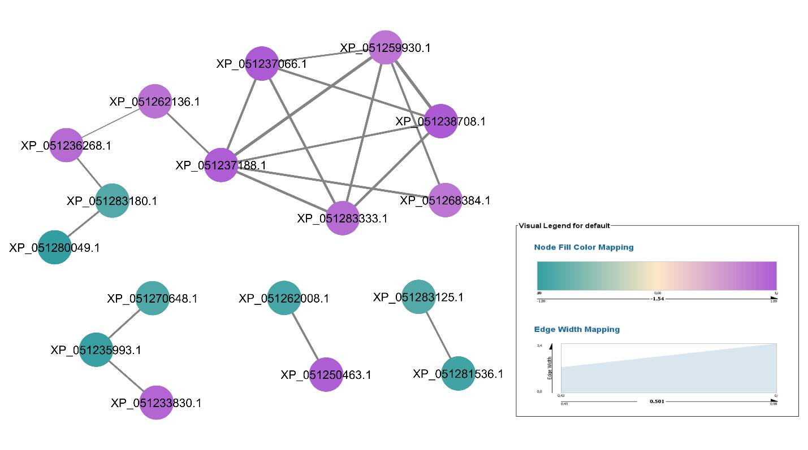

Supplementary Figure S2.B. Protein-protein interaction (PPI) network of green-class proteins.
Edge widths represent the strength of the interaction, while node colours indicate the fold change.

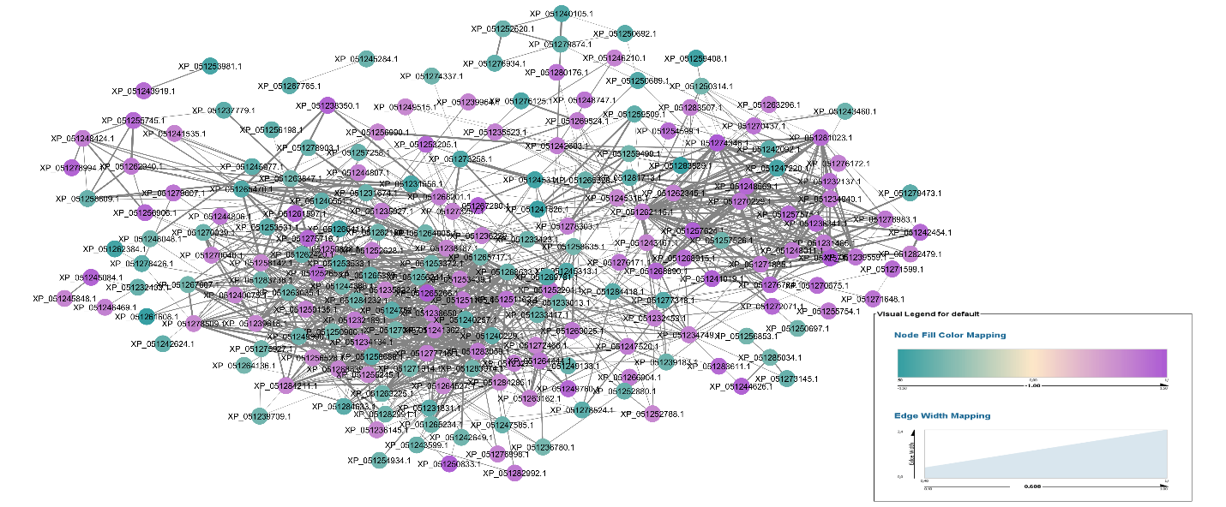

Supplementary Figure S2.C. Protein-protein interaction (PPI) network of red-class proteins.
Edge widths represent the strength of the interaction, while node colours indicate the fold change.

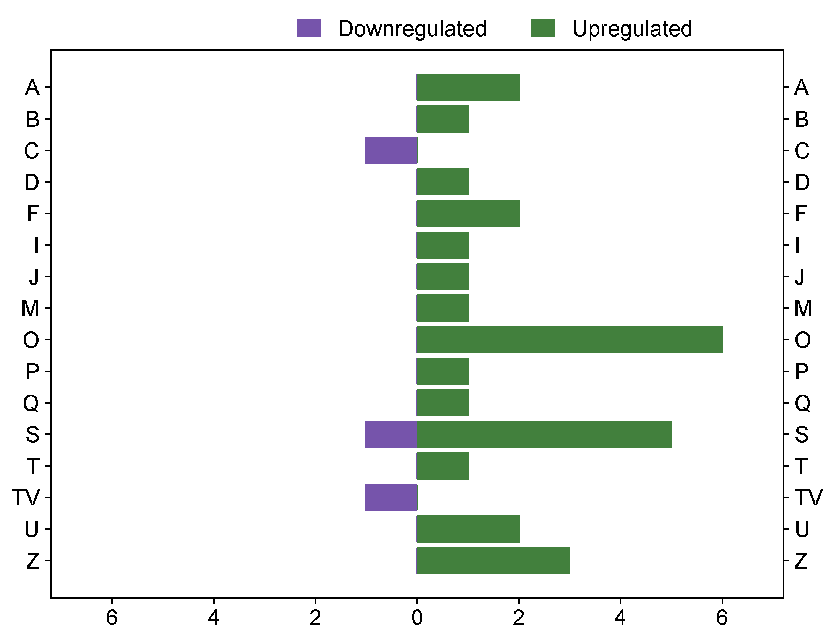

Supplementary Figure S3.A. Predicted COG classes of European sea bass orange-class proteins based on a Tfold comparison "vaccinated" versus "non-vaccinated".
Over- and under-abundant COG classes in green and indigo colours, respectively. A: RNA processing and modification, B: Chromatin structure and dynamics, C: Energy production and conversion, D: Cell cycle control and mitosis, F: Nucleotide metabolism and transport, I: Lipid metabolism, J: Translation, ribosomal structure and biogenesis, M: Cell wall/membrane/envelope biogenesis, O: Post-translational modification, protein turnover, chaperone functions, P: Inorganic ion transport and metabolism, Q: Secondary metabolites biosynthesis, transport and catabolism, S: Function unknown, T: Signal transduction mechanisms, V: Defence mechanisms, U: Intracellular trafficking, secretion, and vesicular transport, and Z: Cytoskeleton.

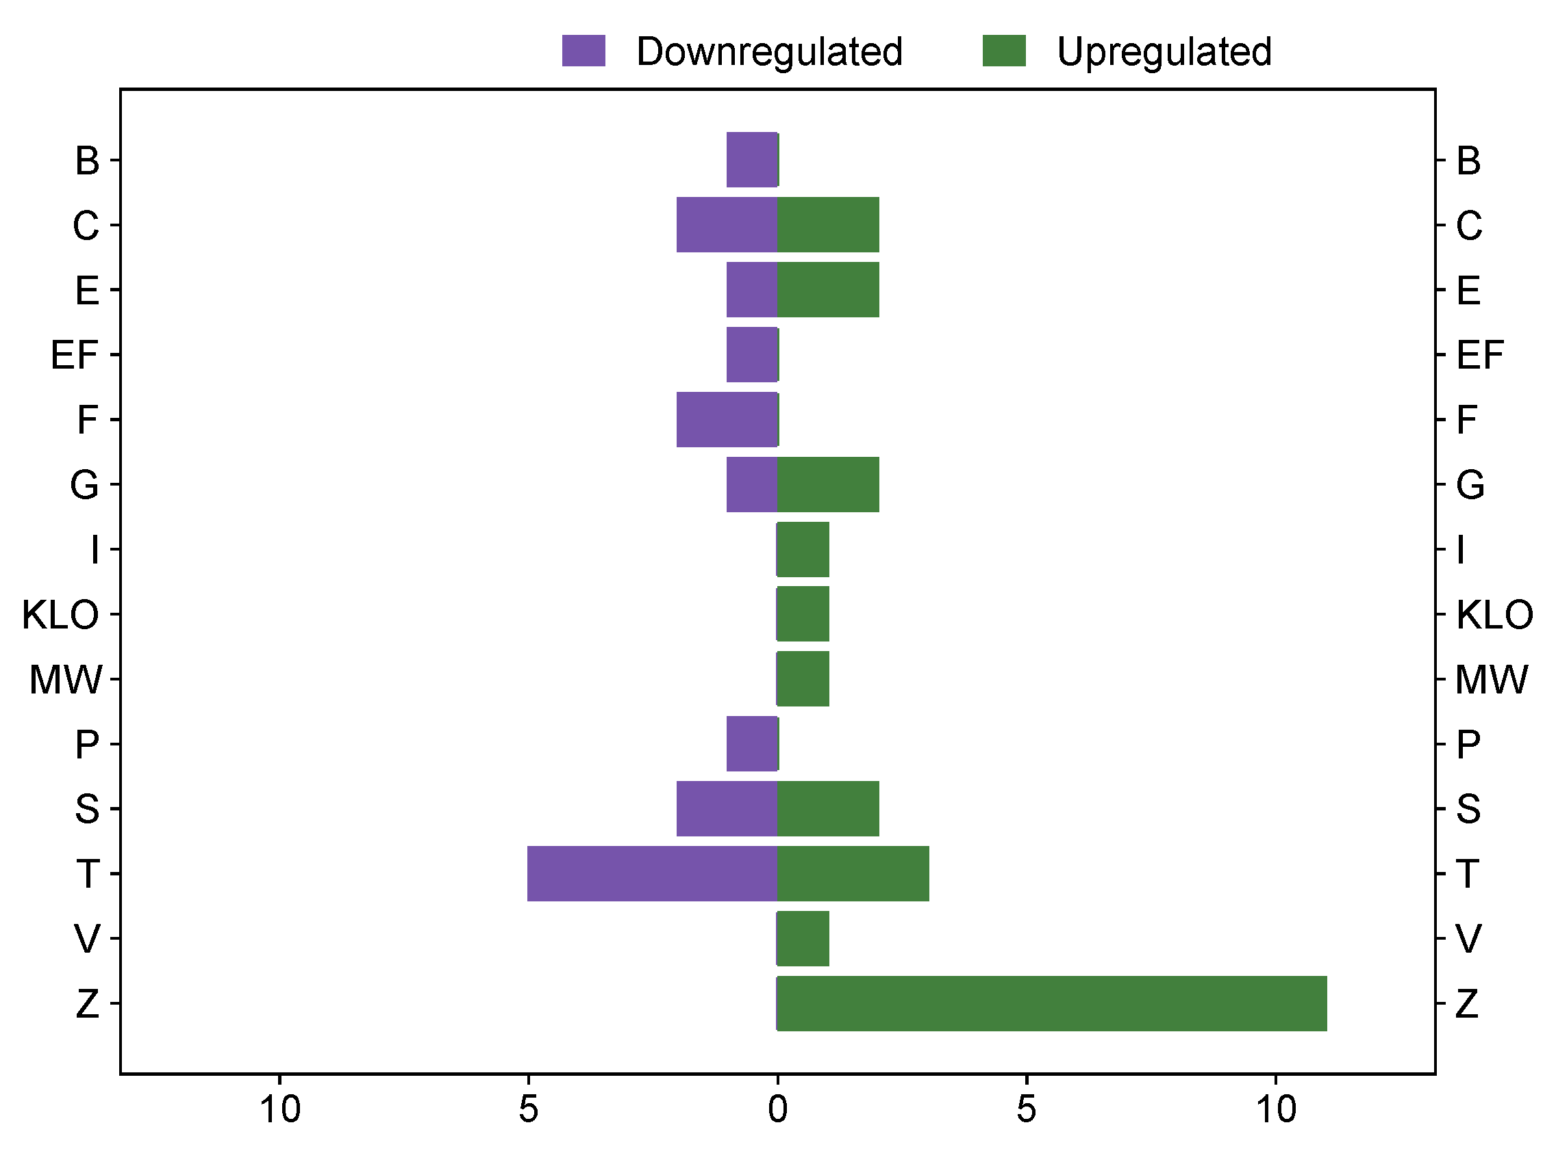

Supplementary Figure S3.B. Predicted COG classes of European sea bass green-class proteins based on a Tfold comparison "vaccinated" versus "non-vaccinated".
Over- and under-abundant COG classes in green and indigo colours, respectively. B: Chromatin structure and dynamics, C: Energy production and conversion, E: Amino acid transport and metabolism, F: Nucleotide metabolism and transport, G: Carbohydrate transport and metabolism, I: Lipid metabolism, K: Transcription, L: Replication, recombination and repair, O: Post-translational modification, protein turnover, chaperone functions, M: Cell wall/membrane/envelope biogenesis, W: Extracellular structures, P: Inorganic ion transport and metabolism, S: Function unknown, T: Signal transduction mechanisms, V: Defence mechanisms, and Z: Cytoskeleton.

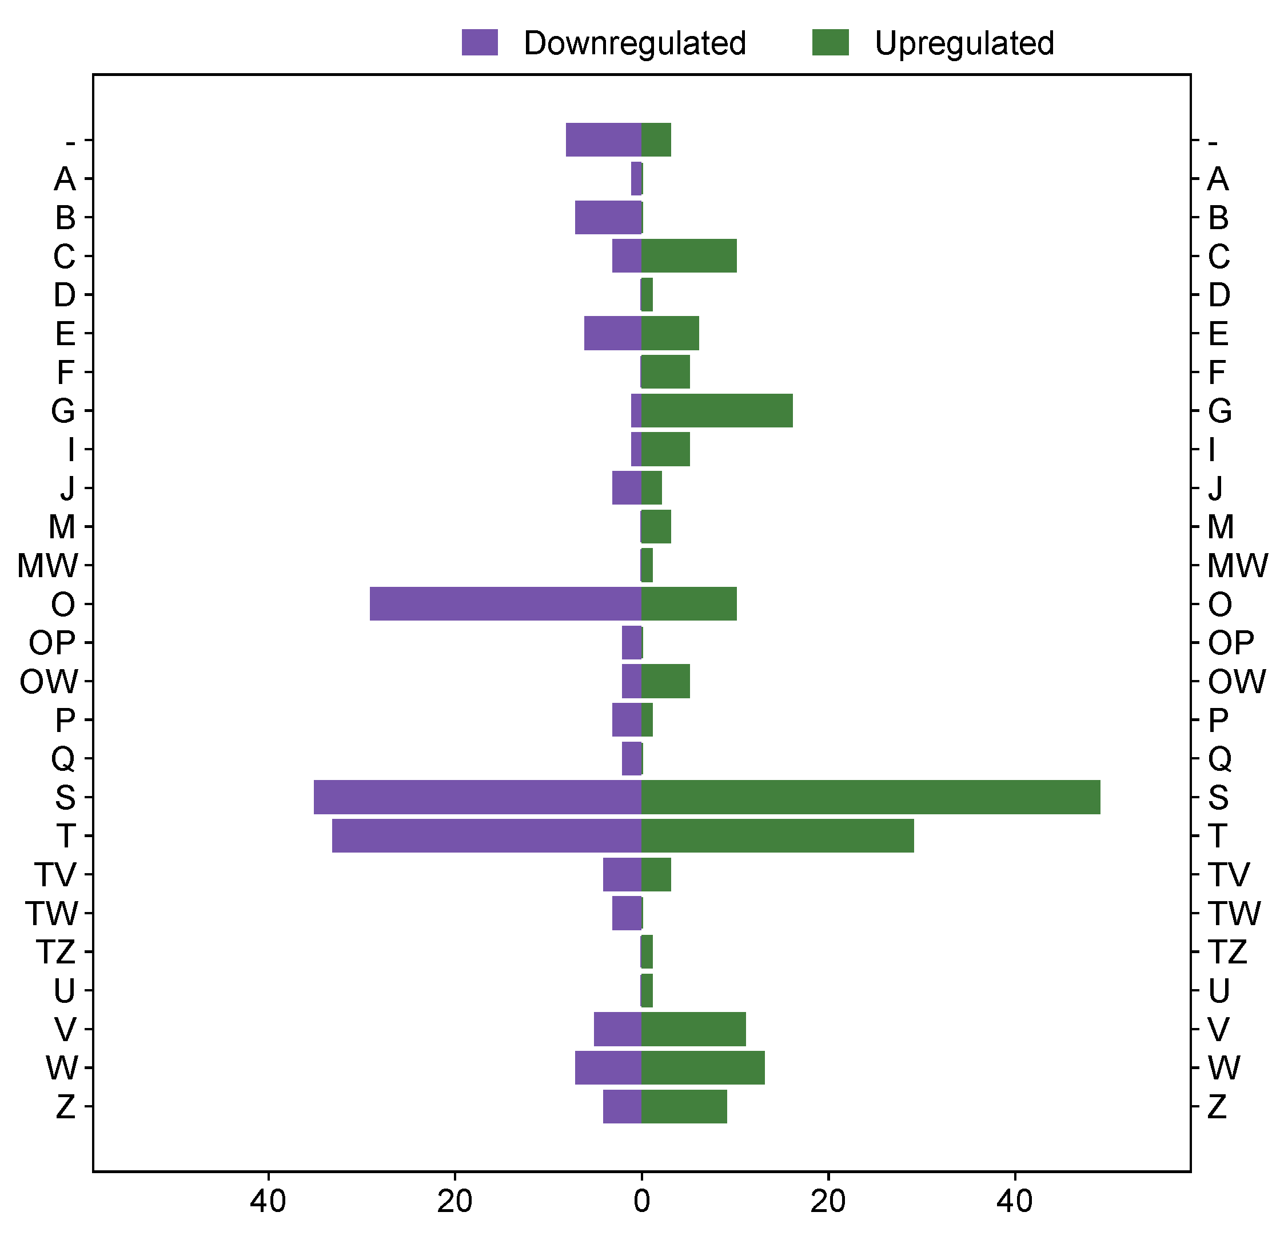

Supplementary Figure S3.C. Predicted COG classes of European sea bass red-class proteins based on a Tfold comparison "vaccinated" versus "non-vaccinated".
Over- and under-abundant COG classes in green and indigo colours, respectively. A: RNA processing and modification, B: Chromatin structure and dynamics, C: Energy production and conversion, D: Cell cycle control, cell division, chromosome partitioning, E: Amino acid transport and metabolism, F: Nucleotide metabolism and transport, G: Carbohydrate transport and metabolism, I: Lipid metabolism, J: Translation, ribosomal structure and biogenesis, M: Cell wall/membrane/envelope biogenesis, W: Extracellular structures, O: Post-translational modification, protein turnover, chaperone functions, P: Inorganic ion transport and metabolism, Q: Secondary metabolites biosynthesis, transport and catabolism, S: Function unknown, T: Signal transduction mechanisms, V: Defence mechanisms, Z: Cytoskeleton, and U: Intracellular trafficking, secretion, and vesicular transport.

Supplementary Table S1. Summary of complement-related proteins identified from the Tfold comparison "vaccinated" versus "non-vaccinated" of Dicentrarchus labrax.
Protein | Locus tag | Tfold | p-value | Domain(s)
Complement component 7b | XP_051267608.1 | 1.63 | 0.1673 | 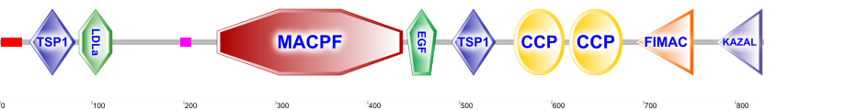
Complement factor H-like | XP_051233191.1 | 1.43 | 0.3827 | 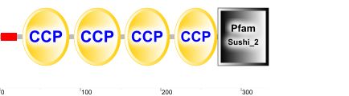
Complement C1q-like protein 4 | XP_051256977.1 | 1.20 | 0.5843 | 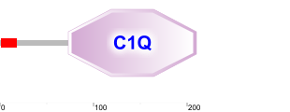
Complement C1q-like protein 2 | XP_051243415.1 | 1.12 | 0.6342 | 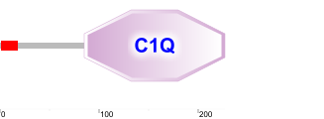
Complement C2 | XP_051252628.1 | 1.10 | 0.3176 | 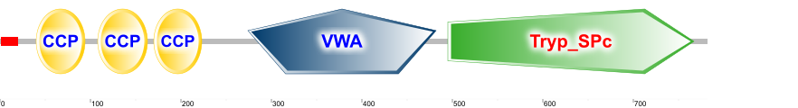
Complement C1q subcomponent subunit C | XP_051270040.1 | 1.08 | 0.5628 | 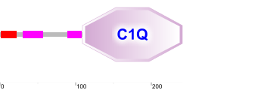
Complement component C9 | XP_051268839.1 | 1.04 | 0.6518 | 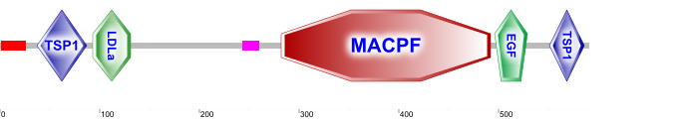
Complement component C7 | XP_051278509.1 | 1.01 | 0.9573 | 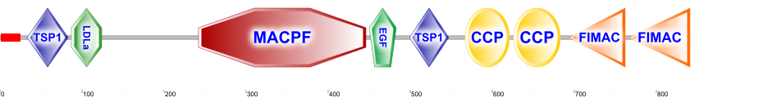
Complement factor B-like | XP_051256245.1 | 1.00 | 0.9830 | 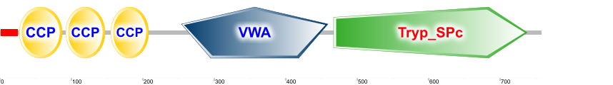
Complement factor I isoform X1 | XP_051250960.1 | −1.01 | 0.8847 | 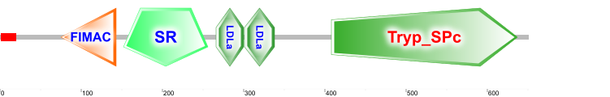
Complement component C6 | XP_051267607.1 | −1.02 | 0.8504 | 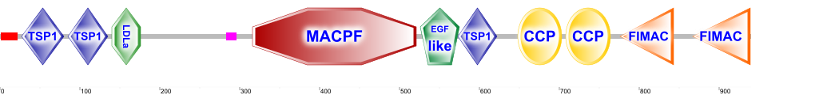
Complement factor D | XP_051242649.1 | −1.04 | 0.7121 | 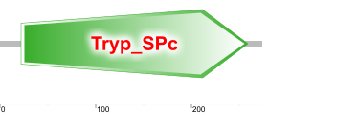
Complement factor H like 4 | XP_051233423.1 | −1.05 | 0.4669 | 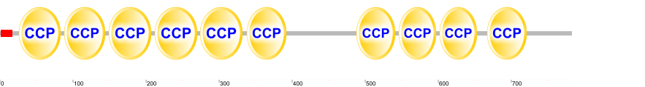
Complement C3-like | XP_051240255.1 | −1.05 | 0.7521 | 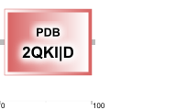
Complement factor B-like | XP_051256244.1 | −1.05 | 0.4105 | 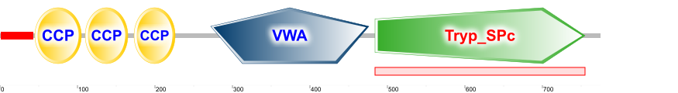
Complement C4-like | XP_051262421.1 | −1.07 | 0.5495
Complement component C8 gamma chain | XP_051266902.1 | −1.07 | 0.4960 | 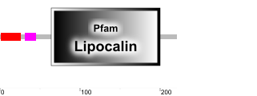
Complement C1q subcomponent subunit C | XP_051270039.1 | −1.08 | 0.4580 | 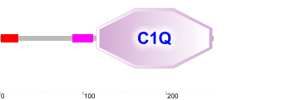
Complement component C8 alpha chain | XP_051249990.1 | −1.09 | 0.2276 | 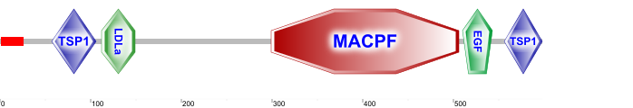
Complement factor H isoform X1 | XP_051231674.1 | −1.10 | 0.3080 | 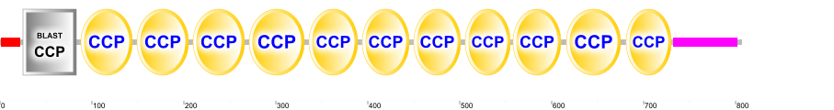
Complement factor H-like isoform X1 | XP_051254211.1 | −1.11 | 0.1851 | 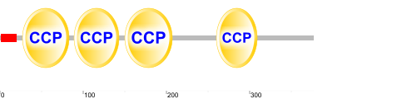
Complement factor H-like isoform X3 | XP_051254228.1 | −1.11 | 0.1851 | 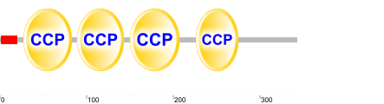
Complement C4 | XP_051262420.1 | −1.12 | 0.4173
Complement C3 isoform X1 | XP_051240230.1 | −1.14 | 0.2150
Complement C3-like isoform X2 | XP_051240229.1 | −1.17 | 0.1402
Complement C3-like | XP_051240232.1 | −1.17 | 0.1252
Complement C3 | XP_051240257.1 | −1.18 | 0.1482
Complement C1q-like protein 4 isoform X8 | XP_051256968.1 | −1.40 | 0.1066 | 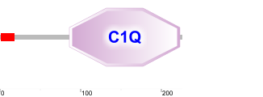
Complement C5 | XP_051258688.1 | −1.20 | 0.0594
Complement C1r subcomponent-like | XP_051262008.1 | −1.71 | 0.1400 | 