Submitted to Scientific Reports Journal

Supporting Information

Guiding mesenchymal stem cells differentiation into chondrocytes using sulfated alginate/ cold atmospheric plasma modified polycaprolactone nanofibrous scaffold
Leila Miri, Shiva Irani, Mohamad Pezeshki Modaress, Hamed Daemi, Seyed Mohammad Atyabi

Keywords
Cartilage tissue engineering, Nanofibrous scaffold, Sulfated alginate, Polycaprolactone, Mesenchymal stem cells

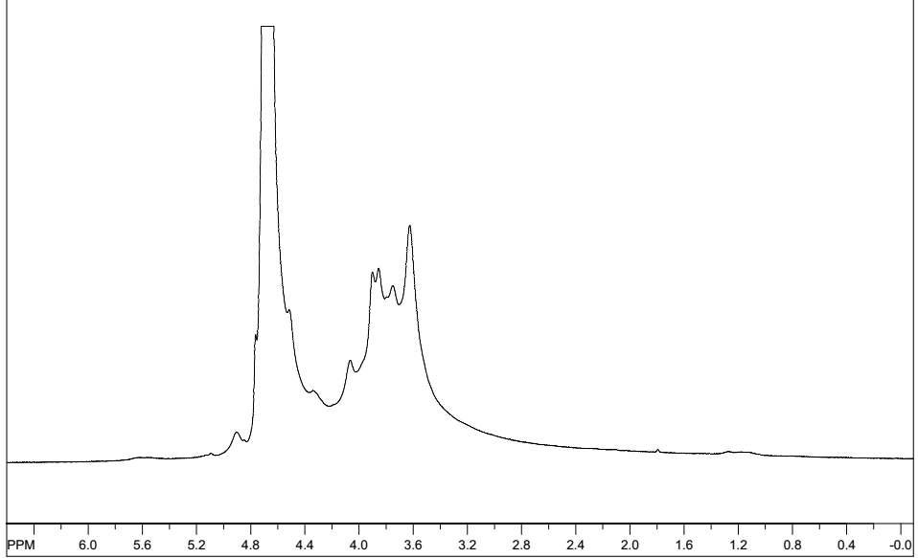
Fig. S1. The ¹H NMR spectrum of sodium alginate (SA)

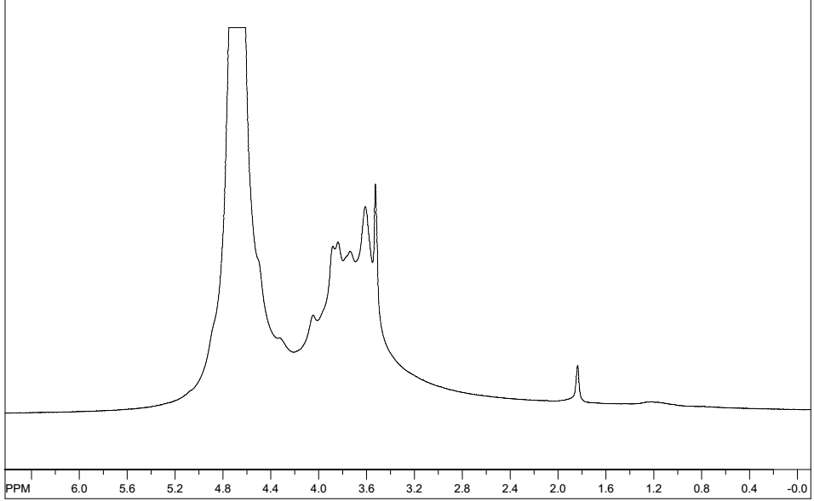
Fig. S2. The ¹H NMR spectrum of sodium sulfated alginate (SSA)

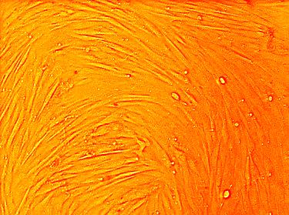
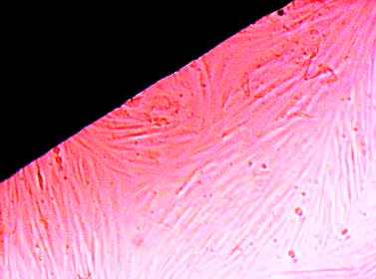
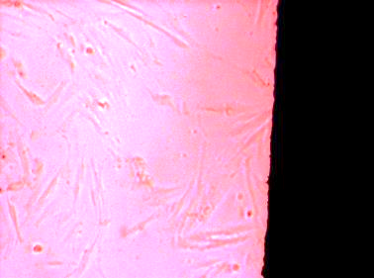
Control PCL SM-PCL
Fig. S3. The inverted microscopy images of cultured MSCs on the scaffolds 72 h after cell culture. The dark areas shown in the images are scaffolds.

(a) (b)
Fig. S4. SEM images of MSCs cultured on the SM-PCL scaffold after 7 days (a). DAPI staining of MSCs cultured on the SM-PCL scaffold without adding differentiation medium after 72 h (b, 400x).

