Extended Data for

Random Saturation Mutagenesis to Generate Highly Diverse Libraries for Directed Evolution
Xinge Diana Zhang^{1†}, Anqi Chen^{1†}, Liyin Chen¹, Rohan Thakur^{1,2}, Perry Ellis¹, Yi Xiao¹, Milos Milcic³, David A. Weitz^{1,4,5*}, Karla Milcic^{1,4,6*}

¹John A. Paulson School of Engineering and Applied Sciences, Harvard University, Cambridge, MA 02138, USA
²Harvard-Massachusetts Institute of Technology Division of Health Sciences and Technology, Massachusetts Institute of Technology, Cambridge, Massachusetts 02139, USA
³University of Belgrade-Faculty of Chemistry, Studentski trg 12–16, 11000 Belgrade, Serbia
⁴Wyss Institute for Biologically Inspired Engineering, Harvard University, 3 Blackfan Circle, Boston, MA 02115, USA
⁵Department of Physics, Harvard University, Cambridge, MA 02138 (USA)
⁶BioSense Institute, University of Novi Sad, Dr Zorana Djindjica 1, Novi Sad 21000, Serbia

†These authors contributed equally to this work

Corresponding authors:
Dr David A. Weitz
E-mail: weitz@seas.harvard.edu
Dr Karla Milcic
E-mail: kilicdurdic@seas.harvard.edu

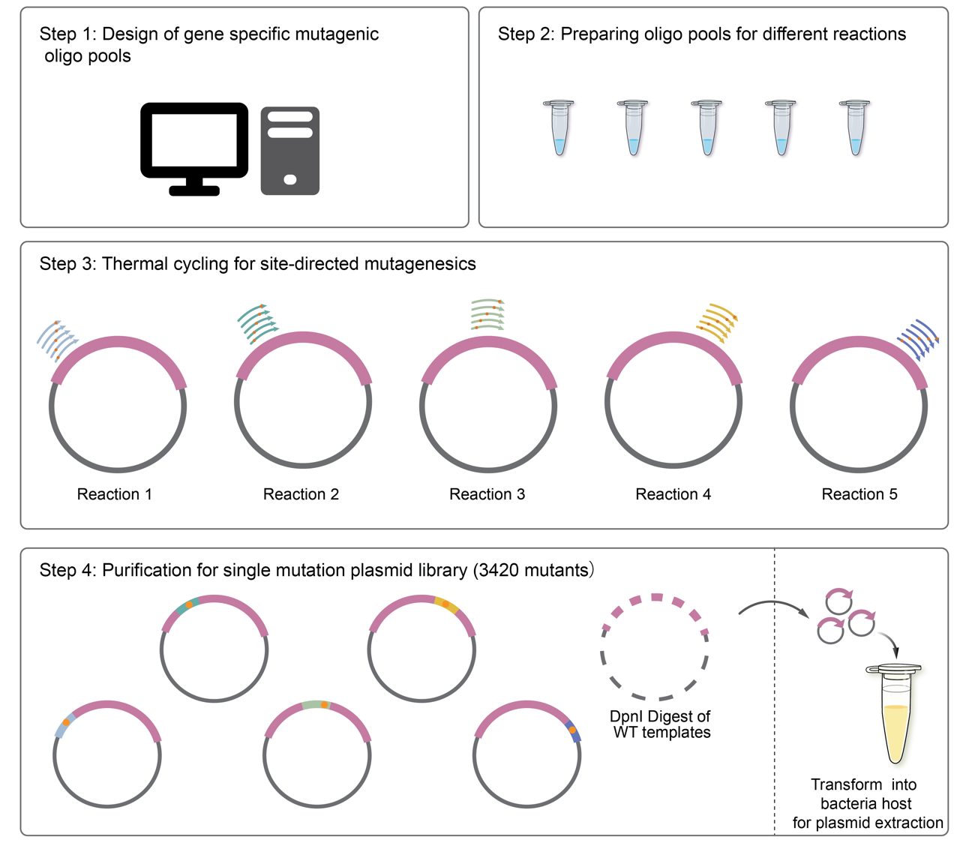
Extended Data Figure 1. Workflow for constructing a single site-saturation mutagenesis library. The process involves four main steps: Step 1, design of gene-specific mutagenic oligo pools using computational tools; Step 2, preparation of oligo pools for different reactions; Step 3, thermal cycling to introduce site-directed mutations across multiple reactions; and Step 4, purification of the plasmid library, yielding 3,420 unique mutants. Following DpnI digestion to remove wild-type templates, the mutated plasmids are transformed into a bacterial host for plasmid extraction.
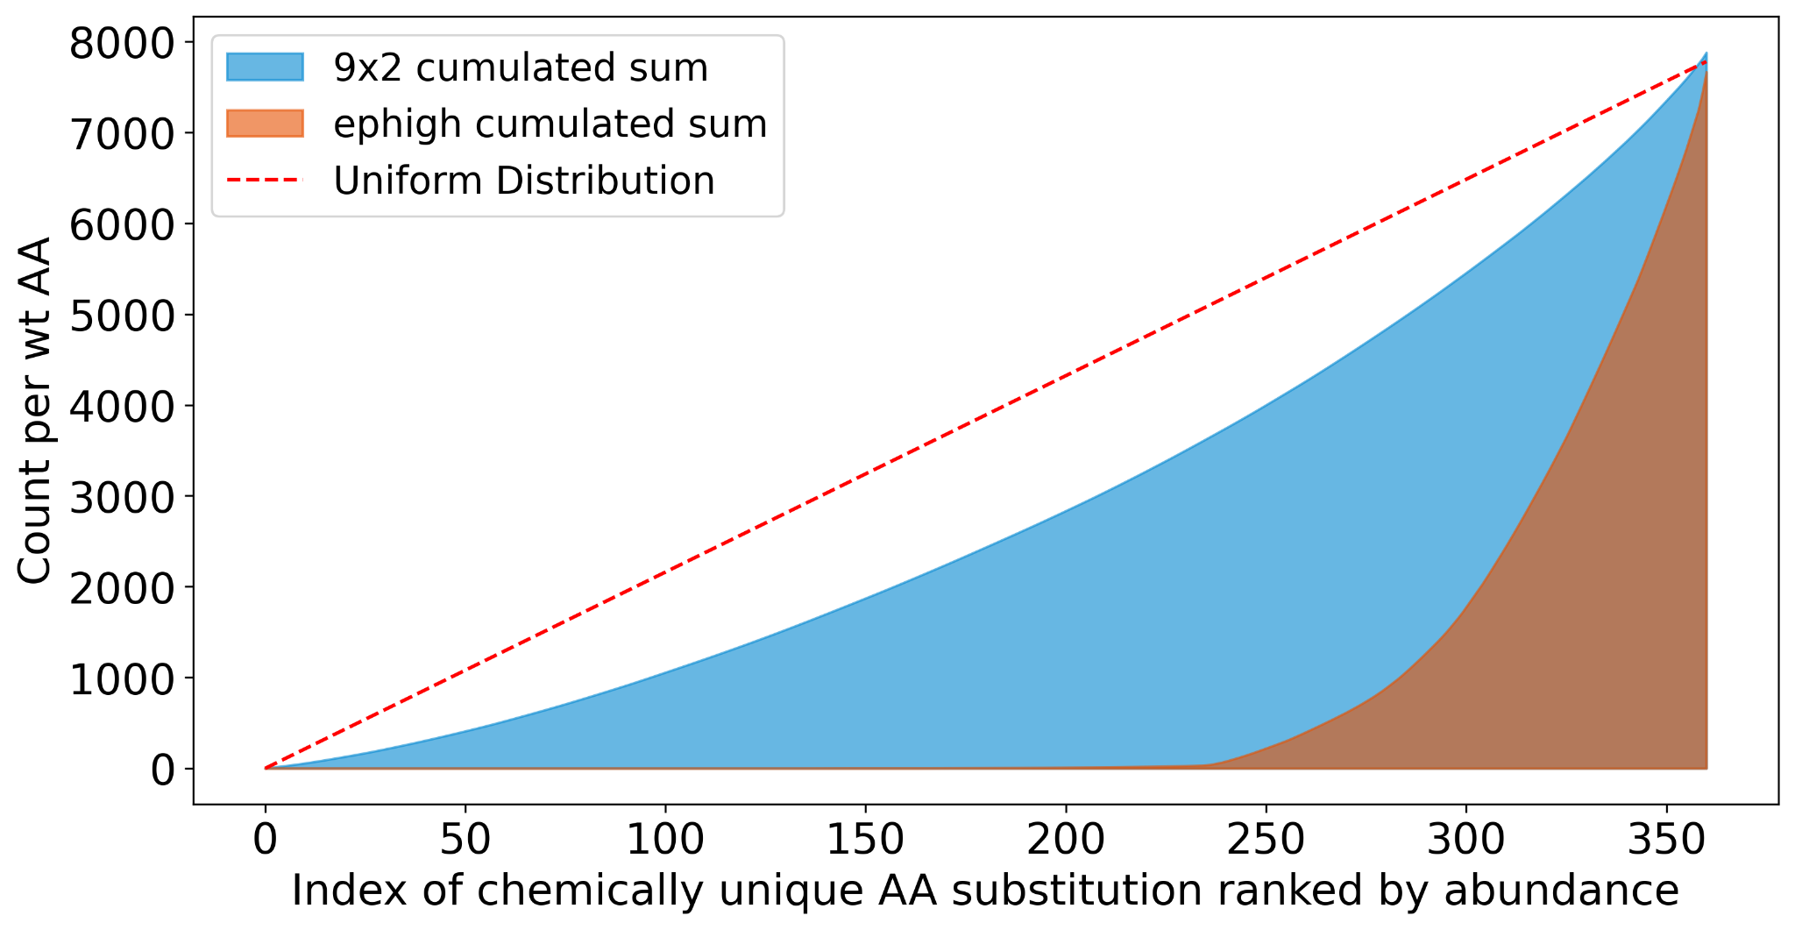
Extended Data Figure 2. Gini coefficient analysis of amino acid substitution abundance in two libraries. The cumulative distribution of chemically unique amino acid (AA) substitutions in the 9x2 (blue) and EPhigh (orange) libraries is compared to a uniform distribution (red dashed line). The area between each curve and the uniform distribution reflects the inequality in substitution abundance. The lower Gini coefficient for the 9x2 library indicates a more even distribution of substitutions compared to the EPhigh library.

Extended Data Table 1. Reported BsLipA variants exhibiting resistance to thermal aggregation. M134 and M137 substitutions are labeled in red. None of these substitutions can be achieved by only one nucleotide change in the methionine codon.

Variant name | AA substitutions | Mutagenesis trajectory | T50 (°C) | Publication
5-A | A15S, F17S, A20E, N89Y, G111D, L114P, A132D, M134E, I157M, N166Y | epPCRx2, recombinationx1, epPCRx1,  recombinationx1, epPCRx1, recombinationx1, site saturation mutagenesis x1 | 93 | Ahmad, 2009
5-B | A15S, F17S, A20E, N89Y, G111D, L114P, A132D, M137P, I157M, N166Y | epPCRx2, recombinationx1, epPCRx1,  recombinationx1, epPCRx1, recombinationx1, site saturation mutagenesis x1 | 93 | Ahmad, 2009
6-B | A15S, F17S, A20E, N89Y, G111D, L114P, A132D, M134E, M137P, I157M, S163P, N166Y | epPCRx2, recombinationx1, epPCRx1,  recombinationx1, epPCRx1, recombinationx1, site saturation mutagenesis x1,  recombinationx1 | 63 | Zahid Kamal, 2011
Variant IX | K112D, M134D, Y139C, I157M | Structural-based position prediction (B-FIT),  iterative saturation mutagenesisx4 | 62.8 | Reetz, Angewandte, 2006
Variant X | R33Q,D34N, K35D, K112D, M134D, Y139C, I157M | Structural-based position prediction (B-FIT),  iterative saturation mutagenesisx5 | 89 | Reetz, Angewandte, 2006; Nature protocol, 2007
Variant XI | R33G, K112D, M134D, Y139C, I157M | Structural-based position prediction (B-FIT),  iterative saturation mutagenesisx5 | 93 | Reetz, Angewandte, 2006; Nature protocol, 2007
MT5 | F17T, M134E, I135E, M137D, Y139D, G158D, N174S | RSMx1 | >95 | This work
MT20 | F17G, M134P, M137A, Y139S, R142M, S163P, N174S | RSMx1 | >95 | This work

