Supplementary Materials for

Random Saturation Mutagenesis to Generate Highly Diverse Libraries for Directed Evolution
Xinge Diana Zhang^{1†}, Anqi Chen^{1†}, Liyin Chen¹, Rohan Thakur^{1,2}, Perry Ellis¹, Yi Xiao¹, Milos Milcic³, David A. Weitz^{1,4,5*}, Karla Milcic^{1,4,6*}

¹John A. Paulson School of Engineering and Applied Sciences, Harvard University, Cambridge, MA 02138, USA
²Harvard-Massachusetts Institute of Technology Division of Health Sciences and Technology, Massachusetts Institute of Technology, Cambridge, Massachusetts 02139, USA
³University of Belgrade-Faculty of Chemistry, Studentski trg 12–16, 11000 Belgrade, Serbia
⁴Wyss Institute for Biologically Inspired Engineering, Harvard University, 3 Blackfan Circle, Boston, MA 02115, USA
⁵Department of Physics, Harvard University, Cambridge, MA 02138 (USA)
⁶BioSense Institute, University of Novi Sad, Dr Zorana Djindjica 1, Novi Sad 21000, Serbia

†These authors contributed equally to this work

Corresponding authors:
Dr David A. Weitz
E-mail: weitz@seas.harvard.edu
Dr Karla Milcic
E-mail: kilicdurdic@seas.harvard.edu

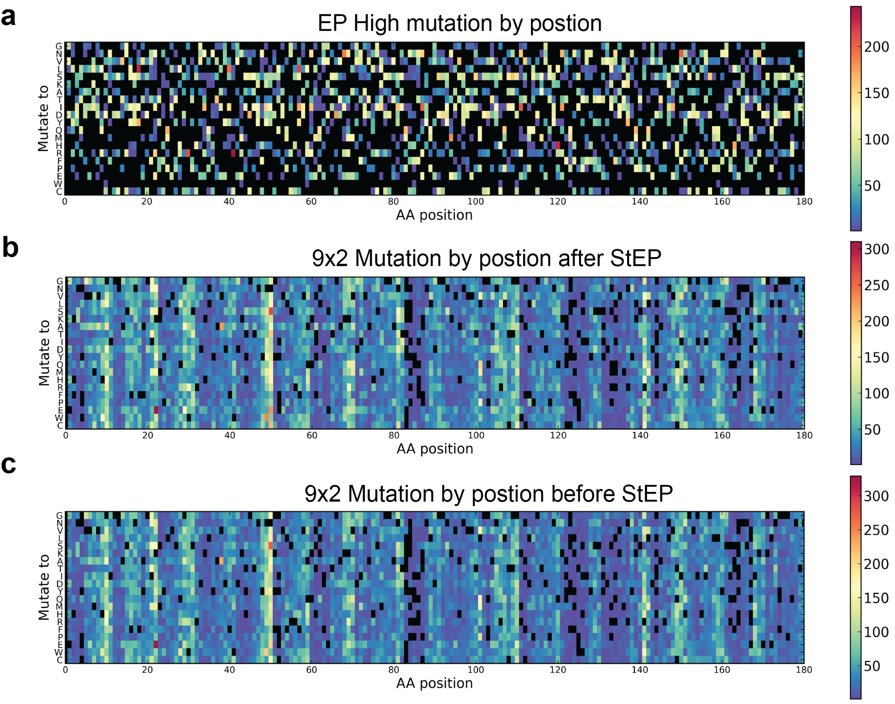
Fig. S1. Analysis of Positional Distribution. (a) Positional distribution of mutations in the EPhigh library. (b) Positional distribution of mutations in the 9x2 library after StEP. (c) Positional distribution of mutations in the 9x2 library before StEP. Mutation by position for 9X2 RSSM library showing similar chemical diversity by position.
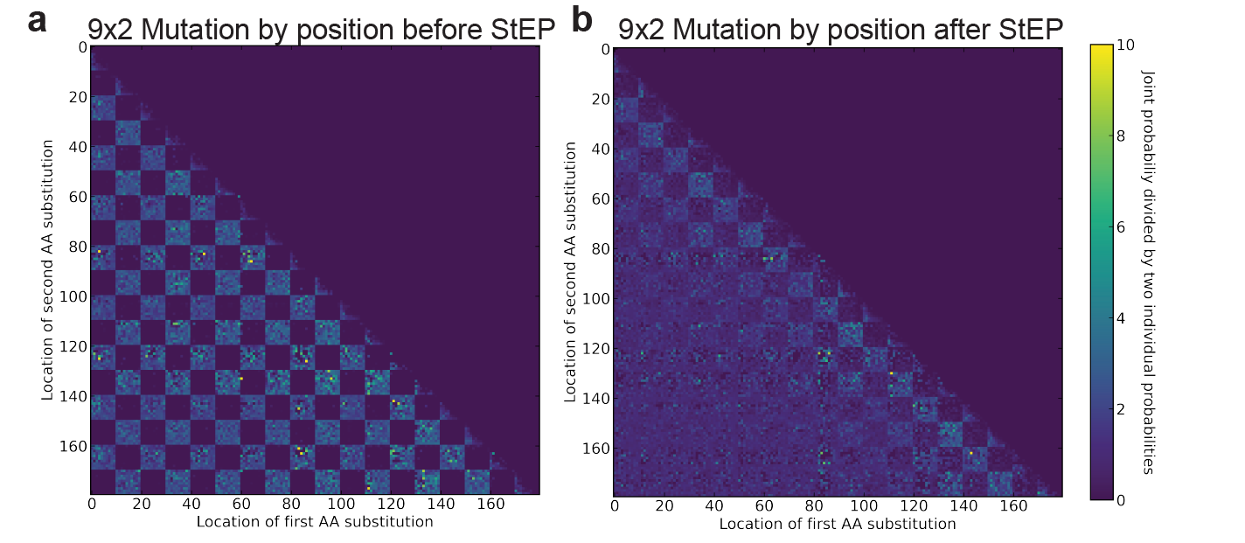
Fig. S2. To decrease the positional correlation and to increase diversity of the final RSSM library, the products from the two reactions are then mixed in equimolar ratio as the templates for StEP. (a) Joint probability heatmap of mutation positions before StEP in the 9x2 library. (b) Joint probability heatmap of mutation positions after StEP in the 9x2 library, demonstrating disruption of positional correlations.
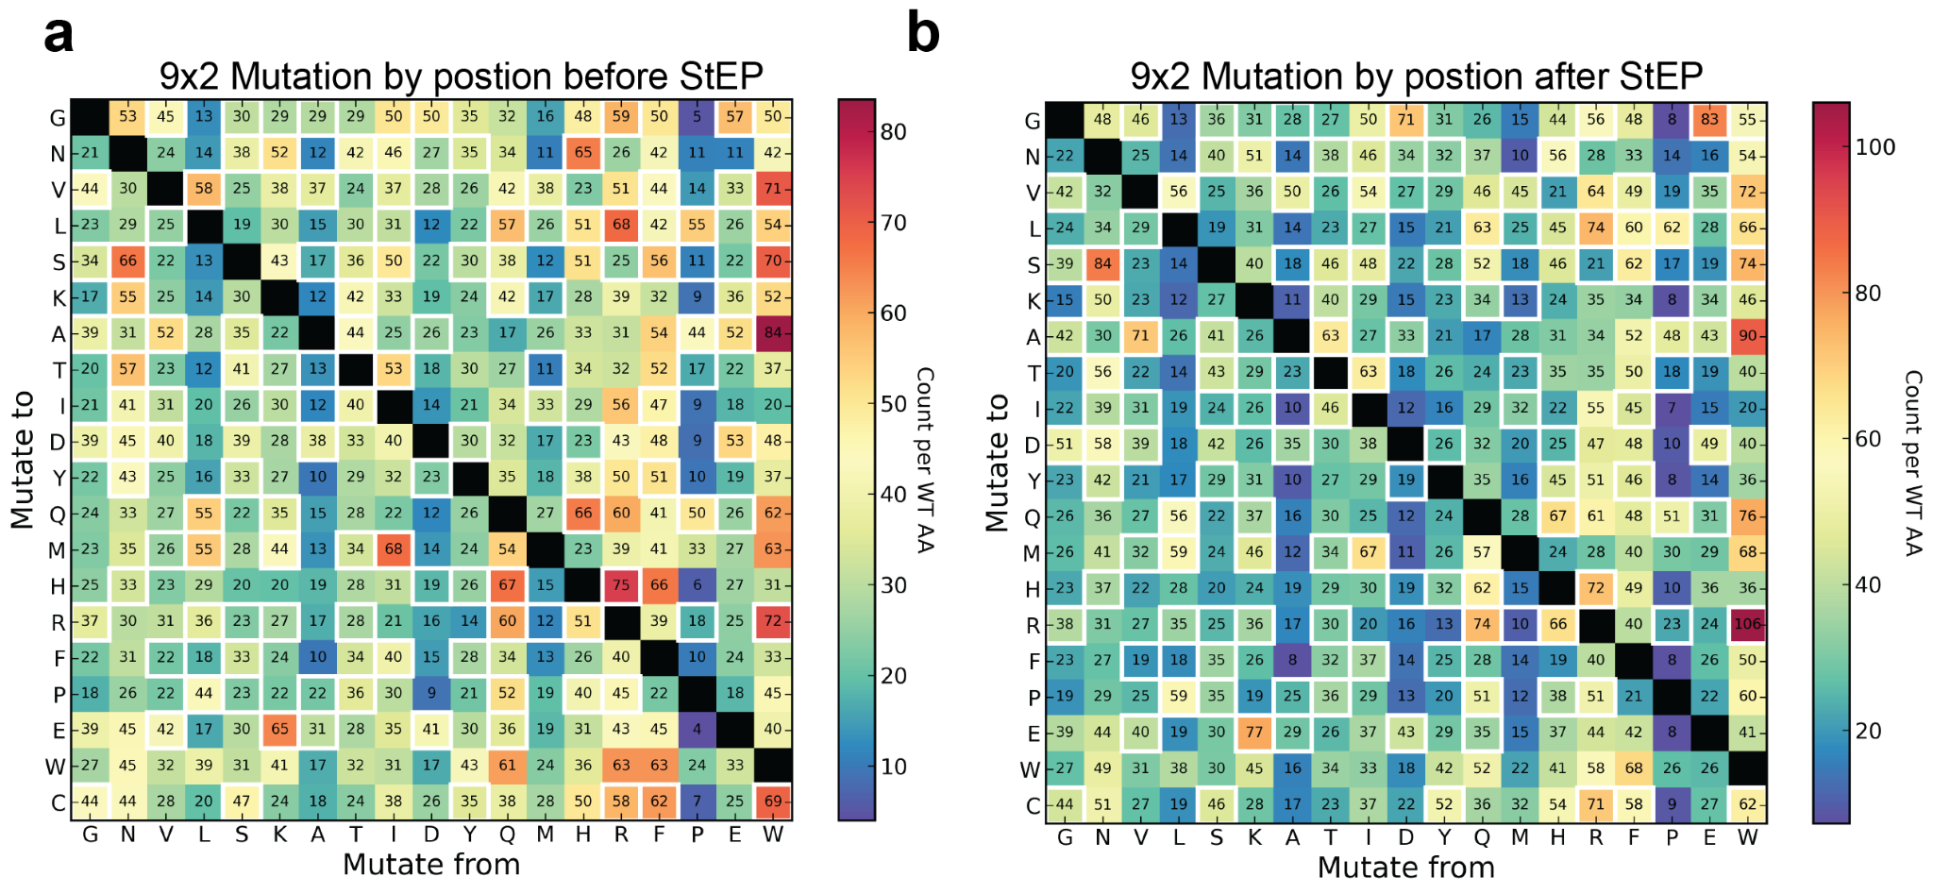
Fig. S3. (a) Heatmap of amino acid substitutions in the 9x2 RSSM library before StEP. White borders highlight substitutions enabled by single nucleotide changes. (d) Heatmap of amino acid substitutions in the 9x2 library after StEP, showing similar chemical diversity in the amino acid substitution enabled.

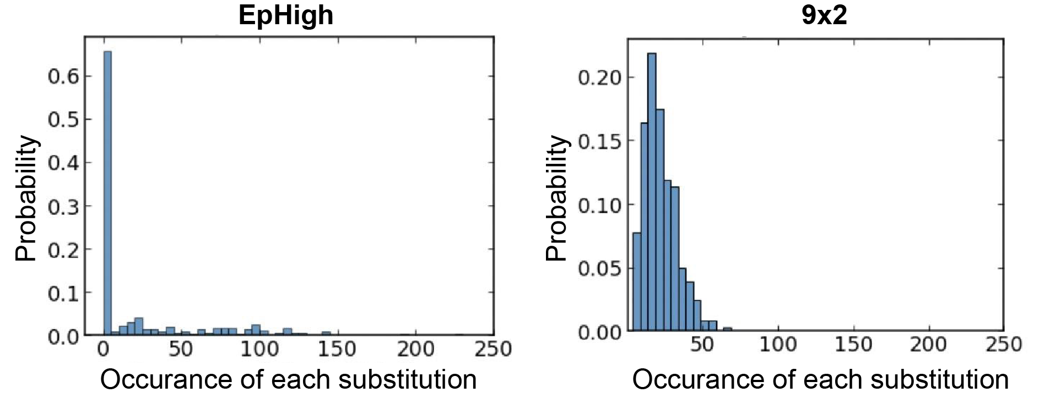
Fig. S4. Distribution of the occurrence of each mutation for the 361 chemically distinct substitutions. The bin width for the histogram is set to 5. 71,674 mutations sampled for EPhigh and 71,673 mutations sampled for 9x2 RSSM library.

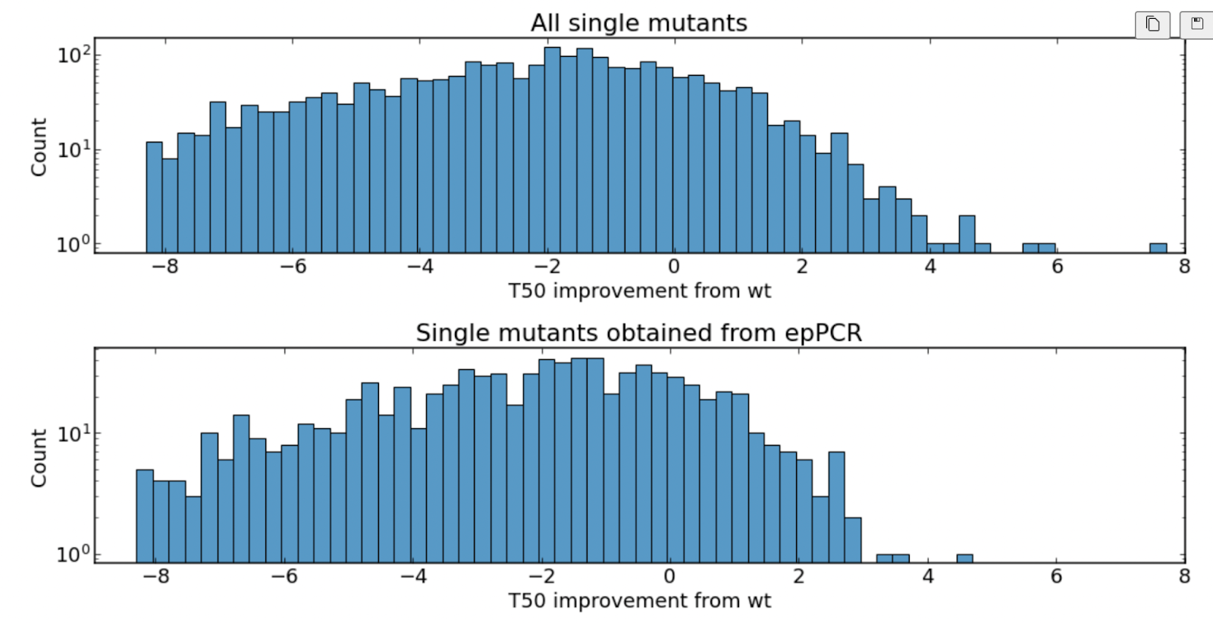
Fig. S5. Histogram of single AA T50 improvement
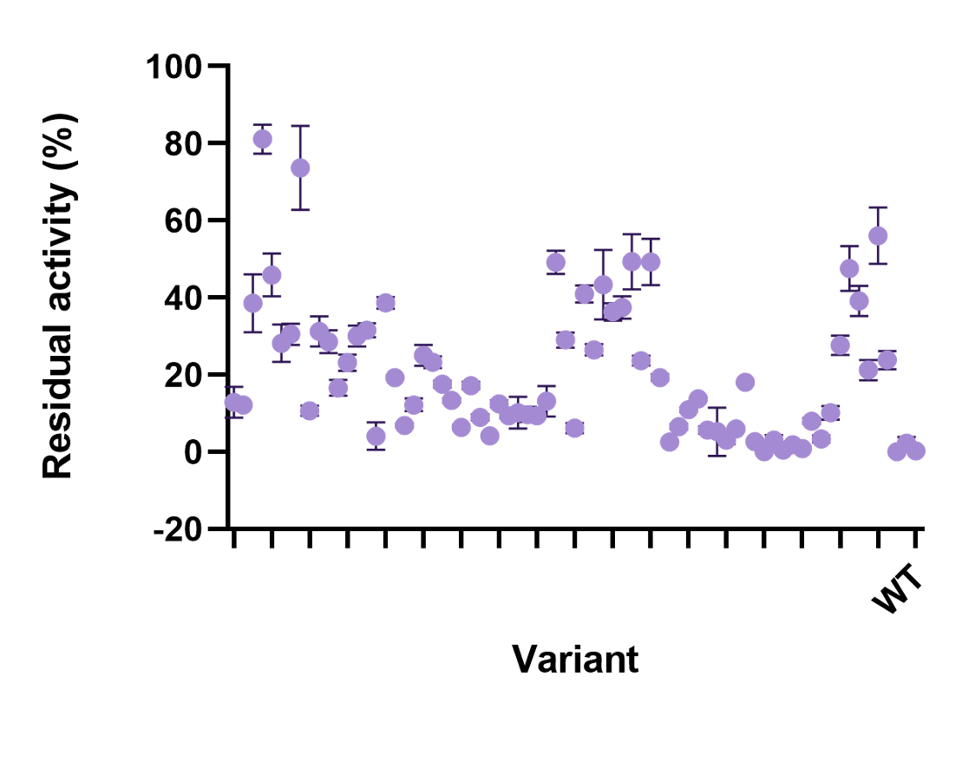
Fig. S6. Residual activity of sorted single variants after heat exposure. To assess the thermotolerance of the variants, cells were lysed, and the lysates were incubated at 80°C for one hour. Residual activity was measured at 25°C using a fluorescence-based assay on a plate reader.
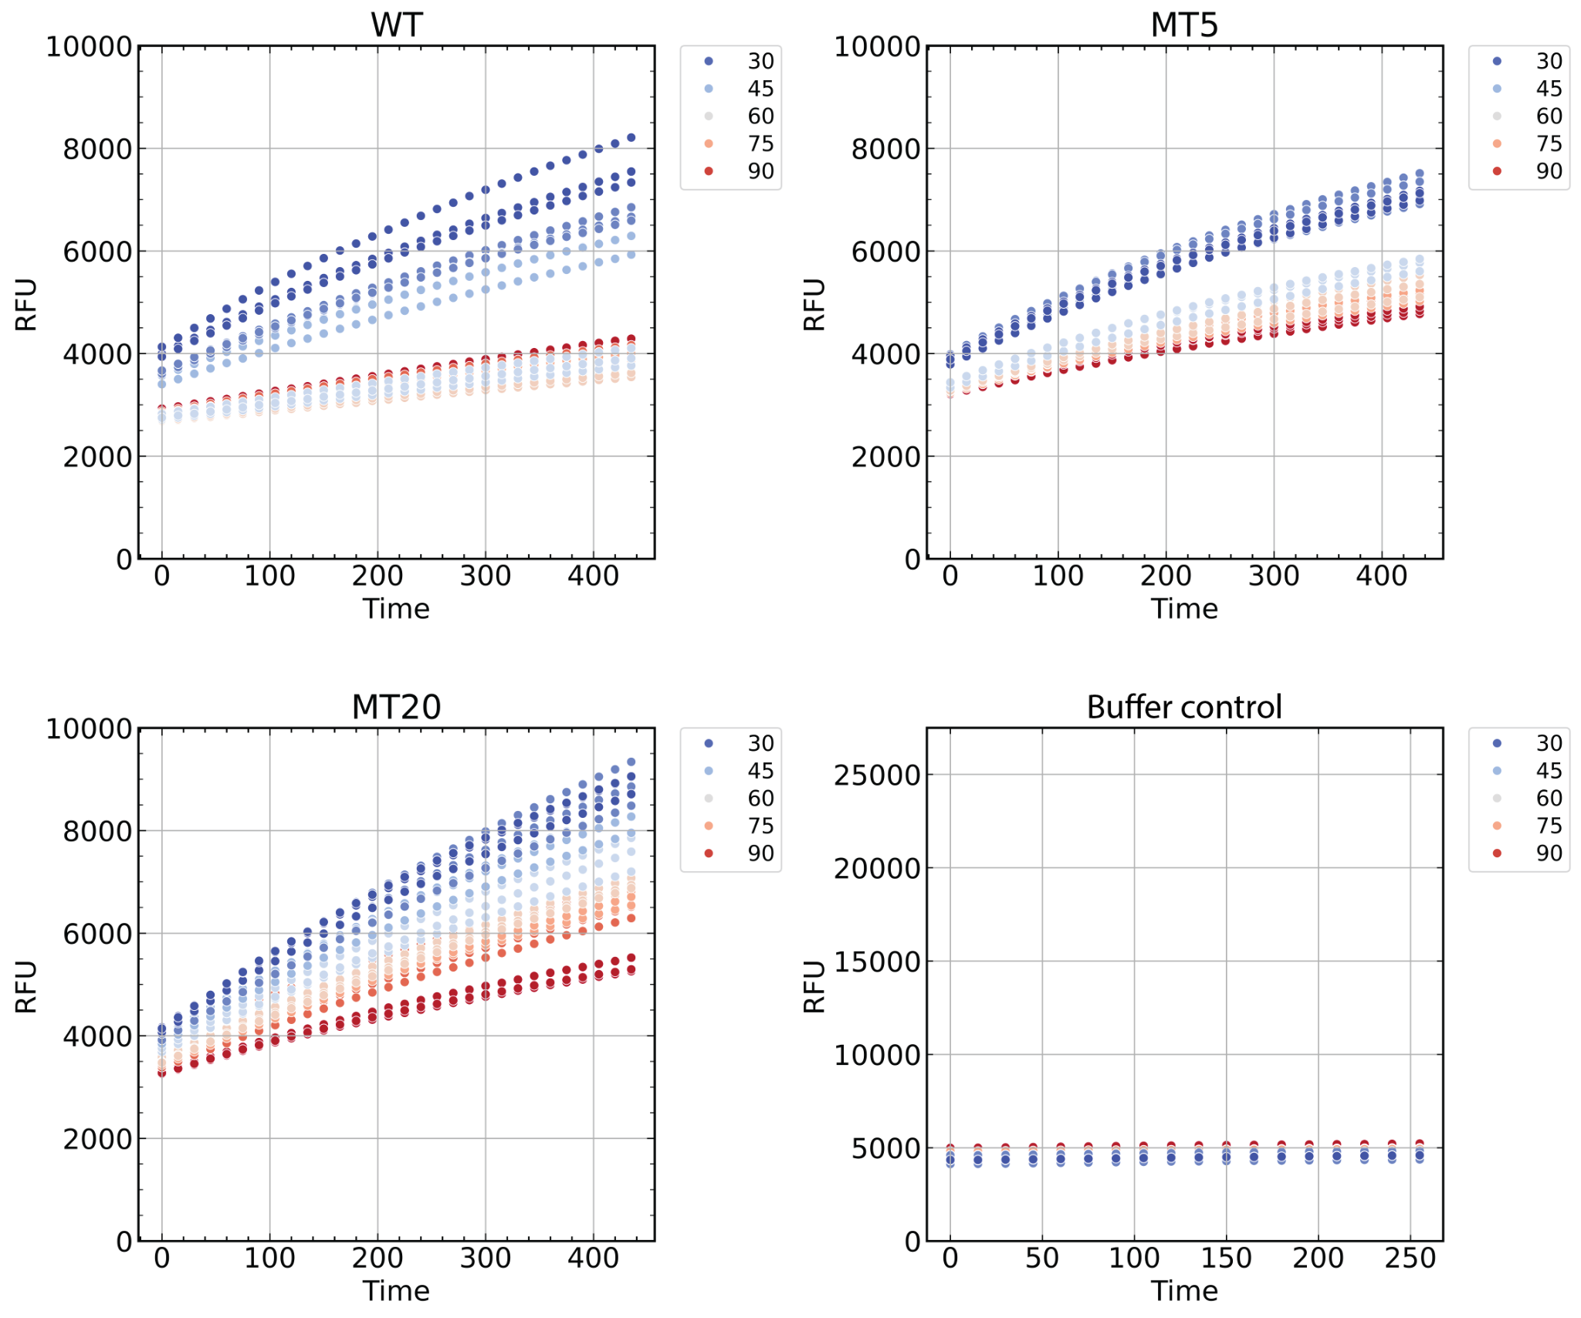
Fig. S7. T₅₀ measurement raw measurement.
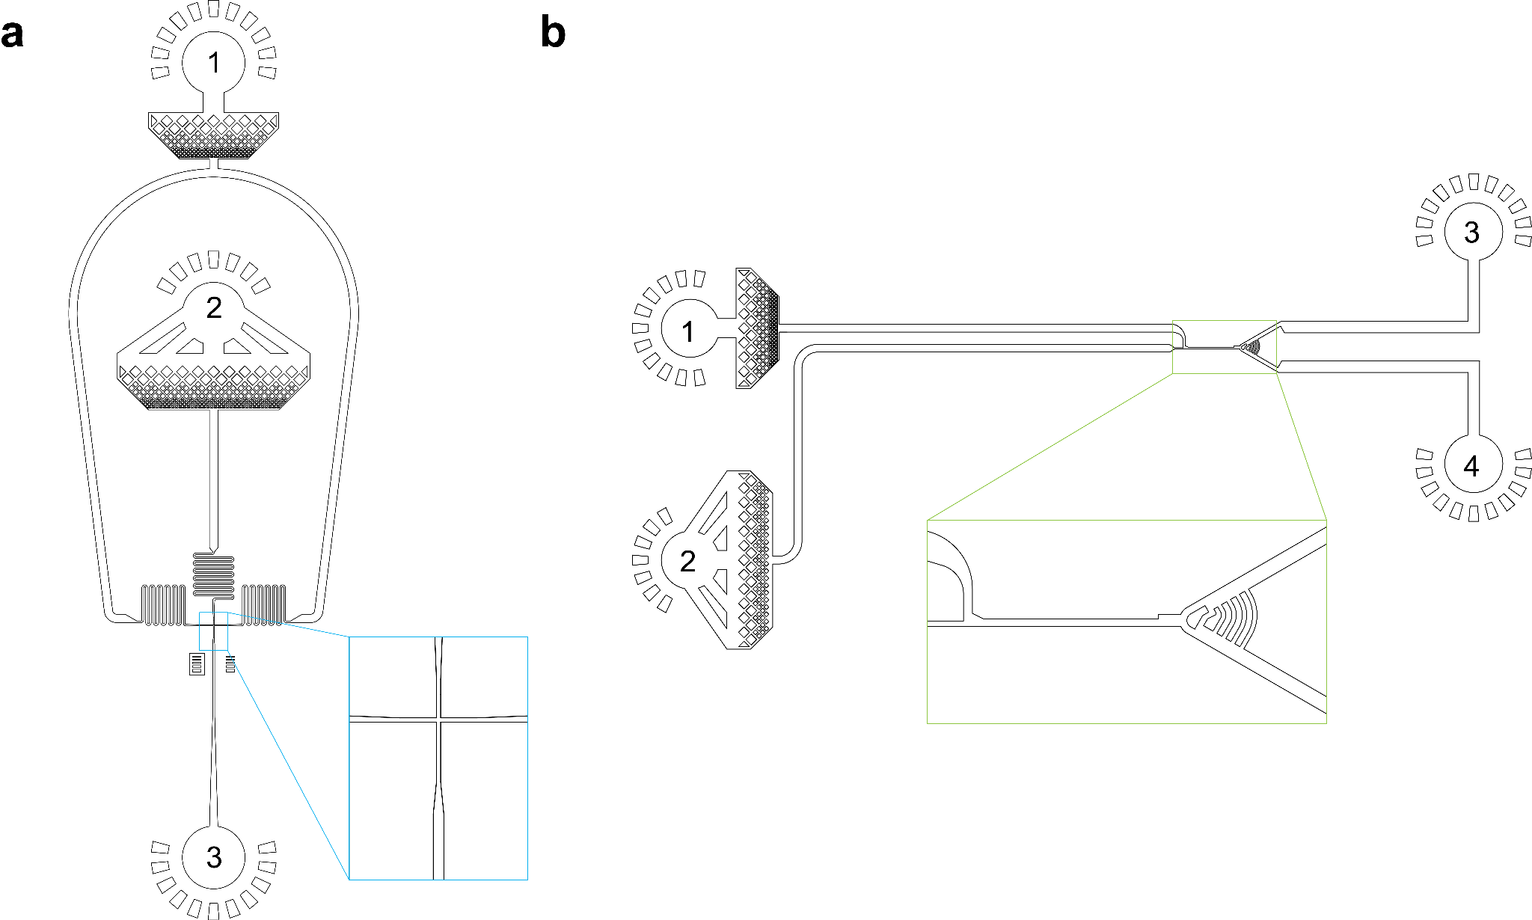
Fig. S8. Designs of microfluidic devices for the droplet screening platform. (a) Design of the device to encapsulate the linear DNA mutant genes and the In Vitro Protein Synthesis reagents. Labels 1 to 3 are the oil inlet, aqueous inlet, and collection outlet, respectively. (b) Design of the device to screen the droplets based on fluorescent intensities. Labels 1 to 4 are the spacing oil inlet, droplet reinjection inlet, sorted droplet collection outlet, and waste outlet, respectively.
Sup. Table.1. Distance between catalytic triad residues

Distance between residues (Å)
S77-D133 |  | D133-H156 |  | S77-D133
Before | After | Before | After | Before | After
5.81 | 19.73 | 2.99 | 12.06 | 2.88 | 8.89
7.18 | 16.69 | 2.73 | 12.35 | 3.10 | 9.14
7.64 | 16.63 | 2.60 | 12.98 | 3.01 | 9.69
6.80 | 19.31 | 2.72 | 15.97 | 3.05 | 8.40
7.63 | 15.62 | 2.72 | 16.01 | 2.92 | 9.54
6.11 | 14.26 | 2.66 | 11.16 | 3.19 | 10.76
6.80 | 23.68 | 2.98 | 9.88 | 3.39 | 11.13
6.83 | 17.56 | 2.61 | 11.96 | 3.04 | 7.68
6.42 | 20.60 | 2.75 | 12.39 | 2.75 | 9.81
6.49 | 19.79 | 2.66 | 11.30 | 3.13 | 14.26
6.98 | 13.60 | 2.74 | 12.61 | 2.92 | 10.62
6.93 | 19.57 | 2.76 | 10.48 | 3.60 | 6.57
7.26 | 19.23 | 2.71 | 13.96 | 2.85 | 9.76
7.03 | 11.21 | 3.32 | 15.05 | 3.29 | 8.69
6.94 | 19.77 | 3.70 | 18.73 | 3.00 | 9.94
6.57 | 16.15 | 2.77 | 18.47 | 2.90 | 8.85
6.67 | 13.10 | 2.93 | 19.29 | 2.67 | 11.84
6.69 | 19.78 | 2.91 | 18.54 | 3.11 | 10.42
6.139 | 15.814 | 2.563 | 126.595 | 2.74 | 87.995

