Supplementary Figures
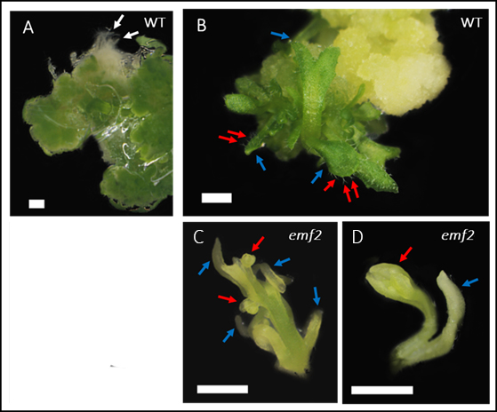
Figure 1. Close-up view of WT and emf2 callus on shoot-inducing media on day 15. (A) WT callus exhibits a deep green color and thin, short roots (white arrows). (B) WT callus developed shoot (blue arrows) with true leaves with trichomes (red arrows). (C, D) emf2 shoot demonstrating filamentous leaves (blue arrows) and flowers (red arrows). Bar=1mm

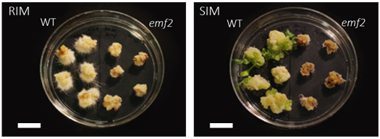
Figure 2. Regenerate test of emf2 calli on root and shoot-inducing media. Top view on WT and emf2 calli responses to RIM and SIM after 30 days. On RIM, WT calli developed root-like hairs and long roots, and emf2 calli accumulated a dark tone and did not regenerate roots. On SIM, four out of five WT calli developed two to five shoots, emf2 calli became darker and decayed. Bar=2cm.

