Abstract Index
Polymorph Analysis of ALZ-801 (Valiltramiprosate), a Valine-conjugated Oral Prodrug of Tramiprosate in Late-stage Clinical Development for Alzheimer’s Disease
D. Pearson, J. Amedio, J.F. Schaefer, M. Tolar, and J.A. Hey

A single crystalline form of ALZ-801 is observed in a range of crystal morphologies, the risk of a change in solid form affecting the delivery of this potential new disease modifying therapy for Alzheimer’s disease is negligible.
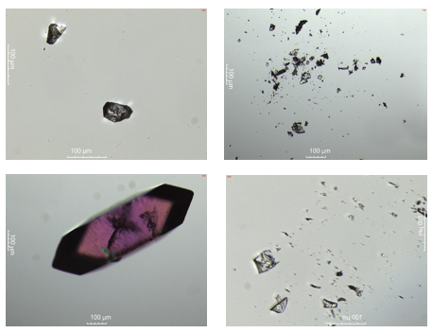

Figure 2: Phase light microscopy image of ALZ-801 crystal pattern 1 (single polymorph). ALZ-801 crystals occur in diverse ranges of morphologies, i.e., tetrahedron, bladed, needles, dodecahedron, slices, prismatic and tabular forms.

