Levan Alpaidze, Rocco Pace
Ecosystem services provided by urban forests in the Southern Caucasus region: a modeling study in Tbilisi, Georgia
SUPPLEMENTARY MATERIAL
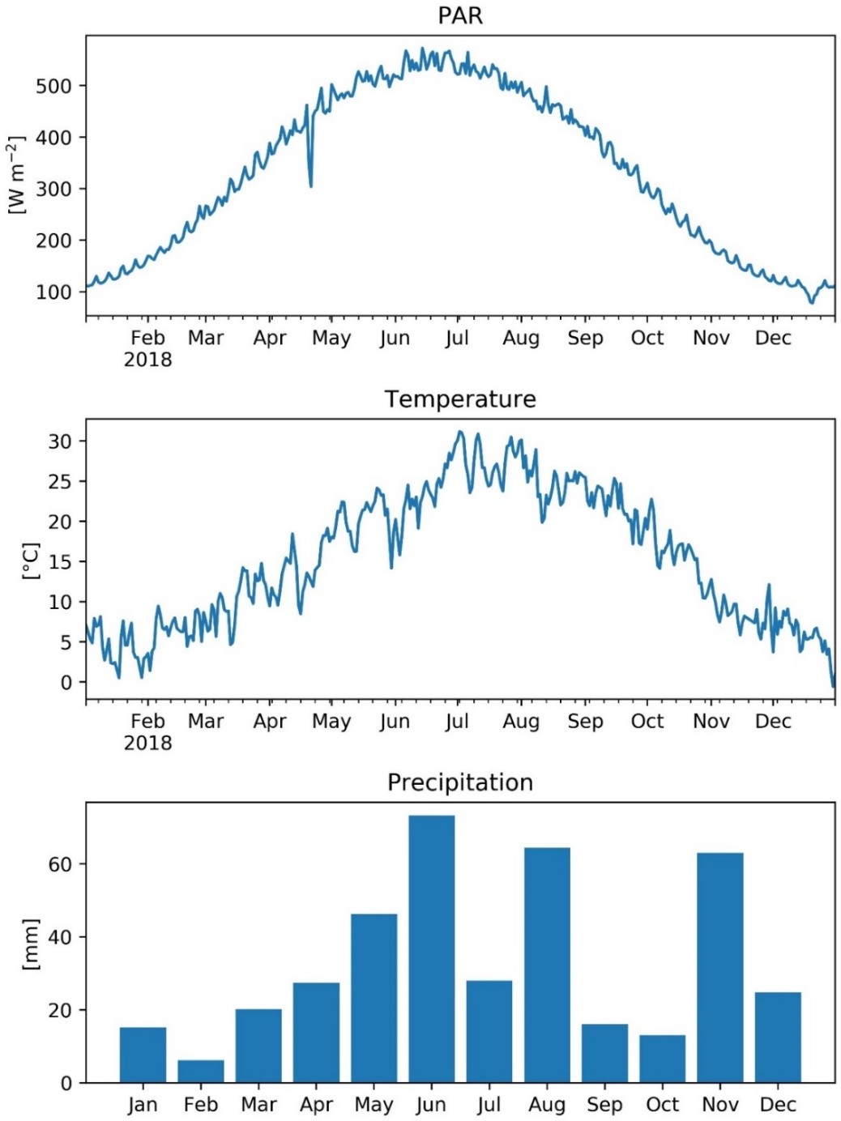
Fig S1. Weather data used for model simulation of Tbilisi in 2018. From top to bottom: daily average photosynthetically active radiation (PAR), daily average air temperature, and total monthly precipitation.
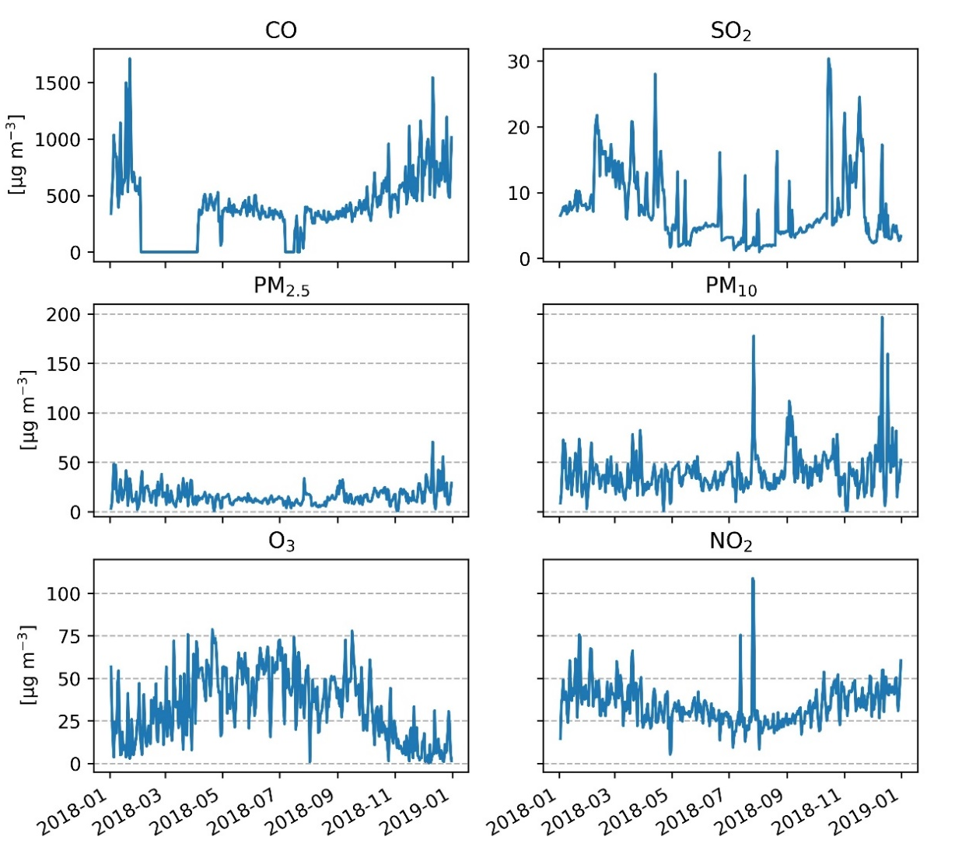
Fig S2. Daily average pollution concentration of CO, SO2, PM2.5, PM10, O3, and NO2 in Tbilisi (year: 2018).

