Extended Data

Scenario Dimensions | CCS and CDR Assumptions
Max. EU CCS (MtCO2/yr) | 110 | 130 | 180 | 350 | 2000 | 2000
2050 EU Land Sink (MtCO2/yr) | 240 | 240 | 240 | 240 | 240 | 370
Standard | FosFree-NZ  (core) | Intm4-NZ | Intm3-NZ | Intm2-NZ | Intm1-NZ | LeastCost-NZ  (core)
HighBio | FosFree-NZ-HighBio |  | Intm3-NZ-HighBio |  | Intm1-NZ-HighBio | LeastCost-NZ-HighBio
CheapDAC | FosFree-NZ-HighBio |  | Intm3-NZ-HighBio |  | Intm1-NZ-HighBio | LeastCost-NZ-HighBio
ExpH2 | FosFree-NZ-expH2 |  | Intm3-NZ- expH2 |  | Intm1-NZ- expH2 | LeastCost-NZ- expH2
HighImp | FosFree-NZ-HighImp |  | Intm3-NZ- HighImp |  | Intm1-NZ- HighImp | LeastCost-NZ- HighImp
NoImp | FosFree-NZ-noImp |  | Intm3-NZ- noImp |  | Intm1-NZ- noImp | LeastCost-NZ- noImp
Ext Data Table 1: Overview about all EU net-zero scenarios investigated in this study. There are two main dimensions of scenario assumptions: First, variations of assumptions related to maximum possible CCS deployment and the 2050 land carbon sink in the EU generate net-zero scenarios with different amounts of residual fossil energy use (columns). Second, variations of technology-related assumptions generate the sensitivity scenarios of the HighBio, cheapDAC, expH2, HighImp and noImp categories (rows). For details on the assumptions in the sensitivity scenarios, please refer to Ext Data Table 2.

Sensitivity  scenarios | Parameter | Default Assumption | New Assumption in sensitivity scenario | Description
HighBio | EU bioenergy potential | 7.5 EJ/yr primary energy biomass | 12.5 EJ/yr primary energy biomass | Based on low scenario (default) and reference scenario (HighBio) in Ruiz et al. (2019).
CheapDAC | DAC learning | Learning rate: 15% | Learning rate: 25% | Sensitivity with optimistic DAC cost assumptions. The standard learning rate of 15% also used for renewable technologies is increased to 25%.
 | DAC Energy Demand: | 5.8 GJ/tCO2 heat, 1.4 GJ/tCO2 electricity | 2.9 GJ/tCO2 heat, 0.7 GJ/tCO2 electricity  (-50% rel. to default) | Default DAC energy demand based on Beuttler et al. (2019) is halved.
 | DAC deployment | No minimum DAC capacity | At least 100 MtCO2/yr global capacity in 2040 | Force some global DAC deployment to have lower CAPEX in the EU in 2050.
ExpH2 | Electrolysis floor costs | 100 €/kW(el) | 300 €/kW(el) | Increase floor cost of electrolysis learning parameterization.
 | Electrolysis electricity price | 20-35 €/MWh(el) | 30-50 €/MWh(el) | To capture uncertainty about electricity prices. Note: The price is endogenous. Ranges are indicative. The parameter we vary is the slope of the price duration curve.
HighImp | E-fuel Imports | 50% of e-liquids demand is always imported | E-liquids and e-gas can be imported at fix price of 150 EUR/MWh in 2050 to EU | Sensitivity with abundant imports at fixed price at a level indicated by Hampp et al. (2023), Pfennig et al. (2023)
NoImp | E-fuel Imports | 50% of e-liquids demand is always imported | No e-liquids or e-gas imports | Sensitivity without e-fuel imports.
Ext Data Table 2: Sensitivity scenarios and their assumptions. Default assumptions refer to the parameters used for all standard scenarios (see Ext Data Table 1). New assumptions refer to the parameters used for the respective category of sensitivity scenarios (first column).

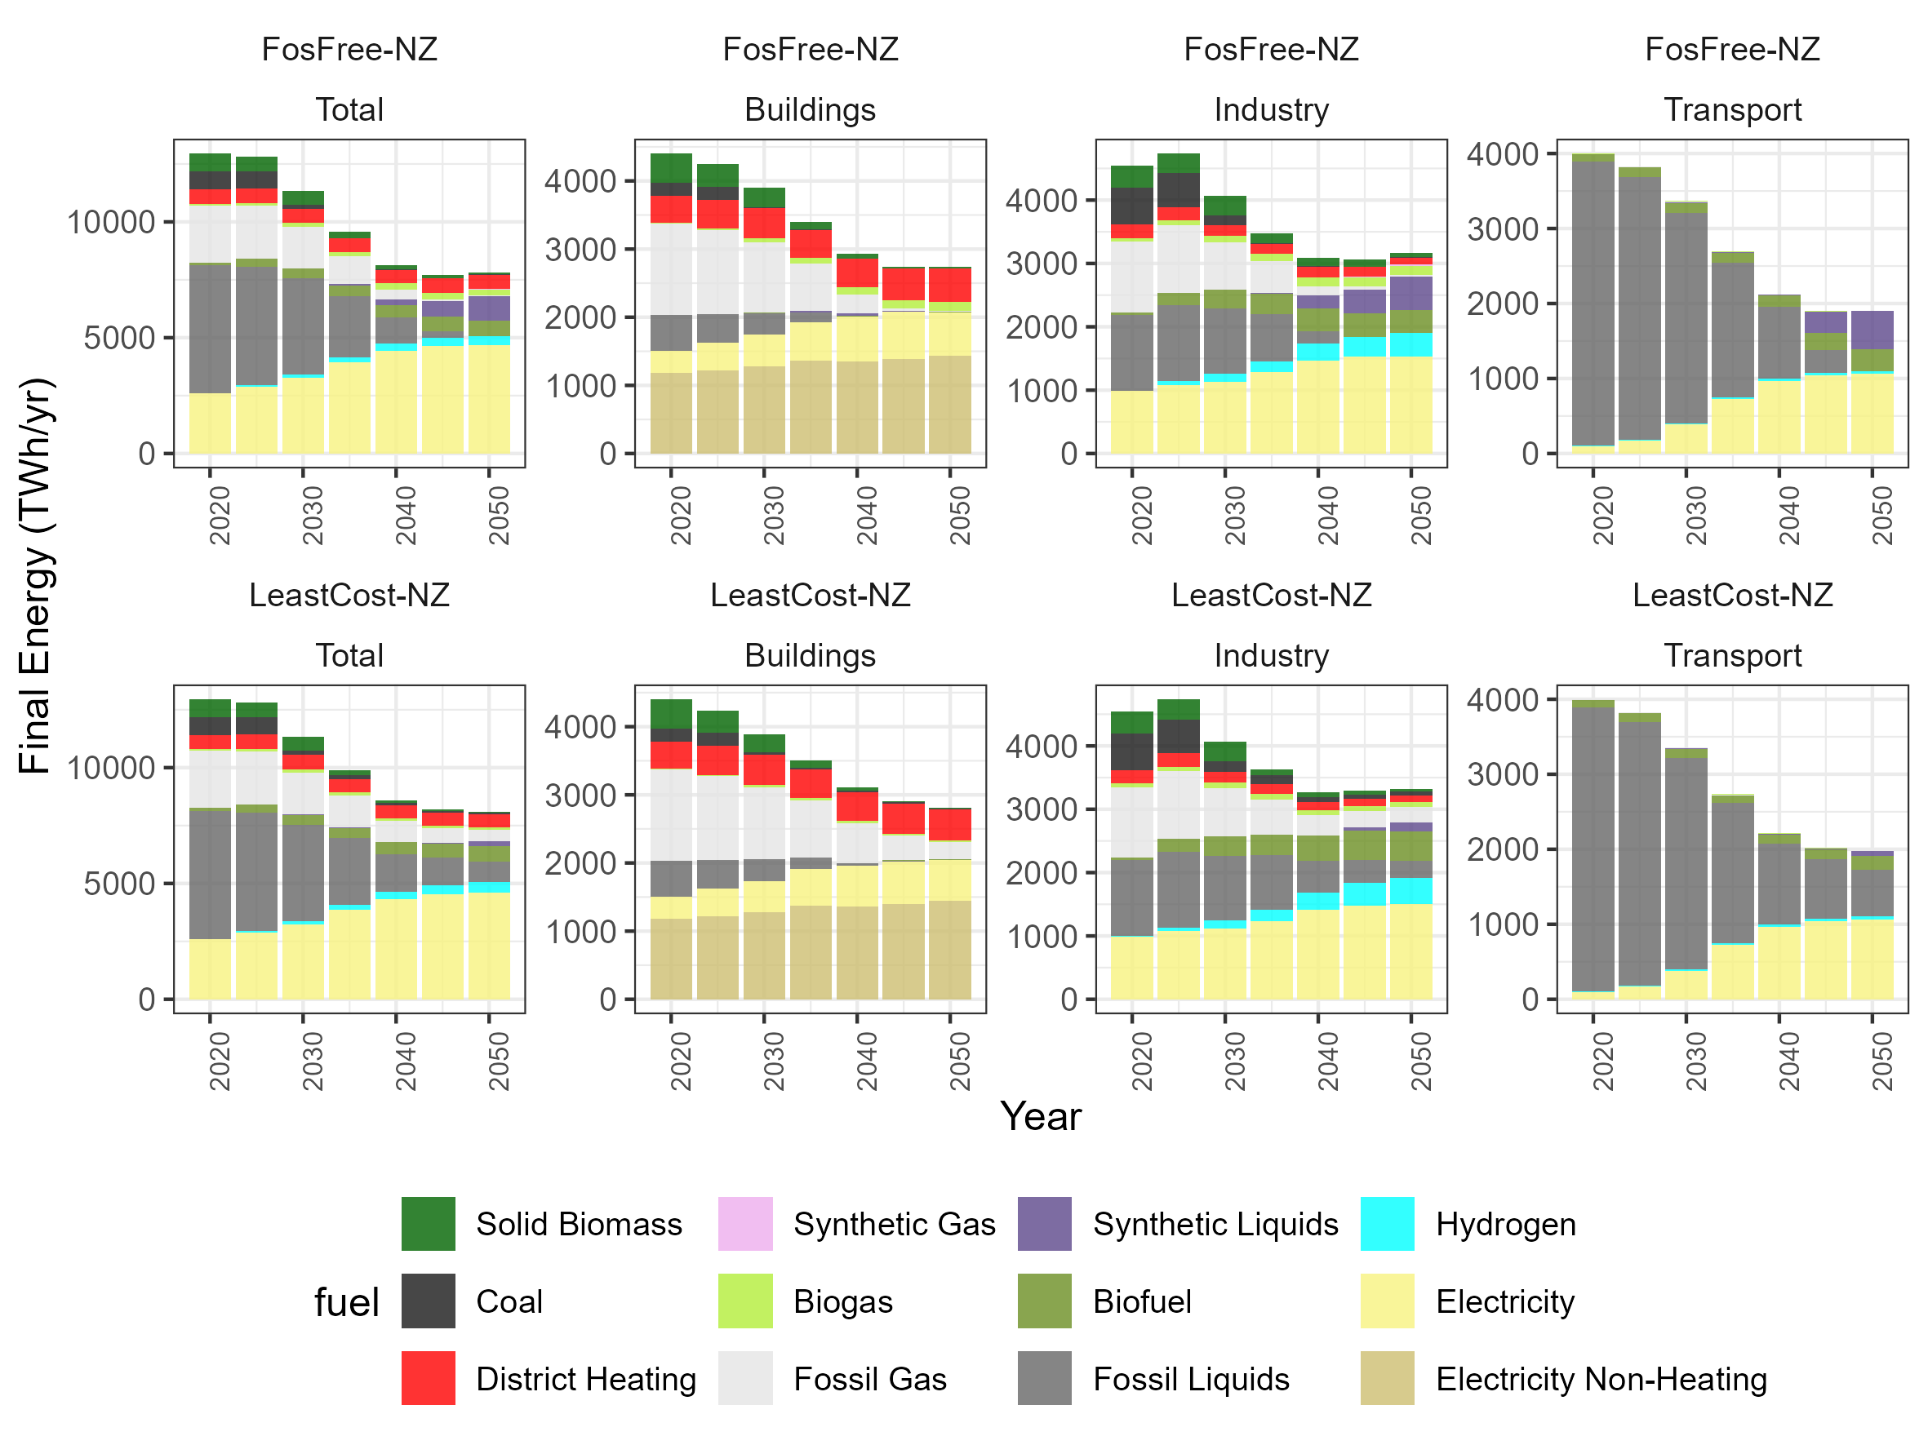
Ext Data Fig 1: Evolution of final energy mix in the EU up to 2050 in the FosFree-NZ and LeastCost-NZ scenarios.

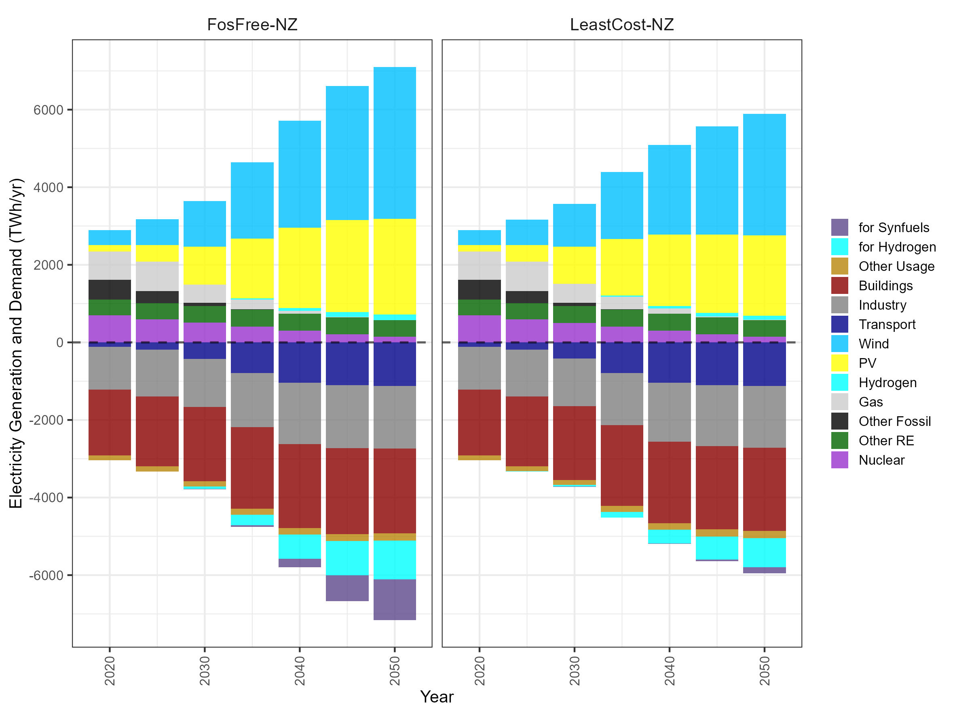
Ext Data Fig 2: Evolution of electricity generation across technologies (positive bars) and electricity demand across sectors (negative bars) in the EU for the FosFree-NZ and the LeastCost-NZ scenario.

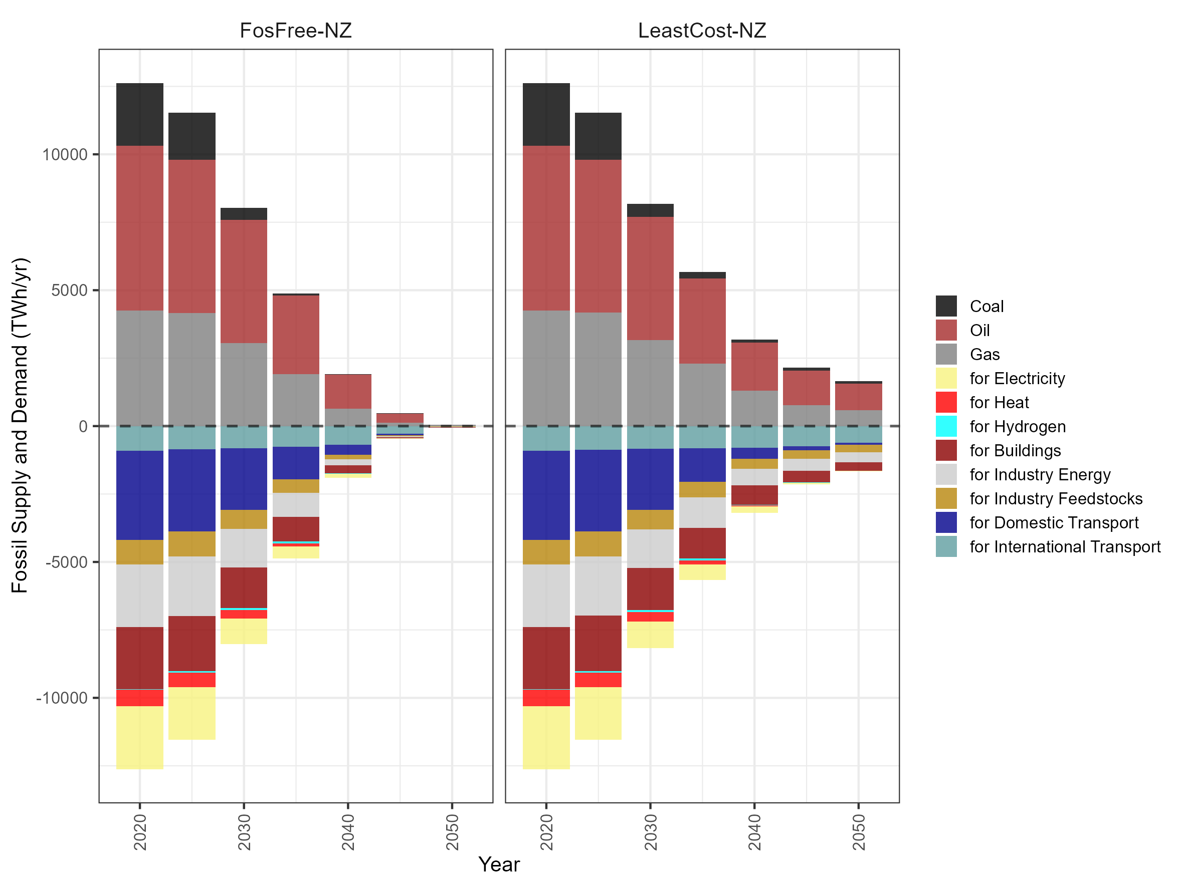
Ext Data Fig 3: Fossil energy supply across energy carriers (positive bars) and fossil energy demand across sectors (negative bars) in the EU in the FosFree-NZ and LeastCost-NZ scenario.

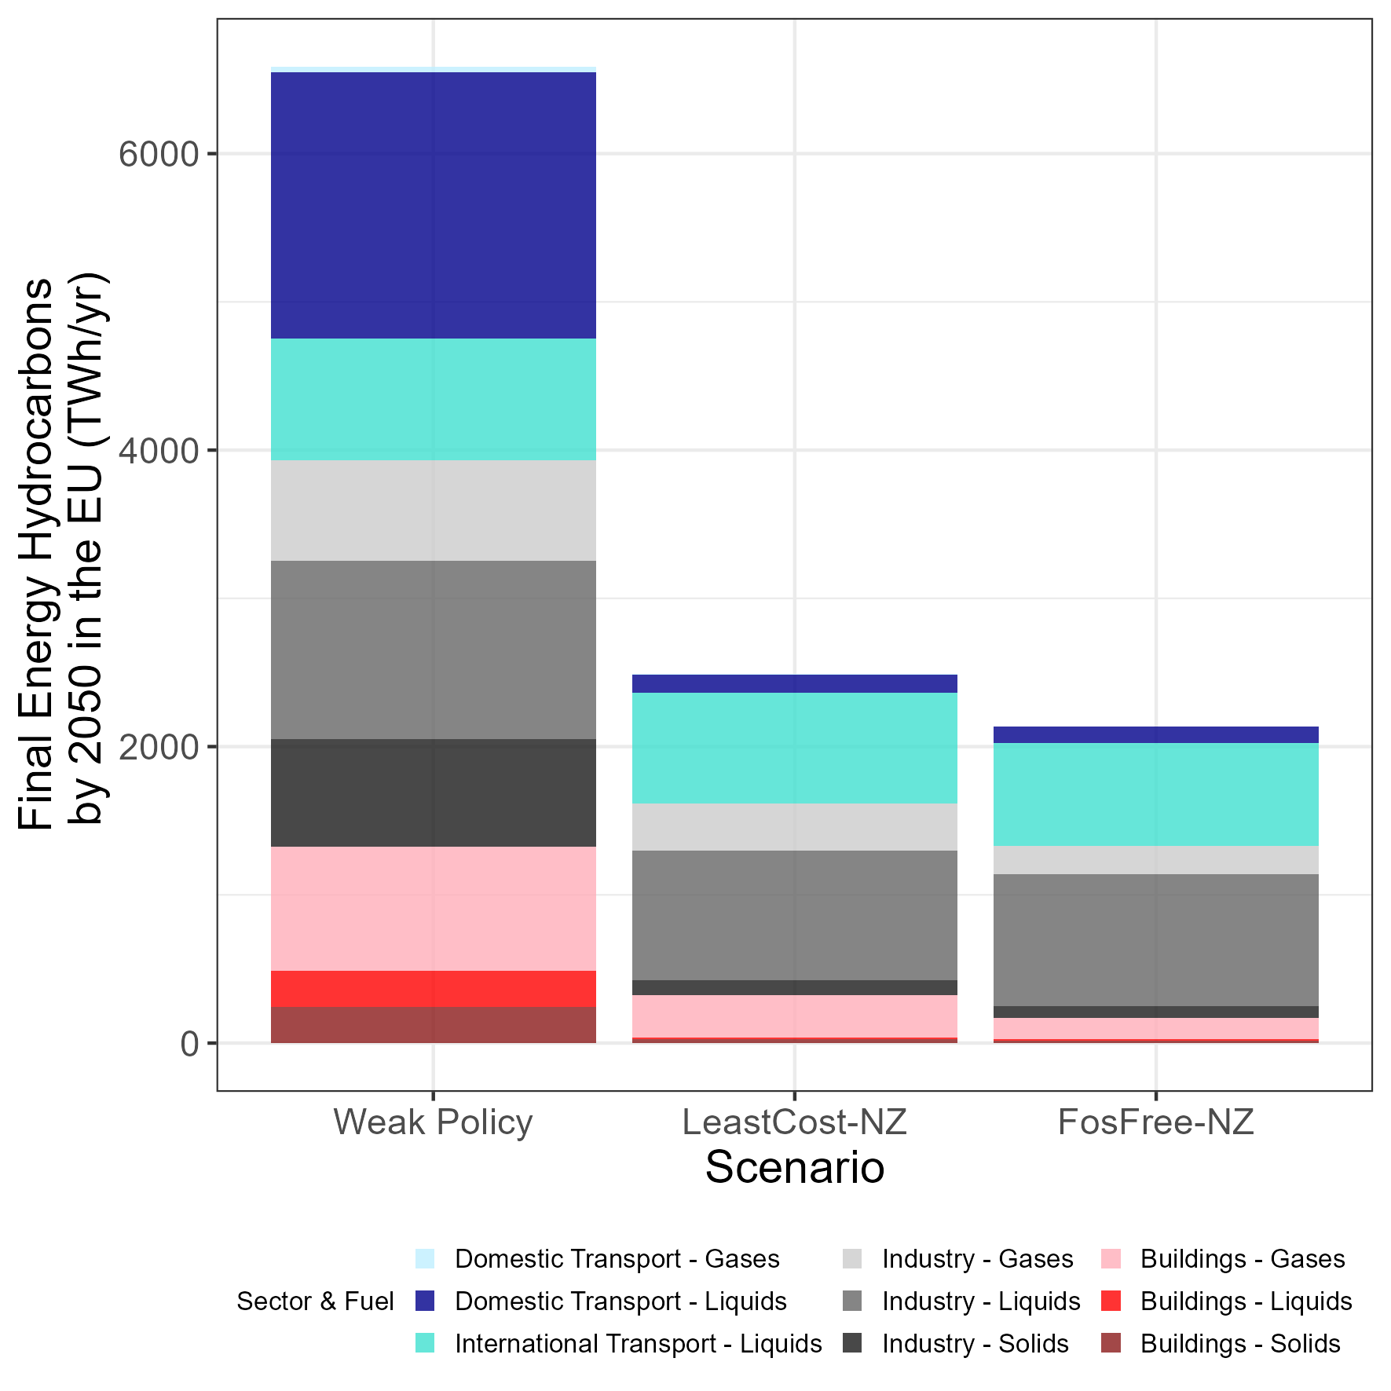
Ext Data Fig 4: Final energy hydrocarbons across sectors and scenarios in the EU in 2050. Next to the two net-zero scenarios LeastCost-NZ and FosFree-NZ, the Weak Policy is shown for 2050, which represents a scenario with a continued low co2 price (see section M5 Weak Policy Scenario and Calculation of Consumption Losses for details).

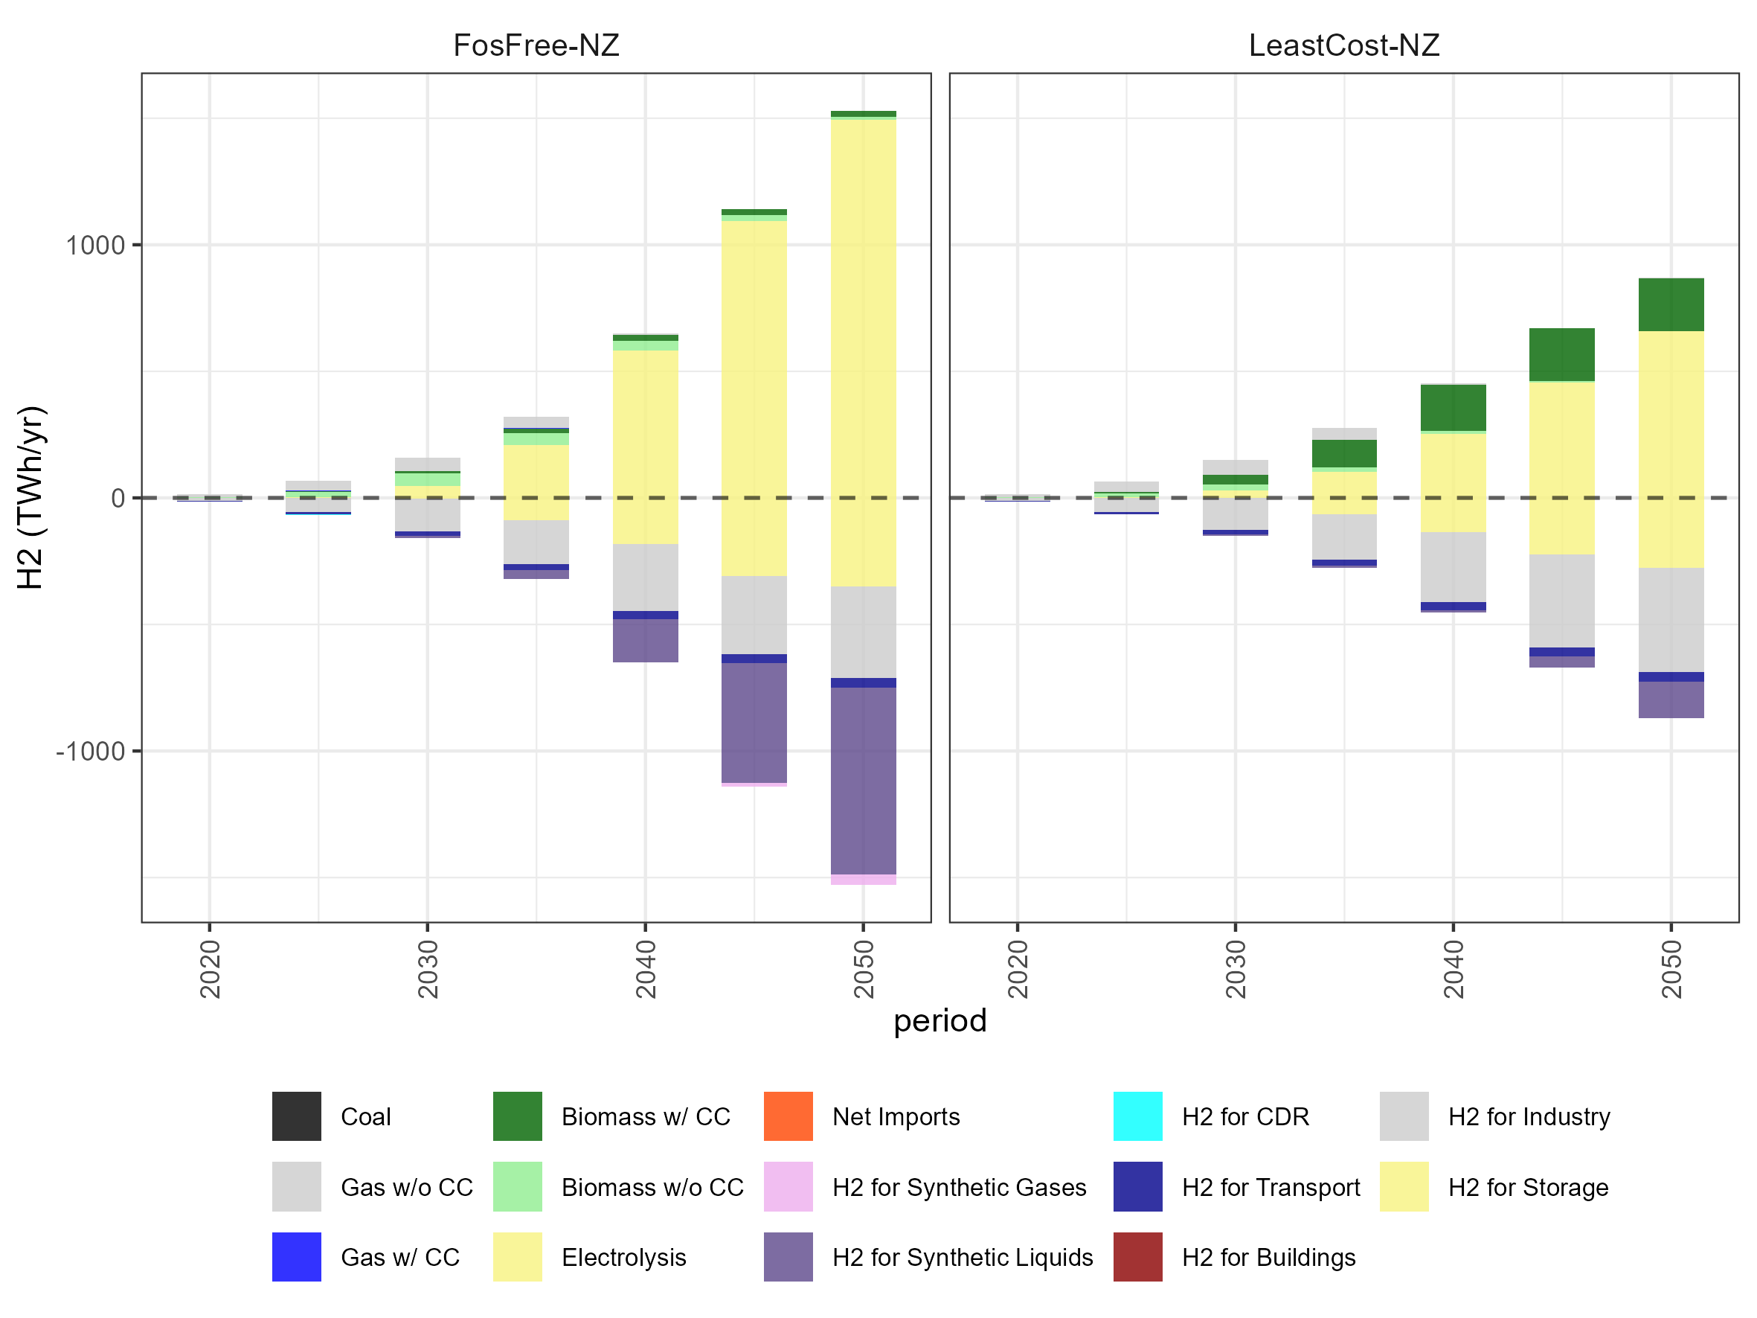
Ext Data Fig 5: Evolution of hydrogen production across technologies (positive bars) and hydrogen demand across sectors (negative bars) in the EU in the FosFree-NZ and LeastCost-NZ scenario.

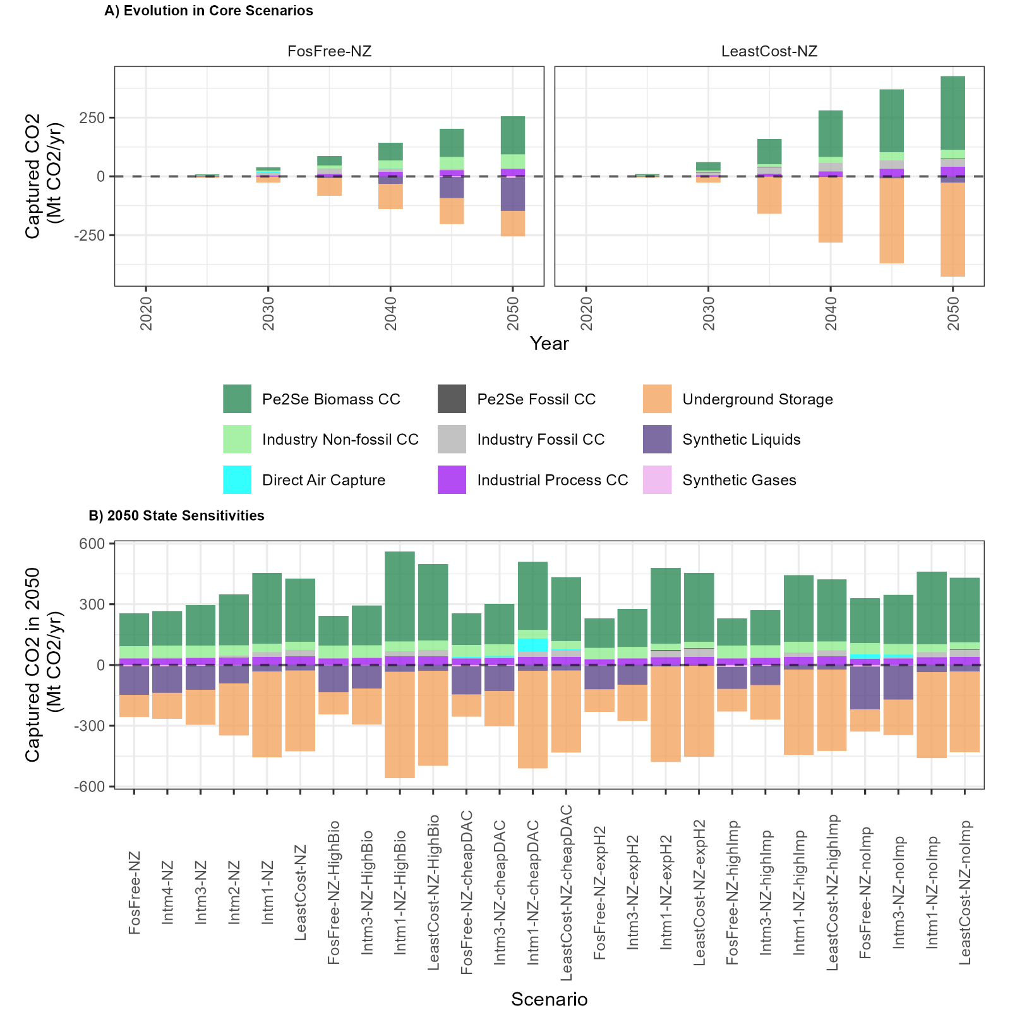
Ext Data Fig 6: Sources (positive bars) and sinks (negative bars of captured carbon) in the EU. A) Evolution of captured carbon flows in the FosFree-NZ and the LeastCost-NZ scenario up to 2050. B) As in A) but only for 2050 and across all net-zero scenarios including sensitivity scenarios. Note that in cheapDAC scenarios some deployment of direct air capture (cyan) is forced. In the FosFree-NZ-cheapDAC scenario, for instance, direct air capture is only deployed up to the forced amount and such that this deployment is not an outcome of the optimization.

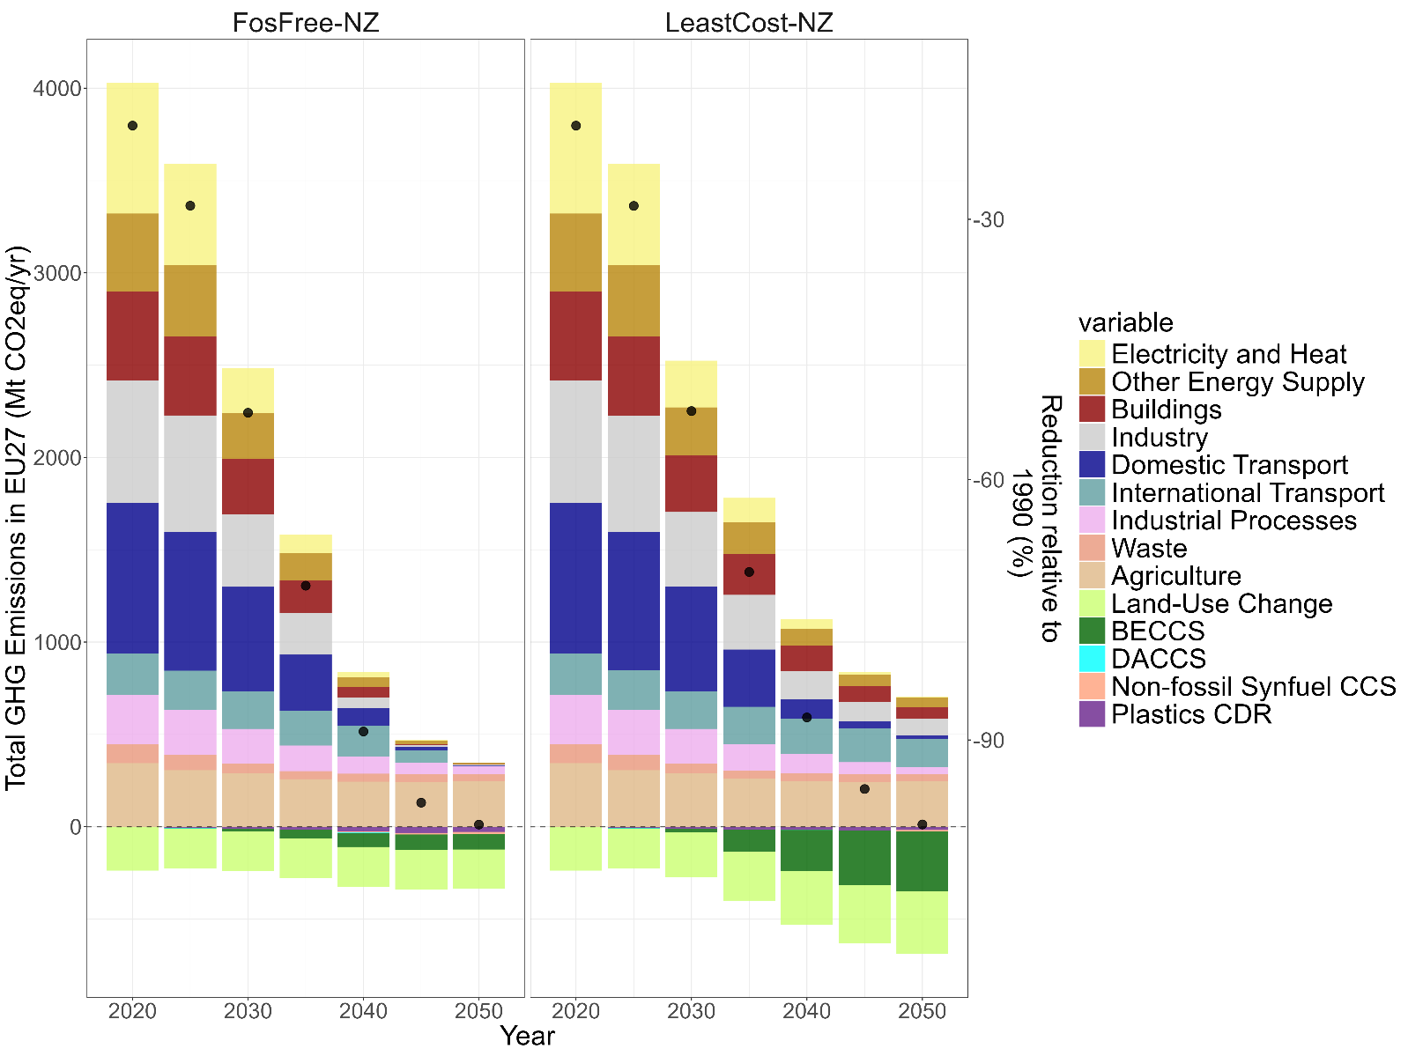
Ext Data Fig 7: Evolution of total GHG emissions in the EU across sectors up to 2050 in the FosFree-NZ and LeastCost-NZ scenarios.

Supplementary Information

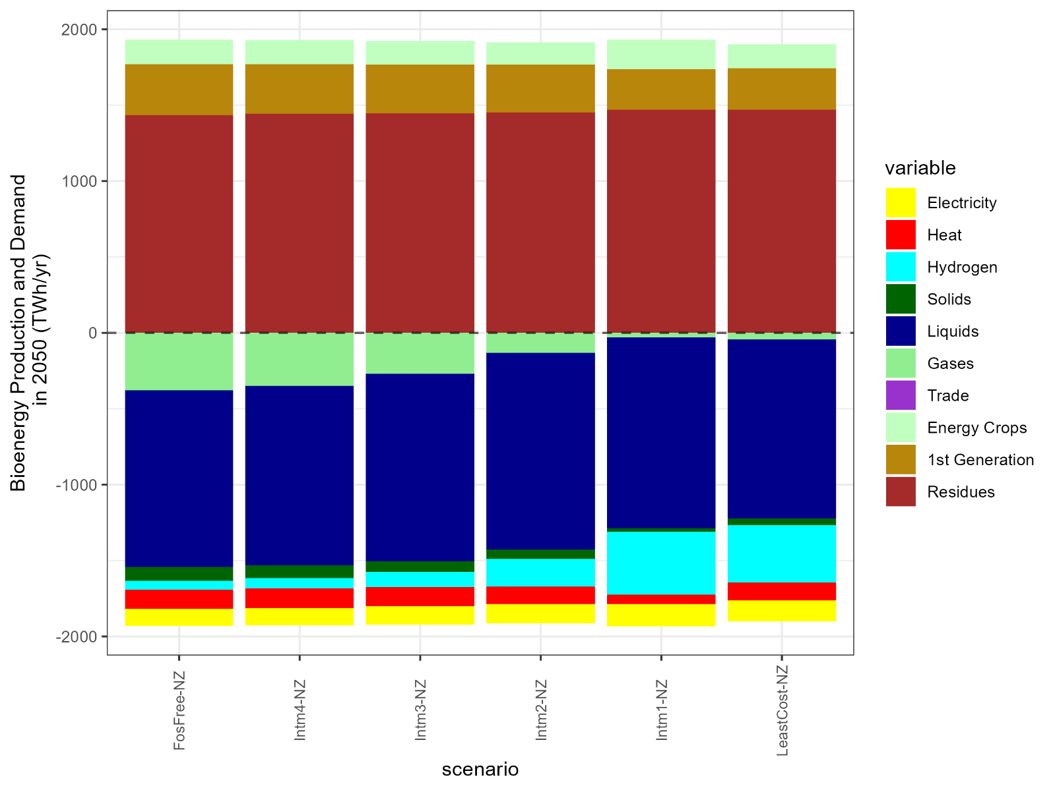
SI Figure 1: Biomass supply (positive bars) and biomass demand across energy carriers (negative bars) in 2050 in the EU for the standard scenarios. Biomass demand for solids, liquids and gases represents bioenergy used in the energy demand sectors (buildings, industry, transport), while biomass for electricity, heat and hydrogen represents bioenergy used in the energy supply sectors.

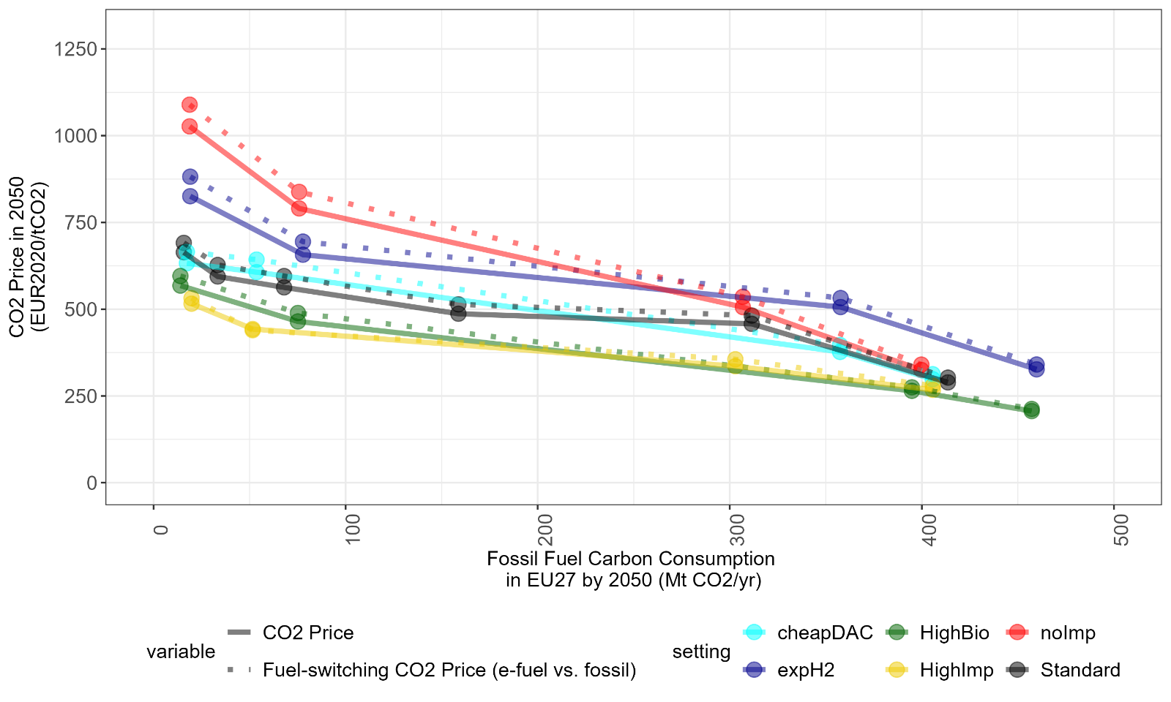
SI Figure 2: Marginal abatement cost and fuel-switching CO2 prices across sensitivity scenarios. Marginal abatement cost by 2050 in the EU on the y-axis against fossil fuel carbon consumption on the x-axis across all net-zero scenarios including sensitivities (solid lines) and corresponding fuel-switching CO2 prices for replacing fossil liquid fuels by e-fuels derived from shadow prices of the model (dotted lines). For the calculation of fuel-switching CO2 prices see section M4. Calculation of Fuel-switching CO2 Price.

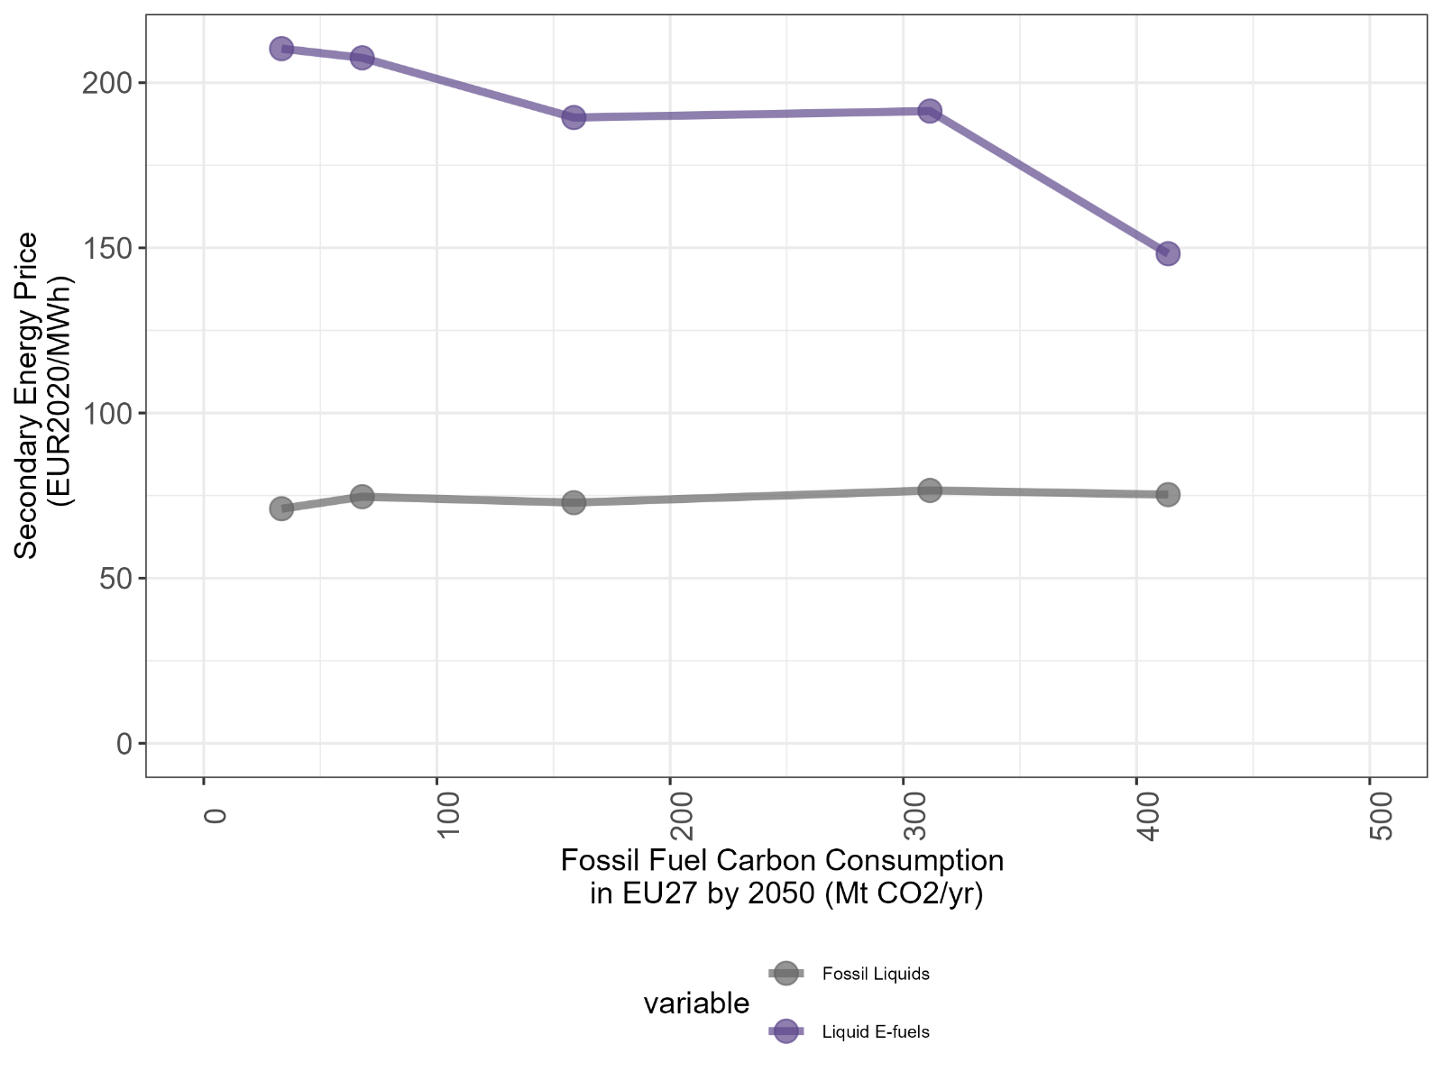
SI Figure 3: Producer prices of fossil liquids and liquid e-fuels in the EU in 2050 across standard scenarios. The plot 2050 regional-average secondary energy price (producer level, i.e. before transport and taxes) of fossil liquid fuels (grey line) and liquid e-fuels (purple) in the EU against fossil fuel carbon consumption in 2050 for the standard scenarios. Only regions with more than 1 TWh/yr of fossil liquids demand were included in the averaging as model prices are not reliable for very low quantities.

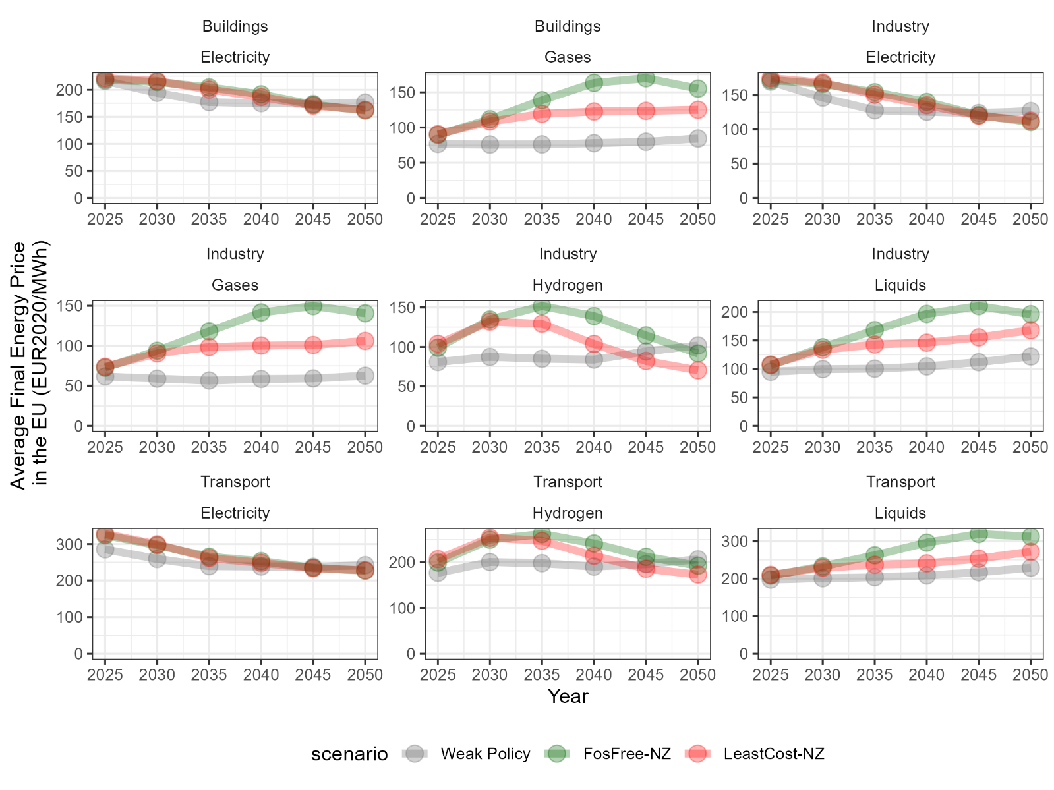
SI Figure 4: Consumer prices of selected energy carriers in the EU across standard scenarios up to 2050. The plot shows regional-averaged final energy prices (i.e. including transmission and distribution as well as taxes) in the EU for electricity, gases, liquid fuels and hydrogen in the end-use sectors (buildings, industry, transport) in the Weak Policy, FosFree-NZ and LeastCost-NZ scenario. The Weak Policy scenario represents a scenario with low ambition of EU climate policy shown as of before the regulation of the European Green Deal that fails to reach European climate targets for 2030 and 2050 (see also section M5 Weak Policy Scenario and Calculation of Consumption Losses).

