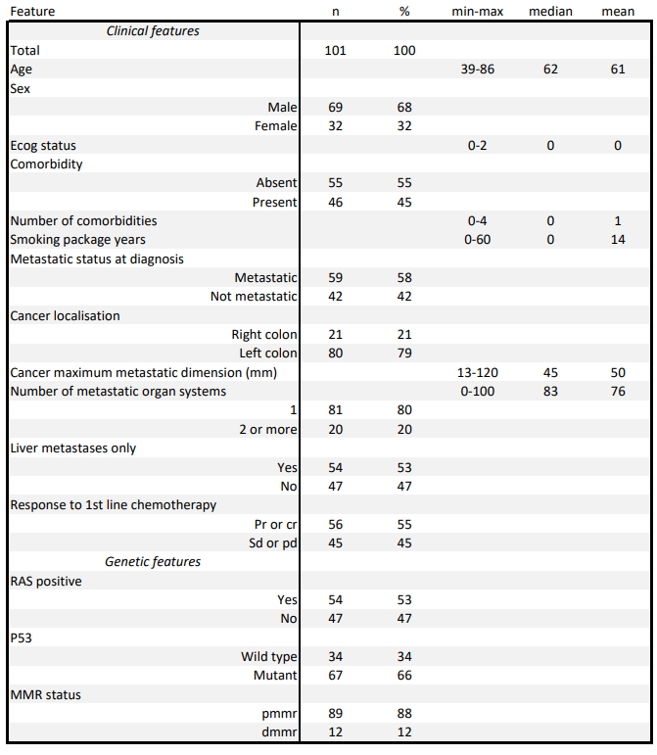
Table 1: The baseline demographic and clinical characteristics of the patients pr: Partial Response, cr: complete response, sd: stable disease,
progressive disease, MMR: mismatch repair, dmmr:deficient mismatch repair, pmmr: procifient mismatch repair

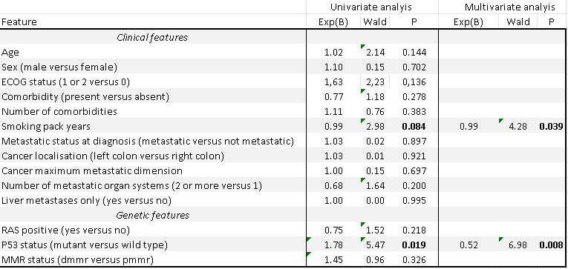Table 2: Correlates of PFS ECOG:Eastern Cooperative Oncology Group, MMR: mismatch repair, dmmr:deficient mismatch repair, pmmr: procifient mismatch repair

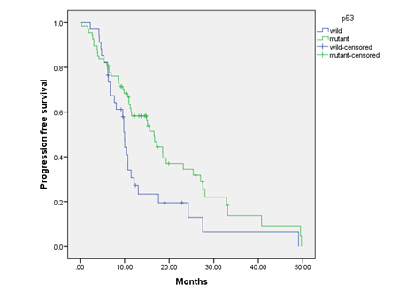
Table 3: p53- PFS

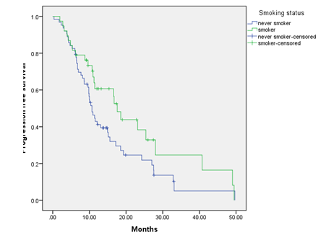
Table 4: Cigarette- PFS

