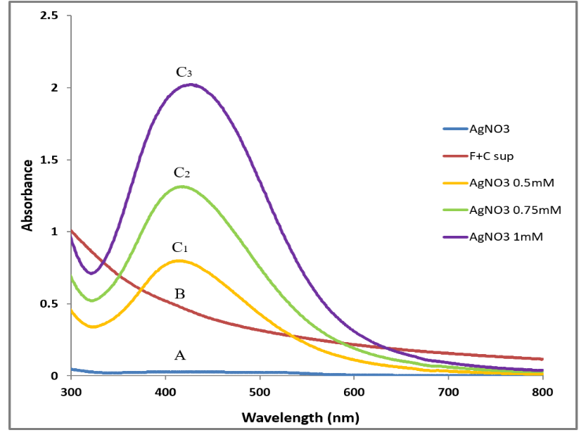

Fig. S1 UV-Vis spectra of AgNPs synthesized after treating C-FS of F. solani and C. aquatica with different concentration of AgNO₃ solution). (A) AgNO₃ solution (1mM) control; (B) C-FS, control; and (C₁, C₂, C₃) 0.5, 0.75, and 1mM AgNO₃ respectively.

