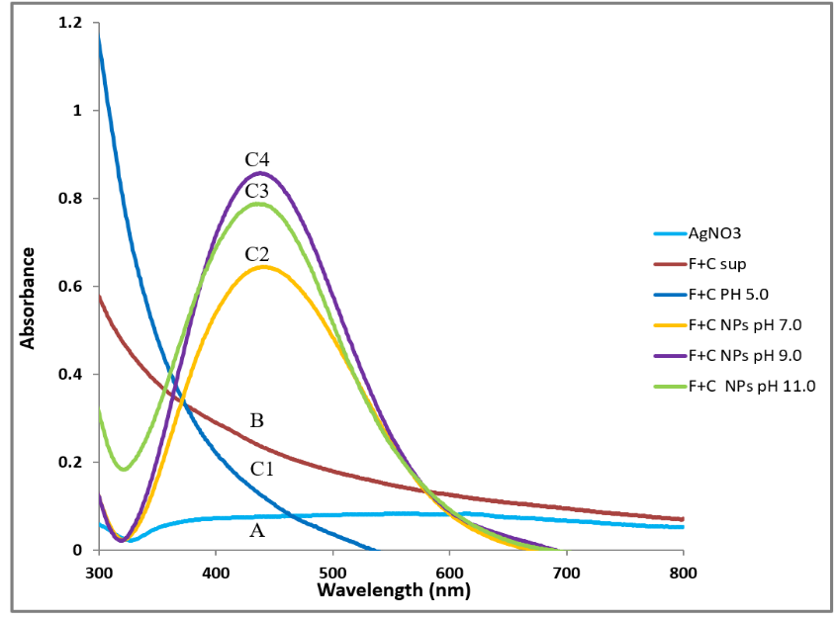

Fig. S2 UV-Vis spectra of AgNPs synthesized after treating C-FS of F. solani and C. aquatica with AgNO₃ solution (1mM) using different pH value. (A) AgNO₃ solution (1mM) control; (B) C-FS, control and (C_{1,} C₂, C₃) pH 5.0, 7.0, and 11.0, respectively. C₄ represents pH 9.0.

