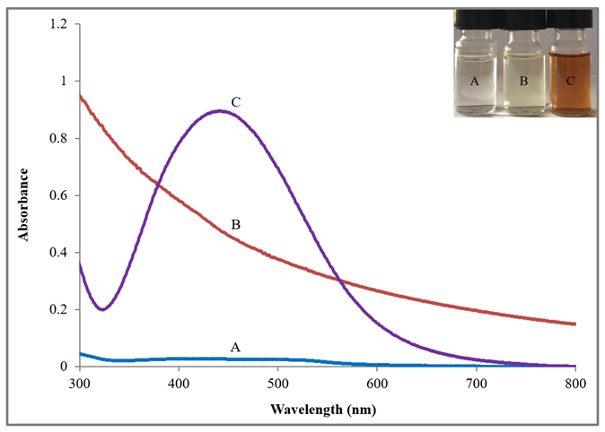

Figure S1. UV-visible absorption spectra of synthesized AgNPs using C-FS of F. solani and C. aquatica under light condition at 25°C. A. AgNO₃ (1 mM solution). B. C-FS. C. C-FS with AgNO₃ solution. Inset: A. AgNO₃ solution without supernatant. B. C-FS. C. C-FS and AgNO₃ solution.

