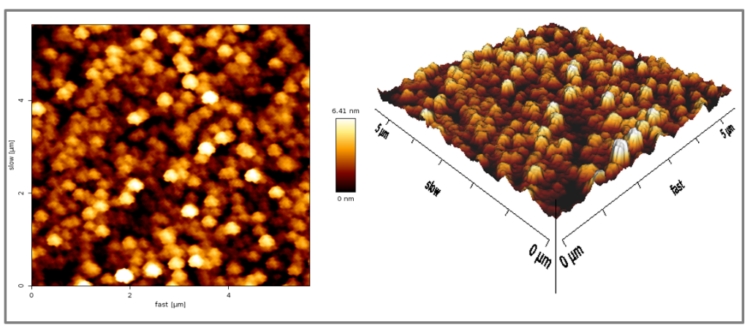

Figure S7. AFM images of AgNPs synthesized by C-FS of F. solani and C. aquatica. Left picture depicts the 2D image of the AgNPs; whereas right picture represents the 3D image.

