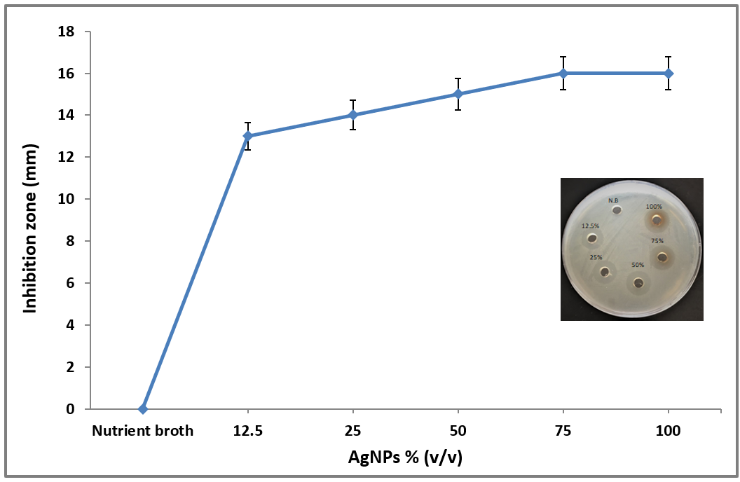

Figure S8. Inhibition zone assay of a clinical isolate of E. faecalis by synthesized AgNPs. Inset: Müeller-Hinton agar plate.

