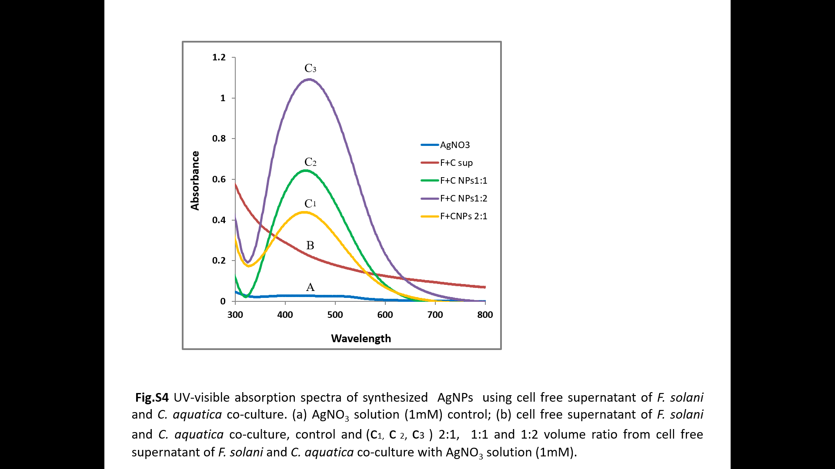

Figure S4. UV-visible absorption spectra of synthesized AgNPs. (A) AgNO₃ solution (1mM) control; (B) C-FS, control and (C_{1,} C_{2,} C₃) 2:1, 1:1 and 1:2 volume ratio from C-FS with AgNO₃ solution (1mM).

