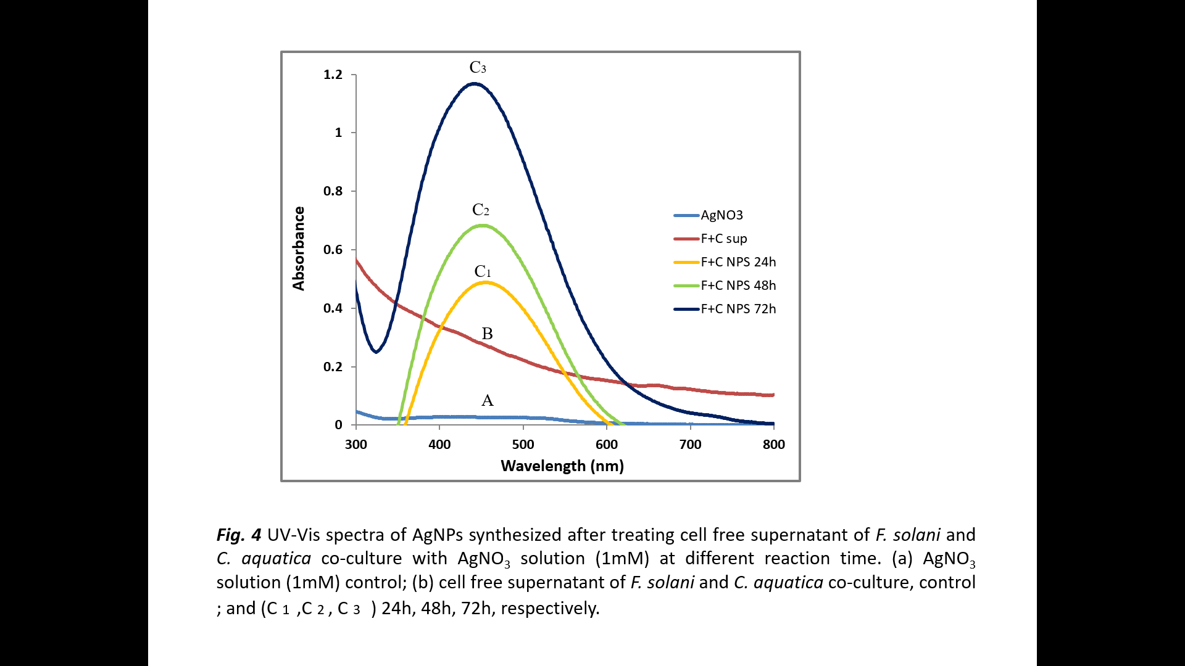

Figure S5. UV-Vis spectra of AgNPs synthesized after treating C-FS of F. solani and C. aquatica with AgNO₃ solution (1mM) at different reaction time. (A) AgNO₃ solution (1mM) control; (B) C-FS, control ; and (C₁ ,C₂ , C₃ ) 24h, 48h, 72h, respectively.

