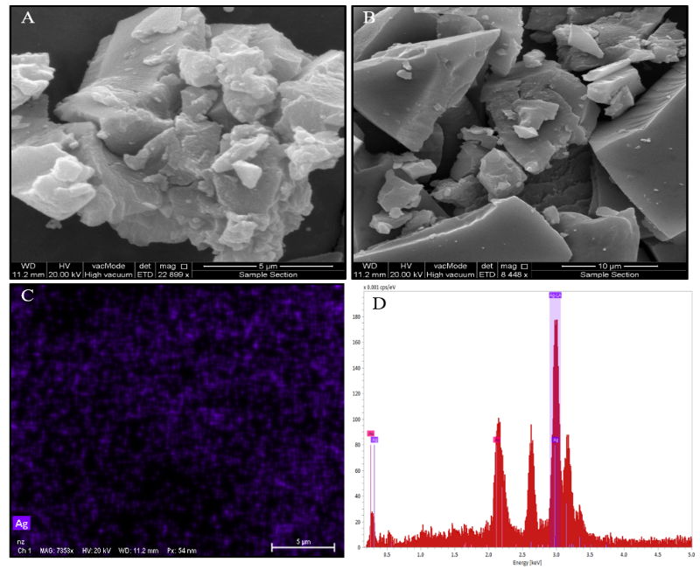

Figure S6. FE-SEM and EDX of AgNPs. A and B. FE-SEM showing high-density of AgNPs with few aggregations. C. Elemental mapping. D. Energy dispersive X-ray spectrum shows strong signal in the silver region and confirms the formation of silver nanoparticles.

