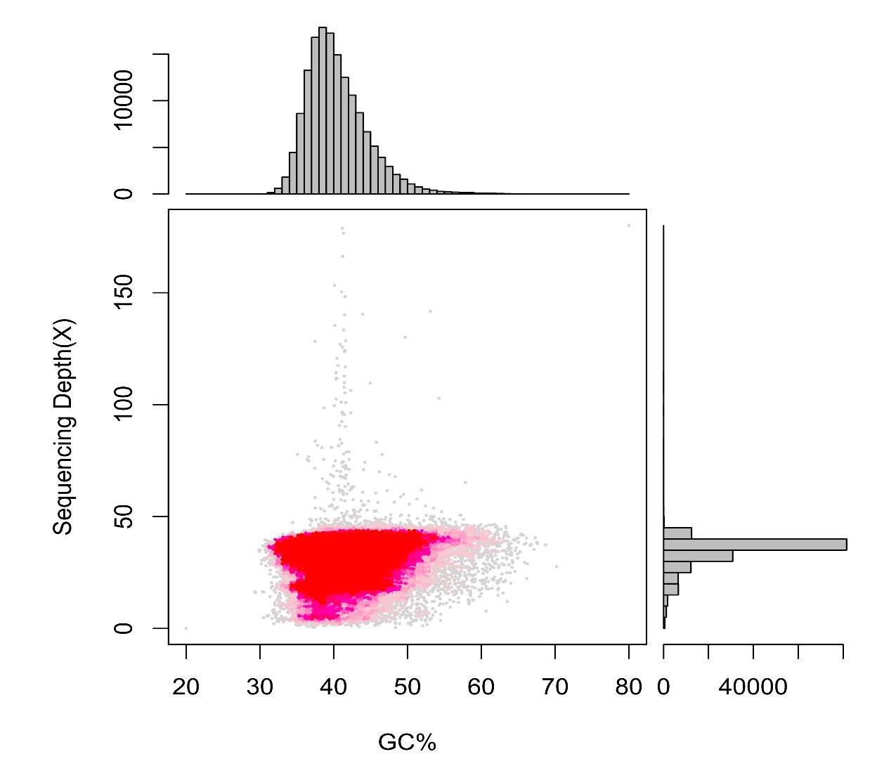
Supplementary Figures

Fig S1. GC content and sequencing depth of V. ammodytes ammodytes genome with 10 Kb bins using ~65 Gb short reads, Related to Fig 3.
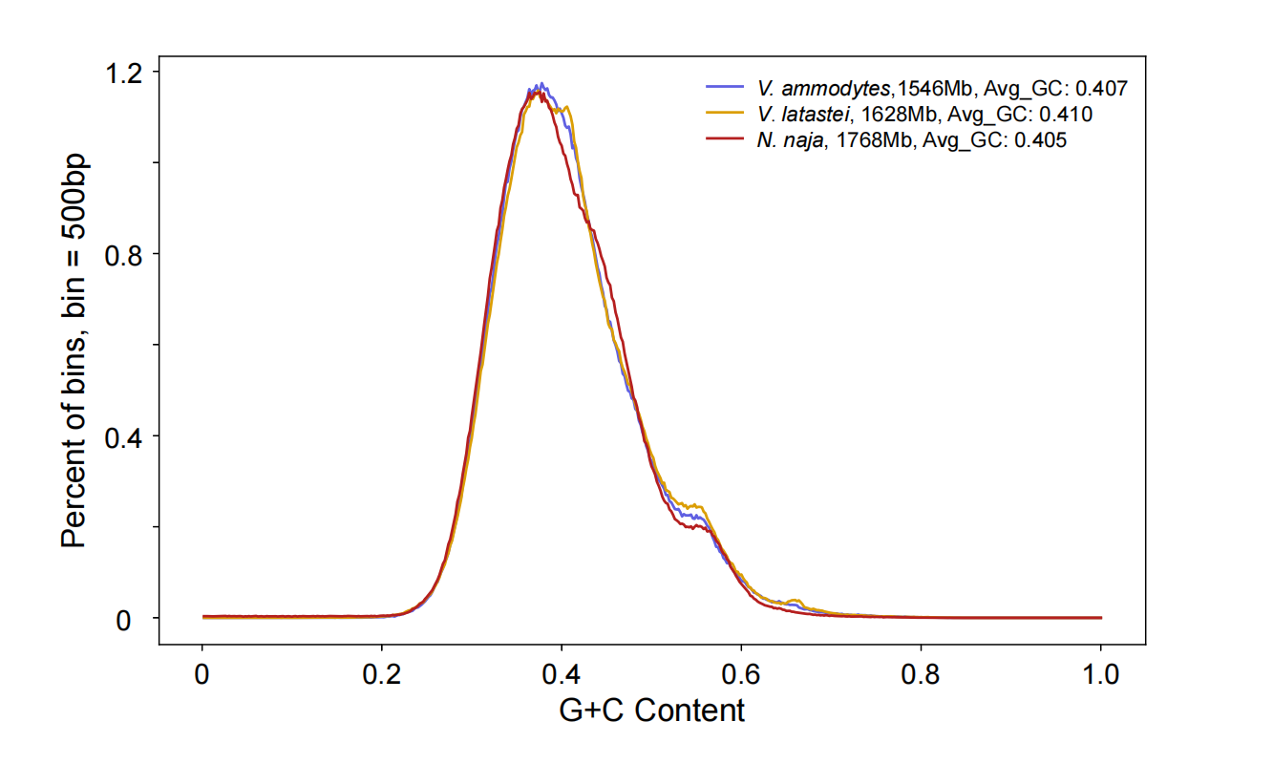

Fig S2. GC content distribution of V. ammodytes ammodytes, V. latastei and N. naja genomes with 500 bp bins, Related to Fig 2.

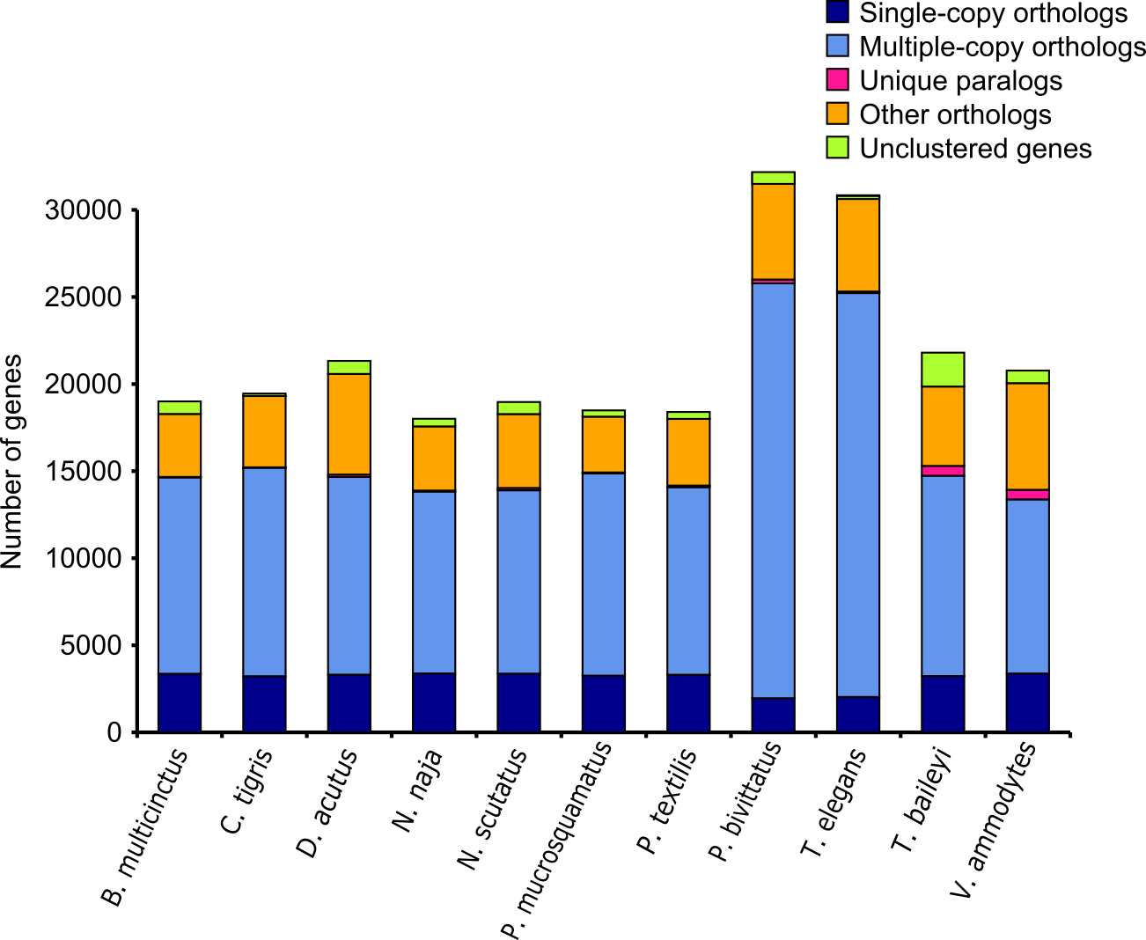
Fig S3. Bar plot representation of homologous gene counts across ten representative snake species and V. ammodytes ammodytes. Each bar corresponds to a specific species, with the total gene count displayed on the y-axis and each color segment representing different gene categories. 'Single-copy orthologs' refer to homologous genes with a single copy within gene families shared across species. 'Multiple-copy orthologs' include genes with multiple homologous copies within shared gene families. 'Unique paralogs' represent species-specific genes unique to their respective families, while 'Other orthologs' include shared homologous genes not classified in previous categories. 'Unclustered genes' are genes not clustered into any defined gene family. This distribution illustrates the variability in gene family structure and composition among the selected snake species.

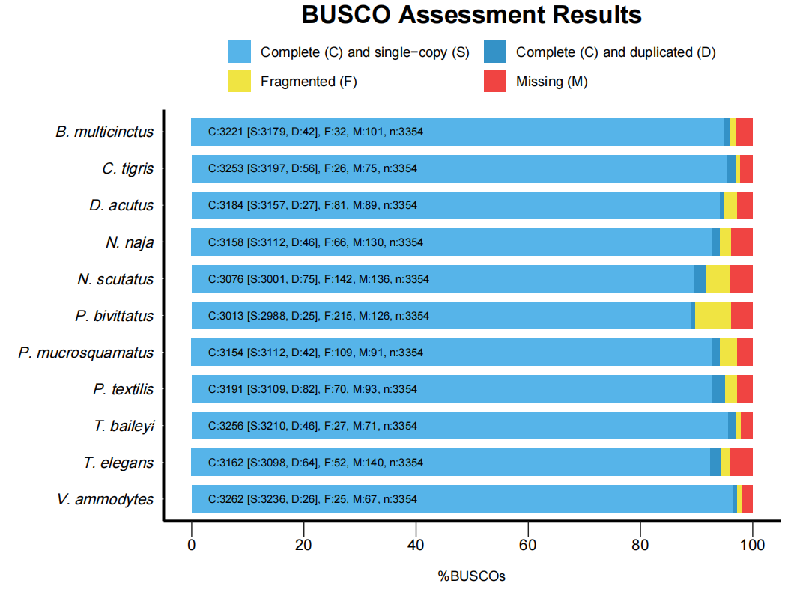
Fig S4. BUSCO assessment of genes of ten representative snake species and V. ammodytes. BUSCO results for the nose-horned viper snake genome sequenced and assembled here as well as for nine previously published snake genomes. The genome completeness assessment was performed using the 3,354 single-copy genes of the Vertebrata set.
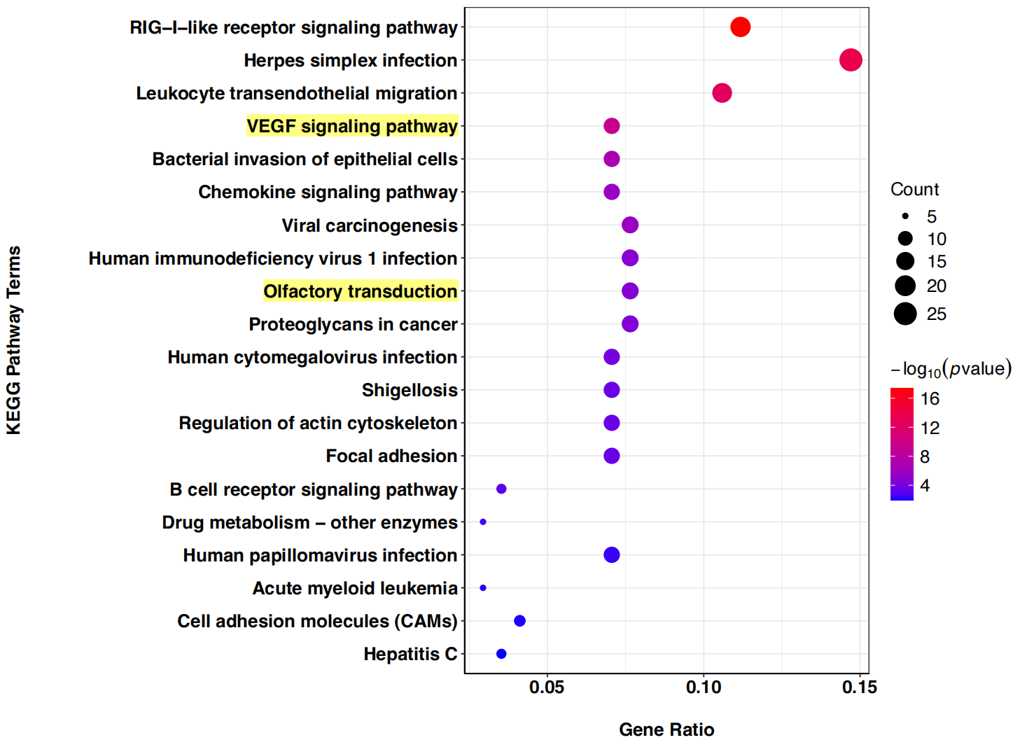

Fig S5 Statistics of KEGG functional pathway enrichment for expansion gene families in V. ammodytes ammodytes, scatter plot of top 20 enriched KEGG pathways.
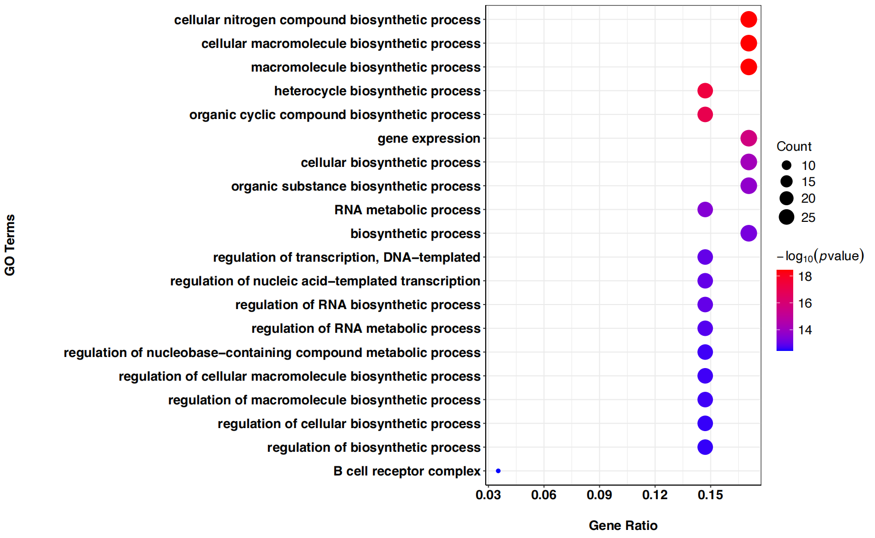

Fig S6 Statistics of GO functional enrichment analysis for expansion gene families in V. ammodytes ammodytes, scatter plot of top 20 enriched GO pathways.

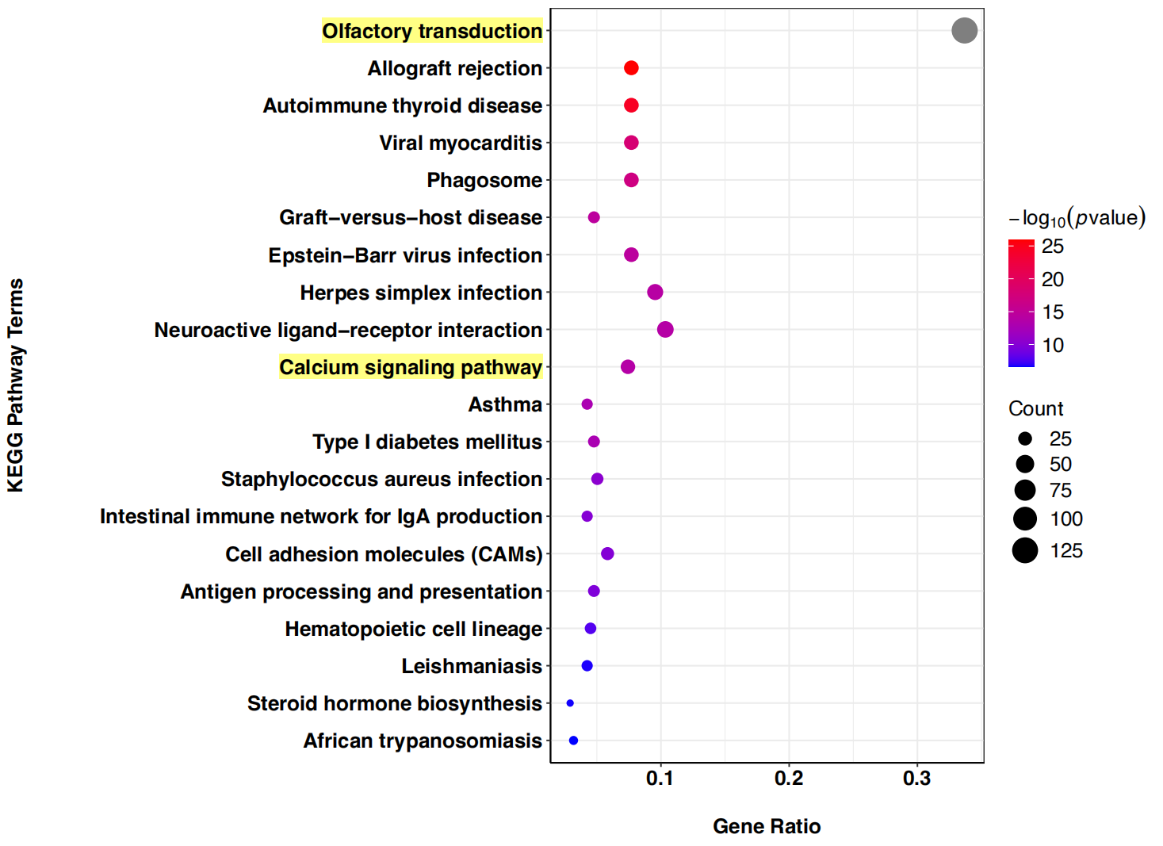

Fig S7 Statistics of KEGG functional pathway enrichment for contraction gene families in V. ammodytes ammodytes, scatter plot of top 20 enriched KEGG pathways.
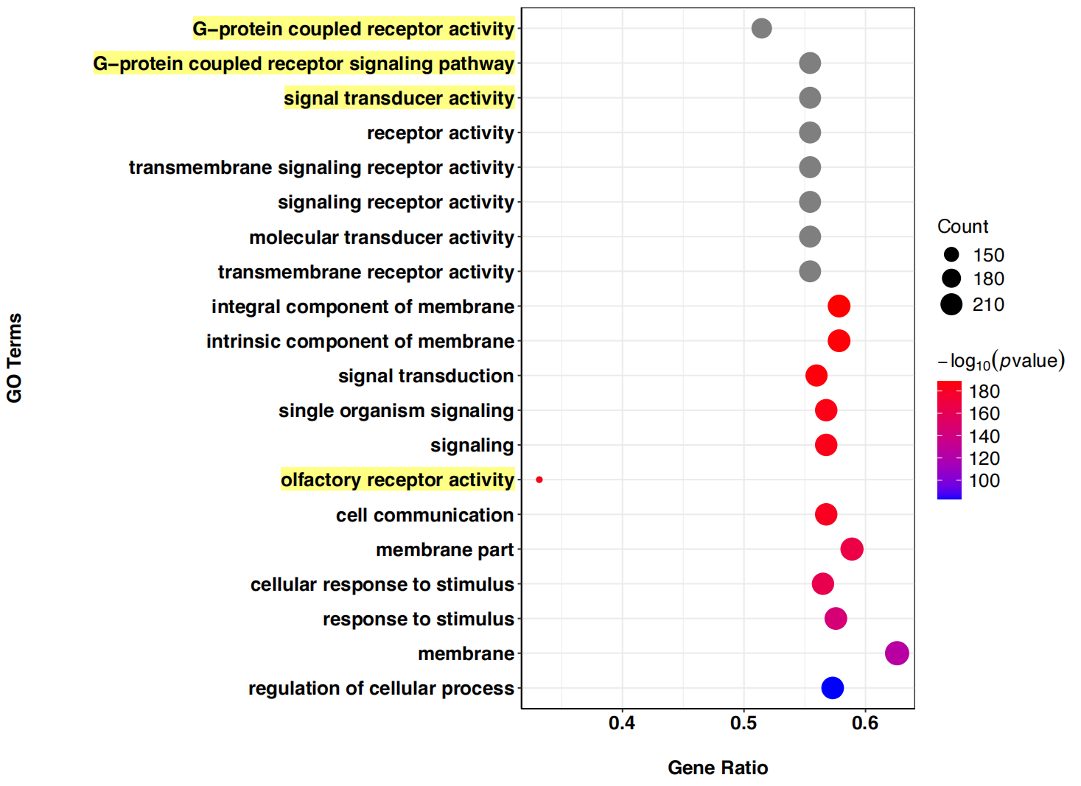

Fig S8 Statistics of GO functional enrichment analysis for contraction gene families in V. ammodytes ammodytes, scatter plot of top 20 enriched GO pathways.

Supplementary Tables

Table S1. Sample information for V. ammodytes sequencing
Sample ID | Tissue | Sequencing strategy | Total raw bases  (Gb) | CNGB Accession
CNS0519618 | Liver | Whole genome sequencing | 270 | CNX0425294
CNS0519621 | Venom gland | RNA-seq | 14.38 | CNR0515773

Table S2. Statistics of whole genome sequencing raw data for V. ammodytes ammodytes. Related to Fig 1
Sequencing platform | Total raw bases  (Gb) | Total clean bases  (Gb) | Coverage  (X)
Hiseq X-Ten | 119.54 | 101.80 | 65.26
Sequel | 160.15 | 102.75 | 65.86
Total | 270 | 204.55 | 131.12

Table S3. Genome assembly summary of V. ammodytes ammodytes. Related to Fig 1.
Assembly level | Parameters | V1  (FALCON) | V2  (NextDenovo) | V2.1  (RaGOO）
Scaffold | Maximal length (bp) | 24,802,607 | 116,945,781 | 352,462,323
Scaffold | N90 (bp) | 220,358 | 2,893,299 | 26,179,766
Scaffold | N50 (bp) | 3,383,186 | 45,902,541 | 210,475,551
Scaffold | number>=100bp | 3,236 | 259 | 24
Scaffold | number>=2kb | 3,236 | 259 | 24
Scaffold | Genome size (bp) | 1,556,375,989 | 1,545,915,679 | 1,545,746,728
Contig | Maximal length (bp) | 24,802,607 | 116,945,781 | 116,975,781
Contig | N90 (bp) | 220,358 | 2,846,300 | 2,846,300
Contig | N50 (bp) | 3,383,186 | 45,902,541 | 45,902,541
Contig | number>=100bp | 3,236 | 262 | 262
Contig | number>=2kb | 3,236 | 262 | 262
Contig | Genome size (bp) | 1,556,375,989 | 1,545,915,610 | 1,545,915,610

Table S4. Comparison of the assembly parameters of V. ammodytes ammodytes genome with other published snake genomes. Related to Fig 2.
Species | Genome Size (Gb) | Contig N50  (bp) | Scaffold N50 (Mb)
Vipera ammodytes ammodytes | 1.56 | 3,383,186 | 210.47
Viper latastei | 1.63 | 44,810,000 | 222.5
Crotalus tigris | 1.6 | 2,110,000 | 223.35
Crotalus horridus | 1.5 | 5,800 | 0.0238
Protobothrops flavoviridis | 1.4 | 3,800 | 0.467
Protobothrops mucrosquamatus | 1.63 | 22,000 | 0.424
Deinagkistrodon acutus | 1.4 | 22,420 | 2.12
Pantherophis guttatus | 1.53 | 563 | 0.0036
Thermopsis baileyi | 1.8 | 16,800 | 2.414
Thamnophis elegans | 1.81 | 432,811 | 440.19
Ophiophagus hannah | 1.66 | 3,980 | 0.226
Pseudonaja textilis | 1.59 | 50,443 | 14.68
Notechis scutatus | 1.66 | 31,763 | 5.99
Naja naja | 1.79 | 310,000 | 223.35
Python bivittatus | 1.44 | 10,700 | 0.207
The species name of the snake in bold indicates that it is possible to download the annotated results of the genome from public databases.

Table S5. Length of assembled 18 pseudo-chromosomes of V. ammodytes ammodytes.
Reference | Molecule | Total length  (bp) | Scaffold count | Contig count
Vipera latastei | All | 1,545,746,728 | 24 | 261
CM044354.1 | Chromosome 1(a+b) | 352,462,323 | 1 | 34
CM044355.1 | Chromosome 2(a+b) | 282,015,633 | 1 | 41
CM044356.1 | Chromosome 3(a+b) | 210,475,551 | 1 | 24
CM044357.1 | Chromosome 4 | 121,795,503 | 1 | 18
CM044358.1 | Chromosome 5 | 99,400,319 | 1 | 18
CM044359.1 | Chromosome 6 | 90,525,129 | 1 | 17
CM044360.1 | Chromosome 7 | 79,111,571 | 1 | 22
CM044361.1 | Chromosome 8 | 26,179,766 | 1 | 1
CM044362.1 | Chromosome 9 | 25,195,248 | 1 | 3
CM044363.1 | Chromosome 10 | 22,420,670 | 1 | 3
CM044364.1 | Chromosome 11 | 20,436,073 | 1 | 6
CM044365.1 | Chromosome 12 | 20,950,040 | 1 | 2
CM044366.1 | Chromosome 13 | 18,872,082 | 1 | 3
CM044367.1 | Chromosome 14 | 13,561,822 | 1 | 7
CM044368.1 | Chromosome 15 | 10,977,292 | 1 | 10
CM044369.1 | Chromosome 16 | 9,944,726 | 1 | 3
CM044370.1 | Chromosome 17 | 6,794,329 | 1 | 3
CM044371.1 | Chromosome Z | 134,084,838 | 1 | 36
 | unplaced | 543,813 | 5 | 5

Table S6. Length of assembled 18 pseudo-chromosomes of V. ammodytes ammodytes compared to V. latastei.
Chromosome ID |  | Size (Mb) |  |  | Percentage (%)
V. ammodytes | V. latastei |  | V. ammodytes | V. latastei |  | V. ammodytes /V. latastei
Chromosome1(1a+1b) | CM044354.1 |  | 336.13 | 353.46 |  | 95.10%
Chromosome 2(2a+2b) | CM044355.1 |  | 268.95 | 285.96 |  | 94.05%
Chromosome 3(3a+3b) | CM044356.1 |  | 200.73 | 212.18 |  | 94.60%
Chromosome 4 | CM044357.1 |  | 116.15 | 119.85 |  | 96.92%
Chromosome 5 | CM044358.1 |  | 94.80 | 100.08 |  | 94.72%
Chromosome 6 | CM044359.1 |  | 86.33 | 89.34 |  | 96.63%
Chromosome 7 | CM044360.1 |  | 75.45 | 77.66 |  | 97.15%
Chromosome 8 | CM044361.1 |  | 24.97 | 25.75 |  | 96.97%
Chromosome 9 | CM044362.1 |  | 24.03 | 25.53 |  | 94.12%
Chromosome 10 | CM044363.1 |  | 21.38 | 22.54 |  | 94.86%
Chromosome 11 | CM044364.1 |  | 19.49 | 20.79 |  | 93.73%
Chromosome 12 | CM044365.1 |  | 19.98 | 20.69 |  | 96.57%
Chromosome 13 | CM044366.1 |  | 18.00 | 18.57 |  | 96.90%
Chromosome 14 | CM044367.1 |  | 12.93 | 13.28 |  | 97.42%
Chromosome 15 | CM044368.1 |  | 10.47 | 10.53 |  | 99.42%
Chromosome 16 | CM044369.1 |  | 9.48 | 10.19 |  | 93.05%
Chromosome 17 | CM044370.1 |  | 6.48 | 7.06 |  | 91.76%
Chromosome Z | CM044371.1 |  | 127.87 | 131.62 |  | 97.15%

Table S7. BUSCO assessment of the assembled V. ammodytes genome with Vertebrata gene set.
Items | Gene number | Percentage (%)
Complete BUSCOs (C) | 3257 | 97.1
Complete and single-copy BUSCOs (S) | 3231 | 96.3
Complete and duplicated BUSCOs (D) | 26 | 0.8
Fragmented BUSCOs (F) | 29 | 0.9
Missing BUSCOs (M) | 68 | 2.0
Total BUSCO groups searched | 3354 | 100

Table S8. BUSCO assessment of assembled of predicted genes.
Items | Gene number | Percentage (%)
Complete BUSCOs (C) | 2900 | 86.5
Complete and single-copy BUSCOs (S) | 2857 | 85.2
Complete and duplicated BUSCOs (D) | 43 | 1.3
Fragmented BUSCOs (F) | 217 | 6.4
Missing BUSCOs (M) | 237 | 7.1
Total BUSCO groups searched | 3354 | 100

Table S9. Summary of function annotation of predicted genes in V. ammodytes ammodytes genome. Related to Fig 3.
Items | Total genes | Swissport | KEGG | TrEMBL | Interpro | GO | All annotated
Gene numbers | 20,674 | 16,987 | 15,950 | 19,431 | 18,685 | 12,940 | 19,969
Percentage (%) | 100 | 82.17 | 77.15 | 93.99 | 90.38 | 62.59 | 96.59

Table S10. Repeat element families in different snake species.
Snake species | Repeat Element Family
Snake species | DNA | LINE | LTR | SINE | Unclassified | Other | Total
V. ammodytes ammodytes | 4.29 | 41.87 | 14.35 | 1.93 | 0.23 | 0.00 | 53.75
V. latastei | 4.46 | 45.63 | 11.1 | 1.92 | 0.55 | 0.00 | 55.95
B. constrictor | 3.02 | 13.03 | 1.44 | 2.69 | 18.45 | 1.98 | 39.59
P. bivittatus | 2.73 | 12.93 | 0.58 | 1.84 | 16.92 | 1.85 | 35.84
D. acutus | 7.96 | 13.84 | 2.59 | 1.82 | 19.42 | 3.17 | 47.47
C. viridis | 2.27 | 13.54 | 5.27 | 1.82 | 3.86 | 12.15 | 38.91
O. hannah | 3.81 | 12.35 | 1.57 | 2.08 | 12.2 | 2.58 | 33.95
N. naja | 2.39 | 10 | 8.15 | 1.38 | 15.78 | 5.52 | 43.22

Table S11. Snake venom genes paralogs identified in the V. ammodytes ammodytes genome and the expression amount in the snake venom gland. Related to Fig 12.
Family name | Full name | Gene number
SVMP | snake venom metalloproteinases (class I, II or III) | 20
Snaclec | snake C-type lectin-like proteins | 19
sPLA₂ | secreted phospholipases A₂ | 11
SPi | serine protease inhibitors (Kunitz-type) | 11
SVSP | snake venom serine proteases | 9
5Nase | 5’-nucleotidases | 7
LAAO | L-amino acid oxidases | 7
MPi | metalloproteinase inhibitors | 6
Hyal | hyaluronidases | 5
CRISP | cysteine-rich secretory protein | 4
NP | natriuretic peptides | 3
VNGF | venom nerve growth factors | 3
VEGF | vascular endothelial growth factors | 2
veficolin | venom ficolins | 1

Table S12. Species information used in comparative genomics analysis.
Species | Database | Version
Vipera latastei | NCBI | GCA_024294585.1
Bungarus multicinctus | NCBI | GCA_023653725.1_ASM2365372v1
Crotalus tigris | NCBI | GCF_016545835.1_ASM1654583v1
Deinagkistrodon acutus | GigaScience | http://dx.doi.org/10.5524/100196
Naja naja | Ensembl | Nana_v5
Notechis scutatus | Ensembl | TS10Xv2-PRI
Protobothrops mucrosquamatus | NCBI | GCF_001527695.2_P.Mucros_1.0
Pseudonaja textilis | Ensembl | EBS10Xv2-PRI
Python bivittatus | NCBI | GCF_000186305.1_Python_molurus_bivittatus-5.0.2
Thamnophis elegans | NCBI | GCF_009769535.1_rThaEle1.pri
Thermophis baileyi | GWH | GWHBJWY00000000
Vipera ammodytes | -- | this study

